THE MINUTES OF THE ACADEMIC SENATE (AS-14)
CALIFORNIA STATE UNIVERSITY, FRESNO
5200 N. Barton Ave ML 34
Fresno, California 93740-8014
Office of the Academic Senate
(559) 278-2743

April 26, 2021

Members excused: P. Hooshmandrad, E. Walter

Members absent: G. Brar, N. Brar, B. Mason, B. Taylor

The Academic Senate was called to order by Chair Holyoke at 4:00 p.m. via Zoom video conferencing.
- Approval of the Agenda.

MSC

- Approval of the Minutes of 4/12/2021
MSC
- Communications and Announcements:
Interim President Jiménez-Sandoval:
- Announced a new effort from the Chancellor’s Office consisting of a web page which will aggregate position statements from CSU Presidents on timely topics such as the Chauvin trial and the January 6 Insurrection. He will send out an announcement when this is published.
- Concerning a mandate on COVID vaccination, the Chancellor’s Office committee continues to work on a system-wide policy based on state and federal guidelines, and more information will be forthcoming soon.
- The California State Budget May 14 revise will be out soon and we are expecting restitution of $299M taken from the CSU a year and a half ago. We are asking for specific growth money to close equity gaps (also a focus of the graduation initiative). Our equity gap is currently 11% and the President stated that some in his cabinet are working on this issue.
- Enrollment numbers for Fall 2021 are “looking very strong” for us, and that this is good as it stabilizes our budget.
- Commencement plans are going well, but please contact Dr. Colin Stewart as he is looking for volunteers.
Senator DeJordy (Management) inquired about lower enrollments in local community colleges and concern about potential negative impact down the road for us. The President said he is working with leadership from our feeder colleges on a campaign to encourage community college enrollment, and that this work is ongoing.
Chair Holyoke announced that the final meeting of the Senate will take place next Monday and will be devoted to our annual budget presentation by the President and VP Astone.
- Installation of Senators.

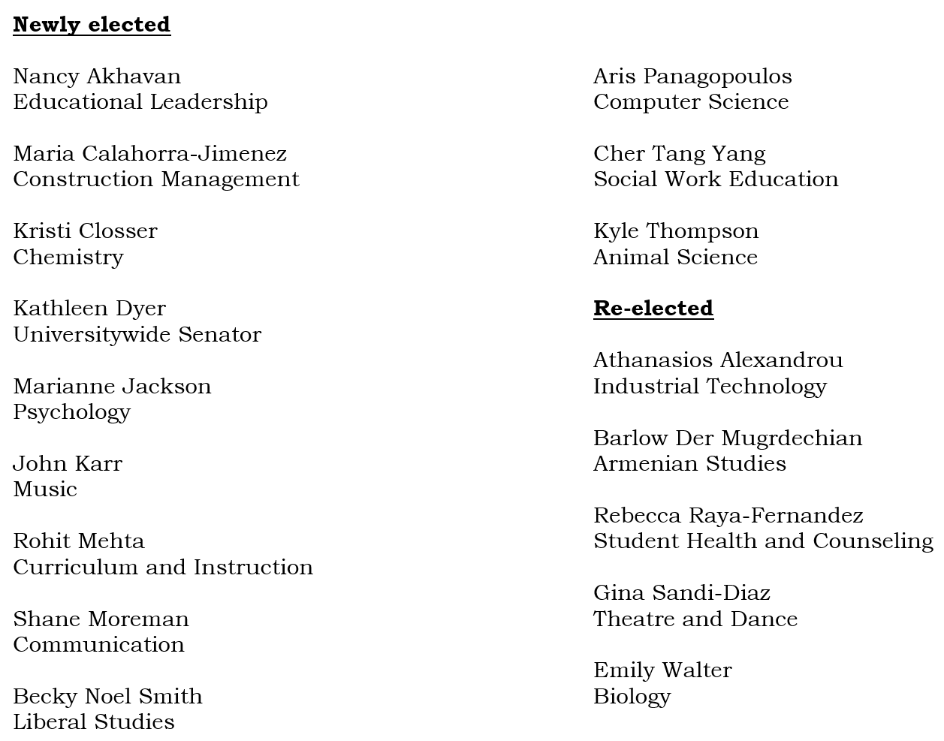

- Consent Calendar
  - Nominations/Appointments to the Nominating/Election Committee.
  - Nominations/Appointments to the Committee for Faculty Equity and Diversity (CFED).
  - Nominations/Appointments to the Student Affairs Committee.

- Election –Nominating/Elections Committee

Don Austin (Chair of Election Committee) presiding

  - Chair/Vice Chair – Academic Senate
Elected:
Chair: Ray Hall
Vice Chair: Tinneke Van Camp

  - Executive Committee – Two Positions
Elected:
Member-at-Large: Rebecca Raya-Fernandez
Universitywide: Kathleen Dyer

- New Business.

Introduced resolution as agenda item 14:
Resolution in support of stable budgetary support for library collections.

- APM 215 - General Education Policies and Procedures. Second Reading.

Some formatting issues were found. While some were corrected, some formatting issues remained unresolved It was taken as a friendly amendment that the policy be designated as interim policy to ensure corrections are made to this version of the policy sometime next Fall.

MSC passed

- APM 218 – American and California Government Graduation Requirement. Second Reading.

No discussion initiated.

MCS Passed

- APM 244 – Guidelines for CR/NC Grading.

Senator Dyer (Universitywide) inquired as the justification for language in the policy suggesting an exception specifically for Liberal Studies. Senator Mullooly (chair of AP&P) explained that the language is “vestigial”, and no longer relevant after the changes proposed today. Removal of that section was removed as a friendly amendment.

Motion to waive second reading:

MSC Passed

Motion to approve policy changes:

MSC Passed

- Task Force Exploring Fresno State Operations in a Post-COVID World. Second Reading.

No discussion initiated

Motion to approve

MSC Passed

- Resolution Regarding Hazardous Work and Study Environment. Second Reading.

Dr. Ben Boone (Music) was recognized to speak on behalf of this resolution.

Senator Herrera (Chicano and Latin American Studies) expressed her department’s desire to be named on the resolution.

Senator DeJordy (Management) suggested that we separate some issues from others in the resolution, and that it would it be beneficial to break this up into separate resolutions. Chair Holyoke replied that in his opinion this would not be an easy task, and would probably not be taken as a friendly amendment.

Senators DeJordy and Van Camp (Criminology) suggested an amended “whereas” to reflect the recent Chancellor’s office statement that the CSU does plan to require vaccines if they achieve full approval from the FDS. Accepted as friendly.

Ms. Zuñiga (ASI) expressed her concern about the resolution’s urgency for students to be vaccinated but not faculty as well. Dr. Boone described that this resolution specifically targets an EO that only applies to students.

Senator Lent (Biology) proposed and supplied language to add a “resolved” statement to the resolution to support mandatory vaccination for faculty and staff.

Motion to amend:
MSC

After incomplete discussion of recommending a potential religious exemption, Chair Holyoke asked the discussants to convene outside of the meeting to make a formal proposal that could be debated after the budget presentation at next week’s meeting.

The Academic Senate adjourned at 5:40p.m.
The next meeting of the Academic Senate will be May 3, 2021.

Submitted by Approved by
Raymond Hall Thomas Holyoke
Vice Chair Chair
Academic Senate Academic Senate

