Annual Assessment Report for 2020-2021 AY
Reports completed on assessment activities carried out during the 2020-21 AY will be due September 30th 2021 and must be e-mailed to the Director of Assessment, Dr. Douglas Fraleigh (douglasf@csufresno.edu).
Provide detailed responses for each of the following questions within this word document. Please do NOT insert an index or add formatting. Furthermore, only report on two or three student learning outcomes even if your external accreditor requires you to evaluate four or more outcomes each year. Also be sure to explain or omit specialized or discipline-specific terms.
Department/Program: _______Psychology__________ Degree: _B.A._
Assessment Coordinator: ________Paul Price___________________

- Please list the learning outcomes you assessed this year.
Outcome 3.1 – Demonstrate Effective Written Communication Skills

- What assignment or survey did you use to assess the outcomes and what method (criteria or rubric) did you use to evaluate the assignment? Please describe the assignment and the criteria or rubric used to evaluate the assignment in detail and, if possible, include copies of the assignment and criteria/rubric at the end of this report.
We used expository writing assignments from an upper-division course (Psych 128) that is taken by many of our juniors and seniors. Students identified and described a podcast or TED talk that was relevant to the course, then described two related research articles, and then wrote an integrated discussion of all three. (See attached.)
We evaluated a sample of 31 assignments using the “Written Communication Value Rubric” developed by the Association of American Colleges and Universities. (See attached.) Each assignment receives scores of 0 to 4 on five different criteria. Because the scoring criteria are quite rigorous, our benchmark for proficiency was a mean score of 2.0 across the five criteria.

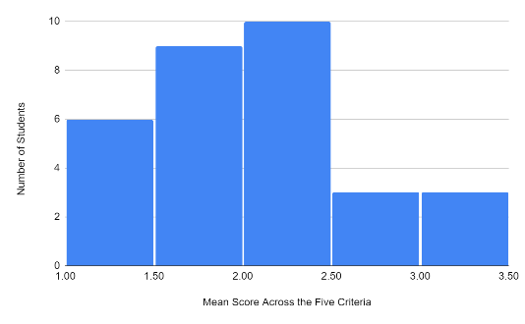
- What did you learn from your analysis of the data? Please include sample size (how many students were evaluated) and indicate how many students (number or percentage instead of a median or mean) were designated as proficient.
About half the students (48%) met the benchmark of a mean score of 2.0 or greater. In terms of individual rubric criteria, the best was “Context and Purpose of Writing,” for which 97% of the students met the benchmark of 2.0. This makes sense in part because the assignment instructions are quite explicit about its purpose, its organization, and the required content in the various sections of the paper. The worst individual criterion was “Content Development,” for which only 58% met the benchmark of 2.0. The main problem here was integrating across multiple sources to present a unified theme or point of view.
We also analyzed these data after eliminating six students who were listed on the course roster as either pre-nursing or Forensic Behavioral Science majors. This made a small difference (e.g., 52% met the primary benchmark) but the overall pattern of results was the same.

- What changes, if any, do you recommend based on the assessment data?
Before recommending any changes, we need to do a more detailed assessment of the extent to which our upper-division courses teach and assess writing within the discipline. When we solicited assignments from our instructors for this assessment activity, only one volunteered. So we need to know whether this reflects a lack of opportunities for our students to develop their writing skills. We will do this as part of updating our SOAP. (See below.)

- If you recommended any changes in your response to Question 4 in last year’s assessment report, what progress have you made in implementing these changes? If you did not recommend making any changes in last year’s report please write N/A as your answer to this question.
Our last assessment activity (in 2018-19) showed that students in Psych 63 (Intro to the Psych Major) still had common misconceptions about the field after taking the course. To address this, we proposed standardizing the learning outcomes for that course. What we have actually done at this point is standardize the course itself. Instead of several sections taught by different instructors (most of whom were adjunct faculty), we have an online component taught by a single experienced tenure-track faculty member, along with in-person activity sections that are led by adjunct faculty).

- What assessment activities will you be conducting during the next academic year?
This is currently up in the air. Our current plan only went through 2020 and we were not particularly happy with several aspects of it. Our main goal for the 2021-22 academic year, therefore, is to update our SOAP, including the learning outcomes, assessments, and timeline. However, we do plan to give our Senior Survey again, which we will probably continue to give annually.

- Identify and discuss any major issues identified during your last Program Review and in what ways these issues have or have not been addressed.
In our last action plan (from 2019), we identified four goals: restructuring our major requirements, refining our advising model, increasing tenure-track faculty, and increasing alumni engagement. We largely accomplished the first goal with a large-scale program revision in 2019-2020. We have addressed the second in a number of ways, including efforts to clarify for students the different roles of department-level and college-level advising. We have addressed the third with the hiring three new tenure-track faculty members in the last two years. And we continue to brainstorm ways to address the fourth.

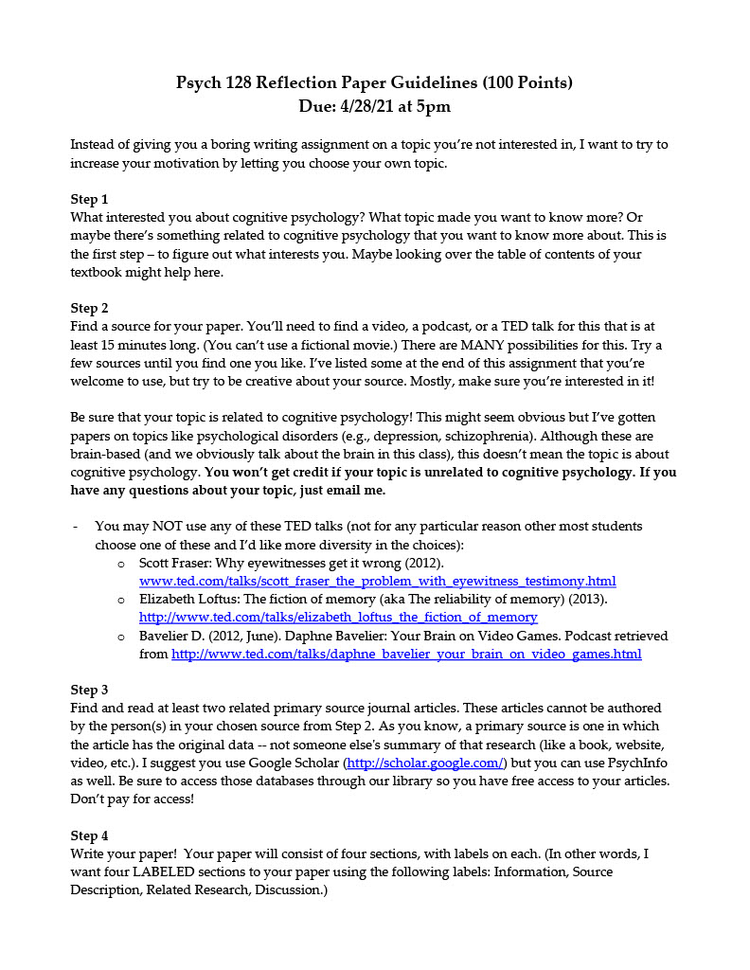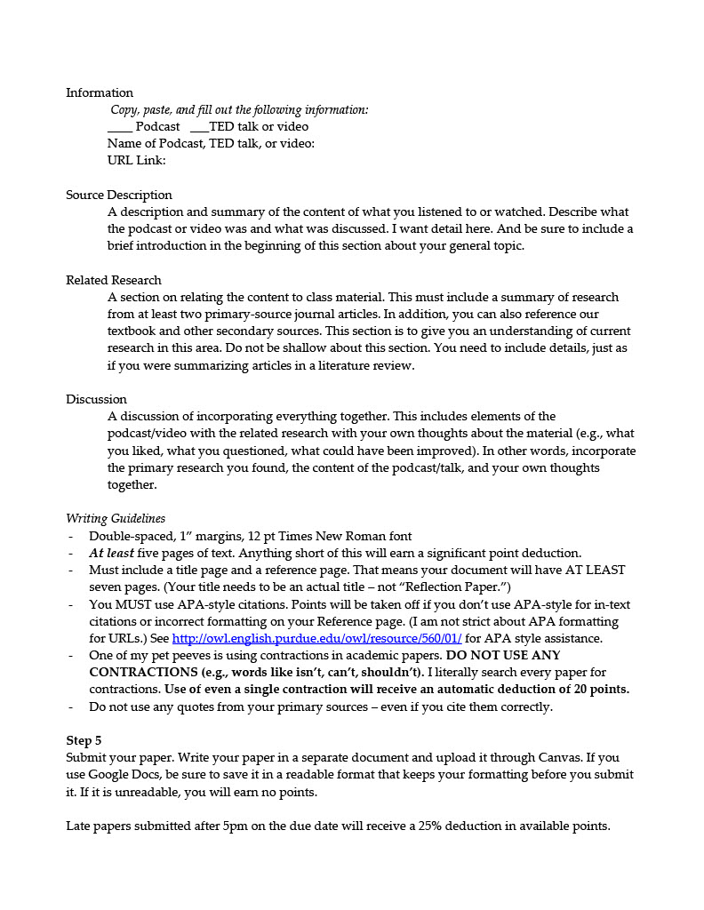
The Assignment

The Rubric

