Annual Assessment Report for 2020-2021 AY
Reports completed on assessment activities carried out during the 2020-21 AY will be due September 30th 2021 and must be e-mailed to the Director of Assessment, Dr. Douglas Fraleigh (douglasf@csufresno.edu).
Provide detailed responses for each of the following questions within this word document. Please do NOT insert an index or add formatting. Furthermore, only report on two or three student learning outcomes even if your external accreditor requires you to evaluate four or more outcomes each year. Also be sure to explain or omit specialized or discipline-specific terms.
Department/Program: Electrical and Computer Engineering Degree B.S.
Assessment Coordinators: Dr. Youngwook Kim and Dr. Aaron Stillmaker

- Please list the learning outcomes you assessed this year.
SLO 1: An ability to identify, formulate, and solve complex engineering problems by applying principles of engineering, science, and mathematics
SLO 3: An ability to communicate effectively with a range of audiences
SLO 7: An ability to acquire and apply new knowledge as needed, using appropriate learning strategies.
- What assignment or survey did you use to assess the outcomes and what method (criteria or rubric) did you use to evaluate the assignment? Please describe the assignment and the criteria or rubric used to evaluate the assignment in detail and, if possible, include copies of the assignment and criteria/rubric at the end of this report.
In the AY 2020-2021, we have evaluated SLO 1-7 using diverse assessment tools. For the purposes of this report, we will limit our reporting to SLO 1, 3, and 7. The assessment tools we employed include a course assessment, student exit survey, embedded questions in selected courses, student faculty forum, and an alumni survey. As ABET has changed the SLO from a-k to 1-7, we have modified SOAP and rubrics for direct assessment to accommodate the new SLO 1-7. The relevant rubrics used to assess SLOs 1, 3, and 7 are included as Appendices I - III to this report.
Course assessments were completed from student evaluations given to all the students on predetermined courses, where individual student success was assessed on each of the department’s SLOs.
The student exit survey is given to all students in our ECE 186B class, which is the second semester senior design class students take their final semester.
The assessment data for the embedded questions to evaluate SLOs 1, 3, and 7 were gathered through a Canvas survey that was assigned to predetermined courses that contain those SLOs. Each instructor assigned a survey used embedded questions of their choice to assess the outcomes based on the rubric we provided (Appendices I - III). The embedded questions used for evaluation are included as Appendix IV.
A student faculty forum was held where they asked questions of the faculty, and the students completed a survey which asked them their opinion on how well our courses were preparing our students for the SLOs.
An alumni survey is annually emailed to former graduates of the programs and survey data is collected which assesses the alumni feeling of the program’s success on the SLOs.
- What did you learn from your analysis of the data? Please include sample size (how many students were evaluated) and indicate how many students (number or percentage instead of a median or mean) were designated as proficient.
Student Course Assessments
We collected data through student course assessments, where each student was able to evaluate if they felt that the course met the stated SLO. Of the course assessments a few courses were chosen to sample the student’s assessment. ECE 1, 85, 90, 102, 118L, 121, 128L, and 174 were chosen as a wide range of early, mid, and late electrical and computer engineering courses. From our rubric we decided that a score of 3 would be considered meeting the benchmark. We expected that majority of the students to feel that they met the SLOs, and as can be seen in Table 1, most of the students state that they felt the courses met a sufficient attainment of the SLOs. It can be seen that SLO 3, oral communication, could be improved upon.
Table 1 –Spring 2021 Student SLO Course Assessments from ECE 1, 85, 90, 102, 118L, 121, 128L, and 174; Summarizing 117 Student’s Evaluations.
 | % of students meeting this benchmark | Average | 5 (Above) | 4 | 3  (Benchmark) | 2 | 1  (Unsatisfactory)
Electrical Engineering Students – 77 Students Evaluated
SLO 1 | 100% | 4.44 | 51.95% (40) | 40.26% (31) | 7.79%  (6) | 0 | 0
SLO 3 | 93.51% | 3.79 | 31.17%  (24) | 25.97% (20) | 36.36%  (28) | 3.90% (3) | 0
SLO 7 | 100% | 4.53 | 58.44%  (45) | 36.36% (28) | 5.19%  (4) | 0 | 0
Computer Engineering Students – 40 Students Evaluated
SLO 1 | 100% | 4.55 | 62.50%  (25) | 30.00% (12) | 7.50%  (3) | 0 | 0
SLO 3 | 90% | 4 | 37.50%  (15) | 35.00% (14) | 17.50%  (7) | 10.00%  (4) | 0
SLO 7 | 100% | 4.5 | 57.50%  (23) | 35.00% (14) | 7.50%  (3) | 0 | 0
Student Exit Survey
Students taking ECE 186B, our second semester senior design course almost always taken in the student’s final semester, were asked to complete a survey about the program’s success at the SLOs. The results from the Spring 2021exit survey are shown in Table 2. As can be seen from the results, all students that took the survey felt that we at least satisfactorily met each of our SLOs.
Table 2 – Spring 2021 Student Exit Survey SLO Assessment Given to Graduating Students – 7 Students Evaluated
 | % of students meeting this benchmark | Average | 5 (Above) | 4 | 3  (Benchmark) | 2 | 1  (Unsatisfactory)
Electrical Engineering Students – 4 Students Evaluated
SLO 1 | 100% | 4.25 | 50%  (2) | 25% (1) | 25%  (1) | 0 | 0
SLO 3 | 100% | 4.5 | 75%  (3) | 0 | 25%  (1) | 0 | 0
SLO 7 | 100% | 4.67 | 66.66% (2) | 33.33% (1) | 0 | 0 | 0
Computer Engineering Students – 3 Students Evaluated
SLO 1 | 100% | 4 | 33.33% (1) | 33.33% (1) | 33.33%  (1) | 0 | 0
SLO 3 | 100% | 4.33 | 33.33% (1) | 66.66% (2) | 0 | 0 | 0
SLO 7 | 100% | 4.67 | 66.66% (2) | 33.33% (1) | 0 | 0 | 0

Embedded Question Assessment
We identified a subset of courses that targeted the SLOs we were trying to evaluate, and we asked the instructors to evaluate each of their students using the rubrics in Appendices I – III and report the average to the assessment coordinator through a Canvas survey. As can be seen from the results in Tables 3 - 5, the one trend that we noticed was lower scores in ECE 85L when compared to another course. This is one of the first ECE courses students take, so this might be somewhat expected. We also notice that ECE 125 (a high failure rate course) has rather low scores, which seems to align with its failure rate. It is good to note that by ECE 186B most students are evaluated as proficient in the measured SLOs.
Table 3 – Embedded Question Assessment of SLO 1 from ECE 85L, 128, and 138L from Spring 2021. Data was collected as an average evaluation of all students in the class. Each row is a different course section. See Appendix I for the rubric.
Course | Identification of Applicable Physics and Mathematics Principles | Utilization of Physics and Mathematics Principles toward Modeling of an engineering system | Application of the Mathematics Methodology toward analyzing an engineering system | Use of mathematical steps toward solving an engineering problem | Interpretation and appropriate presentation of results
Electrical Engineering Students
ECE 128 & 138L | 4.2 | 4.1 | 4.2 | 4 | 3.9
ECE 85L | 3.8 | 3.8 | 3.8 | 3.8 | 5
ECE 128 & 138L | 4.3 | 4.2 | 4.2 | 4 | 3.8
ECE 128 | 3.9 | 4.1 | 3.9 | 3.8 | 3.8
Computer Engineering Students
ECE 85L | 2.8 | 2.8 | 2.8 | 2.8 | 3

Table 4 – Embedded Question Assessment of SLO 3 from ECE 85L and 186B from Spring 2021. Data was collected as an average evaluation of all students in the class. Each row is a different course section. See Appendix II for the rubric.
Course | Spoken communication a) Clarity b) Formality | Presentation a) Clarity of Voice b) Eye Contact | Ability to express ideas and answer questions | Technical content a) Depth b) Soundness
Electrical Engineering Students
ECE 85L | 3.5 | 3.5 | 3.5 | 3.5
ECE 186B | 4.5 | 4.5 | 4 | 4
ECE 186B | 4.8 | 4.8 | 4 | 3.8
Computer Engineering Students
ECE 85L | 3.5 | 3.5 | 3.5 | 3.5
ECE 186B | 4.5 | 4.5 | 4.5 | 4.5
ECE 186B | 5 | 4 | 4.5 | 3.5

Table 5 – Embedded Question Assessment of SLO 7 from ECE 125 and 178 from Spring 2021. Data was collected as an average evaluation of all students in the class. Each row is a different course section. See Appendix III for the rubric.
Course | Referencing relevant information and awareness of alternative solutions | Ability to use appropriate learning strategy | Application of new knowledge
Electrical Engineering Students
ECE 125 | 3 | 2.916 | 2.75
Computer Engineering Students
ECE 178 | 4.3 | 4 | 4.2

Student Faculty Forum
Annually we hold a student faculty forum where students can openly discuss the program, its’ weaknesses and strengths, as well as how it can be improved. The assessment coordinator used this to survey students on their perception of how well the programs are accomplishing the SLOs. As can be seen in the results, Table 6, the students that took the survey largely feel that we are successful in meeting our SLOs, where almost all of them rated that the programs sufficiently cover the SLOs. It should be noted that the lowest of the SLOs was SLO 3, which matches our previous assessment data.
Table 6 – Spring 2021 Student Faculty Forum Survey SLO Assessment Given to Student Attendees– 29 Students Evaluated
 | % of students meeting this benchmark | Average | 5 (Above) | 4 | 3  (Benchmark) | 2 | 1  (Unsatisfactory)
SLO 1: An ability to identify, formulate, and solve complex engineering problems by applying principles of engineering, science, and mathematics | 100.00% | 4.41 | 51.72%  (15) | 37.93%  (11) | 10.34%  (3) | 0 | 0
SLO 1: An ability to identify, formulate, and solve complex engineering problems by applying principles of engineering, science, and mathematics | 96.55% | 3.93 | 24.14%  (7) | 48.28%  (14) | 24.14%  (7) | 3.45%  (1) | 0
SLO 3: An ability to communicate effectively with a range of audiences | 100.00% | 4.24 | 48.28%  (14) | 27.59%  (8) | 24.14%  (7) | 0 | 0
SLO 3: An ability to communicate effectively with a range of audiences | 89.66% | 4 | 37.93%  (11) | 34.48%  (10) | 17.24%  (5) | 10.34%  (3) | 0
SLO 7: An ability to acquire and apply new knowledge as needed, using appropriate learning strategies. | 100.00% | 4.55 | 68.97%  (20) | 17.24%  (5) | 13.79%  (4) | 0 | 0
SLO 7: An ability to acquire and apply new knowledge as needed, using appropriate learning strategies. | 96.55% | 4.10 | 41.38%  (12) | 31.03%  (9) | 24.14%  (7) | 3.45%  (1) | 0

Alumni Survey
Annually we email alumni and ask them to assess the program, and a set of questions ask them how well they feel that the program met our targeted SLOs. The results from the survey are shown in Table 7. As can be seen, every student that turned in the survey thought we covered SLO 1, 3, and 7 sufficiently. One noticeable dip was the EE students seem to feel that we could have covered SLO 3, oral communication, better.

Table 7 –2021 Alumni Survey – 12 Former Students Evaluated
 | % of students meeting this benchmark | Average | 5 (Above) | 4 | 3  (Benchmark) | 2 | 1  (Unsatisfactory)
Electrical Engineering Students – 6 Former Students Evaluated
SLO 1 | 100% | 4.83 | 83.33%  (5) | 16.67%  (1) | 0 | 0 | 0
SLO 3 | 100% | 4 | 16.67%  (1) | 66.67%  (4) | 16.67% | 0 | 0
SLO 7 | 100% | 4.67 | 66.67%  (4) | 33.33%  (2) | 0 | 0 | 0
Computer Engineering Students – 6 Former Students Evaluated
SLO 1 | 100% | 4.5 | 50.00%  (3) | 50.00%  (3) | 0 | 0 | 0
SLO 3 | 100% | 4.83 | 83.33%  (5) | 16.67%  (1) | 0 | 0 | 0
SLO 7 | 100% | 4.67 | 66.67%  (4) | 33.33%  (2) | 0 | 0 | 0

- What changes, if any, do you recommend based on the assessment data?
From the course evaluations we found that most students felt that SLO 1, 3, and 7 were being met, but there were a few students that seemed to think that SLO 3 was not being met. SLO 3 is oral communication, so we plan to inform the department of this, and work with instructors to incorporate more presentations and communication requirements in their courses.
From the embedded questions, one trend we noticed was that students taking first time ECE courses were assessed lower than upper division students. While this may be somewhat expected as they are just entering our program, the assessment coordinators plan to work with the instructors of the introductory courses to make sure they and their students are supported. We also plan to share this information with the Pre-Engineering committee, which is working on a freshmen experience to engage students. We also plan to perhaps adapt our collection methodology for future embedded question assessments to ascertain the percentage of students that are deemed proficient, rather than just an average.
The Student Faculty Forum survey results pointed out once again that our students feel that we could improve on SLO 3, oral communication. As mentioned above, we plan to talk to our department about including more instruction and projects in oral communication.
The Alumni Survey similarly showed us in general we are accomplishing our targeted SLOs, with one possible improvement that could be made in SLO 3.

- If you recommended any changes in your response to Question 4 in last year’s assessment report, what progress have you made in implementing these changes? If you did not recommend making any changes in last year’s report please write N/A as your answer to this question.
N/A
- What assessment activities will you be conducting during the next academic year?
ECE department has a revised SOAP that shows a yearly plan for assessment activities using direct and indirect assessment tools. The direct assessment tools will include embedded questions, lab report, culminating experiences, posters while the indirect assessment contains course assessment, student/faculty forum, exit survey and alumni survey. In this academic year, according to the SOAP, we will conduct exit surveys, embedded questions, and course evaluation. In particular, we will conduct the lab report evaluation that we decided not to do last year. All labs were online due to the pandemic, so it was regarded to be not appropriate to evaluate team works and hand-on experiences using lab courses. We will use lab courses that offer in-person classes like ECE 85L and ECE 118L.
- What progress have you made on items from your last program review action plan?
During the academic year of 2020-2021, the Electrical and Computer Engineering (ECE) Department reviewed the SOAP and made necessary changes including SLO, direct assessment too, and assessment activities timeline.
- Identify and discuss any major issues identified during your last Program Review and in what ways these issues have or have not been addressed.
N/A

Appendices
Appendix I: Developed Rubrics for SLO 1
Math Science Engineering Rubric
SLO 1
Course: ECE _______ Date: _____________
Evaluate on a scale of 1-5 (5 is for excellent); check the proper box
 | 1 | 2 | 3 | 4 | 5 | N/A
Identification of Applicable Physics and Mathematics Principles | Lack of Knowledge |  |  |  | Complete Knowledge
Utilization of Physics and Mathematics Principles toward Modeling of an engineering system | Improper utilization or application |  |  |  | Proper and correct utilization
Application of the Mathematics Methodology toward analyzing an engineering system | Incorrect Application |  |  |  | Correct and Complete Application
Use of mathematical steps toward solving an engineering problem | Incorrect or invalid mathematical steps |  |  |  | Except for minor errors, completion of appropriate mathematical steps
Interpretation and appropriate presentation of results | Lack of Valid  results |  |  |  | Complete results that include proper units

Overall average score __________

Evaluator ____________________________ Date _____________

Appendix II: Developed Rubrics for SLO 3
Oral Communication Rubric
SLO 3
Course #: ECE _______ Date: _____________

Evaluate on a scale of 1-5 (5 is for excellent); check the proper box
 | 0 | 1 | 2 | 3 | 4
Spoken communication  - Clarity  - Formality | unclear pronunciation and lacking vocabulary |  |  | clear pronunciation but lacking vocabulary |  | clear pronunciation and appropriate vocabulary
Presentation  - Clarity of Voice  - Eye Contact | Unclear voice and no eye contact |  |  | clear voice but no eye contact |  | proper level of voice and good eye contact
Ability to express ideas and answer questions | not able to express ideas or answer questions |  |  | Ideas expressed reasonably well but answers to questions is lacking |  | ideas expressed clearly and all questions are answered properly
Technical content  - Depth  - Soundness | no depth and unclear approach |  |  | sufficient depth but unclear approach |  | appropriate depth and sound approaches

Overall average score __________

Evaluator ____________________________ Date ___________________

Appendix III: Developed Rubrics for SLO 7
Acquire and apply new knowledge as needed
using appropriate learning strategies
SLO 7
Course#: ECE _______ Date: _____________
Evaluate on a scale of 1-5 (5 is for excellent); check the proper box
 | 1 | 2 | 3 | 4 | 5 | N/A
Referencing relevant information and awareness of alternative solutions | Inability to satisfactorily demonstrate awareness of background |  | Satisfactory demonstration of at least three indicators |  | Strong demonstration of awareness of background
Ability to use appropriate learning strategy | Lack of learning strategy to acquire knowledge required |  |  |  | Use of proper learning strategy to acquire knowledge required
Application of new knowledge | Lack of demonstration of applying new knowledge on solving of engineering problem or engineering design |  |  |  | Demonstration of proper application of new knowledge on solving of engineering problem or engineering design

Overall average score __________
Evaluator ____________________________ Date _____________

Appendix IV: Embedded Questions
SLO 1
ECE 85L:
Instructor’s own observations on students' prelab work for the design of a BCD to Gray Code Converter for their Lab # 6 experiment.
Instructor’s own observations on students' demonstration for the designed BCD to Gray Code Converter in their Lab # 6 experiment.
ECE 128:
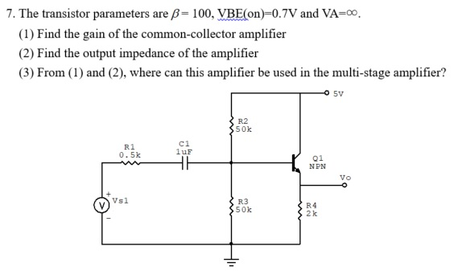

SLO 3
ECE 85L:
Instructor’s own observations during the different assigned in-class activities. Note that, for the eye contact part, it was challenging to evaluate due to the virtual mode of instructions.
ECE 186B:
Observations from final presentations day. Note: eye contact was challenging to note due to virtual mode of presentations as a result of COVID-19.
End of the semester senior design project oral presentation.
SLO 7
ECE 125: 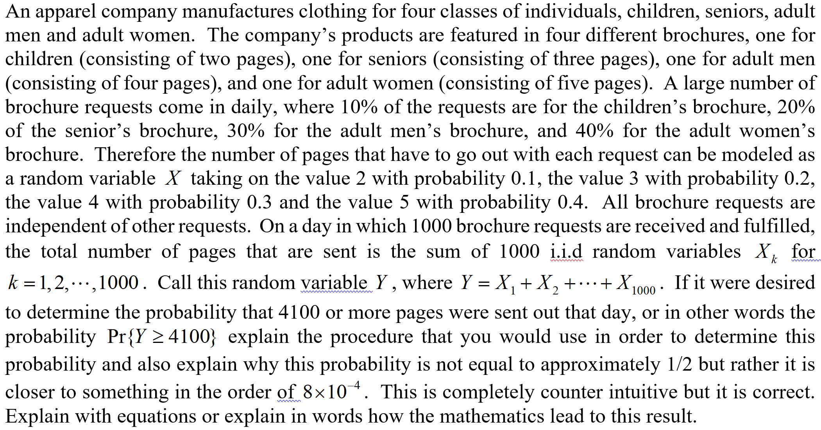
ECE 178:
Students are required to acquire technical engineering design knowledge and skills to do a self-determined group project with the approval of the instructor to design, construct, and debug a soft-core embedded system using the Intel Platform Designer tool and Cyclone FPGA board. The students had to culminate their learned experience into a more advanced software/hardware embedded system design and firmware integration into an Altera FPGA prototyping board.

