Annual Assessment Report for 2020-2021 AY
Reports completed on assessment activities carried out during the 2020-21 AY will be due September 30th 2021 and must be e-mailed to the Director of Assessment, Dr. Douglas Fraleigh (douglasf@csufresno.edu).
Provide detailed responses for each of the following questions within this word document. Please do NOT insert an index or add formatting. Furthermore, only report on two or three student learning outcomes even if your external accreditor requires you to evaluate four or more outcomes each year. Also be sure to explain or omit specialized or discipline-specific terms.
Department/Program: Communicative Sciences and Deaf Studies
Degree: B.A., Deaf Studies, Deaf Education, and Interpreting Options
Assessment Coordinator: Brooke Findley, Ed.D., CCC-SLP, BCBA
- Please list the learning outcomes you assessed this year.
The learning outcomes assessed this year for our undergraduate options in Deaf Studies, Deaf Education, and Interpreting included:
      - PLO: Demonstrate understanding and application of knowledge within their selected discipline/option
        - SLO: Students will understand the social, emotional, linguistic, vocational and intellectual aspects of Deaf culture
        - SLO: Students will understand the basic process of teaching academics to children who are Deaf or hard of hearing
        - SLO: Students will understand theoretical foundations and technical skills needed to interpret in professional settings for children and adults who are Deaf or hard of hearing
      - PLO: Establish appropriate and measurable goals for potential clients or students
        - SLO: Students will assimilate and apply knowledge regarding normal and abnormal development, curriculum requirements, and instructional approaches
        - SLO: Students will apply their knowledge to establish appropriate and measurable goals and objectives for assigned clients and/or students
      - PLO: Communicate effectively with potential clients, students, or consumers
        - SLO: Students will communicate effectively with adults and children who are Deaf or hard of hearing using a variety of communication strategies
        - SLO: Students will synthesize and evaluate the communication environment and match their language to their clients
        - SLO: Students will demonstrate their effective communication skills using American Sign Language (ASL)
      - PLO: Demonstrate professional behavior within their selected discipline
        - SLO: Students will demonstrate professional behavior during their interactions with clients, students, and/or parents
- What assignment or survey did you use to assess the outcomes and what method (criteria or rubric) did you use to evaluate the assignment? Please describe the assignment and the criteria or rubric used to evaluate the assignment in detail and, if possible, include copies of the assignment and criteria/rubric at the end of this report.
Two measures were collected for analysis during the 2020-2021 academic year assessment cycle. These measures were initially scheduled to be reviewed during the 2019-2020 assessment cycle; however, they were delayed due to the postponement of assessment activities secondary to the COVID-19 pandemic. A review of these measures is provided below, along with the learning outcomes to which each measure is tied. Please see Appendix A for an example of the grading rubrics used for these assignments.
      - Evaluation of Lesson Presentation
        - Assignment Discussion: Within their CSDS 164 practicum placement, students complete an assignment in which they are graded on their ability to effectively deliver an instructional lesson. Their supervisor grades the students on their teaching effectiveness, communication skills, quality of lesson plans and materials, implementation of suggestions, punctuality, and self-reflection skills. Should at least 80% of students demonstrate satisfactory performance across relevant items on the practicum grading rubric (see Appendix A), the individual SLOs mapped to this direct measure shall be considered met.
        - Student Learning Outcomes Addressed
          - PLO: Demonstrate understanding and application of knowledge within their selected discipline/option
            - SLO: Students will understand the social, emotional, linguistic, vocational and intellectual aspects of Deaf culture
            - SLO: Students will understand the basic process of teaching academics to children who are Deaf or hard of hearing
          - PLO: Establish appropriate and measurable goals for potential clients or students
            - SLO: Students will assimilate and apply knowledge regarding normal and abnormal development, curriculum requirements, and instructional approaches
            - SLO: Students will apply their knowledge to establish appropriate and measurable goals and objectives for assigned clients and/or students
          - PLO: Communicate effectively with potential clients, students, or consumers
            - SLO: Students will communicate effectively with adults and children who are Deaf or hard of hearing using a variety of communication strategies
            - SLO: Students will synthesize and evaluate the communication environment and match their language to their clients
            - SLO: Students will demonstrate their effective communication skills using American Sign Language (ASL)
          - PLO: Demonstrate professional behavior within their selected discipline
            - SLO: Students will demonstrate professional behavior during their interactions with clients, students, and/or parents
      - Evaluation of Interpreting Services
        - Assignment Discussion: As a part of their interpreting internship in CSDS 175, students are required to provide supervised interpreting services in a variety of professional settings. Students are evaluated on the effectiveness of their interpreting services across a variety of domains. Due to the nature of virtual instruction during COVID-19, these evaluations transitioned from live assessments of interpreting services to virtual asynchronous evaluations of these skills. As such, a new rubric was developed and implemented for this assignment (see Appendix B). Should at least 80% of students demonstrate satisfactory performance across relevant items on the practicum grading rubric, the individual SLOs mapped to this direct measure shall be considered met.
        - Student Learning Outcomes Addressed:
          - PLO: Demonstrate understanding and application of knowledge within their selected discipline/option.
            - SLO: Students will understand the social, emotional, linguistic, vocational and intellectual aspects of Deaf culture
            - SLO: Students will understand theoretical foundations and technical skills needed to interpret in professional settings for children and adults who are Deaf or hard of hearing
          - PLO: Establish appropriate and measurable goals for potential clients or students
            - SLO: Students will apply their knowledge to establish appropriate and measurable goals and objectives for assigned clients and/or students
      - PLO: Communicate effectively with potential clients, students, or consumers
            - SLO: Students will communicate effectively with adults and children who are Deaf or hard of hearing using a variety of communication strategies
            - SLO: Students will synthesize and evaluate the communication environment and match their language to their clients
            - SLO: Students will demonstrate their effective communication skills using American Sign Language (ASL)
      - PLO: Demonstrate professional behavior within their selected discipline
            - SLO: Students will demonstrate professional behavior during their interactions with clients, students, and/or parents
- What did you learn from your analysis of the data? Please include sample size (how many students were evaluated) and indicate how many students (number or percentage instead of a median or mean) were designated as proficient.
Please see below for a discussion of our assessment results for each data source reviewed:
      - Evaluation of Lesson Presentation (n=14):
  - CSDS 164 was offered during the Fall 2020 semester only. Per report of the course instructor, 100% (14/14) of students demonstrated proficient or higher performance on this component of their assessment.
  - Outcome: Goal met (≥80% of students demonstrated satisfactory performance across the relevant items on the practicum grading rubric).
      - Evaluation of Interpreting Services:
  - CSDS 175 was offered during both Fall 2020 and Spring 2021. A total of 23 students across three sections of this course completed this assignment. Per report of the course instructors, 85.7% (6/7) students in the Fall 2020 semester and 100% of students in the Spring 2021 semester (section #1= 6/6, section #2= 10/10) met proficiency requirements across all sections of the rubric for this assignment. As such, the total proficiency rate across the 2020-2021 academic year for this assessment measure was 95.7% (22/23).
  - Outcome: Goal met (≥80% of students demonstrated satisfactory performance across the relevant items on the practicum grading rubric).
- What changes, if any, do you recommend based on the assessment data?
The results of the undergraduate outcomes assessment for the Deaf Studies disciplines were shared at the Department of Communicative Sciences and Deaf Studies’ (CSDS) faculty meeting on September 22, 2021. At this meeting, the CSDS faculty actively participated in review and discussion of the 2020-2021 SOAP data. Since both outcomes were met, no changes were proposed as a result of the presented data.
At this meeting, the SOAP coordinator recommended exploring revisions to the current plan, in order to distribute assessment across the undergraduate curriculum and promote alignment between the SLOs and collected assessment data. Members of the faculty agreed and plan to participate in plan revision during the 2021-2022 academic year.
- If you recommended any changes in your response to Question 4 in last year’s assessment report, what progress have you made in implementing these changes? If you did not recommend making any changes in last year’s report please write N/A as your answer to this question.
N/A
- What assessment activities will you be conducting during the next academic year?
Per review of the current SOAP plan, the following assessment activities are scheduled for next academic year:
- Evaluation of Interpreting Services
- Exit Questionnaire
These activities are aligned with the following program and student learning outcomes:
          - PLO: Demonstrate understanding and application of knowledge within their selected discipline/option
            - SLO: Students will understand the social, emotional, linguistic, vocational and intellectual aspects of Deaf culture
            - SLO: Students will understand the basic process of teaching academics to children who are Deaf or hard of hearing
            - SLO: Students will understand theoretical foundations and technical skills needed to interpret in professional settings for children and adults who are Deaf or hard of hearing
          - PLO: Demonstrate proficiency in written communication
        - SLO: Demonstrate proficiency in writing by writing a professional report
          - PLO: Establish appropriate and measurable goals for potential clients or students
            - SLO: Students will assimilate and apply knowledge regarding normal and abnormal development, curriculum requirements, and instructional approaches
            - SLO: Students will apply their knowledge to establish appropriate and measurable goals and objectives for assigned clients and/or students
          - PLO: Communicate effectively with potential clients, students, or consumers
            - SLO: Students will communicate effectively with adults and children who are Deaf or hard of hearing using a variety of communication strategies
            - SLO: Students will synthesize and evaluate the communication environment and match their language to their clients
            - SLO: Students will demonstrate their effective communication skills using American Sign Language (ASL)
          - PLO: Demonstrate professional behavior within their selected discipline
            - SLO: Students will demonstrate professional behavior during their interactions with clients, students, and/or parents
As previously mentioned, plans are in place to update the current undergraduate SOAP plan for the Deaf Studies program during the 2021-2022 academic year. As such, it is likely that these assessment activities and outcomes may change following these revisions.
- What progress have you made on items from your last program review action plan?
Per review of the previous undergraduate SOAP annual report, there were no recommended changes relative to these items. We are continuing to monitor, as needed.

Appendix A: CSDS 164 Practicum Evaluation Rubric

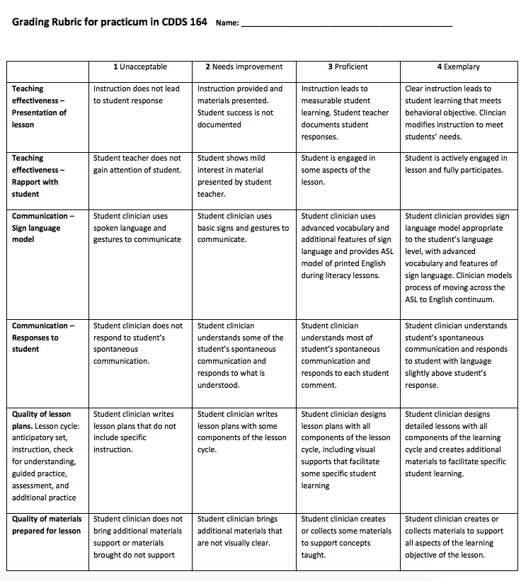

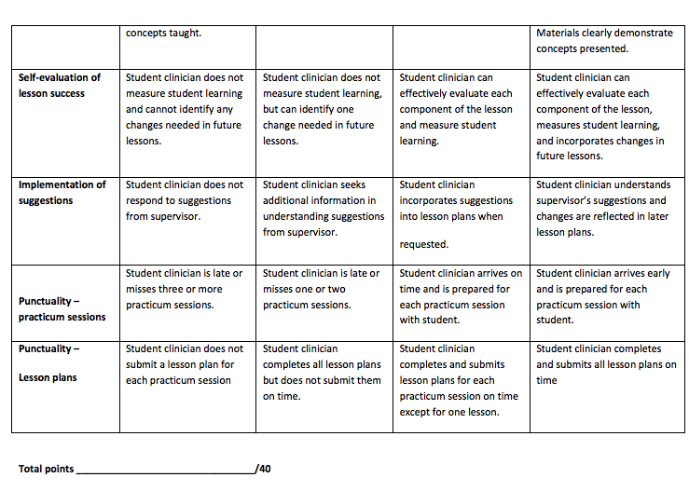

Appendix B: CSDS 175 Practicum Evaluation Rubrics

Student Name: Rater Name: Date:
OVERALL SCORE
Ethics – Pass Defend Fail
ENGLISH to ASL – Pass Defend Fail
ASL to ENGLISH – Pass Defend Fail
OVERALL SCORE : Pass Defend Fail
Student Name:
Rater Name: ETHICS SCENARIO RUBRIC
AREA | EXCELLENT  4 Points | GOOD  3 Points | EMERGING  2 Points | WEAK  1 Point | SCORE
 | Comprehensive answer including all pertinent parts: appropriate CPC tenets; in-depth reference to, and discussion of, tenet; impact on various consumers, interpreter and profession; presents possible solution, or elaborates on conflicts; demonstrates real world knowledge, and cultural sensitivity | Generally strong answer includes several considerations from those listed below: appropriate CPC tenets; in-depth reference to, and discussion of, tenet; impact on various consumers, interpreter and profession; presents possible solution, or elaborates on conflicts; demonstrates real world knowledge, and cultural sensitivity | Answer includes a few considerations from those listed below: appropriate CPC tenets; in-depth reference to, and discussion of, tenet; impact on various consumers, interpreter and profession; presents possible solution, or elaborates on conflicts; demonstrates real world knowledge, and cultural sensitivity | Incomplete or inaccurate answer includes, little to no pertinent parts listed below: appropriate CPC tenets; in-depth reference to, and discussion of, tenet; impact on various consumers, interpreter and profession; presents possible solution, or elaborates on conflicts; demonstrates real world knowledge, and cultural sensitivity | ______
 |  |  |  | TOTAL | ______
2nd Semester Interns 1st Semester Interns
3 - 4 points = PASS 3-4 points = PASS
2 points = Defend 1-2 points = Defend
0-1 points = FAIL 0 points = FAIL
NOTES:

Student Name: 1st Semester/2nd Semester Intern _____
Rater Name:
ENGLISH TO ASL COMPS RUBRIC
AREA | EXCELLENT  4 Points | GOOD  3 Points | EMERGING  2 Points | WEAK  1 Point | SCORE
MESSAGE ACCURACY | Consistently accurate message, main points and details included; signs are consistently conceptually accurate, drops form consistently | Generally accurate message, most main points and some details included. Signs are generally conceptually accurate with some errors in dropping form | Some parts of the message included, some main points and few details included; signs are only conceptually accurate at times, with rare evidence of dropping form | Little message accuracy, main point missed, little to no details, signs are generally not conceptually accurate, message sticks too closely to the source language | _____
SIGN PRODUCTION & USE OF VOCABULRY | Sign parameters are accurate, good use of varied vocabulary | Signs are generally accurate with some minor errors, some varied vocabulary | Signs are only occasionally accurate with frequent errors, limited vocabulary | Signs frequently produced with errors, very limited vocabulary | _____
ASL FEATURES & SYNTAX | Consistent and appropriate use of ASL features (ex: listing feature, constructed action/dialogue, classifiers, etc.). Consistent and appropriate use of Topic-Comment structure, RH?’s, Conditionals etc.) | Generally appropriate use of ASL features (ex: listing feature, constructed action/dialogue, classifiers, etc.). Generally appropriate use of Topic-Comment structure, RH?’s, Conditionals etc.) | Some appropriate use of ASL features (ex: listing feature, constructed action/dialogue, classifiers, etc.). Some appropriate use of Topic-Comment structure, RH?’s, Conditionals etc.) | Little to no use of ASL features (ex: listing feature, constructed action/dialogue, classifiers, etc.). Little to no use of Topic-Comment structure, RH?’s, Conditionals etc.) | _____
Use of Space | Signing size is appropriate and space is consistently used effectively | Signing size generally appropriate and space is generally used effectively | Signing size is appropriate at times, and space is used effectively, but infrequently | Signing size is not appropriate and space is used effectively very rarely, or not at all | _____
Affect and Register | Appropriate match for emotion, intent and pragmatic use of language | Somewhat appropriate match for emotion, intent and pragmatic use of language | Occasional match for emotion, intent and pragmatic use of language | Inappropriate match for emotion, intent and pragmatic use of language | _____
Prosody | Consistently appropriate and effective fluency and use of pauses. | Frequently appropriate and effective fluency and use of pauses. | Occasionally appropriate and effective fluency and use of pauses. | Little to no fluency, and inappropriate use of pauses. | _____
 |  |  |  | TOTAL | ______
ENGLISH TO ASL NOTES:
2nd Semester Interns 1st Semester Interns
15-24 points = PASS 13-24 points = PASS
12-14 points = Defend 10 - 12 points = Defend
0 – 11 points = FAIL 0 – 9 points = FAIL

Student Name: 1st Semester/2nd Semester Intern _____
Rater Name: ASL TO ENGLISH COMPS RUBRIC
AREA | EXCELLENT  4 Points | GOOD  3 Points | EMERGING  2 Points | WEAK  1 Point | SCORE
MESSAGE ACCURACY | Consistently accurate message, main points and details included | Generally accurate message, most main points and some details included | Some parts of the message included, some main points and few details included | Little message accuracy, main point missed, little to no details | ____
SYNTAX | Good command of English, use of complex sentence structure, some use of idioms/figurative speech, errors are corrected and do not impact overall message | Overall command of English with few errors, general use of complex sentence structure, occasional use of idioms/figurative speech, errors are corrected but have minor negative impact to message | Some command of English, some use of complex sentence structure, limited use of idioms/figurative speech, errors are recognized but not corrected | Struggles with command of English, use of simple sentence structure, no use of idioms/figurative speech, errors are not realized | _____
VOCABULARY | Consistent use of appropriate and varied vocabulary. Avoids circumlocution | Generally consistent use of appropriate and varied vocabulary. Generally, avoids circumlocution | Inconsistent use of appropriate and varied vocabulary. Some limited use of circumlocution | Limited use of appropriate and varied vocabulary. Circumlocution used throughout | _____
PROSODY | Consistently appropriate and effective fluency and use of pauses | Frequently appropriate and effective fluency and use of pauses with minimal hesitation | Occasionally appropriate and effective fluency and use of pauses. Frequent hesitation | Little to no fluency. Inappropriate use of pauses. Frequent hesitation | _____
 |  |  |  | TOTAL | _____
2nd Semester Interns 1st Semester Interns
13 - 16 points = PASS 11-16 points = PASS
9 - 12 points = DEFEND 6 - 10 points = DEFEND
0 – 8 points = FAIL 0 – 5 points = FAIL
ASL TO ENGLISH NOTES:

