Annual Assessment Report for 2018-2019 AY
Reports completed on assessment activities carried out during the 2018-2019 AY will be due September 30th 2019 and must be e-mailed to the Director of Assessment, Dr. Melissa Jordine (mjordine@mail.fresnostate.edu).
Provide detailed responses for each of the following questions within this word document. Please do NOT insert an index or add formatting. Furthermore, only report on two or three student learning outcomes even if your external accreditor requires you to evaluate four or more outcomes each year. Also be sure to explain or omit specialized or discipline-specific terms.
Department/Program: Viticulture and Enology Degree: BSc in Enology
Assessment Coordinator: Miguel Pedroza

- Please list the learning outcomes you assessed this year.
      - SLO: Evaluate the microbiological, chemical, and sensory properties of wine through industry-standard methods.
- What assignment or survey did you use to assess the outcomes and what method (criteria or rubric) did you use to evaluate the assignment?
The assignment corresponds to the final exam from ENOL-125 Wine Microbiology. The test included sixty one (61) questions of different types such as multiple choice, true/false, short answer, fill in the blanks, and open questions. Students had two hours to complete the test.
Evaluation Method: 75% or more of the senior students will correctly answer more than 70% of questions

- What did you learn from your analysis of the data? Please include sample size (how many students were evaluated) and indicate how many students (number or percentage instead of a median or mean) were designated as proficient.

According to the data below, the class was compliant with the benchmark of having at least 75% of the students with a grade of 70% of the total points in the final exam. The descriptive statistics show that the vast majority of the group had a positive performance and the group grades adjusted to a typical distribution. Notably, three students (16%) had a score higher than 90 points, whereas only two students (11%) had a failing score.
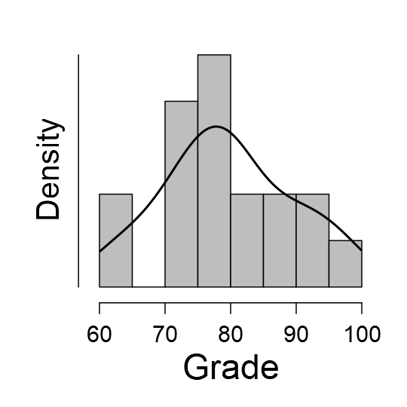
Descriptive Statistics
 |  | Grade
Valid |  | 18
Mean |  | 79.61
Median |  | 78.50
Std. Deviation |  | 9.977
Minimum |  | 62.00
Maximum |  | 98.00
25th percentile |  | 71.75
50th percentile |  | 78.50
75th percentile |  | 88.25

- What changes, if any, do you recommend based on the assessment data?
- Early identification of students struggling with course contents by means of quizzes and midterms grades.
- Tutoring sessions for topics requiring integration of knowledge and memorization of technical terminology.
- Increasing the types of content representation (videos, multimedia, review papers, hands-on experience) for course materials.

- If you recommended any changes in your response to Question 4 in last year’s assessment report, what progress have you made in implementing these changes? If you did not recommend making any changes in last year’s report please write N/A as your answer to this question.
- Restructuration and redesign of semester-long assignments
- Improvement in scheduling and instructions for execution of final reports and presentations.

- What assessment activities will you be conducting during the next academic year?
- SLO 1.a Alumni Survey (Indirect measure)
- SLO 1.b Laboratory exam from ENOL 115
  - Assessment activity: Evaluation of laboratory grades

- What progress have you made on items from your last program review action plan?
- The entire SOAP for the BSc in Enology was revised, focusing on consolidating SLOs that were previously unaligned with program goals
- Curriculum review for the major and minor in Enology (in progress)
- Alignment of courses according to the new curriculum changes
- Revision and update of the SOAP for the BSc. in Viticulture

