Annual Assessment Report for 2018-19 Academic Year
Department: Industrial Technology
Program: Masters of Science in Industrial Technology
Assessment Coordinator: Arun N Nambiar
1. Please list the learning outcomes you assessed this year
This year, we assessed the following learning outcomes:
a. LO 1.2 - Employ data analysis tools to analyze, interpret and derive conclusions from data
b. LO 4.1 - Employ effective presentation techniques to make technical presentations
2. What assignment or survey did you use to assess the outcomes and what method did you use to evaluate the assignment?
a. LO 1.2 was assessed using the two projects in IT 216 - Production Data Analytics b. LO 4.1 was assessed during the final presentations for IT 298 Project using a rubric.
3. What did you learn from your analysis of the data? Please include sample size (how many students were evaluated) and indicate how many were designated as proficient.
a. LO 1.2 - IT 216 had 9 students. 6 students exceeded the expectation of 70%. One student didn’t submit the projects and is currently repeating the course.
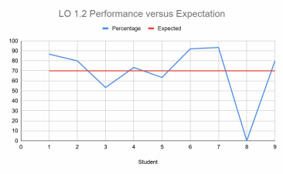
MSIT Assessment Report for 2018-19
b. LO 4.1 - 9 students made presentations for their IT 298 Project. The expectation was that all students should perform at a 3 or better on a 4 point scale. Based on the results, there is some work that needs to be done to improve the level of professionalism and confidence among our students.
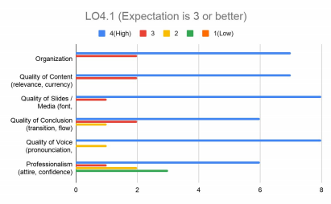
Besides these, an exit survey was also conducted among our graduating students. The expectation was that the program would be ranked 4 or better on all criteria. The results are encouraging, although there is some work to be to increase exposure to leadership and communication skills. This is also reflected in the LO4.1 evaluation.
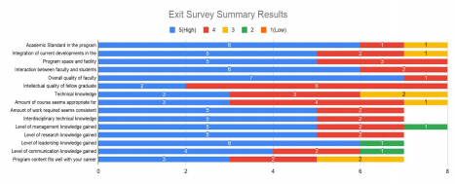2 of 3
MSIT Assessment Report for 2018-19
4. What changes, if any, do you recommend based on the assessment data? Based on the data collected, the department feels that there needs to be greater emphasis on professionalism and communication skills. This would be included in the core courses through increased opportunities to make presentations.
5. If you recommended any changes in your response to Question 4 in last year’s assessment report, what progress have you made in implementing these changes? N/A
6. What assessment activities will you be conducting during the next academic year? This year, the department will be assessing the following learning outcomes: a. LO 1.3 - Compare and evaluate various production systems
b. LO 2.1 - Apply management and organization theory concepts to develop strategic plans for managing technology
7. What progress have you made on items from your last program review action plan? The program will be going through a program review this year.
3 of 3

