Major Assessment Report
Enology B.S.

Department and Degree: Department of Viticulture and Enology

Assessment Coordinator: Miguel A. Pedroza

- What learning outcome(s) did you assess this year? List all program outcomes you assessed (if you assessed an outcome not listed on your department SOAP please indicate explain). Do not describe the measures or benchmarks in this section Also please only describe major assessment activities in this report. No GE assessment was required for the 2016-2017 academic year.

Assessment Method 1: Standard Operating Procedures
SLO:
2.3 Practice vinification techniques, demonstrating knowledge of fermentation, maceration, and other early wine production variables.
2.4 Practice cellaring techniques, demonstrating knowledge of post-fermentation processing of wine and associated chemical changes.
2.5 Practice blending techniques, demonstrating knowledge of sensory evaluation and resulting practices related to managing wine style and quality attributes.
2.6 Demonstrate understanding and application of final wine processing and packaging technologies.
2.7 Know and demonstrate proper use of winery technology and equipment.
3.1 Demonstrate a general knowledge of wine and winery regulations at the federal and California state levels, including the ability to identify appropriate sources for regulatory compliance information.

Assessment method 2: Wine production Literature Review
SLO:
2.1 Analyze grape quality through organoleptic and technical methods and apply resulting data in vineyard, harvest, and wine management.
4.1 Demonstrate the ability to access grape industry knowledge through core resources
4.2 Manage knowledge and information towards achieving project objectives
4.3 Synthesize knowledge and information to achieve objectives and products as assigned
4.4 Communicate, interpret, and evaluate knowledge effectively through oral, written, and visual mediums.

- What assignment or survey did you use to assess the outcomes and what method (criteria or rubric) did you use to evaluate the assignment? If the assignment (activity, survey, etc.) does not correspond to the activities indicated in the timeline on the SOAP, please indicate why. Please clearly indicate how the assignment/survey is able to measure a specific outcome. If after evaluating the assessment you concluded that the measure was not clearly aligned or did not adequately measure the outcome please discuss this in your report. Please include the benchmark or standard for student performance in your assessment report (if it is stated in your SOAP then this information can just be copied into the report). An example of an expectation or standard would be “On outcome 2.3 we expected at least 80% of students to achieve a score of 3 or above on the rubric.”

The assignments selected were the Standard Operating Procedures from the course ENOL-151-Winery Equipment, and the Wine Production Literature Review and Oral Presentation from the course ENOL 164-Wine Production and Analysis.

Both of these assignments correspond to methods scheduled for the AY 2017-2018. We submit these indicators due to the availability of the data at the moment of assessment. Indeed, our Department has gone through a transition period without an assessment coordinator. Furthermore, both of the new Enology instructors started activities at the Fall 2017 semester.

Alignment between assessment methods and SLOs

- Standard Operating Procedures (SOP) and SLOs 2.3, 2.4, 2.5. 2.6, 2.7 and 3.1

2.3 Practice vinification techniques, demonstrating knowledge of fermentation, maceration, and other early wine production variables.
The SOP final submission requires that students perform interviews with winery staff, practice the operation, and write a precise procedure which is expected to preserve wine quality. The detail required for the SOP document is such that students need to perform the task several times.

2.4 Practice cellaring techniques, demonstrating knowledge of post-fermentation processing of wine and associated chemical changes.
One of the objectives of the SOP is to allow operators to execute winemaking tasks in a safe and precise manner. While writing the SOP, student need to practice and repeat winemaking operations in a way that every detail and parameter is communicated in the final document.

2.5 Practice blending techniques, demonstrating knowledge of sensory evaluation and resulting practices related to managing wine style and quality attributes.
Due to the specificity of SOPs and their relation to specific moments in the winemaking process, we found that this SLO is not adequately measured by the SOP assignment. However, students in class are exposed to Blending activities and other post-fermentation operations.

2.6 Demonstrate understanding and application of final wine processing and packaging technologies.
This SLO is assessed more effectively through the laboratory reports compared to the SOP assignment. Similar to the observations in SLO 2.5, SOPs do not address directly this SLO.

2.7 Know and demonstrate proper use of winery technology and equipment.
The SOPs address directly this SLO by requiring students to deepen into the operation of winery equipment and its impact in winemaking. At the end of the course, the students are required to demonstrate the operation of different equipment using the SOP document submitted as part of their final exam. The instructor is then able to identify the level of involvement and mastery of operation.

3.1 Demonstrate a general knowledge of wine and winery regulations at the federal and California state levels, including the ability to identify appropriate sources for regulatory compliance information.
This SLO is assessed in the first section of the SOP document, which details safety and hazards associated to the operation of equipment in compliance with local and national safety guidelines.

SOP benchmark: a note of 7/10 or higher in the SOP evaluation, including the written document and a winery demonstration.

Assessment method 2: Wine production Literature Review
SLO:
2.1 Analyze grape quality through organoleptic and technical methods and apply resulting data in vineyard, harvest, and wine management.
The current assignment require that students perform analysis in an independent way and for monitoring wines produced for research and development purposes. The Project Based Learning approach from the course puts students in the front of responsibility for every aspect of winemaking, including monitoring of chemical and organoleptic analysis.
Assessment is done by the number of analysis and monitoring activities during the winemaking period and the quality of the information including descriptive statistics.

4.1 Demonstrate the ability to access grape industry knowledge through core resources.
During the project design stage, students are required to access databases for documenting scholarly papers related with their production project.
Assessment is done in the final submission by evaluating the quality and quantity of academic references.

4.2 Manage knowledge and information towards achieving project objectives.
This outcome is assessed in a formative way. During the execution of their production projects, students need to document quality parameters of wine in relation with their hypothesis, and synthetize in figures their findings. At the discussion section of their final manuscript, students need to contrast their findings with scientific literature.
Assessment is done by evaluating the relevance of the literature cited and its application to the results observed.

4.3 Synthesize knowledge and information to achieve objectives and products as assigned.
Idem point 4.2. This SLO should be blended into one for future reviews.

4.4 Communicate, interpret, and evaluate knowledge effectively through oral, written, and visual mediums.
The final evaluation requires the use of visual, oral, and written support to accurately communicate the outcomes of the winemaking production projects. Evaluation is done by a panel of faculty and industry experts, which puts students in a professional setting.

- What did you discover from the data? Discuss the student performance in relation to your standards or expectations. Be sure to clearly indicate how many students did (or did not) meet the standard for each outcome measured. Where possible, indicate the relative strengths and weaknesses in student performance on the outcome(s).
Assessment Method 1: Standard Operating Procedures

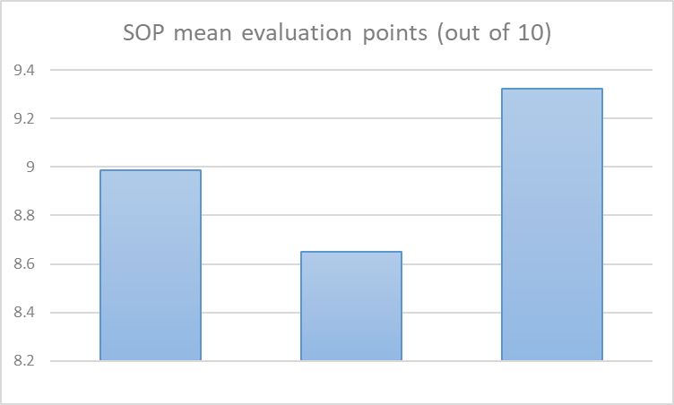
Oral demonstration
Written report
Total

The data in the figure shows the mean evaluation for the final submission of the winery Standard Operating Procedures. As shown, all the evaluations show favorable results above the standard (7/10).
Strenghts: as shown in the figure students were more proficient in communicating the Standard Operating procedure orally compared to the written form. This could be related to the traditional oral communication that occurs in the winery. Nevertheless, it is important to remark that the level of detail in the written reports was outstanding, only requiring minor adjustments to conform to industry standards. Another strength identified was progressive submission of the different sections of the SOP. This allowed students to consolidate a high quality final submission.

Weaknesses: the assignment definition requires more precise guidelines and definitions since the beginning of the semester. Using early submissions as case studies and demonstrations could potentially be a way to effectively communicate the level of detail required by the end of the semester.

Assessment method 2: Wine production Literature Review

As the figure above shows, nearly all students in the class received a grade above the standard of 7/10. Five students received a grade under the standard. One of the reasons behind this low performance was the lack of interaction with team members and the failure to address comments from a preliminary submission of the written manuscript.
Strengths: The effort required for literature review and workshops with the librarian were instrumental to strengthen the research skills of students. Class discussions about presentation of figures and results interpretation prepared students for undertaking successful oral presentations.

Weaknesses: many of the production projects required substantial preparation time and supervision at the beginning of the semester. More structured guidelines for production and analysis moments were necessary to provide guidance during the early winemaking steps. This created “empty data points” for some projects.

- What changes did you make as a result of the data? Describe how the information from the assessment activity was reviewed and what action was taken based on the analysis of the assessment data.

Assessment Method 1: Standard Operating Procedures
The data was useful to identify that students required earlier acquaintance with the concept of SOP and a review of similar documents from the industry. Also, a more structured format and rubric is needed to focus students efforts in clear written communication. Some students used digital technology (websites) to include multimedia and portability features. The later format will be implemented in future years as a benchmark of the evaluation.

Assessment method 2: Wine production Literature Review

A restructuration of the course calendar was implemented in Fall 2018 to allow sufficient time to develop the design of the projects, together with early supervision of the projects. Forms such as a Project Proposal Pre-submission were implemented to provide early feedback and guidance to projects since the beginning of the semester. This supervision should also facilitate the interaction and equitable distribution of winemaking tasks within each winemaking group of students.

- What assessment activities will you be conducting in the 2017-2018 AY? List the outcomes and measures or assessment activities you will use to evaluate them. These activities should be the same as those indicated on your current SOAP timeline; if they are not please explain.

- Wine analysis and Laboratory reports
- Microbiology Final Exam and Laboratory Final exam
- Graduating student survey
- Industry Survey

- What progress have you made on items from your last program review action plan? Please provide a brief description of progress made on each item listed in the action plan. If no progress has been made on an action item, simply state “no progress.”

No progress.

Additional Guidelines: If you have not fully described the assignment then please attach a copy of the questions or assignment guidelines. If you are using a rubric and did not fully describe this rubric (or the criteria being used) than please attach a copy of the rubric. If you administered a survey please consider attaching a copy of the survey so that the Learning Assessment Team (LAT) can review the questions.

