DEPARTMENT OF BIOLOGY
ANNUAL ASSESSMENT REPORT, 2015-16 ACADEMIC YEAR

Assessment activities in the Biology B.S. Program during AY 2015-16
During the 2015-16 academic year, the Department of Biology continued its cycle of assessment activities based on feedback from the recent full Program Review (AY 2012-13) and feedback from the previous year.
The Department of Biology restarted its 7-year Program Review cycle following the Program Review during the 2012-13 academic year. The Department as a whole responded to the external committee’s reviews of our undergraduate and graduate programs, with the Assessment Committee focusing on feedback about learning outcomes and assessment. Table 1 shows the assessment calendar for our undergraduate program. During this academic year, the main departmental assessments are pre/post tests and student research tabulation.
Table 1. Assessment calendar
Assessment Method | 2013-14 | 2014-15 | 2015-16 | 2016-17 | 2017-18 | 2018-19 | 2019-20
- Pre and Post Test | × | × | × | × | × | × | ×
- Ecology Lab Reports |  | × |  |  |  | ×
- Evolution Term Paper |  |  |  | × |  | ×
- Research Experience (Post-Test) |  |  |  | × | × | × | ×
- Research Experience (Evolution Term Paper) |  |  |  | × |  | ×
- Student Research Tabulation | × | × | × | × | × | × | ×
- Pipeline Analysis |  |  |  |  |  |  | ×
- Alumni Survey |  |  |  |  |  |  | ×

Responses to the six questions for the Biology B.S. Program

1. What learning outcome(s) did you assess this year?
Be sure to list the student learning outcome(s) assessed, not simply the activity or assignment evaluated. Note: these should be program level outcomes, not general education outcomes - the GE committee will issue a separate call for GE assessment reports.

We assessed SOAP Learning outcomes 1, 2 and 3, which are stated below. Pre/post tests particularly focused on learning outcomes 1A, 1B, 1C, 2.2 and 3.1 (as highlighted in bold below). Student research tabulation was used for learning outcomes 2 and 3; however, we note that the tabulation only shows the yearly outcomes, so our assessment is very indirect.

Learning outcome 1: Biology Majors will be able to integrate and apply biological knowledge into the following unifying themes:
1A evolutionary patterns and processes
1B energy transformations and flow
1C nutrient cycles
1D homeostasis and equilibria
1E molecular information flow
1F structure-function relationships
1G hierarchy of biological organization
1H developmental patterns and processes
1I complexity of interactions in biological systems
Learning outcome 2:
2.1 Scientific Method: Biology Majors will be able to
2.1A apply the scientific method to biological questions
2.1B generate testable hypotheses
2.1C design experiments to test hypotheses
2.2 Analytical and quantitative skills: Biology Majors will be able to
2.2A make appropriate measurements and create data sets
2.2B graph and display data
2.2C objectively analyze data
2.2D interpret results of experiments
2.3 Lab and field skills: Biology Majors will be able to
2.3A use appropriate equipment and instrumentation
2.3B understand and follow safety procedures
2.4 Teamwork skills: Biology Majors will be able to
2.4A work cooperatively in a group
2.4B solve problems in a group
Learning outcome 3:
3.1 Critical thinking and problem solving: Biology Majors will be able to
3.1A develop an argument and support it
3.1B recognize and use deductive and inductive reasoning
3.1C integrate concepts within and among disciplines
3.1D synthesize knowledge and apply concepts to solve problems
3.1E distinguish between data and inferences based on data
3.2 Biological information skills: Biology Majors will be able to
3.2A understand and evaluate primary biological literature
3.2B integrate published information in oral and written communication
3.2C use biological databases
3.3 Communication: Biology Majors will be able to communicate science effectively to their peers and to the broader scientific community using:
3.3A oral presentations
3.3B written scientific papers and reports

2. What instruments did you use to assess them?
If this does not align with the outcomes and activities detailed in the timeline of the SOAP, please provide an explanation of this discrepancy. If the standards for student performance are not included in your SOAP, you should include them here. For example "On outcome 2.3, 80% of students will score an average of 3.5 out of 5 on the attached rubric.”

Learning outcome 1 was assessed by pre/post tests. Learning outcomes 2 and 3 were assessed by student research tabulation.

2.1. Pre/post tests. Table 2 summarizes assessed courses and assessment instruments used for pre/post tests. All of the instruments are published standard ones.

Table 2. Assessment courses and instruments used for pre/post tests
Surveyed Course | Semester (Instructor) | Instrument | Number of Items
Biology 1A | Spring 2016  (Lent) | A. Colorado Learning Attitudes about Science Survey (CLASS) | 32
 |  | C. Energy and Matter in Dynamic Systems Survey (Wilson et al., 2006) | 5
Biology 1B | Spring 2016  (Katti) | A. Colorado Learning Attitudes about Science Survey (CLASS) | 32
 |  | B. Conceptual Inventory of Natural Selection (CINS) | 20
 |  | D. Measure of Acceptance of the Theory of Evolution (MATE) | 20
 |  | E. Measure of Understanding of Macroevolution (MUM) | 22
Biology 105 | Fall 2015  (Crosbie) | D. Measure of Acceptance of the Theory of Evolution (MATE) | 20
 |  | E. Measure of Understanding of Macroevolution (MUM) | 22
 | Fall 2015  (Katti) | D. Measure of Acceptance of the Theory of Evolution (MATE) | 20
 |  | E. Measure of Understanding of Macroevolution (MUM) | 22

A. Colorado Learning Attitudes about Science Survey for use in Biology (CLASS; Semsar, K., Knight, J. K., Birol, G., & Smith, M. K. (2011). The Colorado Learning Attitudes about Science Survey (CLASS) for use in biology. CBE - Life Sciences Education, 10, 268-278. doi: 10.1187/cbe.10-10-0133).
B. Conceptual Inventory of Natural Selection (CINS; Anderson, D. L., Fisher, K. M., & Norman, G. J. (2002). Development and evaluation of the Conceptual Inventory of Natural Selection. Journal of Research in Science Teaching, 39, 952-978. doi: 10.1002/tea.10053)
C. Energy and Matter in Dynamic Systems Survey (Wilson, C. D., Anderson, C. W., Heidemann, M., Merrill, J. E., Merritt, B. W., Richmond, G., & Parker, J. M. (2006). Assessing students’ ability to trace matter in dynamic systems in cell biology. CBE - Life Sciences Education, 5, 323-331. doi: 10.1187/cbe.06–02–0142)
D. Measure of Acceptance of the Theory of Evolution (MATE; Rutledge, M. L., & Warden, M. A. (1999). The development and validation of the Measure of Acceptance of the Theory of Evolution instrument. School Science and Mathematics, 99, 13-18)
E. Measure of Understanding of Macroevolution (MUM; Nadelson, L. S., & Southerland, S. A. (2010a). Development and evaluation for a measuring understanding of macroevolutionary concepts: Introducing the MUM. Journal of Experimental Education, 78, 151-190. doi: 10.1080/00220970903292983)

2.2. Undergraduate student research tabulation. Data of undergraduate student involvement in research are taken from the Department’s Annual Report. We considered number of publications and number of conference presentations as important data inputs.
3. What did you discover from these data?
Provide a discussion of student performance in relation to your standards of performance. Where possible, indicate the relative strengths and weaknesses in student performance on the outcome(s).

3.1. Instrument A. Colorado Learning Attitudes about Science Survey (CLASS)
Surveyed classes: Biology 1A (N = 102) and 1B (N = 63)
Semester: Spring 2016
Instructor: David Lent (1A) and Madhusudan Katti (1B)
Instrument Details: The Colorado Learning Attitudes about Science Survey for use in Biology is a 31-item Likert scale instrument that generates seven category scores related to students’ attitudes about learning biology. These categories include:
(a) Real World Connections (items 2, 12, 14, 16, 17, 19, 25)
(b) Enjoyment / Personal Interest (items 1, 2, 9, 12, 18, 27)
(c) Problem-Solving: Reasoning (items 8, 14, 16, 17, 24)
(d) Problem-Solving: Synthesis & Application (items 3, 5, 6, 10, 11, 21, 30)
(e) Problem-Solving: Strategies (items 7, 8, 20, 22)
(f) Problem-Solving: Effort (items 8, 12, 20, 22, 24, 27, 30)
(g) Conceptual Connections/Memorization (items 6, 8, 11, 15, 19, 23, 31, 32)
Results:
Biology 1A. After instruction, Biology 1A had significant decreases in students’ perceptions of Real World Connections (p = .031), Problem-Solving: Reasoning (p = .004), and Conceptual Connections/Memorization (p = .038). This suggests that the class negatively influenced students’ attitudes about biology learning in these areas. A suggestion would be to change the nature of the case studies in the class (the data suggest that the current set is not real-world relevant to the students), emphasize resilience in problem solving strategies, and avoid test questions that require memorization of material (and emphasize questions that require meaningful synthesis and sense making).
Biology 1B. After instruction, Biology 1B also had significant decreases in students’ perceptions of learning biology in all CLASS categories (p < .05). The most significant decreases in students’ views included significant decreases in Real World Connections (p = 7.85 E -05), Enjoyment (p = 8.66 E-10), and Conceptual Connections/Memorization (p = 5.76 E-03).
These data suggest that the content examples, problem solving approaches, and emphasis on memorization in Biology 1A and 1B need revision.
3.2. Instrument B. Conceptual Inventory of Natural Selection (CINS)
Surveyed class: Biology 1B (N = 63)
Semester: Spring 2016
Instructor: Madhusudan Katti
Instrument Details: The Conceptual Inventory of Natural Selection (CINS; Anderson et al., 2002) is a 20-item multiple-choice instrument that measures students’ knowledge of natural selection.

Results:
Before instruction, students averaged 10.3 ± 3.9 (out of 20). After instruction, students averaged 9.9 ± 4.3 (out of 20). This does not indicate a significant increase (or decrease) in students’ understanding of natural selection principles after the course (p = 0.600).
At this time, it is difficult to hypothesize why the course did not significantly increase students’ knowledge of natural selection. However, CINS post-instruction scores had significant positive correlations with CLASS category scores for Enjoyment (r = .290; p < .05), Problem-Solving Reasoning (r = .246; p < .05), and Conceptual Connections/ Memorization (r = .463; p < .01). Since these CLASS category scores all significantly decreased after instruction, we can hypothesize that emphasis on personal enjoyment of the topic (Enjoyment), the value of working through difficult problems (Problem-Solving Reasoning), and emphasis on the connections of concepts across biological curriculum (Conceptual Connections) could potentially help to increase CINS scores in future sections of the course.
3.3. Instrument C. Energy and Matter in Dynamic Systems Survey
Surveyed class: Biology 1A (N = 103)
Semester: Spring 2016
Instructor: David Lent
Instrument Details: The Energy and Matter in Dynamic Systems Survey is a 5-item multiple-choice instrument that measures students’ knowledge of energy and matter as related to photosynthesis and cellular respiration.
Results:
Before instruction, students averaged 0.8 ± 0.9 (out of 5) on the knowledge survey. After instruction, students averaged 1.7 ± 1.0 (out of 5). This does not indicate a significant increase (or decrease) in students’ understanding of energy and matter principles after the course (p = 0.083).
In exploring these results by item, students improved in answering questions #1-3 correctly, but correct and incorrect majority populations stayed fairly consistent on questions #4-5. This may have to do with question #4 requiring previous background knowledge on several molecules (O₂, CO₂, glucose, ATP, and NADH) and question #5 presenting similar statements for choices C and D. Note that #4 had two contexts and #5 presented the same question and answer choices for both pre and post-instruction surveys.
It is difficult to hypothesize why the course did not significantly increase students’ overall knowledge of energy and matter.
However, like the CINS data, the scores on the energy and matter survey post-instruction had significant positive correlations with all 7 CLASS category scores (p < .05). Since 3 of the 7 CLASS category scores significantly decreased after instruction, including Real World Connections (p = .031), Problem-Solving: Reasoning (p = .004), and Conceptual Connections/Memorization (p = .038), we can expect that better emphasis on these attitude areas could potentially shift the knowledge scores to be significantly improved in future post-instruction samples.
3.4. Instrument D. Measure of Acceptance of the Theory of Evolution
Surveyed class: Biology 1B (N = 98); Biology 105 (N=46)
Semesters: Fall 2015 (Biology 105), Spring 2016 (Biology 1B)
Instructors: Paul Crosbie (Biology 105), Madhusudan Katti (Biology 1B and 105)
Instrument Details: The Measure of Acceptance of the Theory of Evolution (MATE) is a 20-item Likert-style instrument that measures students’ acceptance of the theory of evolution. It can produce an overall score from 20 (strongly reject evolution) to 100 (strongly accept). It can also produce reliable (α > 0.85) measures for two category scores: (a) acceptance of evolution facts and data and (b) acceptance of the credibility of evolution and rejection of non-scientific ideas.
The relationship between knowledge of science content and acceptance of evolution has been a topic of debate in the literature. Does one preclude the other? Do students need to accept evolution as valid? Some authors note that rejection of evolution can serve as a barrier to developing knowledge about it. Other research has shown that rejection of evolution does not affect the ability to learn about natural selection. This means that students can have an understanding of natural selection without accepting evolution, and conversely, students may accept the theory with poor understanding of it.

Given moderate correlations between content knowledge and evolution acceptance, we considered it important to (a) measure evolution acceptance and (b) explore how knowledge of macroevolution knowledge relates to MATE acceptance dimension(s) -- and therefore gathered data using the MATE.
Results:
As we found significant differences among Biology 1B (Katti) and the two sections of Biology 105 (Crosbie and Katti), we detail results separately by course and section below.
Biology 1B, Katti. Before instruction, students averaged 57.0 ± 9.0 (out of 100) on the acceptance survey, indicating slight rejection of evolution. After instruction, students averaged 57.2 ± 9.4 (out of 100). This does not indicate a significant increase (or decrease) in students’ evolution acceptance after the course (p > .05).
Biology 105, Katti. Before instruction, students averaged 64.0 ± 12.0 (out of 100) on the acceptance survey, indicating slight evolution acceptance, but lower pre-instruction scores than the Crosbie class. After instruction, students averaged 65.7 ± 12.3 (out of 100). This indicates a significant increase in students’ evolution acceptance after the course (p = 1.8 E-45).
Biology 105, Crosbie. Before instruction, students averaged 66.9 ± 11.4 (out of 100) on the acceptance survey, indicating slight evolution acceptance. After instruction, students averaged 70.7 ± 9.7 (out of 100). This indicates a significant increase in students’ evolution acceptance after the course (p = 1.0 E-20).
3.5. Instrument E. Measure of Understanding of Macroevolution (MUM)
Surveyed class: Biology 1B (N = 98); Biology 105 (N=46)
Semesters: Fall 2015 (Biology 105), Spring 2016 (Biology 1B)
Instructors: Paul Crosbie (Biol 105), Madhusudan Katti (Biol 1B and 105)
Instrument Details: The Measure of Understanding of Macroevolution (MUM) comprehensively measures students’ knowledge of macroevolution. This 22-item dichotomous multiple-choice instrument (22-item version redesigned by Walter & Romine (in development) measures five ideas related to the understanding of macroevolution: deep time, phylogenetics, speciation, fossils, and the nature of science.
Results:
As we found significant differences among Biology 1B (Katti) and the two sections of Biology 105 (Crosbie and Katti), we therefore detail results separately by course and section below.
Biology 1B, Katti. Before instruction, students averaged 13.4 ± 3.9 (out of 22) on the knowledge of macroevolution survey. After instruction, students averaged 10.9 ± 6.8 (out of 22). This indicates a significant decrease in students’ knowledge of macroevolution after the course (p < .05).
Biology 105, Katti. Before instruction, students averaged 16.0 ± 12.2 (out of 22) on the knowledge of macroevolution survey. After instruction, students averaged 14.4 ± 4.0 (out of 22). Like the Biology 1B data set, this shift indicates a significant decrease in students’ knowledge of macroevolution after the course (p = 1.23 E-26).
Biology 105, Crosbie. Before instruction, students averaged 17.5 ± 2.2 (out of 22) on the knowledge of macroevolution survey. After instruction, students averaged 17.9 ± 2.2 (out of 22). Although this shift seems small, it indicates a significant increase in students’ evolution acceptance after the course (p < .05).
We are perplexed by the significant decreases in knowledge of macroevolution scores post-instruction for the sections taught by Madhusudan Katti. Without qualitative data to support these shifts in understanding (including interviews and classroom observations), it is difficult to hypothesize why these shifts occurred. Since Madhusudan Katti is no longer a member of the faculty at Fresno State, we plan to continue gathering data in Biology 1B and 105 to document knowledge of macroevolution and the influence of instruction on this learning outcome before any pedagogical shifts are made.

3.6. Undergraduate student research tabulation.
Publications. Undergraduate students were involved in three peer-reviewed publications out of a total of 14 peer-reviewed publications by Biology faculty during this academic year. This means undergraduates are contributing substantively to research in the Biology Department. The three papers were published in BMC Dev Biol. (impact factor 2.096), Genes, Genomes, Genetics (impact factor 2.910), and the Journal of Biological Chemistry (impact factor 4.573). These are not only peer-reviewed, but also high quality journals.
Conference presentations. Biology undergraduate students contributed to a total of 41 presentations in 10 different conferences or meetings. These included the American Society for Microbiology, Central California Research Symposium, San Joaquin River Restoration Program Science Meeting, CSUPERB Annual Symposium, Society for Neuroscience, Society for Integrative and Comparative Biology Annual Meeting, Evolutionary Biology of Caenorhabditis and other Nematodes, Annual Conference for the National Association of Biology Teachers, Society for the Study of Evolution Annual Meeting, and Botanical Society of America Annual Meeting. These diverse conferences or meetings are indicative of the breadth of research biology students are exposed to by biology faculty.

4. What changes did you make as a result of the findings?
Describe what action was taken based on the analysis of the assessment data.

4.1. Adjustments to Biology 1A and 1B instruction.
Comparison between Biology 105 based on instruments D and E pre- and post-tests above suggests that students are learning and our Biology B.S. program is effective. Nevertheless, the ineffectiveness of Biology 1A and 1B courses is puzzling and alarming. Both assessment instruments (A and C) found Biology 1A to be an ineffective course. Biology 1B was ineffective as assessed by all four instruments used (A, B, D and E). It is clear that we need to address such ineffectiveness in both Biology 1A and 1B. While we have not yet taken any action, we are considering possible changes and adjustments. One thing we need to take into account is the fact that our Biology 1A and Biology 1B data are both derived from the courses each taught by one instructor. Furthermore, the Biology 1A instructor taught this course for the first time. Given this, it is possible that our current Biology 1A and 1B assessment data may reflect the instructors’ effect more than courses’ effect, the Assessment Committee plans to collect data for more instructors. It may be important to compare current and future assessment data of Biology 1A and 1B courses taught by other instructors, but assessed by the same instruments. Relatedly, the Assessment Committee plans to discuss the potential advantages of implementing shared core course materials and assessment methods/rubrics into Biology 1A and 1B, such that different instructors would deliver consistent instruction to our students. Then, the Assessment Committee may propose to the Department that different instructors of Biology 1A and 1B courses work toward gradually using more of the shared course materials and shared assessment methods/rubrics. However, it is worth noting that it is already a widespread departmental practice for instructors to broadly share all course materials. For example, the bulk of course materials (PowerPoint presentations, examinations, handouts, etc.) in Biology 1A, 1B, and Biology 105 were all shared with new instructors, and common texts are used for each course. In the meantime, the Assessment Committee will share these assessment data with Biology 1A and 1B instructors for them to identify what may have caused the courses ineffectiveness as determined by the instruments used, and attempt to find appropriate solutions. This may even require a further major redesign of Biology 1A and 1B. The long-term goal is to increase the use of high-impact practices in our courses by all instructors. The first step towards this goal is to explore the possible causes of our observations through faculty and student interviews (see 4.2), which may then lead to major redesign of Biology 1A and 1B. Such a redesign is also necessary to address the high DFW rates and large differences in DFW rates between instructors.

4.2. Efforts of improving students’ attitude toward science.
The Assessment Committee will conduct interviews with a sample of the Biology 1A and 1B students to understand what may have caused significant post-instruction decreases in Biology 1A and 1B students’ views on “Real World Connections”, “Enjoyment”, and “Conceptual Connections/Memorization” scores on the Colorado Learning Attitudes about Science Survey.

4.3. Adjustments to Biology 190 policy.
As revealed in the student research tabulation, the Department of Biology is very successful in guiding undergraduate students in productive research. It should also be recognized that such vigorous research activities by Biology undergraduate students cannot be achieved without the extensive mentoring efforts by Biology faculty. In fact, the faculty’s role in this matter is pivotal. Most of undergraduate students’ research activities are performed within the context of Biology 190 and participating students are fully credited. In contrast, the mentoring Biology faculty through Biology 190 are often not fully credited (i.e. the WTU associated with supervision of independent studies may not be counted as part of the instructors teaching load). Appropriate administrative actions toward this Biology 190 issue may significantly increase research activities and productivity in the Department of Biology, and these changes will be instituted.

4.4. More use of supplemental instruction.
Through the activities of the NSF-FLOCK and newly started Biology Honors Program below, we found that supplemental instruction may have a noticeable effect on student success: students that attended supplemental instruction sessions for Biology 1A demonstrated better knowledge and understanding than students who did not. The Assessment Committee will recommend that the Department use more supplemental instruction.

5. What assessment activities will you be conducting in the 2016-17 academic year?
Briefly list the outcomes to be assessed and how you will measure them. This should align with the activities provided in your SOAP.

As listed in Table 1, Pre/post tests, research experience evaluation (evolution term papers), and student research tabulation will all occur. However, research experience (post-test) will not be done because the responsible faculty member left the Department.

Another important assessment task is to complete a new SOAP within the current academic year. Since the new SOAP will have different goals, learning outcomes, and assessment methods, some adjustments (adopting new assessment trials and/or dropping any assessment activities not fitting the new SOAP) are inevitable. Nevertheless, since this is an on-going process, it is hard to predict exact changes at the moment. A draft of the new SOAP was discussed and amended at the August 2016 Biology Department Faculty Retreat, and new SOAP goals were preliminarily mapped onto courses, as described below.

6. What progress have you made on items from your last program review action plan?
Please provide a brief description of progress made on each item listed in the action plan. If no progress has been made on an action item, simply state "no progress."

We have made progress on several initiatives. First, we redesigned and restructured Biology 64 (Functional Human Anatomy) and Biology 65 (Human Physiology) into more appropriate and pedagogically sound Biology 67A (Human Anatomy & Physiology I) and Biology 67B (Human Anatomy and Physiology II). Secondly, we initiated a Biology Honors program (see below for more details). Thirdly, the Department of Biology fully adopted assigning additional WTU for large enrollment courses as prescribed in APM 337. Last, numerous other courses have either been revised or are under active redesign (e.g. Biology 1A and 1B, Biology 101).
Other departmental activities
which may have impacts on Biology B.S. program

1. Developing new Biology SOAP:
The Assessment Committee and Department of Biology have made significant progress toward the completion of a new SOAP. Biology faculty agreed on adopting the AAAS ision and Change report (2009) as basic framework for our new SOAP. The Assessment Committee has developed new learning goals and outcomes, and aligned these learning outcomes with Biology core courses based on Biology faculty’s inputs. Some efforts may be needed to modify or develop new assessment methods. After these final efforts, our new SOAP will be completed and submitted for approval. This will happen during AY 2016-17, and the new SOAP will become effective for the following academic year.
2. Biology Honors Program:
The Department of Biology launched a Biology Honors Program, and the program admitted its first cohort of students in the Spring of 2016. The Honors Program provides students with the opportunity for advanced studies and interaction with a community of their intellectual peers and to work closely with a faculty mentor of their choosing toward completion of a research project. The program consists of a three-course commitment (3 units total), beginning with an Honors Experimental Design & Writing course taken in the second semester of the junior year, followed by a course in Peer Instruction taken in the first semester of the senior year, and finally an Honors Colloquium taken in the second semester of the senior year. The Honors program will culminate with an honors thesis (3 units). In total, there are 6 units required for completion of the Department of Biology Honors Program.
A total of eight students applied to the upper division honors program. From the eight students that applied two students were transfer students from the Valley community college system and three students were part of the University Smittcamp Family Honors College. From the eight we admitted seven students to comprise the first cohort of the Biology Honors Program. Candidates as a whole were strong; however, several were missing one of the prerequisites, statistics. The students missing this course were admitted under the condition they complete this missing course during the spring semester in which they were admitted. All admitted under this condition completed the course. The one student that was not offered a place in the honors program was denied because their GPA was below the minimum required 3.5. All other students were well above the minimum with an average of 3.9.
Students have all completed the first required course, Experimental Design and Writing. This course is open to only honors students and an equivalent has not been previously offered by the Department of Biology. Students were assessed on their ability to develop and communicate scientific questions and hypotheses both orally and in writing. Throughout the course students were required to give short presentations and provide written samples of their developing scientific research problems. All students finished the course with a grade of ‘A’. At the end of the spring term each student’s GPA was evaluated and each student has a scheduled meeting to discuss an honor’s thesis plan of study with the program coordinator (Davie Lent). The program coordinator assesses the GPA and the plan of study to ensure the student is on track for completion of the honors degree requirements. A review of these will be added to the assessment material upon completion.
The first semester with the first honors cohort has been successful. As the Department progresses through the first cohort and introduces the second cohort in the spring of 2017, the program will have more data to assess its impact, and to provide a better assessment of its value to the enrolled students, the department and the university.
3. Biology FLOCK (Faculty Learning for OutComes and Knowledge):
FLOCK is an NSF-supported project with the goal to establish faculty learning communities that advance and spread evidence-based educational practices throughout the CSM. The participating Biology faculty are Biology 1A or 1B instructors, content experts who help upgrading the course content, and faculty who teach courses that require Biology 1A and 1B as prerequisites. As part of the FLOCK initiative, faculty implemented course content and course pedagogy changes. In Biology 1A, the course has focused on three core concepts (energy; structure and function; information). The course implemented more case studies (David Lent) and developed a new case study on the Zika virus (Mamta Rawat, David Lent). In Biology 1B, the course implemented several new problem- and observation based lab modules (Paul Crosbie, Julie Constable, Madhusudan Katti), while also reworking the entire lab course (Biology 1BL) to halve the number of labs, enabling Biology 101 (Ecology) to gain one course unit (Julie Constable, John Constable, Paul Crosbie). Mamta Rawat, David Lent, and Emily Walter implemented several assessment activities (pre/post tests, attitudes surveys, concept inventories). Emily Walter is overseeing and coordinating the implementation and analysis of these activities, enabling the department to make educational decisions based on scientific evidence gathered about our courses, students, and instructors. The FLOCK also supports several faculty members in their course redesign (through assigned time) and in their course instruction (through supplementary student instructors). Evidence from the Office of Institutional Effectiveness shows that Supplementary Instruction is a very effective intervention strategy: students that attend more supplementary instruction sessions achieve higher grades. In short, FLOCK is reshaping our Biology 1A and 1B courses in terms of content, pedagogy, and assessment. Given this, the Assessment Committee plans to thoroughly evaluate the impact of the Biology FLOCK activities on our BS program in the next academic year.
4. CSM FYE (College First Year Experience):
A Biology faculty member participated in the CSM FYE program. The main components of CSM FYE are a 4-day summer experience and two GE courses (CSM 10 and CSM 15). We recognize there is no direct impact of CSM FYE on our Biology B.S. program. At the same time, we posit Biology FYE program that may address department-specific student success.
M.S. Biology Graduate Program Annual Assessment Report

Assessment activities in the M.S. Biology Program during 2015-16 AY
Background
The Department of Biology offers graduate training with the opportunity to specialize in several areas of advanced biological study. One graduate degree is offered, the Master of Science in Biology. The department also offers a Master of Biotechnology degree (although this is a cross-departmental program) and, via the Moss Landing Marine Laboratories, a Master of Marine Science Degree. Neither of these latter programs are addressed in this SOAP. The M.S. in Biology degree requires a formal thesis following the completion of a field, laboratory or empirically-based research project.
Three major emphases of the Department’s graduate program are 1) to provide training for those wishing to enter Master’s level careers in the biological sciences, 2) to prepare graduate students for teaching biological sciences in the primary and secondary schools, and junior college ranks and, 3) to provide a foundation for students seeking more advanced training at universities offering doctorate or professional degrees.
During the 2015-16 academic year, the Department of Biology continued refining its cycle of assessment activities based on feedback from the recent (2012-13) full Program Review and particularly the favorable feedback from the University Graduate Committee (UGC) received in April 2016. The UGC recommended approval of the MS in Biology as “A program of quality and promise”.

Overview
The Graduate Committee efforts during the 2015-16 academic year were focused more on program recruitment plan development, website enhancement, fee waiver implementation, and social activities to build our graduate student culture rather than on specific student learning outcomes assessment. And to get a better perspective on our graduate student population, the Graduate Committee sought data related to graduation rates and attrition as identified in Table 1.

Table 1. M.S. Biology Graduate Data
 | 2011 |  | 2012 |  | 2013 |  | 2014 |  | 2015 |  | 2016
 | SP | F | SP | F | SP | F | SP | F | SP | F | SP | F
Applicants | 12 | 41 | 6 | 36 | 2 | 33 | 10 | 26 | 13 | 23 | 12 | 33
Admits | 6 | 23 | 4 | 18 | 1 | 15 | 6 | 15 | 5 | 14 | 3 | 15
Enrolled | - | 11 | 2 | 5 | 1 | 3 | 4 | 13 | 4 | 12 | 3 | 13
Grad/Enrolled | - | 10 | 2 | 4 | 1 | 1 | 1 | 3 | IP | IP | IP | IP
Grad Rate | - | 91% | 100% | 80% | 100% | 33% | 25% | 23% | - | - | - | -
Attrition | - | - | 1 | 0 | 0 | 2 | 0 | 1 | 1 | 4 | 0 | -
Total Theses | 10 |  | 14 |  | 9 |  | 14 |  | 6 |  | IP
Total Program |  |  |  |  |  |  |  | 38 | 44 | 42 | 41 | 48
*Note – IP, In progress
Unlike undergraduate education, graduate education success and outcomes is a more nebulous concept and part of an ongoing national dialog (e.g. see GEMS Report, 2014). As we struggle with these definitions and metrics, graduate programs in the biosciences may need to reassess their definition of graduate student success.

1. What learning outcome(s) did you assess this year?
Utilizing our scoring rubrics, we measured GWR/proposal, thesis, and exit seminar performance. Specific student learning outcome(s) were not assessed given other priorities identified from the program reviews (see item #6 below).

2. What instruments did you use to assess them?
Scoring rubrics and exit interviews.

3. What did you discover from these data?
The data analyses are currently ongoing.
4. What changes did you make as a result of the findings?
Not applicable

5. What assessment activities will you be conducting in the 2016-17 academic year?
As described above, we are in the process of comprehensive analyses of the scoring rubrics for improved student learning outcomes assessment. We have adopted the new scoring rubric instruments for the GWR/proposal, thesis, exit seminar, and surveys. The Department is updating the curriculum in other areas to increase our graduate level course offerings. Additionally, as part of the action plan, the department has moved ahead with the development of a Biology Honors program that could be a partial pipeline for the M.S. Biology program in the future.

6. What progress have you made on items from your last program review action plan?
Since the last extensive program review in 2012-13 and as reported in the last annual assessment report, the graduate committee has made significant progress in restructuring the curricular roadmap for the M.S. Biology program
- Curricular Roadmap - Our data suggested that getting students into a writing course early on (i.e. semester 1, see Appendix I) to make substantive progress towards the GWR requirement would accelerate the students’ pace through the graduate degree. Furthermore, offering this class in both semesters would allow the smaller number of spring semester admits to also take advantage of the writing component. In keeping with the mission of offering flexibility in our program, the courses for each degree are individualized and are established by mutual agreement between the student and the adviser with input from the student’s thesis committee. The result creates a cohesive graduate program selected from among classes that are taught with regularity and topics or “T” classes that represent new offerings that may subsequently be transformed into regular offerings.

- Core Course Admission Requirement - Historically, admission to the M.S. Biology program has relied upon the basic university requirements (3.0 GPA+, GREs, letters, Statement of purpose) for applicants as well as the scholarly completion of core courses within our biology core (Ecology, Genetics, Cell Biology, Genetics/Cell Biol lab, Evolution). This has at times limited incoming graduate students to Conditional standing until they have successfully passed with B or better these core courses. For some disciplines in the program, this requirement was deemed unnecessary and increasing the time to graduation. Over the past couple of years, these core requirements have been waived such that all incoming students have Classified status. We believe this will have two positive impacts: (i) improve recruiting by removing a barrier for some potential applicants to the program, and (ii) increase student success by decreasing the time to graduation standard. We think that this has minimal impact on the overall rigor of our program and puts more ownership of the graduate study plan/degree progress on the student and faculty mentor.

- Rubric Development – The graduate committee has continued to develop strong assessment tools for program evaluation. Specifically, several rubrics have been improved with greater faculty participation including:
  - GWR cover letter
  - GWR scoring rubric – This scoring instrument is consistent with the MS Biotech program and provides summative assessment for the student in the areas of Style & format, Writing mechanics, Content & organization, Integration & critical analysis.
  - Thesis scoring rubric – This scoring instrument also provides summative assessment for the student in the areas of Quality of Science (47% weighting), Quality of Writing (33% weighting), and Quality of Presentation (20% weighting). This important rubric is used in combination with other material to help determine student success/ranking towards scholarship and merit (i.e. Dean’s medalist and Best graduate student thesis, etc). This rubric also becomes the basis for assigning the final grade for the thesis units (Biology 299) (see Appendix III).
  - Exit seminar scoring rubric – This scoring instrument also provides summative assessment for the student in the areas of Quality of Science (64% weighting) and Quality of Presentation (36% weighting). This rubric is similar in structure to the thesis-scoring rubric, which improves the ease of use for faculty and thesis committee members (see Appendix IV).

Since the last annual report, the graduate coordinator and graduate committee have made significant progress in the following areas:

- Continue to increase the number of graduate students in the program – As you can see from Table 1, since 2014, we have made substantial gains in the number of students enrolling

- Increase number of graduate assistantships – No progress

- Increase stipends for graduate assistantships – The CSM was recently awarded a NIH Bridges to Doctorate program with UC Merced focused on URM masters students pursuing the biosciences. The students accepted into this program receive a generous 2-year stipend along with other benefits.

- Provide fee waivers for teaching assistantships – With the new fee waiver funds approved and distributed to the respective colleges, we began allocating funds to eligible students based on APM rules. The Biology department received a significant proportion of available funds as we are one of the largest departments with the most TAs. The Graduate Committee developed a policy and a merit-based ranking system to best allocate the funds to the most deserving students.

- Increase recruitment activities – Through DGS, the Graduate Coordinator was awarded a $500 competitive mini recruitment award to be used for various graduate recruitment strategies including marketing merchandise for the program including banners, brochures, and gift items intended for use at career fairs.

- Increase number of graduate course offerings – Several of our topics courses were converted to permanent courses to enrich the course offerings. However, this is still limited by the number of full-time faculty available to teach in a department where significant research activity occurs. We will continue to convert topics courses as appropriate, to better reflect the breadth of program that we routinely offer.

- Increase levels of graduate student support through external grants – see #3 above.

- Build greater camaraderie among graduate students in the program through social activities and team-building exercises – We have had several social events that included faculty and other students of the M.S. Biotechnology program to help us better cultivate a sense of graduate student life on our campus.

Appendix I

Graduate Program Roadmap Faculty Responsible
Fall Semester 1 (7 units)
Writing course (3 units) Ulrike Muller/Brian Tsukimura/Otto Berg
Experimental Design (3 units)
(Behavioural and Ecological/Molecular) David Lent/Madhusudan Katti/Steve Blumenshine
Colloquium (1 unit)
Objective: Set up committee. Have draft of GWR completed.

Spring Semester 1 (8 units)
Bioethics (1 unit) Joe Ross
Colloquium (1 unit)
Course elective (3 units)
Research (3 units)
Objective: Finish GWR

Fall Semester II (7 unit)
Course elective (3 units)
Independent Study (3 units)
Seminar (1 unit)
Objective: Meet with committee

Spring Semester II (8 units)
Thesis Units (4 units)
Course elective (3 units)
Seminar (1 unit)
Objective: Finish thesis, Graduate seminar

Appendix II
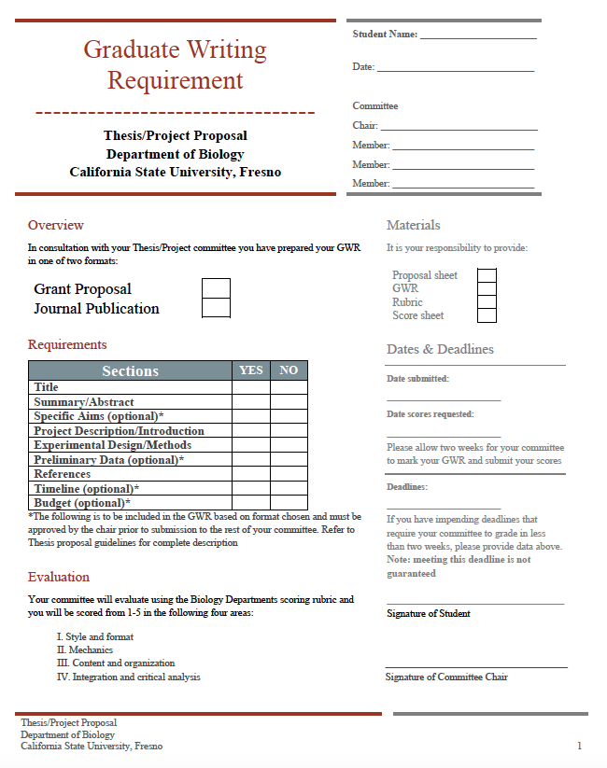
Appendix III
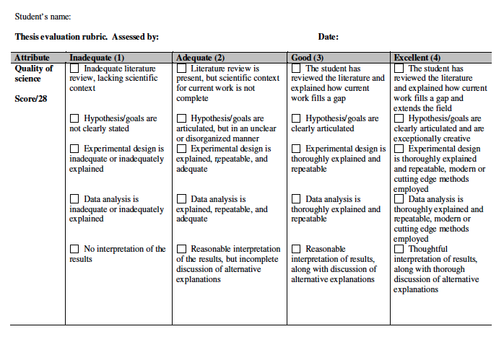
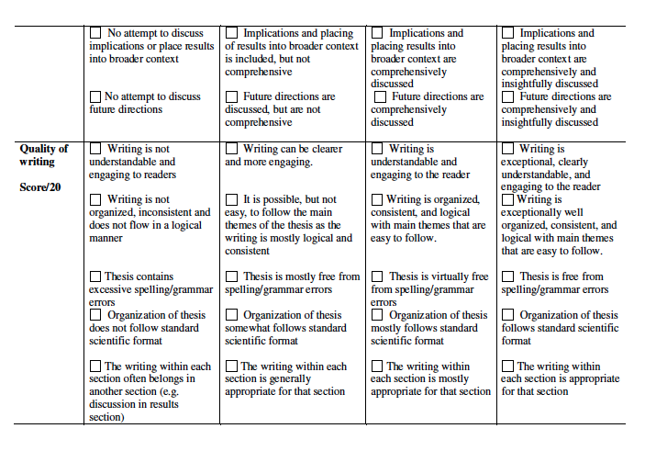

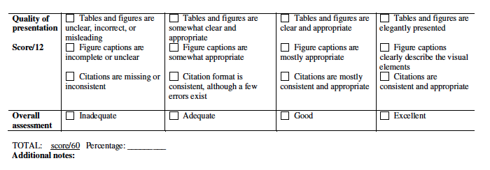

Appendix IV
