GE Portfolio Designation Tool
The GE Portfolio Designation Tool allows GE faculty to designate the assignment that should be submitted to students’ GE ePortfolios. This tool should be used after the faculty member has created the assignment in Canvas. When the tool is used, students’ submissions are seamlessly and automatically duplicated within their GE Portfolio at the same time they submit to the original assignment.
Students’ first submissions to these assignments are duplicated automatically within their GE Portfolio.

How do I access the tool?

As an instructor, you can access the tool in your course by selecting the ‘GE Portfolio Designation”’ button on the course navigation menu. Once selected, the tool will load.

If you do not see the tool in your course navigation, go to Settings > Navigation and enable the ‘GE Portfolio Designation’ tool > SAVE. Only instructors and designers see the tool in the course navigation.

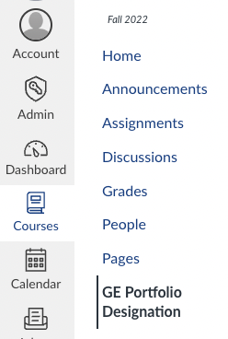
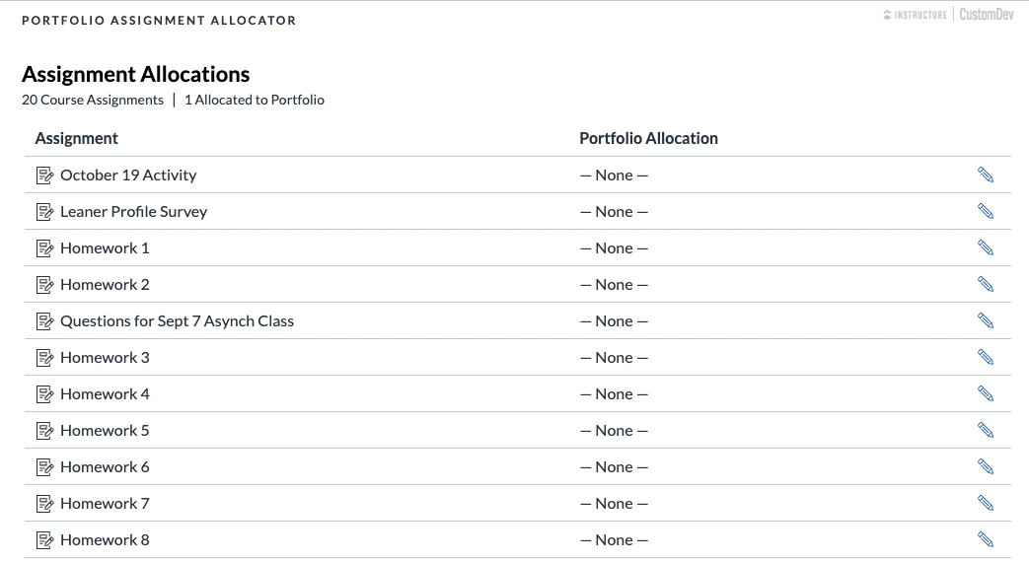

How do I link my Canvas Assignments to a GE area?

After the tool is launched from the course, it will present a list of the courses’ assignments. As the instructor, you can decide which assignment should link to the appropriate GE area, and make that connection by selecting the edit pencil on the line of the assignment you want to pair.

From here, you can choose from the drop down menu which GE area you’d like the assignment to be linked to. You can only choose one GE area per assignment. Once a GE area has been selected, it will become grayed out and no longer selectable. Note, you will need to create the assignment within your Canvas course first for it to show up as an available assignment.

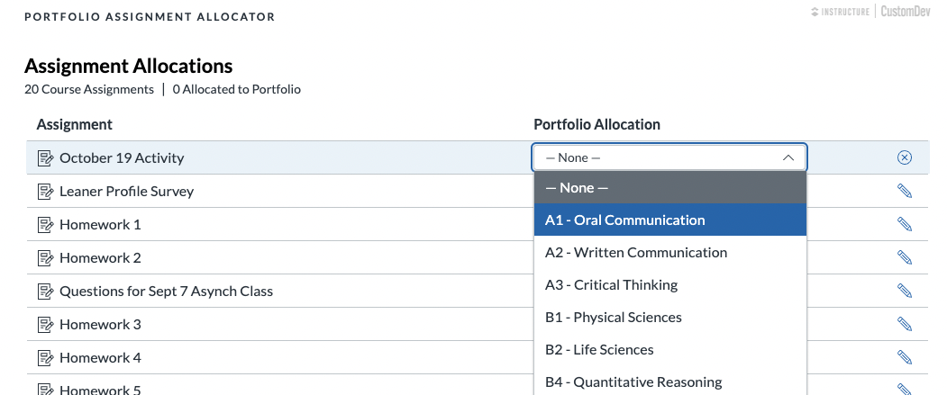

Once you make your GE area allocation selection, click ‘Save’. You can also cancel the selection by selecting the ‘x’. Once saved, you will immediately see it in the tool.

Once the GE area has been linked, students’ assignments will automatically be duplicated and attached to their GE Portfolio.

Notes:
- Assignment submission duplication is limited to Canvas assignments with the following submission types:
  - Text entry, file uploads, media recordings and online URL.
- If a linked assignment is changed from one GE area to a different area, previous student submissions will not be duplicated but new student submissions will be.
- The tool will appear in all Canvas course shells. You may hide this tool for non-GE courses (Settings > Navigation > disable tool > Save).
- When you copy course content from one semester to another, you will need to re-link the designated GE assignment using the tool.
- The assignment needs to be created in Canvas before you can designate it in the GE Portfolio Designation Tool.

Questions? Email universityassessment@mail.fresnostate.edu.

