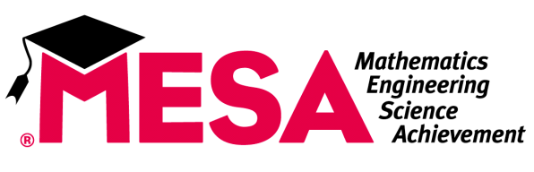
High School
School Site Plan

Student Leadership Members should prepare a school site plan for the 2016-2017 academic year. DUE OCTOBER 6, 2017. Please scan and email (bprieto@csufresno.edu) or Fax (559.278.4517)Your plan should include:

- One academic goal and three strategies that you will use to achieve this goal.

Goal:
Strategy 1:
Strategy 2:
Strategy 3:

- One recruitment and retention goal and three strategies that you will use to achieve this goal. Please make sure your goal aligns with the goals stated on your school-site agreement (you advisor can provide specific information on your school-site agreement).

Goal:
Strategy 1:
Strategy 2:
Strategy 3:

- Three strategies that explain how your school will achieve a goal of more than 70% participation of MESA students at MESA Saturday Academies/Fresno State MESA Online Academy and in the MESA Day Competitions.

Strategy 1:
Strategy 2:
Strategy 3:

- Three strategies that explain how your school will field at least one competitive team to participate in the National Engineering Design Competition (Prosthetic). Consider what resources will be available to these teams and what teachers might be willing to help with this project.

Strategy 1:
Strategy 2:
Strategy 3:

- One college preparation goal and three strategies that you will use to achieve this goal.

Goal:
Strategy 1:
Strategy 2:
Strategy 3:

- A list of MESA activities your club/class will do this year.

- A bell/school schedule (attach).

Please feel free to include any other information related to the goals and activities of your MESA club/class.

Prepared by: ____________________________________________________________________________________________________________________________________________________________

