The Department of Earth and Environmental Sciences, ASI, and Fresno State AAPG Student Chapter presents:
AAPG Distinguished Lecturer
Dr. Kathleen M. Marsaglia
Professor in the Department of Geological Sciences, California State University Northridge (CSUN)

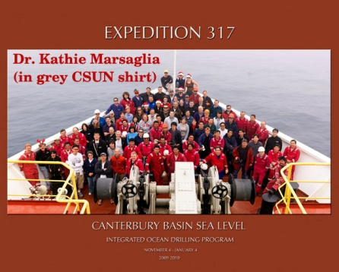
Chasing Bits and Pieces of New Zealand From Source To Sink: Sand Provenance Studies in New Zealand Sedimentary Systems and Implications for Hydrocarbon Exploration Across “Zealandia”

Monday, October 22, 2012
2:00-3:00pm
Engineering East (EE), Room 191
The MARGINS Source-to Sink paradigm holds that deep-sea sandy successions reflect the evolution of onshore fluvial and adjacent shelf systems, with the potential to record distinct eustatic, climatic, and tectonic signals. Deciphering these signals in modern to Late Cenozoic systems increases our ability to interpret continental margin history preserved in ancient deep marine successions. The practical applications of such studies involve predictions of sand composition in buried deep-sea-fan petroleum reservoirs, which in turn can be directly linked to their likely diagenetic pathway(s) and ultimate reservoir quality.

Recent and ongoing work with my students demonstrates that the modern and ancient passive to active margin sedimentary systems of New Zealand are ideal places for holistic, source-to-sink sand provenance studies. These include the Bounty Fan (BFSS), Canterbury Margin (CMSS), Waipaoa River (WRSS), and the petroliferous Taranaki Basin (TBSS) Sedimentary Systems. Our petrologic data sets include:

1. modern river and beach samples;
2. piston and box core samples;
3. sandy core samples from Ocean Drilling Program and Integrated Ocean Drilling Program sites; and
4. Cenozoic to Mesozoic outcrops within stream drainage basins.

These sand samples include first cycle and multi-cycle detritus derived from similar clastic sedimentary/metasedimentary basement rocks (e.g., Torlesse Terrane), as well as sediments derived from progressively metamorphosed versions of these rocks (e.g., Otago Schist), along with variable volcanic and plutonic input. To date, sand detrital modes have been determined for parts of each system and these demonstrate a variety of processes. Unexpected results include a shut-off of sediment supply linked to onshore tectonism in the BFSS, the dynamic interplay of direct fluvial supply and along-shelf current transport in the CMSS, the importance of coastal erosion in generating shelf sand in the WRSS, and the diversity of potential clastic sediment sources in the TBSS. Provenance models developed using these data will help predict reservoir quality as petroleum exploration expands outward from New Zealand to the largely submerged landmass referred to as “Zealandia.” http://www.aapg.org/education/dist_lect/marsaglia.cfm

Dr. Kathleen Marsaglia received her Geology degrees from the University of Illinois at Urbana-Champaign (BS and MS) and UCLA (PhD). Over the years she has worked in the petroleum industry for Arco, Amoco, Exxon and Westport Technology International. She is currently a Professor in the Department of Geological Sciences, California State University Northridge (CSUN). Her expertise is sandstone petrology and sedimentation and tectonics, with over 70 peer-reviewed publications. She has participated as a shipboard sedimentologist on eight ocean drilling cruises (IODP and ODP), most located on passive and active continental margins in the Pacific, Mediterranean and Atlantic. She is the director of the AAPG-SEG West Coast Student Expo at CSUN and a Fellow of the Geological Society of America.

