The Effectiveness of a Promotora Health Education Model for Improving Latino
Health Care Access in
California’s Central Valley

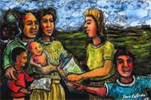

John A. Capitman, Ph.D.
Alicia Gonzalez, B.S.
Mariana Ramirez, B.S.
Tania L. Pacheco, PhD student

Prepared by:

Central Valley Health Policy Institute
Central California Center for Health and Human Services
College of Health and Human Services
California State University, Fresno
University of California, San Francisco LaCMER

This publication was made possible by a grant from


The Effectiveness of a Promotora Health Education Model for Improving Latino

Health Care Access in

California’s Central Valley

Grant No. 1H0CMS300102/02

Acknowledgements

The authors would like to thank the following people and organizations for their invaluable assistance with the publication of this report.

Leadership
Dr. Katherine Flores, MD, Latino Center for Medical Education & Research

Editing
Nancy Pacheco, MBA, Administrative Analyst, Central Valley Health Policy Institute

Collaboration
Luis Santana, Executive Director, Reading & Beyond
Matilda Soria, Research & Development Director, Reading & Beyond
Helda Pinzon-Perez, PhD, Promotora Trainer
Suzanne Kotkin-Jaszi, PhD, Promotora Trainer
Participating Promotoras
Maria Aldaña
Minerva Alvarez
Alma Dreaden
Socorro Gaeta
Collete Holm
Blanca Magaña
Eugenia Perez Melecio
Elizabeth Ragsdale
Mariana Ramirez
Gladis Ruiz
Matilda Soria
Maria Delgado
Barney Zapata

Centers for Medicare and Medicaid Services Liason

Richard Bragg, PhD, Project Officer, Centers for Medicare and Medicaid Services

Table of Contents

Acknowledgements ii

Executive Summary v-viii

Chapter 1: Background
Background 1
Introduction 1
Context 2
Objectives 3
Relevance of CMS Mission and Programming 4

Chapter 2: Methodology
Methodology 5
Project Development 5
Promotora Characteristics 6
Implementation of the Promotora Model 7
Training 7
Ongoing Training 8
Study Population 8
Participant Recruitment 9
Study Design 9
Intervention and Human Subjects Protection 10
Survey Design 11
Recruitment 12

Chapter 3: Data Analysis 13

Chapter 4: Results
Demographics 14
Outcome Measures 15-25
Baseline Measures of Primary Outcomes 15-17
Outcome Measures at Follow-Up 17-18
Outcome Measures at Follow-Up: The role of demographics and race awareness 18-21
Multivariate Analyses of Outcome Measures 21-22
Promotoras’ Reports and Outcome Measures 23-24
Summary of Outcome Measures 25
Program Implementation 25-35
Interview Design 25
Recruitment and Implementation 25
Analysis 26
Process Evaluation 26-29
Respondents’ Barriers 29-32
Promotora Role and Impact 32-33
Promotoras Contributions 33-35
Summary of Program Implementation 35
Chapter 5: Discussion
Discussion 36
Challenges to Project Implementation 37
Effectiveness of Project Management and Workflow 37
Public Health and Policy Implication 38
Implications for Health Services Research Capacity Building 38
Importance of the Study 38

Chapter 6: Information Dissemination 39

Chapter 7: Recommendations for Future Studies 40

References 41

Appendix A: Participant Baseline Survey 38

Appendix B: Participant Follow-up Survey 45

List of Tables 72

List of Figures 73

Executive Summary

Promotoras: Lessons Learned on Improving Healthcare Access to Latinos
John A. Capitman, Tania L. Pacheco, Mariana Ramírez, Alicia Gonzalez

The Central Valley Health Policy Institute (CVHPI) at California State University Fresno seeks policy and program strategies to reduce racial/ethnic and other social inequities in health among San Joaquin Valley residents. Access to health for this particular population is plagued with barriers, but shares many access barriers with the rest of Californians. California’s San Joaquin Valley is a poor region, where significant poverty is present in both urban and rural areas.¹ The region has some of the most medically underserved areas in the state, and the problem is worse for residents of Mexican descent. In 2005, over a quarter (34%) of non-elderly San Joaquin Valley adults who reported being without insurance were born in Mexico.³

OBJECTIVE
Through generous grants from the Centers for Medicare and Medicaid Services (CMS) Hispanic Health Services Research Grant Program and Kaiser Permanente (KP) Fresno-Community Benefits Program CVHPI has been exploring the “Promotora Model” to increase access to Central Valley immigrant elders, adults, and their children. The CMS project focused on legal resident adults and elders while the KP project targeted mixed immigration status families.

PROMOTORA MODEL
Promotoras de salud, also referred to as lay health advisors or Community Health Workers (CHWs), have been used to target hard-to reach populations, traditionally excluded racial/ethnic groups, and other medically underserved communities. Promotoras serve as the cultural bridge between community-based organizations, health care agencies, and their respective communities.^{4,5} Our innovative effort uses CHWs as promoters of health care access. Promotoras focus on increasing enrollment in health insurance programs, receipt of preventive care services, establishing a usual source of care and improve self-efficacy.

“A promotora is someone that is working in the community and comes from within the community.”

POPULATION
The Kaiser Study sample was 103 Fresno County residents who were low-income; undocumented; Latinos ages 18-58. Forty-eight percent of the sample had at least one US born child under age 18 residing in the household. The sample for the CMS study consisted of Latino adults between the ages of 18 through 64 (N=209, 67%) and Latino elders ages 65 and over (N=104, 33%). The participant criteria were Latino adults over age 18 with incomes below 250% of federal poverty level, permanent legal residents or U.S. citizens and residents of Fresno County.

METHODS
Putting the promotora model into practice from November 2007 through May 2009 consisted of 1) promotora training, 2) community outreach and Latino participant recruitment, 3) a baseline survey (pre-test), 4) participant follow-up calls or visits, referrals, and 5) a three-month follow-up survey (post-test). Thirteen promotoras conducted the CMS assessments and four conducted the Kaiser assessments. In both projects, promotoras assisted the client in developing a plan of action for accessing needed health services and provided assistance in understanding and working with health care insurance and provider organizations. Four indicators of health care access were measured in the baseline and follow-up interviews:
Insurance Status: Does the participant have an insurance provider?
Source of Care: Does the participant have a medical home or primary care provider?
Receipt of Physical: Has the participant received a form of medical preventive care?
Self-Efficacy: How comfortable does the participant feel in making his or her own healthcare decisions?

RESULTS
Both studies found significant differences in all indicators from baseline to follow up through appropriate statistical tests. Among the documented adult participants (CMS study), 45%, and 70% had insurance at baseline and follow-up respectively, while among the undocumented participants (KP study) 10% and 20% had insurance at baseline and follow-up, respectively. In addition, among the documented adult participants, 60%, and 90% had a regular source of care at baseline and follow-up respectively, while among the undocumented participants 13% and 59% had a source of care at baseline and follow-up, respectively.

Participants in the CMS study who were first generation and of permanent resident status were less likely to establish a source of care or increase their self efficacy, respectively, than their natural born citizen counterparts. In addition to significantly improving access care measures for the Kaiser study adults, 19 out of twenty-one undocumented children who needed a referral for health insurance were enrolled in the Kaiser Permanente Child Health Plan. Overall, documented participants experienced greater access at baseline and more improvement in access than the undocumented. More information about the studies and these analyses are available in the projects’ final reports, available at www.cvhpi.org.

“The Latino thinks that because they were not born here in this country, it is not their nation … they feel intimidated. As if they don’t have the right to receive this service…it also has to do with the fact that they are treated badly.”

Participants provided the promotoras with feedback about how the intervention had increased their healthcare access. The CMS study found that participant’s barriers lie primarily at the system level, which shaped personal attitudes thus preventing them from seeking or receiving services. Those who felt they were treated worse because of their race and those who needed more referral sites were significantly less likely to report an improvement in their health care access than were other participants.
According to the 79 participants who completed the follow-up survey, the Kaiser study successfully provided 430 referrals to participants and 321 referrals were provided to their families. Sixty-nine percent of participants reported they would recommend the promotora to a friend or relative.
After the intervention, promotoras noticed a positive impact on participant attitudes towards the feasibility of healthcare access. At the final phase of the study, promotoras were interviewed- they perceived participants as more self-efficacious and their work as an essential component to patient care for underserved populations like Latinos.

“[The Intervention] made them more confident, the fact that we were able to give them a sense of security in case they had a question.”

LESSONS LEARNED
There is a continuing need for sustainable funding for promotoras services to achieve appropriate health-care access and utilization for low-income Latinos. The promotora experience of witnessing participant barriers when seeking health care services influenced their performance and evaluation of the process.
The study was designed to measure the impact of a limited promotora intervention over a period of three months. Promotoras became particularly interested in participant needs beyond the study requirements. In order to address participant access barriers, they went beyond their responsibilities- being readily available to participants, volunteering more time, more phone calls, and mileage than required.
Through their contributions, promotoras provided a unique service for participants to overcome system barriers, change their attitudes about, and access to healthcare.

“…in the end they were more confident when talking to the doctor, asking questions”.

IMPLICATIONS AND RECOMMENDATIONS
The work of a promotora can be difficult and emotionally taxing. Ongoing guidance and supervision from the project coordinator is necessary to ensure that promotoras feel supported and encouraged. Furthermore, institutionalization of such a service could be significantly efficient, as an average of 10 hours of intervention per patient can significantly increase healthcare access, including preventative care. Until there are state and national policies that recognize the need for community health workers for those with health care access limitations, promotora model interventions will need to rely on philanthropic funding. Our findings also underscore that as we seek healthier communities, all children residing in the United States, whatever the documentation status of their parents, should be ensured access to health care insurance and access to needed care as part of national and state health reform initiatives.

AUTHOR INFORMATION
John A. Capitman, PhD, is the executive director for the Central Valley Health Policy Institute (CVHPI) and Professor of Public Health at California State University, Fresno. Tania L. Pacheco is research analyst at CVHPI and doctoral student at the Department of Social and Behavioral Sciences at University of California, San Francisco. Mariana Ramirez is a community health assistant for Central California Regional Obesity Prevention Program. Alicia Gonzalez is an Master of Public Health (MPH) candidate at California State University, Fresno.

ACKNOWLEDGEMENTS
The authors wish to thank the Centers for Medicare and Medicaid Services (CMS) Hispanic Health Services Research Grant Program and Kaiser Permanente (KP) Fresno-Community Benefits Program for making these projects possible and UCSF Fresno Latino Center for Medical Education & Research. The authors also thank Nancy Pacheco for editorial and publishing assistance.

SUGGESTED CITATION
Capitman, J.A., Pacheco, T.L., Ramírez, M., Gonzalez, A. Promotoras: Lessons Learned on Improving Healthcare Access to Latinos. Fresno, CA: Central Valley Health Policy Institute, 2009.

ENDNOTES
¹ Bengiamin M, Capitman JA, and Chang X. Healthy people 2010: A 2007 profile of health status in the San Joaquin Valley. Fresno, CA: California State University, Fresno, 2008. Available at: http://www.csufresno.edu/ccchhs/institutes_programs/CVHPI/publications/_CSUF_HealthyPeople2010_A2007Profile.pdf.
² RAND California .2007. Population and demographic statistics: Population estimates. [Data Files]. Retrieved March 2005 from http://www.ca.rand.org/stats/popdemo/pomdemo.html
³Growing a Healthier San Joaquin Valley: Recommendations for Improving the Public Health and Healthcare Infrastructure. Capitman, J.A., Riordan, D.G., Paul, C.M. (2007).
⁴Andrews, J. O., Felton, G., Wewers, M. E., & Heath, J. (2004). Use of community health workers in research with ethnic minority women. Journal of Nursing Scholarship, 36, 358-365.
⁵ Swider, S. M. (2002). Outcome effectiveness of community health workers: An integrative literature review. Public Health Nursing, 19, 11-20.

CHAPTER 1
Background
In 2006, The Centers for Medicare and Medicaid Services (CMS) funded health services research projects to Historically Black Colleges & Universities (HBCU) and Hispanic Serving Institutions (HSI) Health Services Research Grant to implement projects aimed at eliminating health and health care inequities facing African-American and Latino populations in the United States. The University of California, San Francisco Latino Center for Medical Education & Research (LaCMER) and the Central Valley Health Policy Institute (CVHPI) at California State University, Fresno collaborated in an effort to examine the effectiveness of using trained Promotoras de salud, also known as Community Health Workers (CHWs) or lay health advisors,, to deliver an educational intervention to low-income Hispanics in California’s Central Valley.
Introduction
Numerous projects using the Promotora/CHW model have sought to improve health outcomes and increase access to needed care across the United States during the last ten years. Promotoras de salud, generally have been used to target hard-to reach populations, traditionally excluded racial/ethnic groups,
and other medically underserved communities. Promotoras usually belong to the community theyserve, share the same language and culture, and understand the needs of their community. CHW proponents believe that patients and their communities are more receptive to messages provided by CHWs (Swider, 2002; Andrews, et al, 2004). Promotoras serve as the cultural bridge between community-based organizations, health care agencies, and their respective communities (Andrews, Felton, Wewers, 2004; Swider, 2002). Promotoras provide important personal inside knowledge of the communities they serve
to project staff that is critical in tailoring a project to meet the unique needs of any target community. Previous studies have primarily focused on using Promotoras to effectively improve health behaviors, chronic disease management and health outcomes (Balcazar, Alvarado, Hollen, Gonzalez-Cruz, Pedregón, 2005; Forster-Cox, Mangadu, Jacquez, Corona, 2007; Staten, Scheu, Bronson, Peña, Elenes,
2005). Our effort is unique in that we are using CHWs in a fairly new and emerging role as promoters of health care access focusing on increasing enrollment in health insurance programs, receipt of preventive care services, and establishing a usual source of care and self-efficacy. Although prior studies have demonstrated the value of Promotoras in underserved communities, there is no systematic exploration of their value in improving knowledge and attitudes relative to basic health insurance enrollment for this population. Two noteworthy programs, Community Access Program, Linea de Salud in El Paso, Texas and Alianza Dominicana Inc. located in Manhattan, were successful in increasing enrollment in Medicaid and SCHIP by implementing Promotora model programs. The scarce evidence available shows the use of CHWs to be a cost-effective intervention approach for expanding access and receipt of health services to underserved and underinsured populations (Ro, Treadwell, Northridge, 2003). Results of the Community Health Worker Initiative (CHWI) evaluation shed a positive light on the benefits and costs of using CHWs. Researchers compared health-service utilization rates including hospitalizations, emergency department use, and Medicaid costs of individuals served by CHWs with a control group. They found that each client served by a CHW cost an average of $2,700 less per year than clients in the comparison group. The researchers’ projected a savings of approximately $50,000 per year for each CHW hired on the program administration cost assuming each CHW has an average caseload of 30 clients (Ro, Treadwell, Northridge, 2003). The Kentucky CHW Homeplace Project also demonstrated a savings of $935,000 over one year to Kentucky’s health care system due largely to the CHWs success in preventing clients from being admitted into nursing homes and hospital emergency departments (Ro, Treadwell, Northridge, 2003).
This report describes the process for training Promotoras to deliver the educational intervention, final study results, evaluation, and lessons learned from the project development and implementation phases. This report also provides details about the Promotora curriculum development, training modules, pre- and post-test assessments of Promotora knowledge as well as the Promotoras’ perspectives about the impact of the program on participants and themselves.
Context
California’s Central Valley has one of the fastest growing populations in the state with nearly 4 million people living in the region in 2006, about 11% of California’s population. The Central Valley encompasses the San Joaquin Valley, which includes eight counties, including Fresno. Poverty in both urban and rural areas of the region is a significant problem, with 22% of people living below the federal poverty level compared to the state average of 15.1% (UCLA Center for Health Policy Research, 2007)- before the recent recession and farming water shortage. Residents had lower per capita income ($23,882) than both the state ($36,969) and nation ($25,036) (RAND California, 2005). The Valley is one of the least affluent areas of California. In 2000, 33% of residents over age 18 had less than a high school education, which is higher than the state (24%) and the U.S. (20.3%). The region faces higher rates of unemployment than the state (9% and 5% respectively) (Central Valley Health Policy Institute, 2007). The region also has some of the most medically underserved areas in the state and nation. The San Joaquin Valley has just 173 physicians per 100,000 people, compared to the state’s rate of 302 per 100,000 (Central Valley Health Policy Institute, 2006). With regard to health insurance, 16% of the region’s adult population age 18-64 did not have health insurance in 2005 (Central Valley Health Policy Institute, 2008). In 2005, over a quarter (34%) of non-elderly San Joaquin Valley adults who reported being without insurance were born in Mexico.
Objectives
The study’s main goal was to explore whether experienced Promotoras can be trained and actually deliver a structured educational intervention that increases the knowledge and improves the behaviors and attitudes of low-income Latinos with respect to health insurance, healthcare access, and preventive service use. The study had several objectives within the overall study goal of improving health care access for low-income Latinos in California’s Central Valley. The study’s first objective was to develop the participant pre- and post-test instruments that would be utilized in the project. Secondly, project staff established relationships with key health and social service community-based organizations (CBOs) to identify seasoned male and female Promotoras with demonstrable experience in providing culturally and linguistically competent assistance on health issues and existing ties to the target population. The next objective was to develop and implement the Promotora training curriculum. The fourth objective was to create a Community Health Resource Guide for the Promotoras to use when providing potential participant referrals.
We established relationships with various health care and social services organizations including community health centers and insurance enrollment agencies. The guide had specific contact information such as the name of a Spanish-speaking individual. This person most likely worked with the Promotora in resolving a client’s health care issue and the Promotora followed-up when necessary. The assessment tools were pilot-tested with a group of experienced Promotoras who provided valuable feedback on the content and cultural appropriateness of the instruments. Promotoras used participant tracking sheets, which were created to assist Promotoras in clearly documenting the client’s plan of access, referrals provided, and dates and times of telephone follow-up calls made during their participation in the study. Two post-test instruments were developed to assess the clients’ implementation of their plan of access and changes in health insurance status. The first post-test occurred three months after the baseline survey (pre-test) and addressed clients’ experiences in contacting the organizations, making appointments with providers, enrolling in a health insurance plan and self-efficacy (the ability to solve their own health care access problems). The second post-test occurred approximately nine months after participants were recruited. The second post-test inquired about respondent and family member health insurance status, the type of coverage, receipt of a physical exam in the previous three months, and if the participant had a usual source of care. Self-efficacy was determined during the first post-test so it was not included in the second post-test.
Finally, the last objective was to implement and evaluate the intervention to measure the effectiveness of the Promotora health education model in improving participants’ access to health care services, public health insurance enrollment, receipt of preventive care screenings, and self-efficacy. Our expectations were that the Promotoras would show significant improvement in knowledge and attitudes about public insurance eligibility and enrollment, health care access and preventive services use. It was expected that the project participants would demonstrate significant improvements from baseline to follow-up in terms of insurance coverage status, access to a usual source of care, receipt of a preventive service and self-efficacy. Further, it was expected that the Promotoras would improve the knowledge and attitudes of participants with regard to insurance status, appropriate use of primary and preventive care and self-efficacy about future health care use.
Relevance to CMS Mission and Programming
CMS has committed to take a leadership role in developing initiatives that reduce health disparities. The intervention approach to increasing health access to Latino adults and elders aims to provide culturally appropriate education and outreach about insurance coverage, preventative care, and navigating the health system to receive care. The project aims to gain better understanding about access as a step in improving the quality of care for this population in the future.

CHAPTER 2
METHODOLOGY
The project combined a formative evaluation of the development and implementation of a training module for current Promotoras and a one group pre- and post-test assessment of healthcare access and service use among the participating low-income Hispanic adults and elders (n=313). The effectiveness of the training was assessed through pre- and post-tests of the Promotoras' knowledge, attitudes and skills. Both overall changes in insurance status, healthcare access and preventive care use as well as the influence of demographic and health status on changes in these factors were measured for the educational intervention participants. To be eligible to participate in the educational intervention, individuals had to be adults (including at least 50% elders), with incomes below 250% Federal Poverty Level, and legal residents or U.S citizens. The formative evaluation also collected information on the experiences of the participating Promotoras in recruiting participants and delivering the intervention, and as members of the health care and social services team at their sponsoring provider or community agencies.
Project Development
The development phase of the project included various sub-components. The first was to develop relationships with CBOs in the target area that provide a variety of social services to low-income Latinos and have used Promotoras in the past. Eight organizations were contacted and five agreed to participate by referring qualified community advocates who were hired as Promotoras through California State University, Fresno. Table 1 describes the names of the CBOs, the number of Promotoras recruited from each organization and the average number of families each Promotora served during the project per organization.

TABLE 1: Participating Community Based Organizations
# | CBO | No. Promotoras | No. Participants per Promotora/a
1 | Centro La Familia | 2 | 15
2 | Fresno County Health Department-Compañeras en Salud Project | 3 | 18
3 | Reading & Beyond | 6 | 32
4 | Centro Binacional para el Desarrollo de Indígena Oaxaqueño | 1 | 24
5 | Fresno Metro Ministry | 1 | 13
 | Total | 13 | 313
Promotora Characteristics
The goal was to recruit and train twenty experienced male and female CHWs or community advocates to serve as Promotoras de salud in the study. The Project Coordinator was successful in recruiting twenty Promotoras, however due to unforeseen Promotora time and dual employment commitment challenges; seven were unable to participate and the final participating group was reduced to thirteen. The levels of educational attainment, years of community advocacy experience, language and community network skills varied among the participating Promotoras. Over a quarter of the Promotoras had a High School Diploma and the majority had over two years of community advocacy or relevant experience. Two Promotoras previously worked as public health insurance certified application assistors (CAAs) in low-income communities within Fresno County. Three were recruited from the county’s health department Compañeras en Salud (Companions in Health) project that trained Promotoras to educate low-income Latina women about breast cancer awareness, self-examination, and mammogram screening. A handful of Promotoras worked as parent educators in educationally underserved communities in Fresno County providing after school parenting classes and reading tutoring to children. Most Promotoras were bilingual in English and Spanish and one of them spoke Spanish and Mixteco, which allowed for inclusion of Mixteco participants (Table 2). Most of the Promotoras joined the team with some degree of networking skills and existing ties to the target population. However, many still struggled with identifying and recruiting eligible elder participants.
TABLE 2: Promotora Characteristics
Promotora Characteristics | No. Promotoras | %
No High School Diploma | 4 | 30.8%
H.S. Diploma | 4 | 30.8%
Some College | 2 | 15.4%
BA/BS | 2 | 15.4%
MA | 1 | 7.7%
Years of Experience
Minimum 2 Years Experience | 3 | 23.1%
2+ Years Experience | 10 | 76.9%
Language Skills
Bilingual in English/Spanish | 12 | 92.3%
Bilingual in Spanish/Mixteco | 1 | 7.7%
Total | 13 | -

Many conducted presentations at Catholic churches and senior meal site centers to recruit elders , however, they identified only a small number of eligible adults over age 64 who expressed a barrier to accessing health care services. Even among those elders who expressed a concern with health care access, a notable proportion were unwilling to participate because they or their adult sons feared reprisals for participating in a government-sponsored project.
Implementation of the Promotora Model
The implementation of the Promotora model consisted of 1) Promotora training, 2) community outreach and Latino participant recruitment, 3) baseline survey (pre-test), 4) participant follow-up calls or visits, referrals, and 5) a three-month follow-up survey (post-test).
Training
The Promotoras participated in a comprehensive two-day training intended to prepare them in accomplishing their role. Suzanne Kotkin-Jaszi, DrPH and Helda Pinzon-Perez, PhD, both faculty in the Department of Health Sciences, California State University, Fresno developed the Promotora training curriculum. The curriculum consisted of five modules: 1) Introduction and Project Background, 2) the Role of Promotoras, 3) Motivational Interviewing, 4) Importance of Having Health Insurance and a Medical Home, and 5) Public Sponsored Health Insurance Program Eligibility Guidelines including Medicare, Medicaid, and the State Children’s Health Insurance Program (SCHIP). The curriculum also included information about appropriate utilization of emergency hospital services, the importance of having a usual source of care, a primary care doctor and age-appropriate preventive care services for the participant and their family.
Training activities included Promotoras actively role-playing conducting the pre-test assessment with one another. The process for training the Promotoras to be effective communicators of public health insurance, age appropriate use of health care and preventive services to improve participant health care access was challenging. The two-day training may not have been sufficient in preparing a few Promotoras to execute the intervention. Further supervision, coaching, ongoing individualized meetings, and hands on training in completing the required forms were necessary. The Promotoras participated in a pre-test before the training began to assess their current knowledge, attitudes, and practices. The trainers administered a post-test using the same instrument after the end of the Promotora training. Promotoras showed significant improvement in knowledge of health care insurance, motivational interviewing techniques, appropriate utilization of the Emergency Department and age-appropriate health care prevention services. Mean scores improved nearly 20% from 20.1 (pre-test) to 25.6 (post-test) out of a total score of 30 (Table 3).

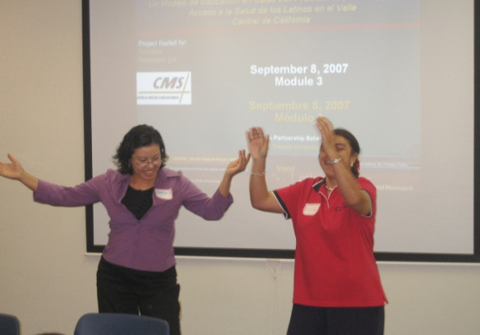
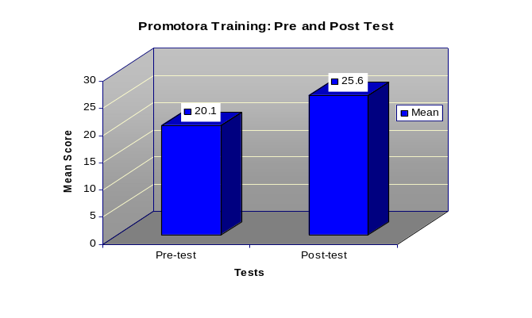
TABLE 3: Promotora Pre- and Post-Training Results
p-Value: 0.002

(Above). Maria Aldana (Promotora) with Dr. Helda Pinzon-
Perez (Trainer) enjoying a break during the training
Ongoing Training
Continuous training and support was provided to Promotoras during the project. Promotora meetings were held at least once a month during the project to discuss their progress in participant recruitment, survey completion, and proper tracking form documentation. A Promotora Guide was created to assist Promotoras in general interviewing techniques such as how to explain and conduct the survey to participants, closing the interview, steps in completing the surveys, filling out the participant tracking sheet and performing follow-up calls with clients as necessary. Although training was continuous, some Promotoras still had challenges in properly documenting their client’s health care access plan on the Participant Tracking Sheet and in completing surveys. Many Promotoras stated the form was too long and complex. Promotoras also stated the educational level of the survey was too high for clients and themselves to understand. For those Promotoras who had challenges in recruiting participants, the project coordinator assisted them in contacting community and senior meal site centers to schedule presentations and their participation at community social gatherings where they can recruit both adults and elders. Although monthly meetings were held and Promotoras were offered support, many still faced challenges in successfully completing the assigned tasks.
Study Population
The target study sample was 400 with 50% being elders over age 64; however, due to recruitment challenges the final sample size was reduced (n=313). The participant criteria included Latino adults over age 18 with incomes below 250% of federal poverty level, permanent legal residents or U.S. citizens and residents of Fresno County. At baseline, 67% of participants were adults (n=195) and 33% were elders (n=104). Both the number of adults and elders was reduced at follow-up (n=290) although the rate of participation remained the same for adults and elders. Twelve participants who completed the baseline survey were lost to follow-up. Promotoras made strong efforts to contact these participants through continuous home phone calls and visiting their homes. Unfortunately, those lost to follow-up had non-working telephone numbers and could not be reached by other means or had moved out of the residence address the Promotora had on file. Some clients fell victims of the economic foreclosure crisis yet maintained communication with the Promotoras and informed them they would be moving out of Fresno County in search for employment. One participant and their family moved back to their country of origin. Twenty-two cases had inconsistent, incorrectly reported data by the Promotora. Twelve cases out of twenty-two resulted in non-workable data and therefore not included in the data analysis. There were ten cases where the race and ethnicity discrimination questions, emergency department use and self-efficacy at baseline could be used. These participants were administered the second follow-up and their workable data was included in the final analysis. However, the project coordinator was not able to contact these ten participants to complete the second follow-up, which inquired about health insurance status and type of coverage for respondent and family members, receipt of physical exam, usual source of care and whether they feel they need help from a Promotora in seeking or receiving services.
Participant Recruitment
Participant recruitment was the principle responsibility of the Promotoras. Promotoras recruited individuals from their own social and community networks. Direct verbal communication is very strong among the Latino community; hence, many individuals and families were recruited by means of participant referrals. Promotoras made presentations at churches, senior meal site centers, migrant parent conferences, and community social gatherings to recruit participants. Difficulties in elder recruitment were an unanticipated problem encountered by the Promotoras. Promotoras encountered roughly 250 potentially eligible elder participants, although there may have been many more because not all Promotoras kept complete records of how many they contacted. Many of these elders did not express any barriers in seeking or receiving health care services. Others, while expressing a need for support in health care access, nonetheless declined to participate in the project because of their own or their adult sons’ concerns with the potential for negative consequences (on citizenship applications or service access) for participating in a government-sponsored project. New strategies for recruitment such as making presentations at additional senior sites were developed and applied throughout the recruitment phase.
The participant criteria limitation of only including permanent legal residents and U.S. citizens influenced the recruitment process by making it more difficult for Promotoras to find eligible respondents for the study. The Promotoras encountered many low-income Latinos in the region who needed assistance in seeking health care services but could not participate in the survey because of their undocumented immigration status. Nonetheless, Promotoras still explained the criteria and provided resources and information to these ineligible individuals whenever they encountered them. It was challenging for Promotoras to keep in contact with those participants who were lost to follow-up because many moved out of the area without providing the Promotora with contact information. Later in the report, we will discuss how recruitment could have been improved.
Study Design
This was an exploratory pilot project that utilized a non-randomized one-group study design. The study explored whether the use of a culturally tailored educational intervention would accomplish the following: a) increase insurance enrollment in Medicare, Medicaid, and the State Children’s Health Insurance Programs (SCHIP), b) improve access to primary care services, c) increase age-appropriate utilization of preventive screenings, and d) increase self-efficacy in locating and accessing health services. This intervention was based on recruiting and training Promotoras as effective communicators of information about Medicare, Medicaid and SCHIP enrollment and proper utilization of primary and preventive health care services.
Intervention and Human Subjects Protection
The intervention included a baseline survey (pre-test), Promotora follow-up calls and home visits, a three-month and five-month survey (post-test). The pre-test assessed basic demographic information such as gender, age, civil status, immigration status (is this referring to legal residency status or civil marriage?), educational attainment, income, and years living in the United States. Health access indicators included respondent and household health insurance status, usual source of care, receipt of physical exam or regular check-up in the previous year, and receipt of preventive care services, emergency department use, self-efficacy, and perceived discrimination both in general and within the health care system.
The intervention consisted of Promotoras completing participant baseline surveys, providing appropriate referrals, performing case management and completing the two follow-up surveys involved a sequence of steps. The Promotora began each interview with general small talk that led to reading the informed consent to the participant and obtaining their signature. An open-ended question, which provided self-reported health care access barriers occurred at the beginning of the baseline survey. The Promotoras consequently administered the survey and determined the participants’ barriers to access. Using the Participant Tracking Sheet, the Promotoras developed an individualized health access plan for each client using the Participant Tracking Sheet form.
The plan included referrals to CBOs that assist individuals with enrolling in public sponsored health insurance programs such as Medicaid, State Children’s Health Insurance Program (SCHIP) or Healthy Families, Medicare and the county’s Medically Indigent Services Program (MISP). The Promotoras referred clients to clinics to establish a usual source of care, find a primary care doctor, or to receive primary and preventive care. Transportation was one of the most commonly self-reported barriers. Therefore, Promotoras provided referrals for public transportation. Promotoras also gave participants referrals to receive social services (i.e. legal assistance, food stamp programs).
The average duration of the baseline was anticipated to be approximately one hour. In fact, Promotoras reported that the baseline required an average of one and one half to two hours to complete. Promotoras conducted biweekly telephone calls and home visits to participants to follow-up on their clients’ health access plan every two weeks before the first follow-up survey was completed. Often participants called the Promotoras to request assistance in completing insurance application forms, making telephone calls to program enrollment offices and to clinics to schedule appointments.
Survey Design
The first follow-up survey was administered about three months after the baseline interview. The purpose of this follow-up interview was to learn about participant experiences with implementing the individualized plan. Before meeting with the participant, the Promotora reviewed the initial plan from the Participant Tracking Sheet. The Promotora marked the questions in the follow-up survey that pertained to the referrals he/she provided. The questions focused on individual experiences with contacting the organization, making the appointment, and receiving the recommended service. Information about emergency department use, perceived discrimination both in general and within the health care system in accessing services as well as self-efficacy were asked again at follow-up.
The second follow-up was designed to obtain more accurate information about participant and family member health insurance status and type of coverage, receipt of physical exam in the previous three months, and whether they now had a usual source of care. All surveys had a number assigned to them, and Promotora knew contact information but not data entry persons.

Recruitment
As noted above, recruitment challenges reduced the sample goal from 400 to 313 as well as the number of participants that completed both follow-up surveys. At baseline, two recruitment requirements (immigration status and age) prevented Promotoras from achieving the specified goal. Since only documented immigrants and U.S. citizens were eligible to participate in the study, many undocumented immigrants that expressed interest in participating were not admitted. Participants’ age posed another challenge since most elders approached by Promotoras were already covered by health insurance and did not express a need for health care services. At first follow-up, the sample was reduced from 313 to 290. The primary challenge at this phase was participants relocating out of the state or the country. The sample decreased even more at second follow-up, from 290 to 287. The three missing participants were not reached because their phone numbers were non-existent at second follow-up. Therefore, the study’s sample decreased at every phase, starting with 313 at baseline, then 290 and first follow-up, and ending with 287 at second follow-up.

CHAPTER 3
DATA ANALYSIS
Quantitative analysis was conducted to measure change in participants’ health care access needs from baseline to follow-up. The data was collected by Promotoras from the baseline and follow-up interviews. SPSS was used for all of the data management of the study. Four dependent variables were identified as indicators of access to health care services: 1) health insurance status, 2) usual source of care, 3) receipt of physical, and 4) self-efficacy. The first three variables were categorized as yes/no questions and coded as “1” for yes and “0” for no. The last variable was categorized as a 5 point Likert-type scale and then categorized into “low” and “high” efficacy. All variables were analyzed together.
Independent variables were categorized into four areas: 1) demographics, 2) race awareness, 3) health services, and 4) Intervention. Demographics ranged from gender and age group to immigration status, this data was categorized and presented as frequencies. Race awareness questions were developed as reference questions, meaning, how people felt they were treated compared to others. Health services questions referred to the type of preventive services participants had received within a year of the baseline survey. The degree of intervention by the Promotora was the last independent variable, but was gathered from the Promotora tracking sheets rather than the survey.
A Paired Sample T-test was conducted to measure change in dependent variables from baseline to follow-up. In addition, bivariate analyses (chi2, t-tests, ANOVA, linear regressions) were used to determine association between the four dependent and a set of independent variables reflecting demographic, health care need, and attitudinal factors. Significant relationships later served as the basis for conducting a multivariate analyses to explore how these factors, in addition to Promotoras’ intervention, had influenced change. The same process was used for the subsample using the Promotora tracking sheets to explore associations between the degree of intervention and the access measures.
Qualitative data was gathered through open-ended surveys administered to Promotoras regarding the program implementation. The tape-recorded material was transcribed and authors of this report translated the themed text. The Promotoras were asked to evaluate the project which resulted in the process evaluation theme later divided into favorable and unfavorable evaluation. The other themed sections , respondents’ barriers (from Promotora’s perspective) and Promotora’s impact were coded into subcategories of the main themes. However, subcategories were found in each of the subsections, pointing to how three themes were interrelated.

CHAPTER 4
RESULTS
Demographics
The sample consisted of Latino adults between the ages of 18 through 64 (N=209, 67%) and Latino elders ages 65 and over (N=104, 33%). Within both age groups, there was an over-representation of female respondents: female adults (N=141, 68%) and female elders (N=53, 51%). The largest percentage of participants, 46% adults (N=96) and 43% elders (N=45), indicated their civil status as “married” at baseline interview. Promotoras asked participants the number of family members in the household, including themselves. The household size of the participants was rather small, over a quarter of adults and nearly half of elders reporter a household size of “1” or “self” (Table 4).
Education levels ranged from “none” to “some college”, with at least half of the participants in each group having completed high school. Adults reported having a higher educational attainment than elders. To calculate the mean income of our sample, participants reported the income filed in their 2006 income tax form. Only respondents that filed their income tax return in 2006 were included in the calculation. Elder participants (N=35) reported a household mean income of $19,522 and adults (N=144) reported a higher household mean income of $23,340.
Generation, immigration status, and the number of years living in the United States determined immigration background of Latino participants. Our sample population traced their immigration status back to third generation, which included grandparents, parents, and respondents’ country of birth. However, both groups, adults (51%) and elders (52%), classified themselves as first-generation immigrants (born outside the U.S). Our aim was to interview Latino legal residents and U.S. citizens, notwithstanding their generation. A large majority of elders (88.2%) identified themselves as “U.S Citizens”, as did the majority of the adults (67.6%). In addition, participants provided the exact number of years they have lived in the U.S. Adults reported an average of 26 years and elders an average of 57 years.

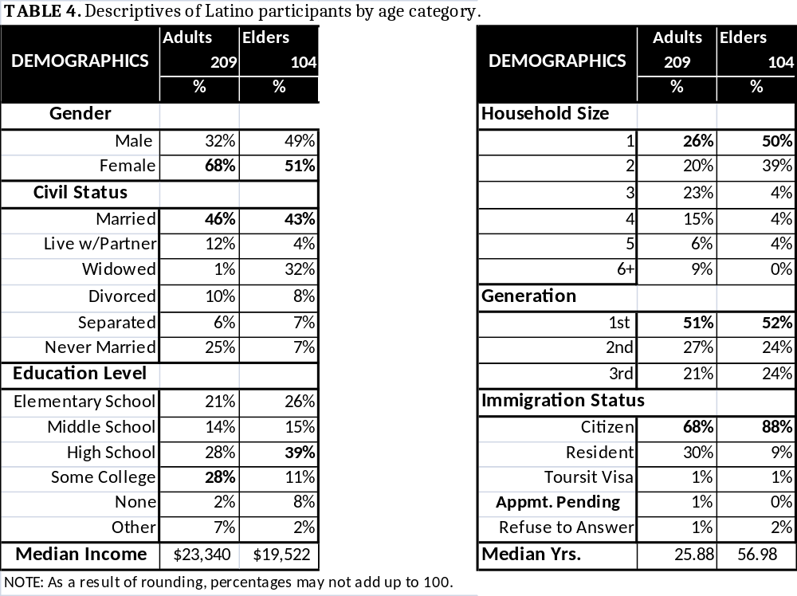

OUTCOME MEASURES
Baseline Measures of Primary Outcomes
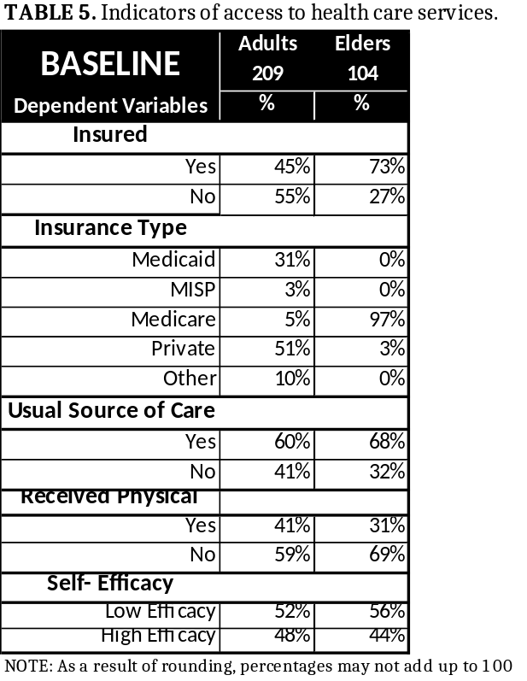
Four indicators of access to health care services were identified as dependent variables: insurance status, source of care, receipt of physical, and self-efficacy. Insurance status was determined by asking participants the following question, “Have you had health insurance in the past year?” Nearly half of adult respondents reported being insured at baseline survey (45%), with a slight majority of these adults covered by private health insurance (51%). For their part, a large majority of elders reported having insurance at baseline (73%) with Medicare (97%) as the primary insurer. We based a second indicator, usual source of care, on the following question, “Is there a place that you usually go to when you are sick or need advice about health?” Over half of adults (60%) and elders (68%) claimed to have a source of care at pre-test. Participants were asked, “When was the last time you received a check-up or physical exam in the past year?” for the third indicator. Respondents that reported dates older than the specified periods of time were coded as “no,” meaning they did not receive a physical, and only those that received a physical within the past year where coded as “yes.” Only 41% of adult respondents indicated they had received a physical within the last year. Notwithstanding the high percentage of insured elder respondents, only 31% of them said they had received a physical within the past year. Finally, to capture participants’ self-efficacy when seeking health care services, they were asked to rate the statement, “I feel confident that I can solve my health care access problems.” Respondents rated the statement from a 5-point Likert-type scale. During analysis, points 1-3 are categorized “Low efficacy” and points 4-5 as “High Efficacy.” Nearly half of adults (48%) and 44% of elders reported having a “High Efficacy” at baseline (Table 5).
Uninsured respondents and people lacking a usual source of care were asked additional questions to better understand their access to health care services. Uninsured participants were asked to report the actions they had taken when in need for medical care. Uninsured adults and elders selected from seven possible sources of care (Table 6). The two most commonly reported sources of care by adults were “Pay out of Pocket” and “Alternative Care,” 42% and 38% respectively. The same potential sources of care were also the most commonly reported by elders, except that for elders, “Alternative Care” was noted 59% while 31% of elders reported paying out of pocket.
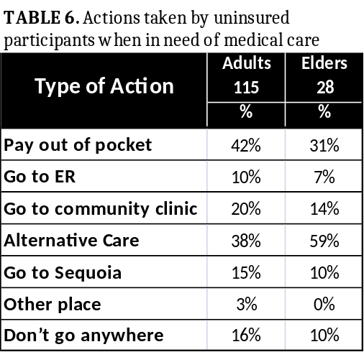
Participants without a source of care at baseline, adults (N=83) and elders (N=33), were asked about their reasons for not having one. The following are the reasons reported: Participants’ lack of knowledge of the system, public insurance requirements, and insurance enrollment sites as well as the system’s lack of translation services, expensive health care services and inconvenient days and times. These reasons were all considered “system barriers”. 77% of adults and 82% of elders reported a system barrier as a reason for not having a source of care (Table 7).
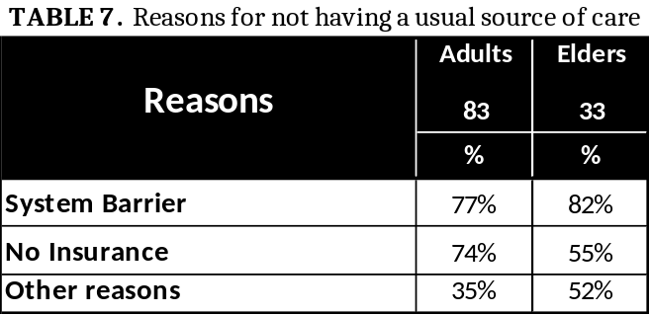

Outcome Measures at Follow-Up
After participant needs were identified at baseline, Promotoras developed a health care access plan and initiated a three-month long follow-up period. The individualized health care access plan included referrals to various health care services, including receipt of preventive care services (i.e. physical), clinics, and health insurance agencies. Through phone calls and personal visits, Promotoras tracked participants’ progress in obtaining the service they were referred to, provided additional referrals, and assisted in the insurance application process if needed. After the three-month intervention, Promotoras conducted a follow-up survey (post-test) to identify the status of participants’ access to health care services and their experiences in implementing the health care access plan.
A Paired-Sample T-test was conducted to compare health care access indicators at baseline (insurance status, source of care, receipt of physical, and self-efficacy) and health care access indicators at follow-up (Table 8). There was a significant increase from baseline to follow-up in every healthcare access indicator. The proportions of insured participants increased from .55 at baseline to .80 at follow up, (t =8.485). Similarly, there was an increase in the number of participants reporting a usual source of care from baseline from .62 to follow-up .92 (t= 9.221). Thirty-six more participants had received a physical by post-test (t=6.863). The self- efficacy of participants when seeking health care services improved. Self-efficacy was ranked from zero being “low efficacy” to four being “high efficacy.” Participants’ self-efficacy mean went from 2.187(SD=1.15) at baseline to 3.239(SD=0.87) at follow-up, (t=12.147). These results suggest that the Promotoras’ intervention does have an effect on participants accessing health care services. The three-month intervention with participants improved their access from baseline to follow-up.
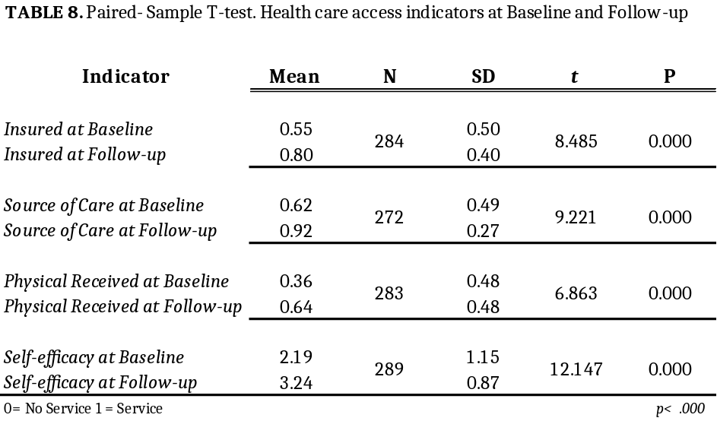

Outcome Measures at Follow-up: The role of demographics and race awareness

In addition to reporting change in participants’ access to health care services from baseline to follow-up, a series of tests were conducted to determine relationships between independent variables and dependent variables at follow-up: Chi squares, t-tests, ANOVA, and linear regressions. Dependent variables at follow-up were insurance, source of care, physical, and self-efficacy. Independent variables included the four dependent variables at baseline, demographics, race awareness, health measures, and intervention measures.
There are a few strong associations among dependent variables at baseline and health care access indicators at follow-up (Table 9A). Respondents’ insurance status at baseline was associated with having insurance and a usual source of care at follow-up. Whether participants had a usual source of care at baseline was related to their insurance status at follow up, (Chi2=4.569*). Receiving a physical at post-test was associated with the self-efficacy level of participants at baseline. Being self-efficacious at post-test was related to receipt of physical at baseline, (t=3.481***).
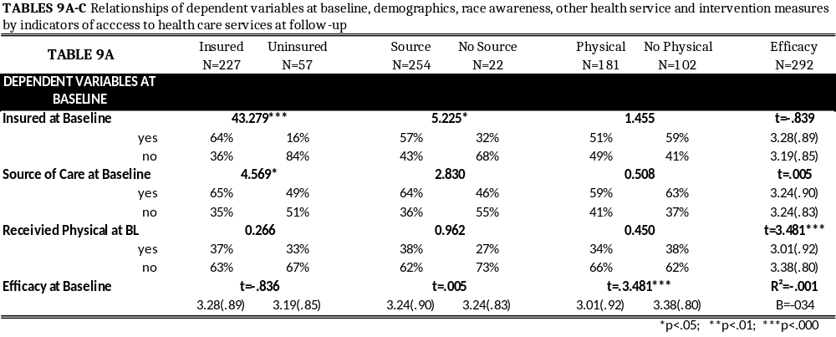
Three of the four indicators of access to health care service were associated with at least one of the seven participants’ demographic characteristics (Table 9). Insurance status at follow-up was associated with five socioeconomic factors: age, marital status, household size, immigration status, and number of years living in the United States. Of the 57 uninsured participants at follow-up 93% were adults, had a household size mean slightly larger than insured, and had lived in the United States fewer years than insured. Marital and immigration status were also significant where married and US citizen participants were more common among the insured than uninsured at follow-up. On the other hand, having a usual source of care at follow-up was only associated with one variable, years living in the U.S. Similar to uninsured participants, those without a source of care at follow-up reported living in the U.S. for less time than participants having a source of care. The analyses showed that having a higher self-efficacy was associated with being older, having lived in the U.S more years, being second or third generation and being a U.S citizen. However, if participants were adults, they had a bigger household size, and had lower than a high school education, they were more likely to have low self-efficacy than were their counterparts (Table 9B).
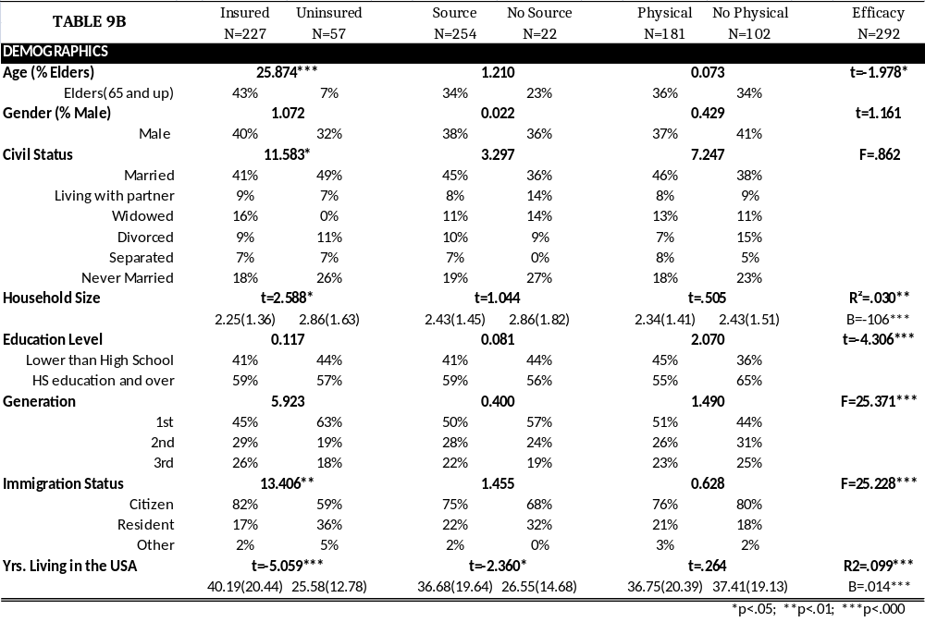
Additional measures like race awareness and health services were added to the list of associations. Three questions were asked to determine respondent race awareness. First, participants reported the frequency of their thoughts about their own race or ethnic group, from “never” to “constantly.” Next, participants reported on the way they had been treated in the past year in relation to other racial groups. Receipt of physical and self-efficacy of participants was associated with at least one of the race awareness measures (Table 9C). In the relationship between race treatment when seeking health services and receipt of a physical at follow-up, participants who reported being treated “the same as” other racial ethnic groups were more likely to have received a physical. Participants rated as having low efficacy reported thinking about their race more than those who had high efficacy (B= -.071). These relationships were further analyzed in multivariate analyses.

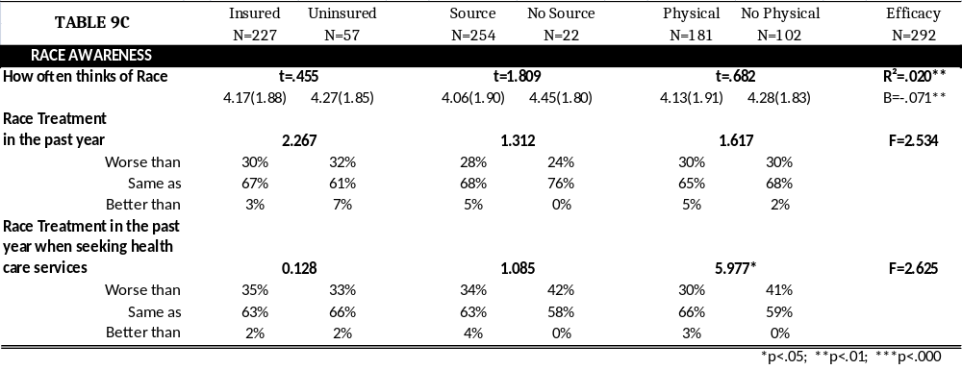

Multivariate Analyses of Outcome Measures
Data derived from the strong relationships reported on tables 9A through 9C were used to perform multivariate analysis in order to determine how these factors influenced change in the indicators from baseline to follow-up. Logistic regressions were performed for the first three dependent variables (insurance status, source of care, and physical) because of their binary nature. Linear regression was used for self-efficacy (Table 10).
A multivariate analysis was conducted to include all covariates. A second analysis utilized only those covariates having a significant impact on dependent variables during the first multivariate analysis. Table 10 shows the logistic and linear regressions including covariates. Using the Wald method, we learned that age, treatment according to race, and the need to schedule a physical influenced insurance status at follow up. First generation participants were 5 times more likely to have had a physical done by follow-up than were their third generation counterparts. When participants felt they were treated “worse than” other ethnic groups, when seeking health care services, they were 73% less likely to receive a physical at follow-up. On the other hand, wanting health education at baseline predicted receipt of physical almost 3 times more than participants that reported not wanting health education. Finally, when conducting linear regression for self-efficacy, only demographic measures predicted change at follow-up. First generation immigrants were less efficacious than were third generation immigrants.
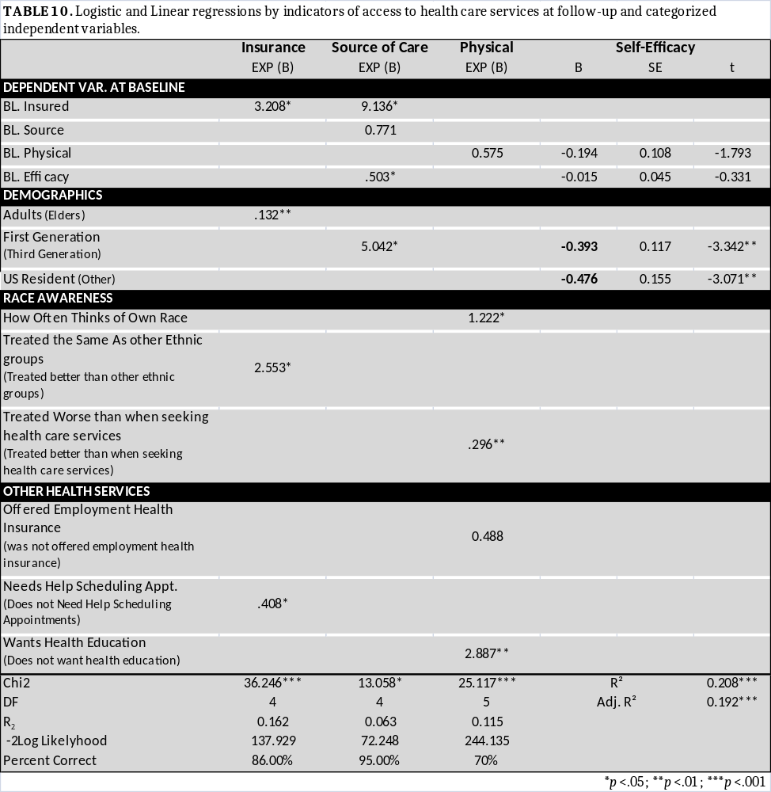

Promotoras’ Reports and Outcome Measures
The research group selected a smaller sub-sample of 87 participants according to their corresponding eighty-seven detailed Promotora tracking sheets. Since tracking sheets were primarily used by Promotoras to document their follow-up calls, most Promotoras only tracked the required one call, even when they had continuous contact with participants. The eighty-seven of the 313 tracking sheets considered for this analysis had thorough information regarding each contact made by Promotoras. There were no statistically significant differences between the Promotoras or the participants used in these sub-analyses and the full sample. The Promotoras’ notes were carefully analyzed and coded into seven intervention process measures:
1) Number of contacts (calls or visits),
2) Number of sites participants were referred to,
3) Type of contact (calls or calls & visits),
4) Person assisted by Promotora (participant only, family only, or both),
5) Barriers experienced by participants during the process (yes, no),
6), Barriers experienced by the Promotoras such as during the process (yes, no), and
7) Additional help such as filling out forms and making phone calls on behalf of participants (yes, no).
Two analyses showed the relationship and the influence of the intervention measures on access indicators. Table 11A shows the relationship between dependent variables at follow-up with the seven intervention process measures. When analyzed for relationships with indicators of health care access at follow-up, three of the intervention measures were associated. Respondent source of care status at follow-up was associated with barriers experienced by Promotoras during the process. Receipt of physical at follow-up was associated with the measure “person assisted,” which refers to the person assisted by the Promotora. Nearly half of participants (45%) had been the only ones assisted by the Promotora in their families. Furthermore, a large majority of participants that did not receive a physical (79%) were those whose family had also been assisted by the Promotora. Finally, the self-efficacy of participants at follow-up showed a relationship with the number of participant referral sites. Those who received more referrals by the Promotoras felt less efficacious at follow-up. Insurance status at follow-up was not associated with any of the intervention measures.

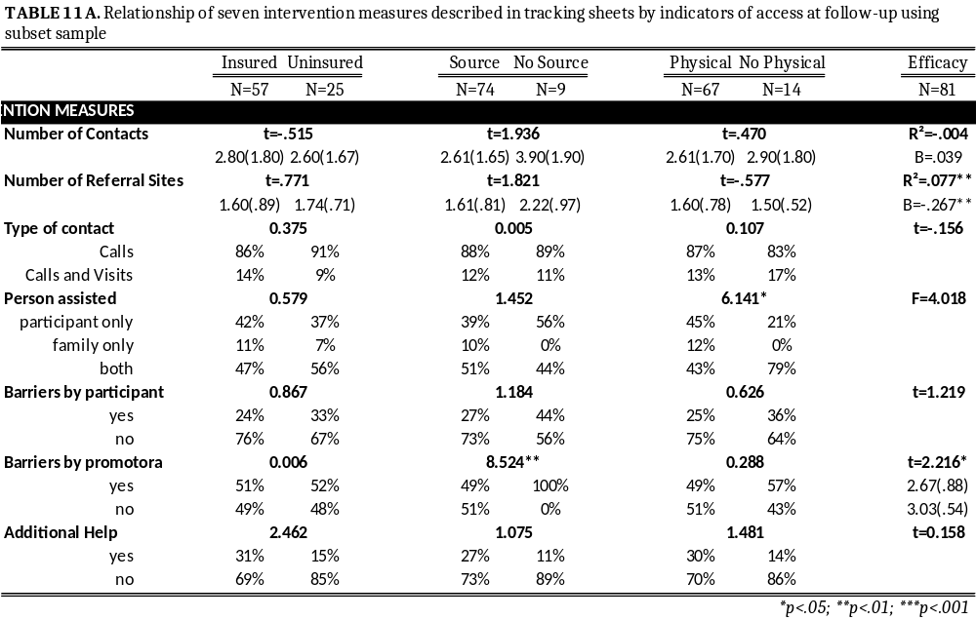
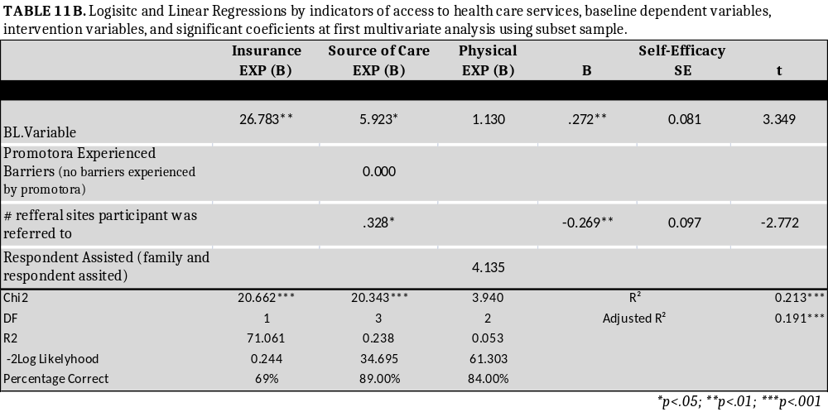
The second analysis with the sub-sample (Table 11B), analyzed the influence of intervention covariates on indicators’ change from baseline to follow-up. While insurance status and physical were not significantly influenced by the intervention measures, an increase in the number of referral sites significantly decreased the odds of having a source of care at follow-up by 67%. Likewise, for every additional site participant was referred to their self-efficacy decreased (B=-0.269**).
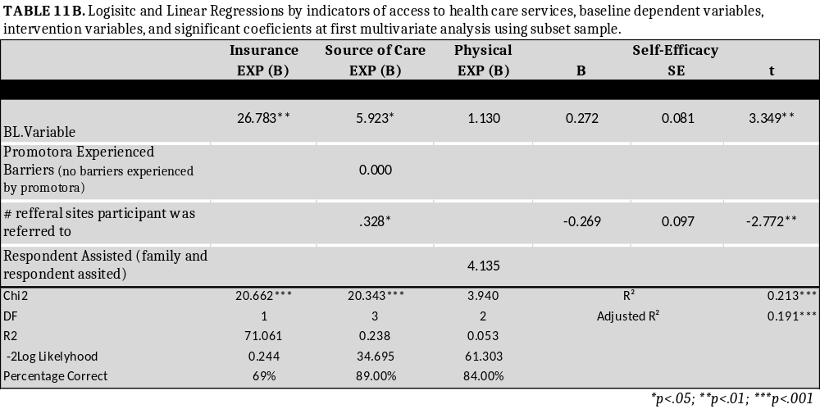
Summary of Outcome Measures
Findings suggest that Promotora intervention in addition to other measures influenced change on participant access to health care services. Every outcome measure (insurance status, source of care, receipt of physical, and self-efficacy) improved after the three-month Promotora intervention. However, there were also strong relationships between indicators and demographics, race awareness, health services, and the intensity of the intervention Promotoras gave to participants. A multivariate analysis demonstrated that change on indicators from baseline to follow-up was reliant on measures additional to Promotoras’ assistance. Participants’ insurance status at follow-up also depended on their age, race treatment in general and needing assistance scheduling appointments. Depending on the participant generation status, participants were more or less likely to have a source of care by follow-up. Promotora intervention affected the likelihood of having a physical. Receipt of a physical was also influenced by the number of times participants think about their own race, by the treatment participants receive when seeking health care services and by whether or not they want health education. Finally, level of self-efficacy was dependent on their immigration generation and immigration status, as well as the number of referral sites.
PROGAM IMPLEMENTATION
Interview Design
To evaluate the study’s implementation, a series of qualitative interviews with participating community health workers was conducted. The interview guide included 29-open ended questions, divided into three main sections: Process, Clients, and Promotora’s Role. The first section, Process, included questions specific to Promotoras’ experience with the intervention design and covered the topics of training, forms (surveys, consent form, tracking sheet), recruitment, resource manual, and follow-up. Eight questions in the Clients section were designed to capture Promotoras’ perspective on the participants’ barriers and their response to the Promotoras’ intervention when accessing health care services. The third section, Promotora’s Role, provided Promotoras with an opportunity to evaluate the negative and positive aspects of their position. A bilingual, culturally competent research assistant translated and transcribed the questionnaire from English to Spanish.
Recruitment and Implementation
Eight Promotoras from our original group of thirteen that participated in the study were recruited for the interviews. Seven of the eight participating Promotoras were bilingual in English and Spanish and one was bilingual in Spanish and Mixteco (Indigenous Mexican dialect). The eight Promotoras participated in the study’s implementation from beginning to end. . Lack of time and personal situations were the main reasons given by the five remaining Promotoras for not participating in the interviews.
A bilingual, culturally competent interviewer conducted separate interviews with the eight recruited Promotoras. In an effort to reduce a biased evaluation, the interviewer was not involved at any point with the study’s design. Additionally, an office at the Central Valley Health Policy Institute was the most appropriate venue to conduct the interviews as it offered the necessary characteristics to avoid biased responses and to secure confidentiality. During each interview, Promotoras were informed of the interview’s purpose and consented for their testimonials to be tape recorded by the interviewer. Based on Promotoras’ preferences, seven of the eight interviews were conducted in Spanish and each took from 1.5 to 2 hours. Upon completion, Promotoras received a $50 gift card for their time.
Analysis
After transcribing and translating the Promotoras’ tape recorded testimonies, their responses were carefully analyzed and categorized into common themes. The analysis was not focused on particular questions instead we identified key words within comments made by Promotoras throughout their responses to the 29-question survey. Key words were the basis for combining Promotoras’ comments into main themes. Finally we were able to separate the themes into the three categories: process evaluation, respondents’ barriers (from Promotora’s perspective) and Promotora’s impact. To maintain Promotoras’ confidentiality, the comments assigned to each category were not identified with their names, rather with the word “Promotora” followed by a number from 1 to 8.

Results
Process Evaluation
Promotoras major concern with assisting participants in meeting their needs influenced their evaluation of the process, both positively and negatively. The process was designed so that the Promotoras had responsibilities in two areas: research and service. Tools such as training, resource manual, tracking sheets and staff assistance were provided to assist Promotoras in achieving research and service. Promotoras suggestions on the tools were considered prior to, during, and after the training. Promotoras reviewed all training materials and plans prior to the training and their input was incorporated. However, when interviewed, Promotoras expressed favorable assessments of the service component of their project experience and unfavorable assessments of the research component of their project experience. Throughout their responses to the 29 questions, there was a clear pattern: Promotoras favorably evaluated any aspects of the study that facilitated their service, while unfavorably evaluated those aspects of the study that challenged or did not contribute to their service. The following model describes Promotoras’ evaluation of the process:
Figure 1: PROCESS EVALUATION
PROMOTORAS’ EMPHASIS ON SERVICE

Favorable Evaluation

Unfavorable Evaluation

Emphasis on Service
“Cuando te involucras con una comunidad para ayudarlos a conseguir servicios, no puedes decir solamente acepto una llamada tuya o solamente te voy a llamar una vez porque las cosas no son así.” Promotora 2
“When you get involved with a community to assist them in receiving health services, you cannot tell them ‘I can only accept one call from you or I will only call you once” because things are not that way.” Promotora 2

When asked about their favorite part of the study, Promotoras answered the following:

“Me siento orgullosa porque me encanta ayudar a la gente…yo pude hacer algo por mi y por alguien mas.” Promotora 1
“I feel proud because I love to help people…I was able to do something for myself and for other people.” Promotora 1

“Mi parte favorita es conocer gente, o ayudarles a saber que hay servicios.” Promotora 2
“My favorite part is to meet people, or helping them know about services.” Promotora 2

“Este proyecto me dio la oportunidad de ayudarles y conectarlos con servicios.” Promotora 3
“This project gave me the opportunity to help them (participants) and to connect them with services.” Promotora 3

“Fue positivo más que nada el haber podido ayudar a mis clientas.” Promotora 4
“Mainly, it was positive to help my clients.” Promotora 4

“Me gusto porque puedo comunicarme con varias personas, pude ver las necesidades de cada persona y sé que pude ayudarlas” Promotora 5
“I liked it because I was able to communicate with many people, I was able to see the needs of each person and I know I was able to help them.” Promotora 5

“Las personas que yo ayude…no sabían la información, no sabían que había ayudas en Fresno porque ellos viven en areas aisladas.” Promotora 6
“People I helped…they did not have information, did not know there is help in Fresno because they live in isolated areas.” Promotora 6

“La parte positive seria que como Promotora yo di un servicio a personas que no hubiesen podido encontrar ese servicio por sí mismos.” Promotora 7
“The positive part would be, as a Promotora I was providing a service to a person that would not found that service on their own.” Promotora 7

“Poder ayudar a la gente, sentir que soy útil, que puedo hacer algo por ellos.”
Promotora 8
“Being able to help people, feeling useful, feeling that I can do something for them.” Promtora 8

Promotoras evaluation of the process was divided into favorable and unfavorable. The favorable components of the process, based on the Promotoras’ perspective, were those directly related to the service component. Promotoras constantly mentioned their appreciation for information that facilitated their intervention with Latino participants. Some of this information included training on health insurance plans, receiving a Resource Manual, and having staff assistance when they needed to locate additional services. On the other hand, Promotoras unfavorably evaluated any aspects of the study that challenge their service to the respondents. They stated that the training on the implementation of the survey and the survey design itself was unclear and represented a challenge during their intervention.

Favorable
“El entrenamiento nos dio una base sobre seguros de salud.” Promotora 7
“The training provided base information about health coverage.” Promotora 7

“Nos explicaron muy bien la diferencia de los seguros médicos.”Promotora 4
“They explained very well the difference in health insurance plans.” Promotora 4

“La información que me dieron, por ejemplo el binder que me dieron con la información…El tener varios contactos me hizo el trabajo más fácil.” Promotora 3
“The information they gave me, for example the binder they gave me with the information…having many contacts made my job easier.” Promotora 3

“El tracking sheet uno tenía que estar apuntando cuando les llamaba y eso me ayudaba a ser más profesional.” Promotora 1
“The tracking sheet, one had to be jotting notes when we called and that helped me be more professional.” Promotora 1

“También Alicia (Coordinadora del Proyecto) me hizo el trabajo más fácil…ella me ayudaba a encontrar más recursos.” Promotora 3
“Also Alicia (Project Coordinator) made my job easier…she would help me find more resources.” Promotora 3

Unfavorable
“Si en el entrenamiento se nos dice cual es el objetivo y nos dicen que es lo que quieren en esa encuesta, dejarnos tener una simple conversación con el cliente. Eso es una de las cosas que no entendíamos bien, el objetivo de las preguntas.” Promotora 3
“If during the training they would have told us what the objective was and they tell us what they want in the survey, let us have a simple conversation with the client. That was one of the things we didn’t understand well, the objective of the questions.” Promotora 3

“Me falto mas entrenamiento. En lo personal, me hubiera haber gustado tener más entrenamiento. En el aspecto de informarle a la gente.” Promotora 1
“I needed more training. Personally, I would’ve liked to have more training as far as informing people.” Promotora 1

“A mí se me hizo muy difícil llevar el tracking sheet. Yo siempre veo a la gente. Yo a todas horas me los encontraba y les preguntaba cómo les iba. Ese era mi follo-up con la gente.” Promotora 5
“It was difficult to me to fill-out the tracking sheet. I always saw people (participants). I would talk to them often and would ask for their progress. This was my follow-up with them.” Promotora 5

“(Encuestas) Estuvieron mal para el servicio que queríamos dar. Para cuestión del estudio tampoco se capto la información porque no había una pregunta que captara sus problemas o que hiciera que se abrieran mas.” Promotora 2
“(Surveys) were not good for the service we wanted to provide. They were not good for the study either because there was not a question that would capture their problems or that would make them open up more.” Promotora2

“Más tiempo hubiera sido mejor. Más tiempo para haber hecho más, por ejemplo en vez de hablarles (a los participantes) haber ido a visitarlos.” Promotora 4
“More time would have been favorable. More time to do more, for example, instead of calling them [participants] to have visited them.” Promotora 4

Respondents’ Barriers
A second category was created gathering examples of barriers experienced by participants according to the perspectives of Promotoras. Based on their intervention and direct contact with Latino participants seeking health care services, Promotoras were able to observe and comment on the barriers participants faced when seeking health care services. The survey data at baseline and follow-up often did not capture the full breadth of participant barriers. When interviewed, the eight Promotoras shared their account of these barriers as they continuously referred to them in their responses to the 29 questions. There were five common barriers categorized into two main themes: 1) System Barriers and 2) Personal Attitude Barriers. Figure 2 shows the respondents’ barriers based on the accounts of the Promotoras.

Figure 2: RESPONDENTS’ BARRIERS

SYSTEM
BARRIERS
PERSONAL
ATTITUDE BARRIERS

Eligibility
Poor Service
Language
Lack
of Trust
Reluctance to Follow-up

System Barriers
Participants’ barriers included those directly experienced with the health care system: eligibility, language, and poor service. Eligibility barriers included all comments made by Promotoras describing participants’ difficulties with health insurance eligibility’s requirements and the application process. Language barriers referred to the Promotoras’ description of participants’ experiencing limited or poor quality translation services offered at health care facilities. The third barrier, poor service, consisted of the participant experience with poor quality customer service as observed by Promotoras. The following are some direct quotes from the Promotoras:

Eligibility
“Yo pienso que si cambiaran los requisitos…porque por un dolar no califican en un lado y por ese mismo dolar estas muy alto. Entonces yo pienso que si modificaran los requisitos podría calificar más personas.” Promotora 1
“I think that if they would change the requirements… because for one dollar they are not eligible at one place and for that same dollar they are too high. So I think that if they would modify the requirements, more people would qualify.” Promotora 1

“Era falta de información, se les cierran los casos muy pronto. O muchos se quejan porque piden muchos requisitos y para las personas es muy difícil conseguir la información que se les pide.” Promotora 2
“It was lack of information; their cases are discontinued too soon. A lot of them complain because too many requirements and for the people it is very difficult to gather the required information.” Promotora 2

“Creo que las experiencias negativas tuvieron que ver, pero pienso que por otra parte ellos simplemente no eran elegibles.” Promotora 7
“I think may be the negative experiences played a part, but I think the other part too in some cases they weren’t just eligible.” Promotora 7

Language
“Me decían, ‘No voy porque no entiendo el idioma’.” Promotora 3
“They would tell me, ‘I don’t go because I don’t understand the language’.” Promotora 3

“Me dijeron, ‘Las personas que me estaban ayudando ahí, me aventaron el papel y me dijeron que si quería aplicar que buscara quien me tradujera’.” Promotora 5
“They (respondents) told me, “The persons that were helping me there threw the paper at me and told me that if I wanted to apply to look for someone who could translate.” Promotora 5

“…los que traducen no son personas preparadas y al contrario, confunden mas al paciente.” Promotora 8
“…the ones that translate are not trained, and on the contrary, they confuse the patient even more.” Promotora 8
Poor/Rude Service
“Yo creo que el sistema es tan complicado que intimida a la persona o el primer trato que se les da. Se intimidan y ya no preguntan a nadie más.” Promotora 4
“I think the system is so complicated that it intimidates the person on the first treatment they get. They are intimidated and don’t ask questions to anyone else.” Promotora 4

“Las trabajadoras sociales solo hacen las preguntas pero no son nada cordiales.” Promotora 1
“Case workers only ask questions, but are not nice at all.” Promotora 1

“…escuche mucho, ‘no me siento a gusto’ ‘no entiendo o el doctor no me entiende’” Promotora 7
“…I heard a lot ‘I don’t feel comfortable’ ‘I don’t really understand or the doctor doesn’t understand me’.” Promotora 7

Personal Attitude Barriers
A second set of barriers respondents faced when seeking health care services were lack of trust and reluctance to follow-up. These were classified as barriers because they can play an important part on whether a participant seeks or receives health care services. It is important to mention that Personal Attitude Barriers were derived from System Barriers. For Lack of trust, Promotoras described the negative attitude participants developed after experiencing any of the System Barriers. In addition, Reluctance to Follow-up captured various accounts by Promotoras on participant reluctance to seek services or follow through because of having experienced System Barriers.
Lack of Trust
“Si esta persona (participante) ve a alguien de tras de un escritorio o en la clínica, lo ven a otro nivel y se intimidan” Promotora 3
“If this person (participant) sees someone behind a desk at the clinic, they see him/her at another level and feel intimidated.” Promotora 3

“No llaman a Medi-Cal porque no le tienen confianza o en ocasiones las trabajadoras sociales no respetan mucho a la persona.” Promotora 6
“They don’t call Medi-Cal because they don’t have trust or in other occasions the case workers don’t respect people.” Promotora 6

“Me sentí triste, frustrada en ese aspecto, ver qué miedo le tienen al sistema es triste.” Promotora 8
“I felt sad, frustrated in that aspect, to see they are scared of the system is sad.” Promotora 8

Reluctance to Follow-up
“Desgraciadamente con los problemas de Medi-Cal, dejan de aplicar, dejan de ir a sus citas por falta de comunicación con Medi-Cal.” Promotora 6
“Unfortunately with Medi-Cal’s problems, they stop applying, they stop going to their appointments because of lack of communication with Medi-Cal.” Promotora 6

“El Latino piensa que porque no nació aquí en este país, no es su tierra. Cuando vienen aquí, van a agarrar algún servicio y aunque lo van a pagar se sienten intimidados. Como que no tienen el derecho de recibir este servicio. Tiene que ver con el hecho de que no son de aquí, pero también tiene que ver con el hecho de que los traten mal.” Promotora 3
“The Latino thinks that because they were not born here in this country, it is not their nation. When they (Latinos) come here, they go get a certain service and even though they are paying for these services, they feel intimidated. As if they don’t have the right to receive this service. It has to do with the fact that they are not from here (U.S.A), but it also has to do with the fact that they are treated badly.” Promotora 3

“Para aquellos que sienten la presión del sistema, creo que eso realmente hizo que ellos no buscaran servicios de salud.” Promotora 7
“For those that feel an external system pressure of the system was ingrained- I think this really kept them from seeking health care services.” Promotora 7

Promotora Role and Impact
A third category derived from the interviews describes “Promotora Role and Impact (Figure 3).” Their continuous communication with Latino respondents throughout the study allowed them to recognize the skills needed to better asses their needs. During the interviews, Promotora accounts constantly emphasized the uniqueness of their intervention and the positive impact this had on Latino participants. Promotora comments describing the characteristics of their intervention were identified as “Promotora Contributions.” Since comments describing the impact of their intervention were positive and reported a change in the participant behavior, we labeled the impact aspect as “Positive Change in Attitude.” The following graph illustrates the findings under the “Promotoras’ Role and Impact” category:

Figure 3: PROMOTORAS’ ROLE AND IMPACT
PROMOTORA CONTRIBUTIONS
POSITIVE CHANGE IN ATTITUDE

Identification
Availability
Time

Promotoras Contributions
The Pomotores’ accounts on the of their interventions with Latino participants were characterized by three factors: 3) Identification, 2) Availability, and 3) Time. At several points during the interviews, Promotoras accredited part of their success in assisting Latino participants to a sense of Identification, which is not based solely on being Latino, but also being similar to participants in cultural, economic, and educational backgrounds. A second, Availability, refers to the importance of making participants feel supported when seeking health care services. A third area where the Promotoras’ descriptions agreed upon was the need for more Time to achieve a successful intervention. Promotoras went over their 100 hour allotted intervention time for the benefit of participants. These are some comments on the three main contributions claimed by Promotoras:
Identification
“…no el hecho de ser Latina si no de ser de la comunidad que ha tenido los mismos problemas que yo. Que saben que soy de la comunidad, me conocen y confían en mí.” Promotora 2
“…not so much being Latina, but being from the same community and have had the same problems as me. They know I’m from the community, they know me and trust me.” Promotora 2

“…venimos de donde mismo, de las mismas costumbres, mismas raíces. Es más fácil que las personas se abran más contigo.” Promotora 4
“…we come from the same place, the same customs, and same roots. It is easier for people to open up with you.” Promotora 4

“(participants) dicen, ‘tenemos las mismas raíces, sufrimos lo mismo,’ saben de dónde venimos y hay más credibilidad de que les vamos a ayudar….y nosotros sabemos eso porque hemos vivido esas cosas.” Promotora 6
“(participants) say, ‘we have the same roots, we suffer the same,’ they know where we come from and there is more credibility in that we will help them… and we know that because we have lived the same things.” Promotora 6

Availability
“Yo me he dado cuenta que la gente necesita apoyo y que sepan que tu estas ahí para ayudarlos con cualquier pregunta cuándo van al doctor, a llenar papeles. El apoyo, el sentir a la Promotora ahí les da más confianza.” Promotora 1
“I’ve noticed that people need assistance and need to know that you are there for them to assist them with any questions when they go to the doctor, to fill out papers. The support, feeling that the Promotora is there gives them more confidence.” Promotora 1

“Ellos ven que pueden hacerlo por ellos solos, pero necesitan la ayuda de alguien en quien ellos tengan confianza para decirles se hace así. “ Promotora 2
“They see they can do it for themselves, but they need the assistance from someone they trust to tell them this is how to do it.” Promotora 2

“No es suficiente para decirle, ‘vaya usted,’ nosotros sabemos que ellos tendrán problemas, pero estamos ahí disponibles para contestar sus preguntas.” Promotora 8
“It’s not enough to tell them, ‘go yourself,’ we know they’ll face issues, but we are available to answer their questions.” Promotora 8

Time
“Claro que yo no hice específicamente paso por paso, pero si me pase de mis responsabilidades para ayudar a la persona.” Promotora 1
“Of course I did not do everything step by step specifically; but I did go over my responsibilities to assist the person.” Promotora 1

“100 horas no son suficientes, hicimos más que eso por la necesidad de la familia, no la del trabajo.” Promotora 3
“100 hours is not enough, we did more than that because of the family needs, not because of the job.” Promotora 3

“Una Promotora se sienta, le explica, tiene tiempo de informarles que está pasando con el cliente y llegar en detalle al problema como podemos solucionarlo. Las case workers no tienen ese tiempo y no lo van a hacer.” Promotora 6
“A Promotora sits down, explains is to them, and takes the time to inform them of what is going on with the client and gets to the details of the problem and how to solve it. Case workers don’t have the time and will not do it.” Promotora 6

Positive Impact
Finally, Promotoras reported seeing a change in the attitude of their participants after their intervention. At the final phase of the study, Promotoras perceived participants as more self-efficacious, as is also evident in the quantitative data (Table 9A). The following quotes are examples of Promotoras’ observation of change in the attitude of their participants:
Change in Attitude
“Eso los hizo más seguros, el hecho de poderles dar esa seguridad en caso de una pregunta uno puede ayudarles.” Promotora 1
“That made them more confident, the fact that we were able to give them a sense of security in case they had a question.” Promotora 1

“El hecho de tener alguien ahí los cambio.” Promotora 2
“The fact they had someone there changed them.” Promotora 2

“Más confiados, la misma practica los hizo seguir en el camino.” Promotora 3
“More confident, the same practice made them follow the path.” Promotora 3

“… al final eran más confiados en hablar con el doctor, en preguntar.” Promotora 4
“…in the end they were more confident when talking to the doctor, asking questions.” Promotora 4

“La gente por fin dijo, ‘si es posible poder hacer algo’…cuando lo hacen agarran más confianza.” Promotora 6
“People finally said, ‘it is possible to do something’…when they do it, they become more confident.” Promotora 6

“La persona se siente valorada, se siente que hay gente que les importa, que no los dejamos solos...” Promotora 5
“The person feels valued; they feel there are people who care about them, that we don’t leave them alone...” Promotora 5

Summary of Program Implementation
The Promotora experience of witnessing participant barriers when seeking health care services influenced their performance and evaluation of the process. The study was designed to measure the impact on participants’ access to health care services of a limited Promotora intervention within completion of about 5 hours of follow-up activity for each client over the three month period. Promotoras went beyond their responsibilities by being available to the participants at all times and by volunteering more time, more phone calls, and mileage than required. As previously mentioned, participants barriers lie primarily at the system level, which shaped personal attitudes thus preventing them from seeking or receiving services. Through their contributions, Promotoras provided a unique service to overcome the system barriers and influence a change in participant attitudes and receipt of services. Analyzing the experiences of Promotoras on the implementation of the project, allows for a clearer understanding of their role on the process.

CHAPTER 5
DISCUSSION
The findings of this pilot research project demonstrate the effectiveness of utilizing Promotoras in a new and emerging role such as agents in improving health care access for low-income Latinos in the Central Valley. The personalized service and availability of the Promotoras resulted in a significant improvement of main outcome indicators from baseline to follow-up. Similar cultural background, language, and economic struggles made their clients feel comfortable, establishing a trusting relationship between the client and Promotora, according to the Promotora accounts. The Promotoras listened to their clients’ needs and provided them with continuous assistance as they navigated the complex health care system to implement the health care access plan developed between both.
Project Impact on Study Population:
- Significant improvement in self-efficacy from baseline to follow-up
The Promotora intervention had an effect on participants’ behavior in accessing health care services. Participants learned where to enroll in a health insurance plan, how to establish a usual source of care, and where to receive preventive care services.
- Increase in the number of participants who had a usual source of care from baseline to follow-up
The Resource Manual helped Promotoras identify a usual source of care for the large percentage of participants who lacked one at baseline. The guide provided a list of accessible community health centers. However, transportation was a deterrent in accessing services for participants who lived outside of the public transportation service area. Promotoras
- Insurance status among participants improved substantially from baseline to follow-up
The Promotoras simplified the process of enrollment in a health insurance program by explaining the eligibility requirements in a basic and culturally appropriate manner, by offering translation assistance, and helping them complete insurance enrollment application forms.
- Receipt of preventive care (physical) significantly increased from baseline to follow-up among participants
The Promotoras emphasized prevention, which contributed to participants receiving a physical exam or regular check-up by follow-up. These findings demonstrate the positive impact Promotoras can make in empowering their clients to obtain timely preventive care services before chronic conditions and other illnesses develop. This can lead towards improving health outcomes for low-income Latinos both in the Central Valley and other densely Latino populated regions.
Challenges to Project Implementation
The dedication and commitment played an important role in motivating participants to take action in accessing health care services as well as in improving main outcome indicators. The Resource Manual that contained specific contact information to various health and social agencies was a tremendous strength for Promotoras. However, Promotora training did not fully prepare them to perform the assigned tasks in the ‘real world’. Additional coaching and supervision for Promotoras was needed to reinforce proper data collection as well as in completing the forms to ensure inter-rater reliability. Limited fiscal resources made it difficult to reimburse Promotora mileage to perform outreach in rural communities, who have less access to health care services. Challenges ensuring data quantity and quality were difficult, as many Promotoras did not document each contact and follow-up made on the Participant Tracking Sheet. The lack of careful recruitment and selection of Promotoras to ensure they were able to administer the interviews and correctly complete the data collection tools was a limitation that resulted in an underestimated number of contacts made per client.
Effectiveness of Project Management and Workflow
The role of the Promotora in improving health care access is imperative for low-income, limited English proficient Latino communities. Promotoras break down a multitude of barriers, which can lead to a better quality of life for this population. Promotoras have proven to be effective in increasing access to care in underserved and hard to reach populations because of their culturally competent and personalized service approach.
Replicating this intervention at low-cost requires a supply of experienced Promotoras and a bilingual/bicultural program coordinator. Finding a consistent source of funding for these services is a major challenge. Reimbursements to safety net providers in California are not adequate for them to support Promotoras in access and enhancement roles. Replication projects may need to rely on philanthropic dollars until state and national policies recognize the need among populations with difficult health care access. Replication projects must recognize the potential for a disconnect between the service and data collection roles of Promotoras and should devote adequate resources to training and ongoing supervision of data collection activities. We underestimated the Promotoras’ research role and focused more on the service than was necessary. Planning sufficient time for ensuring full completion of tracking data collection is necessary during implementation. Future projects also need to emphasize the importance of process documentation by Promotoras.

Public Health and Policy Implication
The existing and complex health care delivery system can benefit tremendously from the use of Promotoras because of their primary prevention approach that can increase the use of preventive care services and reduce the costs for the treatment of chronic conditions. Reimbursing the work of Promotoras through California’s Medicaid program as in the Minnesota CHW Project can lead to reducing health care delivery system costs. Future research is necessary to quantify exactly how much time and resources are actually needed to train Promotoras to fulfill this imperative innovative health care access advocacy role as well as the impact in reducing health care costs.
Implications for Health Services Research Capacity Building
Our experience in this pilot project taught us that training Promotoras on the applicability of research and delivery in the ‘real world’ must be provided from the beginning. The participating Promotoras should be involved in each step of the planning and implementation processes. Specifically, they should engage in the design process of data collection tools. In addition, the work of a Promotora can be difficult and emotionally taxing, thus, ongoing guidance and supervision from the project coordinator, is necessary to ensure that Promotoras feel supported and encouraged.
Importance of the Study
Community health workers providing information and coaching services to populations that are heavily underserved and are plagued with economic, language, and cultural barriers is the missing piece in the larger framework to reduce health disparities in the United States. Targeting such populations and providing these services in relation with accessing health care and navigating the complex system in their local vicinity is a unique strategy that when applied to the Central Valley, Promotoras are perhaps some of the few people that are capable of outlining this process to the population. The study allowed a deeper look into some of the larger systematic barriers that people face when seeking health care like stringent eligibility requirements and poor service, both of which need to be looked at seriously when crafting any programming aimed at the underserved. In summary, the study provided a unique curriculum and was carried out with one of the fastest growing populations in the United States.

CHAPTER 6
INFORMATION DISSEMINATION
The projects involving community health workers to improve access are few, but the results from those and this study are encouraging to continue the work. Furthermore, the ability to carry out a project with a vulnerable population in the Central Valley demonstrates the need for such projects in this locale as well as the potential effectiveness with Spanish-speaking participants. Numerous opportunities are presented to work with this population to improve their health outcomes, but disseminating this work widely within the community and beyond will help frame the prospects of community-based work differently. Dissemination will allow researchers, providers, and policymakers to see the impact a Promotora model can have on battling system barriers and improving healthcare access with the hope of reaching better health outcomes in the future.
The writers and collaborators in this project will disseminate the information in four different ways. First, we have developed community friendly executive summaries, in English and Spanish, of the CMS-funded project and a follow-up study exploring a similar service for undocumented Latinos in Fresno. The findings from both studies will be discussed in a press conference which will be two-fold: invite the Promotoras to see the results of the projects and let the community know about the value of Promotoras and future directions. Next, we are writing an article to submit for peer review titled “Effective Promotora Interventions to Increase Health Care Access to Latinos: Challenges Persist for Latino Immigrants.” The article will highlight Latino healthcare access inequities in the Central Valley, policy barriers preventing immigrants and legal non-citizens from receiving care, and the capability of Promotoras to ameliorate the situation through their unique personalized intervention. To date, the Central Valley Health Policy Institute receives calls from various research institutes, community health providers, among others wanting to learn more about the Promotoras studies used to increase access.

CHAPTER 7
Recommendations for Future Studies
Findings point the success of Promotora interventions for improving health care access to low-income, limited English proficient Latino communities. The five key factors to this intervention were the Promotora model, Promotora training and guidance, the resource manual, proper survey instruments, and Promotora tracking sheets. Future studies on increasing healthcare access to this population should use people from within the communities to administer the intervention, as this brings a higher level of comfort level for participants and makes the community member, or Promotora, feel engaged and with an increased knowledge. The other four key factors benefited from polishing in an extension project we undertook using the same model.
The work of a Promotora can be difficult and emotionally taxing. Training the Promotoras should be two-fold. While understanding the role of a community member engaging their counterparts in an intervention is important, so is their understanding of their role as data collectors. Ongoing guidance and supervision from the project coordinator is necessary to ensure that Promotoras feel supported and encouraged, questions about the survey instrument are answered, and issues are noted for future studies. Training and ongoing guidance in the extension project was more extensive to emphasize the importance of quality data collection. Making the connection between data collection and program success is vital so Promotoras feel invested in collecting the most accurate information possible.
The resource manual was a unique tool that Promotoras used to connect participants with resources to increase their access to healthcare services. A resource manual tailored to the locality, with contact information of specific staff members, gives Promotoras the motivation to intervene when needed and the possibility for participants to feel they have an ally in an office they have found intimidating in the past. Likewise, perfecting the survey instrument and tracking sheets helps Promotoras properly assess the needs of the participants and connect them with the proper services. Future studies should ensure that instruments properly assess healthcare access needs and that Promotoras know very well how to use these instruments as assessment tools.
Making the case for effective methods of reducing healthcare disparities by increasing healthcare access requires properly executed intervention research. Finding the most effective and efficient intervention can make the case for institutionalizing the Promotora model. These models already exist in the public health sectors of other countries. Future studies piloting institutionalization should look to those models for best practices while learning the lessons of past research with the targeted population.
REFERENCES
Andrews, J.O, Felton, G, Wewers, M.E, Heath, J. (2004). Use of community health workers in
research with ethnic minority women. Journal of Nurse Scholars, 36(4), 358-365

Riordan, D., Capitman, J.A. Central Valley Health Policy Institute. (2006). Health Professional
Shortages in the San Joaquin Valley: The impact on Federally Qualified Health Centers.
Available at http://www.csufresno.edu/ccchhs/documents/HPSReport-FinalCopy.pdf

Bengiamin, M., Capitman, J.A., Chang, X. (2007). Healthy People 2010: A 2007 profile of
health status in the San Joaquin Valley

Balcazar, H., Alvarado, M., Hollen, M.L., Gonzalez-Cruz, Y., Pedregón, V. Evaluation
of Salud Para Su Corazón (Health for Your Heart) – National Council of La Raza Promotora outreach program. Preventing Chronic Disease; 2(3), 1-9

Forster-Cox, S.C., Mangadu, T., Jacquez, B., Corona, A. (2007). The Effectiveness of the
Promotora (Community Health Worker) Model of Intervention for Improving Pesticide Safety in US/Mexico Border Homes. (California Journal of Health Promotion, Volume 5, Issue 1, 62-75

Staten, L.K., Scheu, L.L., Bronson, D., Peña, V., Elenes, J. (2005). Pasos Adelante: the
effectiveness of a community-based chronic disease prevention program. Preventing Chronic Disease, Vol. 2, Issue 1, 1-11. Available from: URL: http://www.cdc.gov/pcd/issues/2005/jan/04_0075.htm

Swider, S.M. (2002). Outcome effectiveness of community health workers: An integrative
literature review. Public Health Nurse; 19(1):11-20

Ro, M.J., Treadwell, H., Northridge, M. (2003). Community health workers and community
Voices: promoting good health [policy brief on the Internet]. Washington (DC): Community Voices. Available from URL: http://www.communityvoices.org

RAND California. (2005). Personal and Per Capita Personal Income Statistics. [Data Files]. Retrieved February 2009 from http://ca.rand.org/stats/economics/persincnaics.html

UCLA Center for Health Policy Research. (2007). California Health Interview Survey [Data Files]. Available from http://www.chis.ucla.edu


APPENDIX A: Participant Baseline Survey



participant survey

A Promotor(a) Health Education Model for Improving
Latino Health Access in California’s Central Valley

Date: ________________________________________________________________________________

Promotor(a)’s Name: ________________________________________ID:________________________

Participant Name: __________________________________________ ID:________________________

Participant Telephone_________________________ Message Telephone _________________________

Organization/Site: _____________________________________________________________________

Interview Address: _____________________________________________________________________

Informed Consent Completed and Signed [check mark] ________________________________________

You have been asked to participate in this study because you are a Latino adult who lives in _______ County.
Our goal is to help you obtain knowledge about health insurance programs that you may qualify for so that you and your family can have better access to medical care and age appropriate preventive services.
The information we collect from you for this study will be maintained in strict confidence. There will be no individual identifiable information in the final report.
Thank you for your participation.

Demographic Questions

- What is the gender of the participant? (Promotor(a) please check the correct box).
a) Male b) Female

- What is your date of birth? _______/_______/________
Month day year

- Please tell me the country of birth of: (indicate their country of birth).
a) You __________________b) Parents _____________________c) Grandparents _____________________

- Are you a U.S. Citizen, Legal Permanent Resident or Other? (Promotor(a) emphasizes that he/she is not from the Immigration and Naturalization Service INS and the next question is very important for our study and it will not affect your immigration situation. Your answer will help us determine which government/public sponsored health insurance programs you qualify for).
a) U.S. Citizen……………........ e) Refuse to answer………... (go to Question 5)
b) Permanent Legal Resident…. f) None of the above…….… (go to Question 5)
c) Tourist/VISA……………….. g) Other………………….… (go to Question 5)
d) Application pending………... Please indicate which
_____________________________________
- Is there another member in your household for whom you are responsible for who is a U.S. Citizen, Legal Permanent Resident or Other?
a) U.S. Citizen……………........ e) Refuse to answer………...
b) Permanent Legal Resident…. f) None of the above…….…
c) Tourist/VISA……………….. g) Other………………….…
d) Application pending………... Please indicate which
_____________________________________

- How many years have you lived in the U.S? _______ (number of years)

- How do other people classify you in this country? Would you say that you are….

a) White…………………………….
b) Black or African American……...
c) Hispanic or Latino……………….
d) Asian…………………………….
e) Native Hawaiian…………………

f) Other Pacific Islander……………..
g) American Indian………………….
h) Alaska Native….…………………
i) Some other group…………………
Please indicate which ____________________________

- How often do you think about your race or ethnic group? Would you say…..

a) Never………………..
b) Once a year…………
c) Once a month……….
d) Once a week………...
e) Once a day………….
f) Once every hour. …...
g) Constantly…………..

- Within the past year, have you felt that you were treated worse than, the same as, or better than people of other races or ethnic groups?
a) Worse than…………… b) The same as………….. c) Better than……………

- Within the past year when seeking health care, do you feel your experiences were worse than, the same as, or better than the experiences of people of other races or ethnic groups?
a) Worse than…………… b) The same as………….. c) Better than……………

- What is your civil status? (For instance, are you married, living with a partner in a married like relationship, widowed, divorced, separated, never married).

a) Married……………………
b) Living with partner in …....
a married like relationship
c) Widowed…………….........
d) Divorced……………...
e) Separated……………..
f) Never married………...

- What was the highest grade level that you passed?
a) Elementary School …………… d) Some college…………………..
b) Middle School ………………... e) None…………………………...
c) High School or Equivalent……. f) Other, indicate which one
__________________________________

- Have you been offered health insurance through your employer?

a) YES b) NO (go to Question 14) c) My job (i.e: gardener, house keeper)
doesn’t offer health insurance
13a) If YES, did you accept it? a) YES b) NO
13b) If you did not accept, can you please tell me why?
______________________________________________________________________________________
______________________________________________________________________________________
______________________________________________________________________________________

- Please tell me who are the people who actually live in your household, whether they are your dependents, and if they have health insurance coverage: (Dependents are people that you support financially, i.e. you buy them food, clothes, and living expenses, etc. Due to the limitations of our study, only documented individuals are qualified to use Medi-Cal, SCHIP and Medicare programs).

# | RELATIONSHIP  (daughter, son, niece, NEPHEW, uncle, grandparent, etc.) | DEPENDENT  (Yes/No) | AGE | GENDER  (M/F) | Health Insurance Coverage  (for example: Medi-Cal, Medicare, Healthy Families)
1
2
3
4
5
6
7
8
9
10

- Did you fill your IRS income taxes of 2006?
a) YES (Go to Question 16) b) NO (Go to Question 17)

- If you said YES, how much income did you report in your 2006 income tax form? (If Participant does not know exactly how much, Promotor(a) ask for an approximation). $__________________________

- Would you like to obtain more information about programs offered by the government? May I call you back? (Refer to Income Eligibility Card #1). a) YES b) NO

Questions About Your Health Care Source

- Have you had health insurance in the past year? a) YES (go to Q 19) b) NO (go to Q 20)

- If YES, are you covered by any of the following health insurance providers?

a) Medi-Cal………………………….
b) Medi-Cal with HMO………..…....
c) Medicare Original …………….
d) Medicare HMO or PPO…….…….

e) Private Health Insurance …………….
(i.e. Kaiser Permanente)
f) Other………………………………….
Please indicate which one: ____________________________________

- If NO, what do you do when you need medical care?

a) Pay out of pocket……………………..
b) Go to Hospital Emergency Room……
c) Go to Community Health Clinic……..
d) Alternative care (home remedies)……
e) Go to Sequoia Health Center…………

f) Don’t go anywhere…………………....
g) Other place…………………………....
Please indicate what do you do
________________________________________________________________________


If Participant is under age 65, please answer questions 21 to 25.

- Have you applied for Medi-Cal, MISP, or Private Health Insurance? (Refer to Card #2 de Medi-Cal, MISP for eligibility information).
a) YES (go to Question 24) b) NO (go to Question 22)

- Is there any reason that would keep you from applying for Medi-Cal?
a) YES (go to Question 23) b) NO (go to Question 25)

- Would you like to tell me more about it? ______________________________________________________________________________________________________________________________________________________________________________________________________________________________________________________________________________
__________________________________________________________________________________________

- If YES, and you have Medi-Cal, have you received any of the following covered Medi-Cal preventive services? (Refer to Medi-Cal Card #2 for details on services).
YES, when was the last time?
- Flu shot YES NO ____/____/______
- Hepatitis B vaccine YES NO ____/____/______
- Cholesterol screening YES NO ____/____/______
- Breast cancer screening (women only) YES NO ____/____/______
- Cervical cancer screening (women only) YES NO ____/____/______
- High blood pressure screening YES NO ____/____/______

- If NO, do you want me to help you with the enrollment process for Medi-Cal or MISP programs?
a) YES b) NO

If Participant is over age 64, please answer Questions 26 to 36. If not, go to Question 37.

- Medicare is a health insurance program for people age 65 or older, under age 65 with certain disabilities, and people of any age with End-Stage Renal Disease (permanent kidney failure requiring dialysis or a kidney transplant). At this time, are you covered by Medicare?
a) YES (go to Question 29) b) NO (go to Question 27)

- Is there anything that would prevent you from applying for Medicare? a) YES b) NO

- Would you like to tell me about it?
________________________________________________________________________________________________________________________________________________________________________________________________________________________________________________________________________________________________________________________________________________________________________

- If YES, is your Medicare coverage given through a managed health care organization? (Medicare through a managed care organization means your access to care is coordinated through your primary care provider (for example: doctor, nurse, etc.).
a) YES (go to Question 31) b) NO (go to Question 30)

- If NO, do you want me to help you with the enrollment process? a) YES b) NO

- What is the name of your Medicare managed care, PPO or PFF plan? (PPO = Preferred Provider Organization; PFF = Private Fee for Service) (Promotor(a) refer to Card #5 for more information on the types of plans and ask: “Can I please see your Medicare insurance card so I can verify your health plan name and number”).
a) Aetna Golden Medicare Premier Plan (H0523-034-0)..……………
b) Aetna Golden Medicare Value Plan (H0523-032-0)...……………..
c) Concert (H4577-014-0) ..…………………………………………..
d) Freedom Blue Plan I (R9943-001-0)...……………………………..
e) Freedom Blue Plan II (R9943-002-0)...…………………………….
f) Humana Gold Choice PFFS (H1804-272-0)...……………………...
g) Humana Gold Choice PFFS (H1804-274-0)...……………………...
h) Humana Gold Choice PFFS (H1804-276-0)...……………………...
i) Kaiser Permanente Senior Advantage (H0524-013-0).......................
j) Secure Horizons Medicare Complete Plan 1 (H0543-035-0)...……..
k) Secure Horizons Medicare Complete Plan 3 (H0543-125-0)...……..
l) Smart Value Plus (H5419-004-0)...…………………………..……..
m) Smart Value Enhanced Plus (H5419-009-0)...………………..…….
n) Summit (H4577-006-0)...……………………………………………
o) Today’s Options Premier Plus (H5421-045-0)……………………...
p) Today’s Options Value Plus (H5421-044-0)...……………………...
q) Other...................................................................……………………
Please write plan name and number_______________________________________

- Some people who are eligible for Medicare also have private health insurance that is sometimes called Medigap or Medicare Supplement. Do you have this type of health insurance? (Refer to Medicare Card #5 for more
details).
a) YES b) NO c) I don’t know

- Do you know if you are enrolled in Medicare Part A (Hospital), Part B (health insurance), Part A & B, Part D (Prescription Drug Coverage) or Part C (combines Part A, B and D)? (Refer to Medicare Card #5 for more details).

  - Part A
  - Part B
  - Part A and B
  - Part C
  - Part D
  - I don’t know

- If you are enrolled in Medicare, have you received any of the following covered Medicare preventive services? (Refer to Medicare Preventive Services Card #5 for details)
YES, when was the last time?
  - Flu shot YES NO
  - Pneumonia vaccine YES NO ____/_____/_____
  - Hepatitis B shot YES NO ____/_____/_____
  - Diabetes screening YES NO ____/_____/_____
  - Cardiovascular screenings YES NO ____/_____/_____
  - Bone mass measurements YES NO ____/_____/_____
  - Glaucoma testing YES NO ____/_____/_____
  - Breast cancer screening YES NO ____/_____/___
(women only)
  - Cervical cancer screening YES NO ____/_____/___
(women only)
  - Colon cancer screening YES NO ____/_____/_____
  - Prostate cancer screening YES NO ____/_____/_____
(men only)

- If you answered NO to any of these screenings, what has been the problem in receiving these services?
__________________________________________________________________________________________________________________________________________________________________________________________________________________________________________________________________

- Do you want help in accessing these Medicare covered preventive services?
a) YES b) NO

Questions about Your Child(ren)’s Health Care Source
(Please refer back to Question # 14 regarding their children’s health insurance coverage. If you do not have children go to Question # 45)
- If your child(ren) or grandchildren DO NOT have health insurance, what is the main reason?
a) Don’t know what they qualify for…….
b) Don’t know how to enroll them………
c) Other reason(s)………………. ………
Please indicate which one: ____________________________________________________________________________________________________________________________________________________________________________

- Do you need me to help you with the enrollment process for Medi-Cal, MISP or Healthy Families for your children or grandchildren? a) YES b) NO

- Have you had any of the following problems when looking for enrolling your children or grandchildren in health insurance? Please check ALL that apply.

a) Can’t afford to pay…………………….......
b) Don’t understand the health care system…
c) Lack of translation services……….……….
d) Inconvenient days or times………….…….
e) Cultural barriers……………………..……..
f) Don’t know where to go…………………...
g) Non Applicable..………………………..
h) Other reason(s) …………………….…...
Please indicate which one: _____________________________________________________________________________________________________________________

- When was the last time you took your child for an annual check-up or physical exam?
____/______/_________
Day month year

- Do you need help with arranging an appointment for an annual check-up or physical exam for your children?
a) YES b) NO

- Have your children received information from a doctor or other medical provider about how to grow up healthy? (For example: Has your child received education about healthy nutrition, violence prevention, exercise, sexually transmitted diseases (STDs), avoiding tobacco/alcohol/drug use, traffic safety).
a) YES b) NO c) SOME INFORMATION

- Do you want health education/disease prevention resources for your children?
a) YES b) NO

- Do you need help with obtaining immunization services for your children? (For example: Polio, Measles, Mumps, Rubella, Varicella, Hepatitis B, Pertussis and Flu Vaccines).
a) YES b) NO

Your Access to Health Care

- Is there a place that you USUALLY go to when you are sick or need advice about your health?
a) YES b) NO

- If NO, Please check ALL the reasons that apply?

a)Don’t know what I qualify for…….
b)Don’t know how to enroll…………
c) No health insurance…….………..
d) Lost health insurance………….......
e) Can’t afford to pay………………...
f) Don’t understand the health care
system ……………………….…….
h) Lack of transportation……………...
i) Lack of child care…………………..
j) Inconvenient days/times……………
k) Cultural barriers …………………...
l) Don’t need………..……………........
m) Don’t know………………………...
n) Other reason(s)…………………….

g) Lack of translation services……….. Please share with us your reason(s):
_______________________________________________________________________________________________________________________________________________________________________________________________________________________________________________________________________________________________________________________________________________________
- In the past 3 months, have YOU gone to the Hospital Emergency Room (ER) for medical treatment? Please tell me what happened. (Promotor(a), please note what respondent says. If needed, probe to find out:)
46a) Condition that lead you to ER visit? ________________________________________
46b) How many times did you go?
a) none………...
b) once………...
c) twice………..
d) three times.....
46c) What was the condition for your most recent visit: ________________________________________________________________________
46d) Did you go to the ER because you could not get care elsewhere or because of the seriousness of your condition? ________________________________________________________________

- In the past 3 months, has ANOTHER FAMILY MEMBER gone to the Hospital Emergency Room (ER) for medical treatment? Please tell me what happened. (Promotor(a), please note what participant says. If needed, probe to find out:)
47a) Condition that lead you to ER visit? ________________________________________
47b) How many times did you go ?
a) none…………
b) once…………
c) twice…………
d) three times......
47c) What was the condition for his/her most recent visit: ________________________________________________________________________________
47d) Did he/she go to ER because he/she could not go elsewhere or because of the seriousness of his/her condition? ________________________________________________________________

- When was the last time you received a check-up or physical exam in the past year?
____/________/_____
Day month year

- Do you need help with arranging an appointment for an annual check-up or physical exam for yourself?
a) YES b) NO

- Have you received counseling from a doctor or other medical provider about disease prevention and living healthy? (For example: education about healthy nutrition, exercise, tobacco prevention, or obesity prevention). a) YES b) NO c) SOME INFORMATION

- Do you want health education/disease prevention resources? (For example: preventing diabetes, high blood pressure, and information on cancer screening tests).
a) YES b) NO

- We have talked today about several different challenges accessing health insurance and health care that you and/or your family are facing. How would you rate the following statement: “I feel confident that I can solve my health care access problems.”
  - Strongly disagree…....
  - Disagree……….…….
  - Uncertain……….…...
  - Agree……….……….
  - Strongly agree………
If you have any questions, comments, or concerns about the study or to obtain a copy of the results, please contact one of the following researchers: Dr. Marlene Bengiamin or Dr. John A. Capitman at
(559) 228-2150. Thank you for your participation in this study.

APPENDIX B: Participant Follow-up Survey

follow-up interview
participant survey

A Promotor(a) Health Education Model for Improving
Latino Health Access in California’s Central Valley

Date: ______________________________________________________________

Promotor(a)’s Name: ____________________________________ID:__________

Participant Name: ______________________________________ID:___________

Participant Telephone ________________________Msg Tel._________________

Organization/Site: ___________________________________________________

Interview Address: ___________________________________________________

Informed Consent Completed and Signed [check mark] ______________________




PROMOTOR(A): The purpose of this follow-up interview is to learn more about the participant’s experiences in implementing the plan they have agreed upon. Before meeting with the participant, review your initial plan for this person which is indicated in the Participant Tracking Sheet. Then the Promotor(a) should go through PART I of the follow-up interview survey and mark the questions that are relevant to the plan you developed and only ask those. Ask all the questions in PART II for all participants.
The information we collect from you for this study will be maintained in strict confidence. There will be no individual identifiable information in the final report. Thank you for your participation.

PART I

- Promotor(a) ASK PARTICIPANT: Have there been any major changes in your family or household since we last met (probe for changes in who is living with participant. Probe for any changes in family well-being).
______________________________________________________________________________________________________________________________________________________________________________________________________________________________________________________________________________________________________________________________________________________________________________________________________________________________________________________________________________________________________________________________________________________________________________________________________________________________________________________

- Promotor(a) ASK PARTICIPANT: Have there been any major changes in your health or use of health care or in your family members’ health or use of health care since we last met? (probe for any changes in health insurance coverage, access to medical care, or health status).
________________________________________________________________________________________________________________________________________________________________________________________________________________________________________________________________________________________________________________________________________________________________________________________________________________________________________________________________________________________________________________________________________________________________________________________________________________________________________________________________________________________________________________________________________________

- Promotor(a): Did the plan include a referral to MEDI-CAL enrollment site?
a) YES ◻ b) NO ◻
If YES, Ask participant:
- Did you contact the Medi-Cal enrollment office? a) YES ◻ b) NO ◻
b. If no, please explain why:
________________________________________________________________________________________________________________________________________________________________________________________________________________________________________________________________________________________________________________________________________________________
- If yes, Did you complete an application? a) YES ◻ b) NO ◻
- If no, please explain why:
______________________________________________________________________________________________________________________________________________________________________________________________________________________________________________________________________________________________________________________________________________________
- If yes, Are you now enrolled? a) YES ◻ b) NO ◻
- Please tell me about your experience:
________________________________________________________________________________________________________________________________________________________________________________________________________________________________________________________________________________________________________________________________________________________

- Promotor(a): Did the plan include a referral to MISP enrollment site? a) YES ◻ b) NO ◻
If YES, Ask participant:
- Did you contact the MISP office? a) YES ◻ b) NO ◻
- If NO, please explain why:
______________________________________________________________________________________________________________________________________________________________________________________________________________________________________________________________________________________________________________________________________________________________________________________________________________________________________________
- If yes, did you complete an application? a) YES ◻ b) NO ◻
- If no, please explain why:
_________________________________________________________________________________________________________________________________________________________________________________________________________________________________________________________________________________________________________________________________________________________________________________________________________________________
- If yes, Are you now enrolled? a) YES ◻ b) NO ◻
- Please tell me about your experience:
______________________________________________________________________________________________________________________________________________________________________________________________________________________________________________________________________________________________________________________________________________________________________________________________________________________________________________

- Promotor(a): Did the plan include a referral to a CLINIC to find a Primary Care Physician?
a) YES ◻ b) NO ◻
If YES, Ask participant:
  - Did you schedule an appointment? a) YES ◻ b) NO ◻
  - If yes, Did you go to the clinic? a) YES ◻ b) NO ◻
  - If No, Please explain why:
________________________________________________________________________________________________________________________________________________________________________________________________________________________________________________________________________________________________________________________________________________________

  - Do you now have a Primary Care Physician? a) YES ◻ b) NO ◻
  - If No, explain why:
________________________________________________________________________________________________________________________________________________________________________________________________________________________________________________________________________________________________________________________________________
  - Please tell me about your experience:
________________________________________________________________________________________________________________________________________________________________________________________________________________________________________________________________________________________________________________________________________________________

- Promotor(a): Did the plan include a referral to a clinic to obtain one of the following preventive screenings? a) YES ◻ b) NO ◻
If YES, Ask participant:
- Have you received any of the following covered preventive services? YES, when did you receive it?
Flu shot YES NO ____/____/______
Hepatitis B vaccine YES NO ____/____/______
Cholesterol screening YES NO ____/____/______
Breast cancer screening (women only) YES NO ____/____/______
Cervical cancer screening (women only) YES NO ____/____/______
High blood pressure screening YES NO ____/____/______
Other screening: YES NO ____/____/______
Please list: _______________________

- If you have NOT received any preventive screenings, please explain why:
________________________________________________________________________________________________________________________________________________________________________________________________________________________________________________________________________________________________________________________________________________________
- Have you received counseling from a doctor or other medical provider about disease prevention and living healthy? (For example: education about healthy nutrition, exercise, tobacco prevention, or obesity prevention).
a) YES b) NO
  - If YES, Please tell me how helpful you think this is going to be:
________________________________________________________________________________________________________________________________________________________________________________________________________________________________________________________________________________________________________________________________________________________

- Promotor(a): Did the plan include scheduling an annual check-up or physical exam?
a) YES ◻ b) NO ◻
If YES, ask participant:
  - Did you schedule an appointment for your annual check up or physical exam?
a) YES ◻ b) NO ◻
  - If no, please explain why:
______________________________________________________________________________________________________________________________________________________________________________________________________________________________________________________________________________________________________________________________________________________________________________________________________________________________________________

  - If yes, Did you receive an annual check-up or physical exam? a) YES ◻ b) NO ◻
  - Please tell me about your experience:
________________________________________________________________________________________________________________________________________________________________________________________________________________________________________________________________________________________________________________________________________________________

- Promotor(a): Did the plan include referral to DENTAL HEALTH SERVICES? a) YES ◻ b) NO ◻
If YES, ask participant:
  - Did you schedule an appointment? a) YES ◻ b) NO ◻
  - Please tell me about your experience: __________________________________________________________________________________________________________________________________________________________________________________________________________________________________________________________________________________________________________________________________________________________________________________________________________________________

- Promotor(a): Did the plan include a referral to ADVOCACY SERVICES? a) YES ◻ b) NO ◻
If YES, ask participant:
a. Did you contact with the organization? a) YES ◻ b) NO ◻
b. Please tell me about your experience:
________________________________________________________________________________________________________________________________________________________________________________________________________________________________________________________________________________________________________________________________________________________

- Promotor(a): Did the plan include a referral to SOCIAL SUPPORT SERVICES? a) YES ◻ b) NO ◻
If YES, ask participant:
  - Did you contact the organization? a) YES ◻ b) NO ◻
  - Please tell me about your experience:
________________________________________________________________________________________________________________________________________________________________________________________________________________________________________________________________________________________________________________________________________________________
- Promotor(a): Did the plan include a referral to Women’s (Prenatal) services?
a) YES ◻ b) NO ◻
If YES, ask participant:
  - Did you enroll for state benefits for Pregnant Women? a) YES ◻ b) NO ◻
  - If no, please explain why:

______________________________________________________________________________________________________________________________________________________________________________________________________________________________________________________________________________________________________________________________________________________________________________________________________________________________________________

  - Please tell me about your experience:
________________________________________________________________________________________________________________________________________________________________________________________________________________________________________________________________________________________________________________________________________________________

- Promotor(a): Did the plan include a referral for TRANSPORTATION SERVICES?
a) YES ◻ b) NO ◻
If YES, ask participant:
  - Did you use the transportation service you were referred to? a) YES ◻ b) NO ◻
  - If no, please explain why:
________________________________________________________________________________________________________________________________________________________________________________________________________________________________________________________________________________________________________________________________________________________

  - Please tell me about your experience:
________________________________________________________________________________________________________________________________________________________________________________________________________________________________________________________________________________________________________________________________________________________

Questions about Your Child(ren)

- Promotor(a): Did the plan include a referral to Healthy Families (SCHIP) enrollment site?
a) YES ◻ b) NO ◻
If YES, ask participant:
  - Did you contact a CAA to enroll in Healthy Families (SCHIP)? a) YES ◻ b) NO ◻
  - If no, please explain why:
________________________________________________________________________________________________________________________________________________________________________________________________________________________________________________________________________________________________________________________________________________________

  - If yes, Did you complete an application? a) YES ◻ b) NO ◻
  - If no, explain why:
________________________________________________________________________________________________________________________________________________________________________________________________________________________________________________________________________________________________________________________________________________________
  - If yes, are your children now enrolled? a) YES ◻ b) NO ◻
  - Please tell me about your experience:
______________________________________________________________________________________________________________________________________________________________________________________________________________________________________________________________________________________________________________________________________________________________________________________________________________________________________________

- Promotor(a): Did the plan include a referral to a CLINIC to find a Primary Care Physician for your child(ren)? a) YES ◻ b) NO ◻
If YES, Ask participant:
  - Did you schedule an appointment? a) YES ◻ b) NO ◻
  - If yes, Did you go to the clinic? a) YES ◻ b) NO ◻
  - If No, Please explain why:
________________________________________________________________________________________________________________________________________________________________________________________________________________________________________________________________________________________________________________________________________

  - Do your children now have a Primary Care Physician? a) YES ◻ b) NO ◻
  - If No, explain why:
________________________________________________________________________________________________________________________________________________________________________________________________________________________________________________________________________________________________________________________________________
  - Please tell me about your experience:
__________________________________________________________________________________________________________________________________________________________________________________________________________________________________________________________________________________________________________________________________________________________________________________________________________________________

- Promotor(a): Did the plan include a referral for child(ren) to receive immunizations?
a) YES ◻ b) NO ◻
If YES, ask participant:
  - Did you schedule an appointment for your children to receive immunization? a) YES ◻ b) NO ◻
  - If no, please explain:
________________________________________________________________________________________________________________________________________________________________________________________________________________________________________________________________________________________________________________________________________________________
  - If yes, Did your child(ren) receive an immunization? a) YES ◻ b) NO ◻
  - Please tell me about your experience:
______________________________________________________________________________________________________________________________________________________________________________________________________________________________________________________________________________________________________________________________________________________________________________________________________________________________________________

- Promotor(a): Did the plan include a referral for ADOLESCENT to receive preventive care? a) YES ◻ b) NO ◻
If YES, ask participant:
  - Did you schedule an appointment for your adolescent to receive preventive care?
a) YES ◻ b) NO ◻
  - If no, please explain why?
________________________________________________________________________________________________________________________________________________________________________________________________________________________________________________________________________________________________________________________________________________________
  - If yes, Did your adolescent receive some type of preventive service? a) YES ◻ b) NO ◻
  - Please tell me about your experience:
________________________________________________________________________________________________________________________________________________________________________________________________________________________________________________________________________________________________________________________________________________________

- Have your children now received information from a doctor or other medical provider about how to grow up healthy? (For example: Has your child received education about healthy nutrition, violence prevention, exercise, sexually transmitted diseases (STDs), avoiding tobacco/alcohol/drug use, traffic safety). a) YES ◻ b) NO ◻
  - If YES, Please tell me how helpful you think this is going to be:
________________________________________________________________________________________________________________________________________________________________________________________________________________________________________________________________________________________________________________________________________________________

- Promotor(a): Did the plan include scheduling an annual check-up or physical exam for child(ren)? a) YES ◻ b) NO ◻
If YES, ask participant:
  - Did you schedule an appointment for annual check-up or physical exam for child(ren)?
a) YES ◻ b) NO ◻
  - If no, Please explain why:
________________________________________________________________________________________________________________________________________________________________________________________________________________________________________________________________________________________________________________________________________________________
  - If yes, Did your child(ren) receive an annual check-up or physical exam? a) YES ◻ b) NO
  - Please tell me about your experience:
___________________________________________________________________________________________________________________________________________________________________________________________________________________________________________________________________________________________________________________________________________________________________________________________________________

- Promotor(a): Did the plan include referral to DENTAL HEALTH SERVICES for your CHILD(REN) or ADOLESCENT? a) YES ◻ b) NO ◻
If YES, ask participant:
  - Did you schedule an appointment? a) YES ◻ b) NO ◻
  - Please tell me about your experience:
________________________________________________________________________________________________________________________________________________________________________________________________________________________________________________________________________________________________________________________________________________________

If Participant is over age 64, please answer Question .

- Promotor(a): Did the plan include a referral to HICAP for Medicare enrollment?
a) YES ◻ b) NO ◻
If YES, ask participant:
a. Did you contact an enroller for Medicare at HICAP? a) YES ◻ b) NO ◻
b. If no, please explain why:
________________________________________________________________________________________________________________________________________________________________________________________________________________________________________________________________________________________________________________________________________________________
- If yes, Did you complete an application? a) YES ◻ b) NO ◻
- If no, please explain why:
______________________________________________________________________________________________________________________________________________________________________________________________________________________________________________________________________________________________________________________________________________________
- If YES, Are you now enrolled? a) YES ◻ b) NO ◻
- Please tell me about your experience:
______________________________________________________________________________________________________________________________________________________________________________________________________________________________________________________________________________________________________________________________________________________________________________________________________________________________________________

- If you are now enrolled in Medicare, is your coverage given through a managed health care organization? (Medicare through a managed care organization means your access to care is coordinated through your primary care provider (for example: doctor, nurse, etc.).
a) YES b) NO

- Promotor(a): Did the plan include a referral to a CLINIC to find a Primary Care Physician?
a) YES ◻ b) NO ◻
If YES, Ask participant:
  - Did you schedule an appointment? a) YES ◻ b) NO ◻
  - If yes, Did you go to the clinic? a) YES ◻ b) NO ◻
  - If No, Please explain why:
________________________________________________________________________________________________________________________________________________________________________________________________________________________________________________________________________________________________________________________________________________________

  - Do you now have a Primary Care Physician? a) YES ◻ b) NO ◻
  - If No, explain why:
________________________________________________________________________________________________________________________________________________________________________________________________________________________________________________________________________________________________________________________________________
  - Please tell me about your experience:
________________________________________________________________________________________________________________________________________________________________________________________________________________________________________________________________________________________________________________________________________

- If you are enrolled in Medicare, have you received any of the following covered Medicare preventive services?
YES, when was the last time?
  - Flu shot YES NO
  - Pneumonia vaccine YES NO ____/_____/_____
  - Hepatitis B shot YES NO ____/_____/_____
  - Diabetes screening YES NO ____/_____/_____
  - Cardiovascular screenings YES NO ____/_____/_____
  - Bone mass measurements YES NO ____/_____/_____
  - Glaucoma testing YES NO ____/_____/_____
  - Breast cancer screening YES NO ____/_____/_____
(women only)
  - Cervical cancer screening YES NO ____/_____/_____
(women only)
  - Colon cancer screening YES NO ____/_____/_____
  - Prostate cancer screening YES NO ____/_____/_____
(men only)

  - If you have not received any preventive screenings, please tell me why:
__________________________________________________________________________________________________________________________________________________________________________________________________________________________________________________________________
______________________________________________________________________________________

PART II. (All participants answer these questions)

Race/ethnicity questions……………………………………………………………………………………
- How do other people classify you in this country? Would you say that you are….

a) White…………………………….
b) Black or African American……...
c) Hispanic or Latino……………….
d) Asian…………………………….
e) Native Hawaiian…………………

f) Other Pacific Islander……………..
g) American Indian………………….
h) Alaska Native….…………………
i) Some other group…………………
Please indicate which ____________________________

- How often do you think about your race or ethnic group? Would you say…..

a) Never………………..
b) Once a year…………
c) Once a month……….
d) Once a week………...
e) Once a day………….
f) Once every hour. …...
g) Constantly…………..

- Within the past year, have you felt that you were treated worse than, the same as, or better than people of other
races or ethnic groups?
a) Worse than…………… b) The same as………….. c) Better than……………

- Within the past year when seeking health care, do you feel your experiences were worse than, the same as, or
better than the experiences of people of other races or ethnic groups?
a) Worse than…………… b) The same as………….. c) Better than……………

emergency room utilization…………………………………………………………………………….

- In the past 3 months, have YOU gone to the Hospital Emergency Room (ER) for medical treatment? Please
tell me what happened. (Promotor(a), please note what respondent says. If needed, probe to find out:)
a) Condition that lead you to ER visit? ________________________________________
b) How many times did you go?
a) none………...
b) once………...
c) twice………..
d) three times.....
c) What was the condition for your most recent visit: ________________________________________________________________________
d) Did you go to the ER because you could not get care elsewhere or because of the seriousness of your condition? ________________________________________________________________

- In the past 3 months, has ANOTHER FAMILY MEMBER gone to the Hospital Emergency Room (ER) for
medical treatment? Please tell me what happened. (Promotor(a), please note what participant says. If needed,
probe to find out:)
a) Condition that lead you to ER visit? ________________________________________
b) How many times did you go?
a) none…………
b) once…………
c) twice…………
d) three times......
c) What was the condition for his/her most recent visit: ________________________________________________________________________________
d) Did s/he go to ER because he/she could not go elsewhere or because of the seriousness of his/her condition? ________________________________________________________________

your access to medical care………………………………………………………………………………

- Is there a place that you now go to when you are sick or need advice about your health?
a) YES b) NO

- During the past three months, we have been working together to solve your health care access problems. How
would you now rate the following statement: “I feel confident that I can solve my/family health care access
problems”.
- Strongly disagree…....
- Disagree……….…….
- Uncertain……….…...
- Agree……….……….
- Strongly agree………

- I would add two last open-ended questions: a) Please think back over the last months and the work we have done together. Is there anything else I could have done to be more helpful?
______________________________________________________________________________________________________________________________________________________________________________________________________________________________________________________________________________________________________________________________________________________________________________________________________________________________________________

- Do you have any recommendations/suggestions for how I could have helped someone such as yourself more?
______________________________________________________________________________________________________________________________________________________________________________________________________________________________________________________________________________________________________________________________________________________________________________________________________________________________________________

- Would you recommend working with a Promotor(a) to a friend or family member who needs help accessing health service? a) YES b) NO
Please explain why:
______________________________________________________________________________________________________________________________________________________________________________________________________________________________________________________________________________________________________________________________________________________________________________________________________________________________________________

If you have any questions, comments, or concerns about the study or to obtain a copy of the results, please contact one of the following researchers: Dr. Marlene Bengiamin or Dr. John A. Capitman at
(559) 228-2150. Thank you for your participation in this study.

