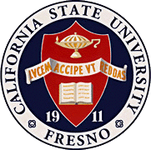
California
State
University,
Fresno
____

General Education Committee

Thomas Administration Building, 130
5241 N. Maple Ave. M/S TA54
Fresno, CA 93740-8027

559.278.4468
Fax 559.278.834

http://www.csufresno.edu/academics/ policies_forms/general_education/ index.shtml

_{M E M O R A N D U M}

8 February 2013

To: R. Lynn Williams, Chair, Academic Senate, and the Senate Executive Committee

From: Paul Crosbie, Chair, General Education Committee

Re: General Education Policies, Procedures and Program Description

At its meeting on 8 February 2013, the General Education committee voted to recommend to the Academic Senate the attached revisions to the current General Education Program Description, Policies and Procedures.

The attached revisions are mainly clarifications of existing policies and procedures. Currently the General Education program is guided by a Program Description that also includes any Policies and Procedures, a Committee Charge, and Writing Requirements; the latter were approved by the Academic Senate in 2012. All three of these documents are currently posted in the General Education area of the Undergraduate Studies web site, and the first two are also attached. No further revisions of the Writing requirements are proposed, so that document is not attached.

The changes are thus:
1. The Committee Charge and description of its composition are now stated at the beginning of the new Policies document. That renders the current Committee Charge obsolete, and it should therefore be deleted.
2. The current Program Description begins with a statement of the structure and intent of the GE program, followed by details of each Area within the program, and then followed by a combination of both Policies and Procedures. The Committee has sought to extract and revise Policies from this document and to incorporate them into the new Policies Document, and to create a new independent Procedures document from the Procedures within the current Program description. A final section titled “Approval and Evaluation of General Education Courses” is included in both new documents, as the committee felt that improved the clarity and explanatory power to faculty of both documents.
3. We have substantially rewritten the Program Description for each Area, and created the new Program Description, that does not include any policies or procedures. The most substantial change to the program description is the inclusion of student learning outcomes (approved by the Academic Senate in March 2010) within the description for each area. Additionally, there are now descriptions of each of the upper division areas of General Education, all of which were absent from the previous
document, although there was some oblique reference to them within each of the Areas A-E. These changes also render the current Program Description obsolete, and it too should be deleted.

Please feel free to contact me if you have any questions, and I would appreciate the opportunity to address the Senate when these items are placed on the agenda.

Sincerely,
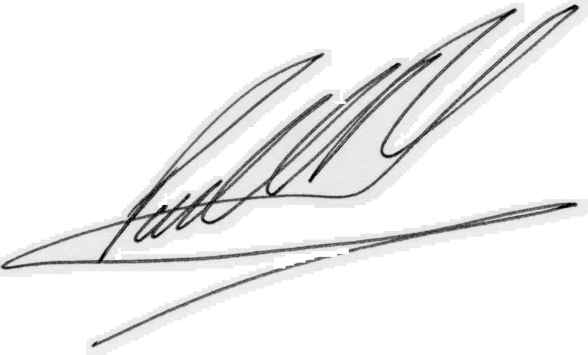

Paul Crosbie
(559) 278-2074
pcrosbie@csufresno.edu

cc: GE committee
Dennis Nef, Associate Vice President and Dean of Undergraduate Studies

