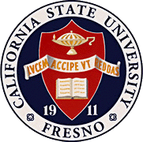
California
State
University,
Fresno
____

James Mullooly (Chair) - COSS
Ahmad Borazan – CSB
Xuanning Fu - Ex-Officio
Dave Goorahoo - JCAST
Elias Karam - ASI
Hovannes Kulhandjian - LCE
Kathi Rindahl - CHHS
Oscar Vega - CSM

Academic Policy & Planning Committee

Academic Senate
Henry Madden Library 3206
5200 North Barton Avenue M/S ML34
Fresno, CA 93740-8014

P 559.278.2743
F 559.278.5745

_{M E M O R A N D U M}

February 6, 2019

MEMORANDUM
TO: Thomas Holyoke, Chair
Academic Senate
FROM: James J. Mullooly, Chair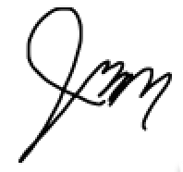
Academic Policy & Planning Committee

RE: APM 415 (Dispute Resolution)

When the motion to abolish APM 415 due to its superfluity and invalidity was brought to the Senate in the Spring of 2018, AP&P was tasked with investigating the possibility of moving the hitherto unused duties of this committee to APM 243 and the Student Academic Petitions Committee stipulated therein.
In the Fall of 2018, AP&P’s investigation discovered that the Student Academic Petitions Committee is not part of the AS and thereby outside of our jurisdiction as it were. Additionally, this body reviews academic issues only. AP&P believes moving this last level of appeal outside of AS’ purview will not satisfy the Senate’s original request. Our concern is that it will add confusion and not be in the best interest of Faculty and Students.
At the 11.8.18 meeting, AP&P urged the Senate to reconsider the original motion to abolish APM 415.

