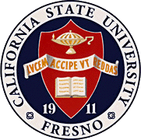
California
State
University,
Fresno
____

James Mullooly (Chair) - COSS
Tiewei Liu - HML
Kathi Rindahl - CHHS
Florence Cassel Sharma JCAST
Oscar Vega - CSM
Sebastian Wenthe - ASI
Xuanning Fu - Ex-Officio

Academic Policy & Planning Committee

Academic Senate
Henry Madden Library 3206
5200 North Barton Avenue M/S ML34
Fresno, CA 93740-8014

P 559.278.2743
F 559.278.5745

_{M E M O R A N D U M}

September 18, 2017

MEMORANDUM

TO: Thomas Holyoke, Chair
Academic Senate
FROM: James Mullooly, Chair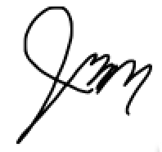
Academic Policy & Planning Committee

RE: APM 113 (Academic Organizations)

This memorandum will serve to inform the Academic Senate that the Academic Policy & Planning Committee moved to approve your consideration of the following modifications to APM 113 at our 9/7/17 meeting.
MSC- To forward the current draft of AMP113 to the Senate for its consideration.

Attached: APM_113_Policy_on_Academic_Organization_and_Governance_-_Exec_revisions_(AP&P 8.31.17).docx

KEC:vb

