Major Assessment Report Template

Please download this document and provide a response to each question in the appropriate section. Send your assessment reports to Dr. Angel Sanchez (aansanchez@csufresno.edu) in the Office of Institutional Effectiveness and copy Dr. Melissa Jordine (mjordine@csufresno.edu). Please complete a separate report for each Bachelors and Masters program offered by the department.
- What learning outcome(s) did you assess this year? List all program outcomes you assessed (if you assessed an outcome not listed on your department SOAP please indicate explain). Do not describe the measures or benchmarks in this section Also please only describe major assessment activities in this report. No GE assessment was required for the 2016-2017 academic year.

SLO: (g) an ability to communicate effectively
SLO: (m) a recognition of the need for acquiring GME related work experience prior to graduation

- What assignment or survey did you use to assess the outcomes and what method (criteria or rubric) did you use to evaluate the assignment? If the assignment (activity, survey, etc.) does not correspond to the activities indicated in the timeline on the SOAP, please indicate why. Please clearly indicate how the assignment/survey is able to measure a specific outcome. If after evaluating the assessment you concluded that the measure was not clearly aligned or did not adequately measure the outcome please discuss this in your report. Please include the benchmark or standard for student performance in your assessment report (if it is stated in your SOAP then this information can just be copied into the report). An example of an expectation or standard would be “On outcome 2.3 we expected at least 80% of students to achieve a score of 3 or above on the rubric.”

In this course, students work in teams and conduct three projects and submit a written report and give a presentation for each of these projects i.e., three reports and three presentations are required.

The following is used to grade students’ presentations.
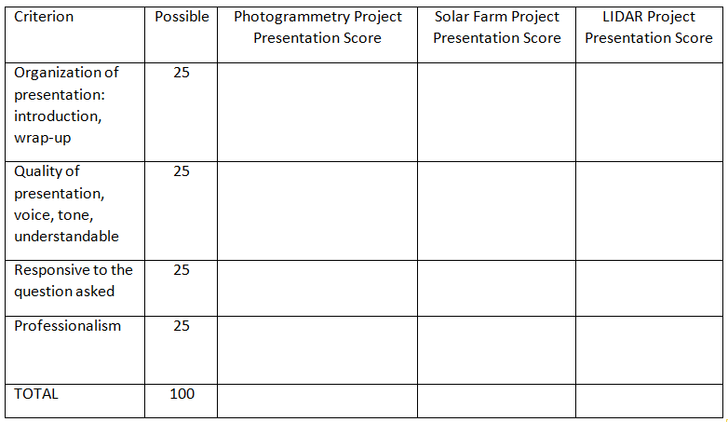

Grades awarded for written reports indicate whether students can put the knowledge they have accumulated throughout their education in the program into practice, in other words, students need to prove that they learned the subjects delivered in the program courses, and if they did not this will make them recognize the need for acquiring GME related work experience prior to graduation (this is a senior year course) which brings us to the student learning outcome “(m) a recognition of the need for acquiring GME related work experience prior to graduation”.

Grades awarded for presentations and in some degree for written reports will be indicative of students’ ability on effective communication and this aligns with the student learning outcome “(g) an ability to communicate effectively”.

The benchmark or standard for student performance is 60% since it corresponds to the lowest passing grade of “D”.

Average grades for the activities
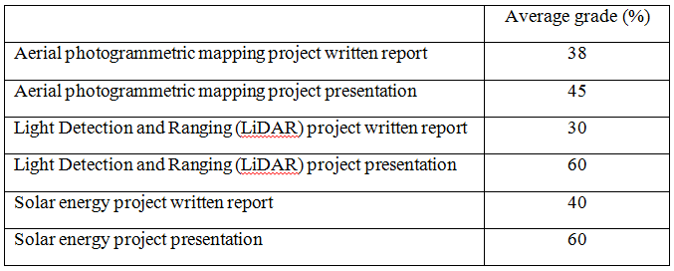

- What did you discover from the data? Discuss the student performance in relation to your standards or expectations. Be sure to clearly indicate how many students did (or did not) meet the standard for each outcome measured. Where possible, indicate the relative strengths and weaknesses in student performance on the outcome(s).

This cohort of students’ performance is the poorest so far. There were only four students in class. For outcome “(g) an ability to communicate effectively” three students met the standard. For outcome “(m) a recognition of the need for acquiring GME related work experience prior to graduation” three students met the standard.

Probably, low enrollment in class was the main factor on poor student performance because these projects require extensive data gathering, data analyses, interpretation of findings, report writing and presentation of the results. Since there were only two students in each group, groups did not have enough manpower to accomplish all the assigned tasks.

- What changes did you make as a result of the data? Describe how the information from the assessment activity was reviewed and what action was taken based on the analysis of the assessment data.

If low enrollment in class continues, either less groups will be formed or the number of the activities will be reduced to the level that students can accomplish the assigned tasks.

- What assessment activities will you be conducting in the 2017-2018 AY? List the outcomes and measures or assessment activities you will use to evaluate them. These activities should be the same as those indicated on your current SOAP timeline; if they are not please explain.

- an ability to apply knowledge of mathematics, science, and engineering
- an ability to design and conduct experiments, as well as to analyze and interpret data

- What progress have you made on items from your last program review action plan? Please provide a brief description of progress made on each item listed in the action plan. If no progress has been made on an action item, simply state “no progress.”

Despite all my e-mail exchanges, I was unable to access the last program review. I informed Dr. Jordine on this too.

Additional Guidelines: If you have not fully described the assignment then please attach a copy of the questions or assignment guidelines. If you are using a rubric and did not fully describe this rubric (or the criteria being used) than please attach a copy of the rubric. If you administered a survey please consider attaching a copy of the survey so that the Learning Assessment Team (LAT) can review the questions.

