Major Assessment Report Template – PETE Option
Department of Kinesiology

Please either download this document and provide a response to each question in the appropriate section or cut and paste all six questions into a word document and provide a response for each one. E-mail your assessment report(s) to the Director of Assessment, Dr. Melissa Jordine (mjordine@csufresno.edu). Please complete a separate report for each B.A/B.S. and M.A/M.S. program offered by the department.

Department and Degree: Kinesiology, Bachelor of Science, Physical Education Teacher Education (PETE)

Assessment Coordinator: David A. Kinnunen, Ph.D.

- What learning outcome(s) did you assess this year? List all program outcomes you assessed (if you assessed an outcome not listed on your department SOAP please indicate explain). Do not describe the measures or benchmarks in this section Also please only describe major assessment activities in this report. No GE assessment was required for the 2016-2017 academic year.

SLO: 1. Knowledge of the Fundamental motor skills (see attachments)
SLO: 2. If eligible, successful completion of Departmental Subject Matter Exam – two examples are provided (see attachments). This exam is offered to qualifying students in place of the CSET (California State Exam for Teachers – single subject in Physical Education Teacher Education). Students who do not qualify for the Departmental exam are directed to pursue Subject Matter Comptence (SMC) by taking the CSET exam provided by/through the State of California Department of Education.

- What assignment or survey did you use to assess the outcomes and what method (criteria or rubric) did you use to evaluate the assignment? If the assignment (activity, survey, etc.) does not correspond to the activities indicated in the timeline on the SOAP, please indicate why. Please clearly indicate how the assignment/survey is able to measure a specific outcome. If after evaluating the assessment you concluded that the measure was not clearly aligned or did not adequately measure the outcome please discuss this in your report. Please include the benchmark or standard for student performance in your assessment report (if it is stated in your SOAP then this information can just be copied into the report). An example of an expectation or standard would be “On outcome 2.3 we expected at least 80% of students to achieve a score of 3 or above on the rubric.”

1. Fundamental motor skills chart examination - 2 examples are provided (see attachments) – taken while students are enrolled in Kinesiology 110.

- What did you discover from the data? Discuss the student performance in relation to your standards or expectations. Be sure to clearly indicate how many students did (or did not) meet the standard for each outcome measured. Where possible, indicate the relative strengths and weaknesses in student performance on the outcome(s).

Student performance varies – SMC exams results are quite good (occasionally near or at 100% success) . FMS exam results vary among class sections and from semester to semester. Latest results (for the past 2 years) are attached.

- What changes did you make as a result of the data? Describe how the information from the assessment activity was reviewed and what action was taken based on the analysis of the assessment data.

SMC questions are modified on a regular/yearly basis and focus on the current pedagogical trends being demonstrated and modeled in the A&A courses, as well as adapting to any significant changes that may occur in the State and National guidelines. FMS questions and exams utilize a combination of video analysis, charts, diagrams and movement experiences to enhance the learning of the FMS from both a practitioner and teaching perspective.

- What assessment activities will you be conducting in the 2017-2018 AY? List the outcomes and measures or assessment activities you will use to evaluate them. These activities should be the same as those indicated on your current SOAP timeline; if they are not please explain.

We have and will continue to assess student knowledge and competence in both subject matter competence and fundamental motor skill knowledge. This is in line with the state and national organizations guidelines. The assessment activities will remain the same pending any modifications required by changes in the state and national standards and guidelines (none pending at the present time).

- What progress have you made on items from your last program review action plan? Please provide a brief description of progress made on each item listed in the action plan. If no progress has been made on an action item, simply state “no progress.”

While small changes or modifications are made from time to time – no significant changes or modifications have been made due to the unchanged state and national standards and guidelines.

Additional Guidelines: If you have not fully described the assignment then please attach a copy of the questions or assignment guidelines. If you are using a rubric and did not fully describe this rubric (or the criteria being used) than please attach a copy of the rubric. If you administered a survey please consider attaching a copy of the survey so that the Learning Assessment Team (LAT) can review the questions.

Copies of the relevant assignments are attached. For a more detail and an in depth understanding the departmental SOAP document is attached at the end of this document.

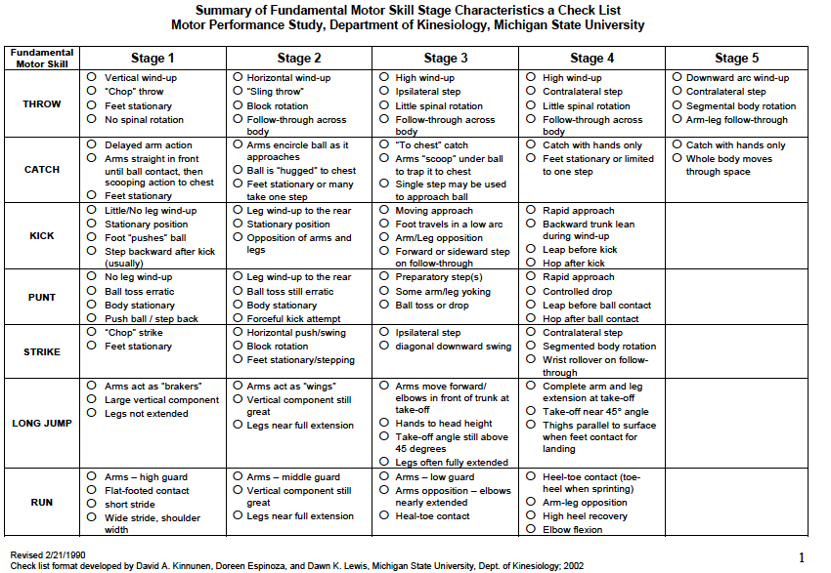

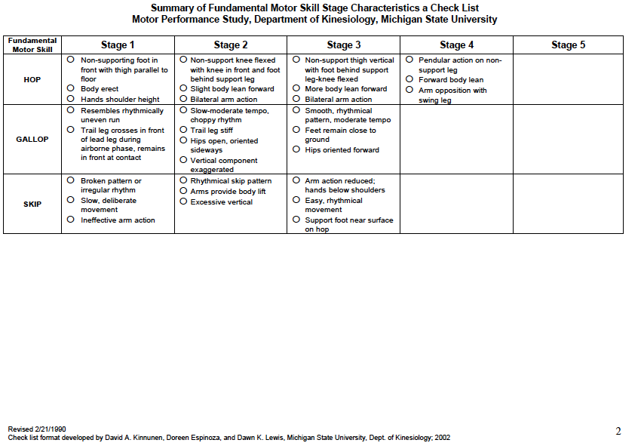
Summary of Fundamental Motor Skill Stage Characteristics a Check List
Motor Performance Study, Department of Kinesiology, Michigan State University

Fundamental Motor Skill | Stage 1 | Stage 2 | Stage 3 | Stage 4 | Stage 5
THROW | Vertical wind-up  “Chop” throw  Feet stationary  No spinal rotation | Horizontal wind-up  “Sling throw”  Block rotation  Follow-through across body | High wind-up  Ipsilateral step  Little spinal rotation  Follow-through across body | High wind-up  Contralateral step  Little spinal rotation  Follow-through across body | Downward arc wind-up  Contralateral step  Segmental body rotation  Arm-leg follow-through
CATCH | Delayed arm action  Arms straight in front until ball contact, then scooping action to chest  Feet stationary | Arms encircle ball as it approaches  Ball is “hugged” to chest  Feet stationary or many take one step | “To chest” catch  Arms “scoop” under ball to trap it to chest  Single step may be used to approach ball | Catch with hands only  Feet stationary or limited to one step | Catch with hands only  Whole body moves through space
KICK | Little/No leg wind-up  Stationary position  Foot “pushes” ball  Step backward after kick (usually) | Leg wind-up to the rear  Stationary position  Opposition of arms and legs | Moving approach  Foot travels in a low arc  Arm/Leg opposition  Forward or sideward step on follow-through | Rapid approach  Backward trunk lean during wind-up  Leap before kick  Hop after kick
PUNT | No leg wind-up  Ball toss erratic  Body stationary  Push ball / step back | Leg wind-up to the rear  Ball toss still erratic  Body stationary  Forceful kick attempt | Preparatory step(s)  Some arm/leg yoking  Ball toss or drop | Rapid approach  Controlled drop  Leap before ball contact  Hop after ball contact
STRIKE | “Chop” strike  Feet stationary | Horizontal push/swing  Block rotation  Feet stationary/stepping | Ipsilateral step  Diagonal downward swing | Contralateral step  Segmented body rotation  Wrist rollover on follow-through
RUN | Arms – high guard  Flat-footed contact  short stride  Wide stride, shoulder width | Arms – middle guard  Vertical component still great  Legs near full extension | Arms – low guard  Arms opposition – elbows nearly extended  Heal-toe contact | Heel-toe contact (toe-heel when sprinting)  Arm-leg opposition  High heel recovery  Elbow flexion
LONG JUMP | Arms act as “brakers”  Large vertical component  Legs not extended | Arms act as “wings”  Vertical component still great  Legs near full extension | Arms move forward, elbows in front of trunk at take-off  Hands to head height  Take-off angle still above 45 degrees  Legs often fully extended | Complete arm and leg extension at take-off  Take-off near 45° angle  Thighs parallel to surface when feet contact for landing
WALKING | High guard-arm position  Wide base of support  Flat-footed contact  Toeing-out | Base of support narrows  Arms are lowered and work in opposition to the legs  Toes point more in a forward direction | Heel strike is exhibited
HOP | Non-supporting foot in front with thigh parallel to floor  Body erect  Hands shoulder height | Non-support knee flexed with knee in front and foot behind support leg  Slight body lean forward  Bilateral arm action | Non-support thigh vertical with foot behind support leg-knee flexed  More body lean forward  Bilateral arm action | Pendular action on non-support leg  Forward body lean  Arm opposition with swing leg
GALLOP | Resembles rhythmically uneven run  Trail leg crosses in front of lead leg during airborne phase, remains in front at contact | Slow-moderate tempo, choppy rhythm  Trail leg stiff  Hips open, oriented sideways  Vertical component exaggerated | Smooth, rhythmical pattern, moderate tempo  Feet remain close to ground  Hips oriented forward
SKIP | Broken pattern or irregular rhythm  Slow, deliberate movement  Ineffective arm action | Rhythmical skip pattern  Arms provide body lift  Excessive vertical | Arm action reduced; hands below shoulders  Easy, rhythmical movement  Support foot near surface on hop
The FMS Matrix is the property of the Motor Performance Study at Michigan State University’s Department of Kinesiology. Content is redacted to fulfill copyright agreements. Contact Dr. David Kinnunen at California State University, Fresno to receive the complete matrix.

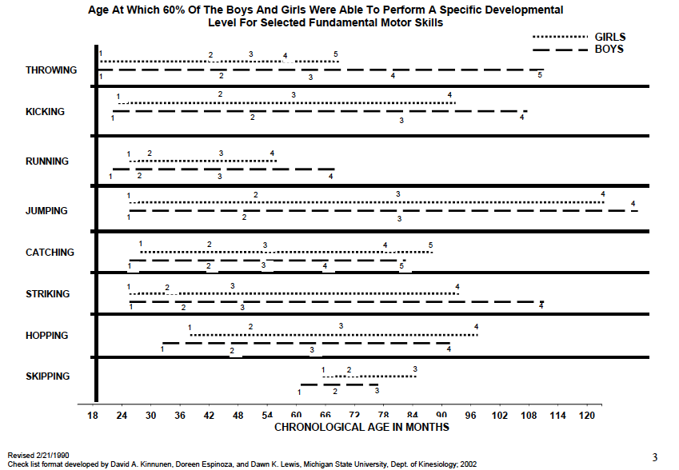
California State University, Fresno
Department of Kinesiology

Physical Education Subject Matter Competence Written Exam
Catalogue Year 2008 – Present

Administering the PE SMC Exam: PE majors who meet the PETE program requirements to take the PE SMC exam are randomly assigned three of the questions below and given 90 minutes to complete all three items.

Grading the PE SMC Exam: The PE SMC exam is graded using the scoring rubrics created by the PETE faculty. PE majors must achieve an average score of three or higher to pass the Physical Education Subject Matter Competence (SMC) exam item. Students who receive a score of one (1) on any SMC question have failed the exam. Students’ responses are graded on knowledge and depth of selected domains within Physical Education. PE majors who fail the SMC exam may retake the exam one time only. Students who fail to pass the exam on the second attempt must take the CSET exam.

PE SMC Exam Items:
- Describe personal and situational factors that influence an individual’s activity choice in physical education. Discuss how you will encourage/motivate maximum participation from all class members. (Q1)
- Discuss the concept of readiness as it relates to motor development and physical education. (Q2)
- State and define the health-related components of physical fitness. Next, explain how you would apply the health-related components of fitness to your PE curriculum that is standards-based. (Q3)
- Describe ways to increase students’ physical and social competence by using teaching cues, feedback and reinforcement. (Q4)
- There are a multitude of movement concepts and forms that physical educators teach to create a balanced program (ex: aquatics, dance, gymnastics, combatives, etc.). Give examples of how you will accommodate a variety of developmental levels to ensure your students’ success in at least one of these movement areas. (Q5)
- Describe one evaluation strategy for addressing the health-related domain and one for the affective learning domain. Explain how these strategies could be used as formative assessments. (Q6)
- In your teaching strategies, how can you connect other subject areas to enhance learning across the curriculum? (Q7)

Question #1
Describe personal and situational factors that influence an individual’s activity choice in physical education. Discuss how you will encourage/motivate maximum participation from all class members.

Unsatisfactory  1 point  Student describes at least 3 factors that do not depict the current conditions for PE, or  Student identifies and discusses strategies that are inappropriate practice in PE, 1) are unrelated to the factors identified, 2) barely or do not demonstrates understanding of inclusive PE  Answer lacks organization and coherence | Basic  2 points  Student describes at least 3 factors that somewhat depict the current conditions for PE. Student identifies and discusses strategies where one is an inappropriate practice and that 1) are somewhat related to the factors identified, 2) barely demonstrates understanding of inclusive PE, and 3) reflects one of the following: motivation theory, behavior change model, principles of pedagogy, and National and CA State PE standards. Answer is somewhat organized but lacks coherence | Above Average  3 points  Student describes 3 or more factors that accurately depict the current conditions for PE. Student identifies and discusses 3 or more appropriate strategies to improve participation that 1) are related to the factors identified, 2) demonstrates sufficient understanding of inclusive PE, and 3) reflects the behavior change model, principles of pedagogy, and National and CA State PE standards.  Organization of answer needs improvement but it is easy to understand | Outstanding  4 points  Student fully describes 5 or more factors that accurately depict the current conditions for PE. Student identifies and discusses 3 or more appropriate strategies to encourage maximum participation that 1) directly address the factors identified, 2) demonstrates a deep understanding of psychological, social and emotional care of students and others, and 3) reflect best practices according to motivation theory and the behavior change model, PE pedagogy, and National and CA State PE standards. Answer is well-organized, cohesive, and easy to understand.

Question #2
Discuss the concept of readiness as it relates to motor development and physical education.

Unsatisfactory  1 point  The answer to the question is lacking any detail. Some information provided is accurate.  The answer demonstrates a lack of understanding of the content. Response may be unorganized, not cohesive, and difficult to understand. | Basic  2 points  The answer does not address a portion of the question, or major details are missing.  Almost all information provided is accurate.  The answer demonstrates basic understanding of the content. Response is organized, cohesive, and easy to understand. | Above Average  3 points  The answer is missing slight details.  All information provided is accurate.  The answer demonstrates understanding of the content. Answer is well organized, cohesive, and easy to understand. | Outstanding  4 points  The answer is complete.  All information provided is accurate.  The answer demonstrates a deep understanding of the content. Answer is well organized, cohesive, and easy to understand.

Question #3
Please describe the health related components of physical fitness. Next, explain how you would apply the health-related components of fitness to your PE curriculum that is standards-based.

Unsatisfactory  1 point  Student is unable to state any principles related to the principles of physical fitness. Answer lacks detail, depth and is unorganized. | Basic  2 points  Student mentions at least two principles of physical fitness. Student vaguely defines or supports the answer and fails to make a connection of the stated principle and its relation to any variable within physical education (developmentally appropriate teaching, content standards assessment). | Above Average  3 points  Student identifies and discusses several component of physical fitness (cardio-respiratory endurance, flexibility, body composition and/or muscle strength and endurance). Student makes a connection with fitness principles to lesson plans, content standards (national, state) and gives assessment strategies. | Outstanding  4 points  Student directly states all the principles of physical fitness (cardio-respiratory endurance, flexibility, body composition and/or muscle strength and endurance) as well as specifically outlines how to incorporate each principle within their teaching (i.e. FITT principle). Student provides a comprehensive understanding of the principles and their impact and connection within physical education. Student mentions specific content standards and the understanding of the principles as they relate to physical fitness testing.

Question #4
Describe ways to increase students’ physical and social competence by using teaching cues, feedback and reinforcement.

Unsatisfactory  1 point  Response did not address question, is incorrect, or mostly included incorrect information related to best practices for providing feedback, reinforcement, and instruction. | Basic  2 points  Response includes some incorrect information, is inconsistent with best practices, and/or lacks quality and depth. E.g., answer included vague information related to method for giving feedback, reinforcement and instruction; specific methods for improving specific outcomes are vague or inconsistent. | Above Average  3 points  Response reflects best practices for feedback, reinforcement and instruction, but addresses 1 or 2 outcomes expected to improve (skill acquisition, competence, motivation).  Response mainly consists of examples for improving outcomes, rather than describing methods and the use of appropriate terminology. | Outstanding  4 points  Response reflects best practices for feedback, reinforcement and instruction and addresses all 3 outcomes expected to improve (skill acquisition, competence, motivation).  Response is detailed, thorough, and specific that includes the use of appropriate terminology and description of methods.  Response may or may not include specific examples. If used, examples are appropriate for describing methods.

Question #5
There are a multitude of movement concepts and forms that physical educators teach to create a balanced program (ex: aquatics, dance, gymnastics, combatives, etc.). Give examples of how you will accommodate a variety of developmental levels to ensure your students’ success in at least one of these movement areas?

Unsatisfactory  1 point  Student is unable to describe any methods of accommodating students of varying developmental levels and/or provide incorrect or inappropriate information. He/She fails to give specific examples relating to a specific content area and does not discuss the ways in which he/she will encourage and embrace this type of diversity within his/her classes while also creating a safe learning environment for diverse learners. | Basic  2 points  Student references only one method of accommodating students of varying developmental levels, and gives vague examples relating to one specific content area. Method mentioned might include reference to groupings, challenge by choice, determining individual activities depending on pre-assessment, and the use of peer teaching to name a few. Student fails to reference, or references very vaguely, the ways in which he/she will encourage and embrace this type of diversity within his/her classes while also creating a safe learning environment for diverse learners. | Above Average  3 points  Student references at least two methods of accommodating students of varying developmental levels, giving specific examples relating to one specific content area. Methods might include specifics on groupings, challenge by choice, determining individual activities depending on pre-assessment, and the use of peer teaching to name a few. Student also references the ways in which he/she will encourage and embrace this type of diversity within his/her classes or how he/she will create a safe learning environment for diverse learners. | Outstanding  4 points  Student references multiple (at least 3) methods of accommodating students of varying developmental levels, giving specific examples relating to two or more content areas. Methods might include specifics on groupings, challenge by choice, determining individual activities depending on pre-assessment, and the use of peer teaching to name a few. Student also references the ways in which he/she will encourage and embrace this type of diversity within his/her classes while also creating a safe learning environment for diverse learners.

Question #6
Describe one evaluation strategy for addressing the health-related domain and one for the affective learning domain. Explain how these strategies could be used as formative assessments.

Unsatisfactory  1 point  Candidate described an evaluation strategy that is not consistent with a formative evaluation approach or does not address the health-related or affective learning domain | Basic  2 points  Candidate described an evaluation strategy that is not consistent with a formative evaluation approach and addresses the health-related or affective learning domain | Above Average  3 points  Candidate described an evaluation strategy that is consistent with a formative approach and does address the health-related or affective learning domain | Outstanding  4 points  Candidate described a specific evaluation strategy in detail that is consistent with a formative evaluation approach and demonstrates a clear understanding of current issues effecting evaluation in the health-related or affective learning domain

Question #7
In your teaching strategies, how can you connect other subject areas to enhance learning across the curriculum?

Unsatisfactory  1 point  The candidate did not make any connection between physical education and other subjects in the school curriculum. The physical education content stood alone and did not cross the curriculum | Basic  2 points  Reference was made by the student that connected physical education to another subject in the school curriculum; however, the connection was irrelevant, unimportant, and/or simplistic at best | Above Average  3 points  Several connections were made linking different subject areas to physical education content. The links were relevant, current, and added to the overall educational experience | Outstanding  4 points  A variety of connections were made relating physical education content with other subject areas. Specific examples were given that clearly demonstrated how physical education and other academic subjects (math, science, history, English etc.) are linked through education

