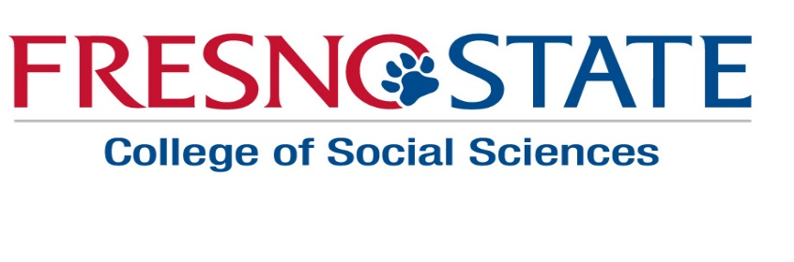
College of Social Sciences
Institute for Leadership and Public Policy
CALL FOR APPLICATIONS FOR PAID INTERNSHIPS
DEADLINE: MARCH 29, 2017
The Institute for Leadership and Public Policy is seeking applications for its Public Leadership Internship Program. Selected interns will participate in professional training and career development workshops and be matched with a public-service organization over the Fall 2017 semester. Each intern will receive a $2,000 stipend and be required to provide a minimum of 100 hours of service to a public, non-profit, or private organization chosen in collaboration with the Institute. Prior to the internship placement, students will participate in workshops on resume writing, interviewing, and professional skills. Potential placement organizations may include city, county, state or federal government agencies, non-profit groups, the Public Defender’s Office, the District Attorney’s Office, or private law firms. Interns will also participate in a career development workshop, which includes career exploration and panels of local leaders and alumni, and other Institute activities. Interns may elect to receive 3 units of course credit for the internships.
Eligibility
- Must be a major in the College of Social Sciences
- For undergraduates, must have completed a minimum of 60 units and have junior standing
- Minimum 3.0 G.P.A. in major
- Considering a public-service oriented career

Application
To apply submit the following materials:
- Complete application form
- Resume
- Unofficial transcripts
- 1-page personal statement on why you are interested in the internship and what careers you are considering in the public and non-profit sector
Submit application materials by March 29, 2017 to:
College of Social Sciences Dean’s Office
Social Sciences 108

Questions
Please contact Professor Jeff Cummins at jcummins@csufresno.edu or Professor Annabella España-Nájera at aespanajera@csufresno.edu if you have questions regarding the program.

