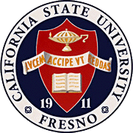
California
State
University,
Fresno
____

James Mullooly (Chair) – COSS
Ahmad Borazan – CSB
Dave Goorahoo - JCAST
Kathi Rindahl - CHHS
Oscar Vega – CSM
Nichole Walsh - KSOEHD
Aaron Stillmaker - LCOE
Bernadette Muscat - Ex-Officio

Academic Policy & Planning Committee

Academic Senate
Henry Madden Library 3206
5200 North Barton Avenue M/S ML34
Fresno, CA 93740-8014

P 559.278.2743
F 559.278.5745

_{M E M O R A N D U M}

February 3, 2022

MEMORANDUM
TO: Ray Hall, Chair
Academic Senate
FROM: James Mullooly, Chair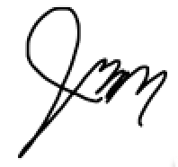
Academic Policy & Planning Committee

RE: APM 232 (Policy on Student Absences)

This memorandum will serve to inform the Academic Senate that the Academic Policy & Planning Committee moved to approve your consideration of the following policy modification at our 1/27/22 meeting.
MSC To forward APM 232 to the Executive Committee for the Senate’s Consideration.

AP&P has made changes to footnote 3 in consultation with Laura Yager, University Registrar and Bernadette Muscat, Dean of Undergraduate Studies. This change is in accordance with a new Federal law authorizing military service student absences.

Attached: AMP232 (Absence Policy) APP Draft 1-27-22.docx

CC: vb, Laura Yager, Bernadette Muscat

