2016-17 Review of the status of research at the California State University, Fresno

Prepared by the Research Subcommittee of the APP (“the committee”)

Tamás Forgács (Chair, CSM, tforgacs@csufrenso.edu)
Jenna Kieckhaefer (Vice-chair, COSS)
Cameron Lane (Graduate Student)
Song Lee (Kremen)
James Marshall (Dean of Research and Graduate Studies)
Samina Najmi (CAH)
Fayzul Pasha (LCE)
Helda Pinzon-Perez (CHHS)
Vang Vang (HML)

Executive Summary This report provides a snap-shot of the state of research at Fresno State, as perceived by two major stakeholder groups: faculty, and the deans of the colleges. The committee finds that our faculty and colleges are notably heterogeneous in almost all aspects of research, including research expectations, research intensity, student involvement in research, internal research funding, external research funding, and perhaps most importantly, in the way we perceive research and its role in our academic endeavor. The committee concludes that there is a need for (i) increased clarity in the institutional vision/mission/directives regarding research, and the role it should play in our faculty’s career development; and for (ii) a funding model which supports that mission uniformly across campus units, and across various faculty ranks. We invite all involved parties to engage in a discussion that will result in a research mission which (i) accurately reflects our faculty’s aspirations, (ii) enhances the undergraduate experience, and (iii) is pragmatic and sustainable given the current and expected university budgets.

Activities for the 2016-17 review

Goal: To address the charge of the committee to write a yearly review and report to AP&P and the VPAA on the state of current research activity on campus. As outlined in the committee’s charge, this review shall include, but is not limited to the reporting on (i) successful research, (ii) perceived barriers to research, (iii) space availability, (iv) computer services facilities, (v) library and (vi) equipment budgets for research related activity. This task of writing the review may be accomplished in cooperation with school research committees and appropriate administrative groups.

Interpretation of goals for this review. We focus on two specific groups of stakeholders in the research endeavor: research faculty, and the deans of the various colleges. We do not address items (i)-(vi) separately. Instead, we report on those as part of the responses we received from the two stakeholder groups through in person interviews (for the deans) and through a campus-wide survey (for faculty).

Description of dean interviews. Committee members met with the deans of the Colleges of Agricultural Science and Technology (JCAST), Arts and Humanities, Health and Human Services, Science and Mathematics, Social Sciences, and Engineering. Deans were asked to assess the state of research in their colleges, identify areas where they’d like to see changes, and supports they’d need in order to be able to make those changes.

Summary of dean interviews. Committee members conducted interviews with the deans of seven schools and colleges, and the library (CSM, JCAST, LCEE, CAH, CSS, Kremen, CHHS, HML) in an effort to understand how the top college administrators view the state of research in their respective colleges/schools. There were several themes that emerged from these interviews:
- Funding issues. There are colleges that wish to provide more assigned time/financial support to faculty to enhance their research profile, but are unable to do so due to funding issues. The university budget model may be a contributing factor as it (i) distributes the funds (FTEs etc), and (ii) the amount it distributes to the colleges (CSM notes that over 90% of its budget is personnel related).
- Culture change. Historically Fresno State has thought (and perhaps still thinks) of itself as a teaching institution. Consequently, institutional inertia can prevent the support mechanisms for research from (fully, or at all) developing. Instances of such inertia include high teaching loads and service requirements (which is exacerbated for associate professors serving as department chairs), and lack of sustained and wide-spread efforts among faculty to seek external funding. Existing programs, which favor junior faculty due to shortage of funds, can disenfranchise senior faculty. Support for research shouldn’t just be offered to attract new hires, but should be offered continually to retain the new hires, and to help all faculty grow in the area of research.
- Unique needs of colleges. CAH appears to be in the direst situation regarding research funding, and starts each fiscal year in the hole. It clearly has difficulty supporting the ‘classroom’ (i.e. teaching faculty) in research. JCAST on the other hand is the only college which reported no difficulties finding funding for research, but which is having trouble bringing their researchers into the classroom due to job classification issues.
There seems to be no one way common to all colleges when it comes to supporting research. Some have their own programs, some rely entirely on the Provost’s annual allocation for RSCAs, and some have state budget line items to draw from. Some colleges wish to push for increased research activity (LCOE, CSM, Kremen), while others would like to find a way to make research part of their faculty’s sustained activities.
- Undergraduate research. Colleges view undergraduate research positively, and would like faculty and students to continue to engage in such activities. The committee notes that support for students conducting undergraduate research seems adequate and multi-sourced (ASI (used to be the award from the Dean of Undergraduate Studies), college programs, individual departments), while support for faculty mentoring undergraduate research is weak (both in terms of assigned time and in terms of monetary support).

(For an unabridged account of these interviews please see Appendix A.)

Description of the faculty survey. The committee, in conjunction with the Office of Institutional Effectiveness, created a short survey (see Appendix B) with the aim of finding out whether faculty across campus are engaged in research (and to what extent), and whether or not they perceive the institutional support they receive for their research activities to be adequate. Besides “demographical information”, the committee inquired about the number of publications (which we used as a proxy to measure research activities) of the faculty members since their hire at Fresno State (numerical answers), and we also asked faculty to answer three yes/no questions with free response options regarding the workload, release time and infrastructure components of their research activities. The survey was administered at the beginning of the Spring 2017 semester. We allowed three weeks for completion, and there were three follow-up emails sent to faculty who had not yet completed the survey. The survey closed with an overall response rate of 19%, lending it institutional validity.

Summary of results of the faculty survey.

While almost 2/3 of the faculty at Fresno State are in fact lecturers (827 out of 1377, or 60%), their research production, and involvement in research should be considered separately from the rest of the faculty, as they are not in fact required at any stage to conduct research.
Of the 195 assistant professors 109 responded to the survey (55.9% response rate), of the 122 associate professors 50 responded (41%), while of the 205 full professors, 55 responded (26.8%). The average number of peer reviewed papers published by faculty who responded (according to rank) is 3.75 (assistant), 5 (associate) and 7 (full). Overall, survey respondents paint a picture of continually research active faculty at Fresno State. For the quantitative analysis of the survey, please see Appendix C. It would be educational to know what the average number of peer reviewed papers per year is according to rank, as this figure would help us better understand the fluctuation of research activity across ranks. However, our data wasn’t detailed enough to be able to furbish an answer to this question.

Almost three-quarter of respondents find that Fresno State does not provide adequate support for research as part of faculty workload. About half the respondents (48%) believe that there is adequate support for obtaining internal or external release time to conduct research, and also about half (51.5%) believe that Fresno State provides adequate support for research in the form of infrastructure.
Regarding research as part of the workload, the themes explaining the responses are: course overload; too many new course preparations; lack of tenure density; advising/administrative overload; mentoring/supervising students consumes available research time; service overload; increase in class size/no TA; applying for research time takes time; too much busy work; class scheduling; research during personal time/only on external grants; adequate support at present.
Regarding opportunities to obtain release time, the themes explaining the responses are: lack of opportunities; not enough time; opportunities are helpful; there are barriers.
Finally, regarding support infrastructure, the themes explaining the responses are: lab space; more tech support; funding for technicians; travel funding; qualified equipment personnel; more journals/databases; stronger communication between college administrators and faculty.
For the qualitative analysis of the written responses to Question 4 please see Appendix D.

Appendix A – Transcripts of the interviews with the deans of various colleges

College of Science and Mathematics

Overall assessment of the Dean is that research production in the college is fine, and there is no hard target for the college to aim for in any given year. As an area for improvement, the dean identified the number of publications, and the grant activities of the college. In particular, the number of publications could go up, and the amount of grant money brought in could even be doubled, according to the dean.
The dean of CSM acknowledged the importance and necessity of appropriate funding for research activities. He noted that faculty teaching load has come down in the college. In the past year, the following CSU sources were provided for this purpose:
- The provost set aside $800K for research. This pot of money has two funding components: it provides equipment funds, and money for RSCA awards.
- The chancellor’s office now has a line item funding RSCA, which is currently at a system-wide total of $2.5M. The campus distribution of these funds is according the FTEFs. CSM received $18K from this source last year.
- College programs - the college provided $75K in RSCA, of which $50K came from recovered indirect costs on the college grant activities. This constituted about 25% of the indirect recovery.

A concern of the dean was that about 90% of the annual budget of the college is personnel related, and he expects this number to grow. If it does, some or all of the college programs could suffer, including research support. In light of the budget make-up, the dean emphasized the importance of externally funded research. He noted the providing faculty with the necessary time to write and execute grants and to publish is an area of potential improvement. He would like to see a sustained trend of grants providing buyouts for faculty, but notes that there is a substantial amount of research in the college which is not grant funded (or not at all funded), and that a certain percentage of grant activity is not research related/wouldn't necessarily qualify as research.
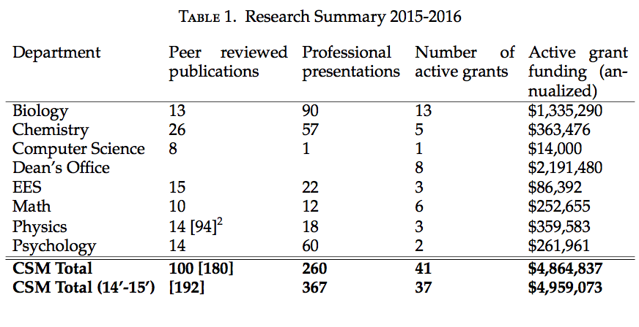
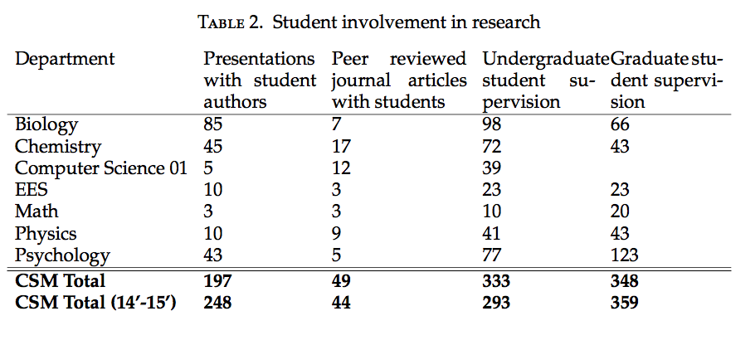
College of Health and Human Services

Overall, the College of Health and Human Services has multiple programs to support research. These programs and research endeavors from faculty are detailed in the webpage of the College at: http://fresnostate.edu/chhs/index.htm
The following are excerpts of the interview with Dean Hironaka-Juteau and Dr. Jason Whiting, chair of the CHHS Research Committee:

- Suggestion for the university level: When there are resources at the university level to support research, have them available as soon as possible and known to the faculty
- Suggestion: Policies and practices that provide the widest range of possibilities with flexibility in spending times
- Problem: Lateness in the assignment of the monies
- Challenge: There are some faculty who have very clear research agendas but are others who are just starting to define their lines of research
- Suggestion: Create more opportunities for the money to flow
- The College has the outstanding thesis, dissertation, and project Awards at the Masters level
- For undergraduate research we need funds and awards to provide more opportunities
- Suggestion: Motivation starts from the faculty side- financial motivators for faculty to be more inclined to support undergraduate research- create awards- some departments through student success money support undergraduate research- some funds from the College Honors Program- money to support data collection and poster presentations -Faculty apply for graduate assistants, student assistants-Rationalize the resources- determine at what time to promote research (junior, senior levels?)
- We can build upon with pre-existing awards from the College- applications for creating activities awards
- Challenges for Undergraduate research: What percentage of the first generation think about Master's degree- what does it take to have that ability to pass barriers- having them experienced data collection, data analysis for undergraduate students
- College Honors program- Undergraduate students do a research project- How to disseminate that information to the undergraduate students- How the college could create a venue for undergraduate students to apply for that kind of research- Faculty sharing information- decentralized and centralized models- there is a need for a faculty mentor who to support the student.
- In our college we have the funds for Provost Research and Creative Activities Award- There should not be distinction whether is tenured or not tenured faculty- Equal opportunities for both- We can use the university to mentor/support people in applying for the funds
- Suggestion: Reset people's mind set about who needs to engage in research- Not only people in tenure track but all faculty so they feel included
- Support from the Research Committee- Educating and coaching faculty on how to pursue research dollars and how to get funds- some faculty not engaged in research as much- programs such as the Summer Academy- identify funds that could support increased education and awareness of proper research techniques
- Center for Faculty Excellence- greater presence in trainings and sessions from faculty that help not only the teaching side but also the research side- Research could be time consuming but increased likelihood of success if identify the correct sources- we can do through the Centers in the College such as the Central Valley Health Policy Institute, the Center for Nursing Excellence and others to mentor and support faculty and students in research
- Because our university focus is on teaching, not necessarily we attract faculty with intensive research agendas- intercept ways to do research, teaching, and community service- our university focus is on teaching - There is a need to thread the various aspects of the job of the faculty member (teaching, research, and community service)- finances are driven in a research institution- in our CHHS applied research is valuable- Engaged university
- Suggestion for Research Committee of the Academic Senate: I would be interested in hearing the historic piece of the reviews and recommendations of the application process for research awards- strategic planning- priorities and how we all paddle in the same direction- to do all what we can to support faculty not only to recruitment but to retain them
- Budgets- we know that we generate 41% of the entire campus on research and grants
- Of the grants we submit, about 85% success rate- it comes from the Training Academy and SWERT- the success is out of the culture of grant writing

I asked the Dean if the CHHS has a specific budget table for Research (similar to the one shared by Tamas from the College of Sciences and Mathematics) and Dean Hironaka-Juteau said there is no specific budget table like that in the CHHS.

Jordan College of Agricultural Science and Technology

- The state of research in the college is active, and robust, with a “slight dip” due to an almost complete turnover in one department. Research is measured in terms of the number of faculty engaged in research, and grants and funding (the most important criterion). Funding for this college is different from other colleges in that JCAST has direct state funding due to legislation. The California Agricultural Technology Institute is state funded, $1.2M each year to support applied research and the dissemination of results to industry. This money funds three research centers (IFA, CIT and VERC) and faculty in JCAST are supported by the staff in these centers, along the division lines of their expertise. Center directors set up conferences and oversee dissemination efforts. A percentage of the CATI money supports research through the dean's office. In addition to CATI, there is the Agricultural Research Institute (ARI) which is a system wide entity. State funds $4.5M each year which is allocated to four campuses (Cal Poly Pomona, Cal Poly San Luis Obispo, Chico and Fresno State) Fresno State gets about $830K a year, which is money that is open to campus proposals for ARI related research (typically faculty from three colleges apply: LCOE, CSM and JCAST). The final piece of the funding picture is the Jordan gift, part of which paid for the new JCAST research center, and part of which is providing about $400K per year to support research. The college has 3 endowed positions, and regular faculty are assigned a 12-12 teaching load (other than the new faculty who get the 9-9 for the first two years) Most faculty are encouraged to do summer pay as compensation for research rather than AY release, as there is a lack of expertise in our area which prevents department from hiring qualified substitutes.
- Future of research in JCAST - Dean Witte expects and wants an increase. In particular, IFA and the Viticulture and Enology Research Center's research production should increase. This increase should be able to support dedicated researchers, some of whom the dean wants to bring into the classrooms. There are pretty well established mechanisms to support researchers on the foundation side, the dean would like to see that model transplanted to the other centers.
- Barriers - there is a need for a dedicated research administrator in the college (maybe another associate dean), and also a need for a more sensible classification of the researchers in the centers, so that they can teach a class from time to time. Up until recently facilities were a problem but the new JCAST research center addressed those issues. A friendlier environment in terms of teaching load would benefit the college, in particular a 9-9 teaching load would be much better, with 6 units each semester dedicated to non-direct contact engagement (research, service). Pre-tenure JCAST does pretty well in terms of supporting faculty research time, but post tenure support mechanisms could improve.
- Student research is a high priority to the faculty and the college is engaging students in research pretty well. They have 7 departments and 10 degrees, not many graduate students, but their honors students (undergrad) all do research, and many non-honors students do as well.

Lyles College of Engineering

Department | Peer reviewed  publications | Professional  presentations | Number of  active grants | Active grant  funding
CE | 10 | 26 | 14 | 782,563
CM | 5 | 4 | 4 | 38,784
ECE | 7 | 11 | 3 | 409,568
GE | 4 | 7 | 0 | 0
ME | 2 | 4 | 3 | 66,672
Total | 28 | 52 | 24 | 1,297,587
*In addition to above grant funds, a total of $1.6 M was secured in 2016-17

Obstacles: (1) Heavy teaching load, (2) commitment to service (3) lack of administrative support, (4) lack of qualified graduate students, (5) absence of Ph.D. program etc.
Expectations: (1) University should move toward for research more aggressively as Artificial Intelligence including data science based online lectures can be popular in the future, (2) More applied research in energy-water-food is promising, (2) More research awards and release time should be given to faculty to encourage and reduce teaching load or to initial research.
College of Social Sciences
Vision and expectation for research in the College of Social Sciences
- Endless amounts of money for research for faculty and also for undergraduates (or at least have course/work credit like independent study - perhaps 8-10 students for a faculty course release, also Masters students supervising).
- For Criminology, to have labs and space that's needed for research.
- Hire a grant writer for the College.
- Encourage more interdisciplinary research.
- Bridge funding and interest gaps.
Are those expectations met?
- We are in the process of making the space for the Criminology lab.
- Some interdisciplinary research, but envision more in the future.
What kind of support is needed from the University to be able to support research in the College to the desired extent?
- There is no funding model for research since we're a teaching institution, but we are doing a lot of research. We need to change that.
- Address the workload issues for graduate students, like having a differential funding model for graduate students. Right now when faculty are working on theses they are doing it for free.
- Need to find a better way to deal with workload issues.
- The hard sciences are able to buy out their time more than we are able to with grants, so they are teaching less and thus able to conduct more research, fund students, etc.
College of Arts and Humanities

CAH receives only state funds for research support. About 180K.
No grants, except Dr. Godfrey’s (English) for San Joaquin Writing Project.
We’re not fully funded as a college. We begin with a deficit of 11% every year because that is how the money is disbursed according to the university formula.
Not even enough to cover salaries.
Yet 25% of all FTES, all workload, generated by CAH.
For most other colleges, the funding gap doesn’t matter: Ag has its own funding sources, Social Sciences has over-enrolled classes, etc. Though funding for other colleges is similar, grants and outside funding are not readily available for artists and humanists.
Dean posed the question: Do we teach based on the needs of our disciplines or do we over enroll in every discipline? Since we are responsible for teaching writing, oral communication, artistic expression, critical thinking, world languages, literary analysis, musical performance, theatrical production, and all aspects of media production, it is detrimental to the students’ academic formation and learning to have overenrolled courses. The current budget formula rewards overenrolled courses, as the only way to generate “extra” funding.
We can’t over-enroll, if we wanted to. CFA protects ENGL 5 and 10 and caps all courses at 25; fire marshal won’t permit over-enrollment in Art & Design, Theater, Music, and MCJ. It’s counterproductive to overenroll in world languages, philosophy, and linguistic courses.
Assigned Time: The College faculty are involved in all areas of shared governance –they are leaders in the Senate (Kevin Ayotte), Union (Diane Blair, Lisa Weston, John Beynon), and various prominent committees on campus (Robert Maldonado, amongst others). CAH receives $5000 for release-time for these active faculty members, yet this is not enough to cover their salary. So, it costs CAH hugely to give assigned time (especially 4-unit releases). If a professor’s salary is 90K, the cost of one 4-unit course release is 15K, which means CAH has to account for $10K to cover the rest of the faculty’s salary.
There is a funding formula for the operating budgets of all CAH departments. The formula does not fully fund the departments because the College does not have the resources. For example, English accounts for 25% of CAH’s FTES, but given that it’s a large department and many of its faculty are active in their field, the faculty receive scare resources to travel to conferences.
Even within this limited context, CAH faculty are active leaders in their fields, and many are internationally recognized.
The Grant Writing Committee was established with the objective of promoting grant writing. We have been the recipients of prestigious grants (NEH, NEA, James Irvine Foundation, etc.), but such grants are few, and do not support programmatic funding.
CAH Dean has offered to come and talk to our committee personally.

Kremen School of Education

Dean's Comment: Expect 3 peer reviewed, indexed articles. This is really a WASC minimum for us to offer a doctorate program in the school. One publication in a book or book chapter could be used in place of a published article. Faculty should submit one, substantial external grant. This seems very minimal but faculty would balk at more based on our teaching loads. We should try to hold to this. Expect publishing an article every other year to teach in the doctoral program.

Interviewer note: It seems that the dean used guidelines from WASC set amount of research but he would like to see more research being done. However, due to teaching expectations, he knows the faculty would not favor more research added to their probationary plan.

Library Services

The field of librarianship is more practical research, however “research” in all disciplines and fields are supported in the library. My new faculty members are encouraged to do research and published. In fact, publication is listed in their Probation Plan for tenure and promotion. I am generous with my funding for all faculty in the library to do research and pursue professional development opportunities because I want them to succeed.

Appendix B – Faculty survey instrument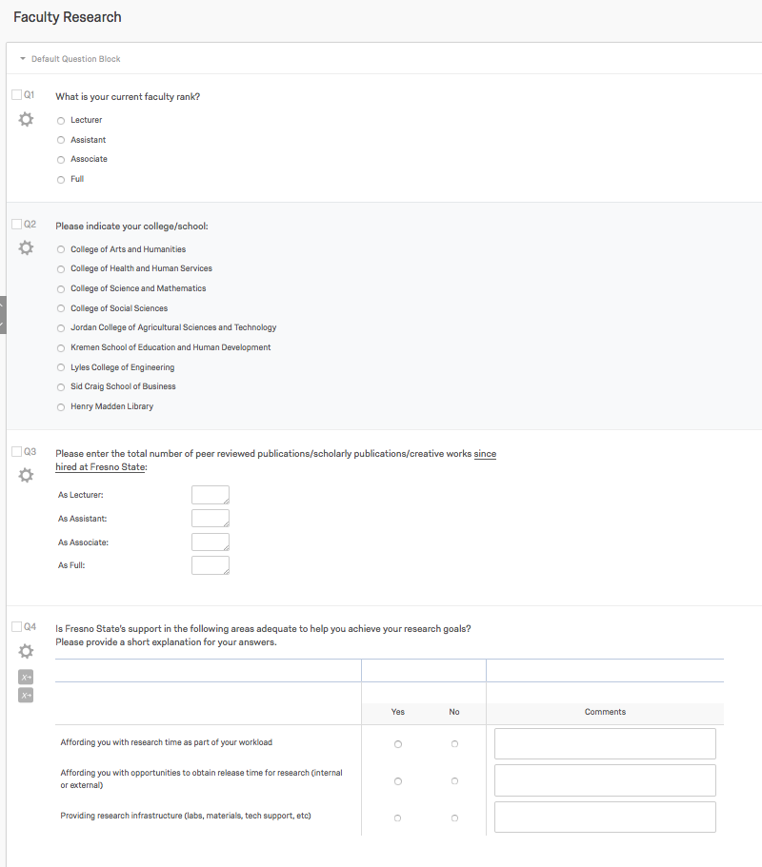

Appendix C – Quantitative analysis of the faculty survey

We sent the survey on faculty research to 1377 faculty members on campus, with three follow-up reminder emails for those who have not yet completed the survey. The breakdown of the participant pool by academic rank is as follows:
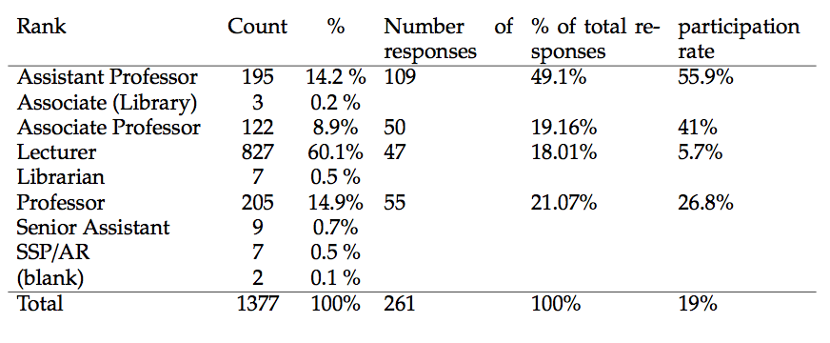

The following graph shows the participation by colleges:
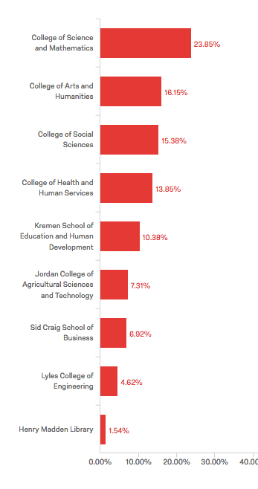
In preparation for analysis, we cleaned up the dataset. In particular, we
- deleted two observations with rank ASSIST, because they only indicated publications as ASSOC;
- deleted two observations with entries “2 submitted not yet approved” under publications';
- changed text entries such as “1 book” to numerical entries such as “1” on six occasions;
- changed an entry ``none'' and an entry “N/A” to the numerical entry “0”;
- deleted one observation with rank ASSOC who publications in as FULL;
- deleted one ASSOC rank, whose publications were 160, 320, and 45 as LECT, ASSIST and ASSOC respectively, as this observation was clearly an outlier;
- deleted observations with empty entries at a lower rank, and some number of publications given at a higher rank, for we didn't know if the person was hired at a higher rank, or simply didn't put in “0” for publications at a lower rank.

These actions resulted in 255 observations. Of these, 209 represented faculty in one of the ASSIST, ASSOC or FULL rank category. We ran two types of tests on the cleaned-up dataset:
- [ANOVA] The analysis of variance test compares multiple groups in an effort to establish whether there are statistically significant differences between the means of a statistic associated with each group. Even if the test signals the presence of a statistically significant difference in means, it does not indicate where the difference lies.
- [t-test] To find where the difference may lie, we ran 2-sample t-tests pairwise comparing the samples means of ASSIST, ASSOC and FULL.

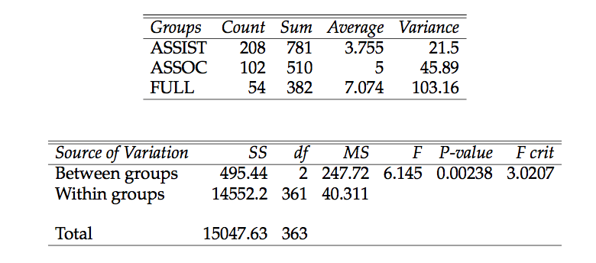
Analysis of Variance results. As the results indicate, there is a significant difference between the means of the three categories ASSIST, ASSOC and FULL, even at the 1% significance level p-value 0.00238). Thus we needed to run three 2-sample t-test to determine where the difference lies.

t-test results. The results of the three 2-sample t-tests are displayed in the following tables:
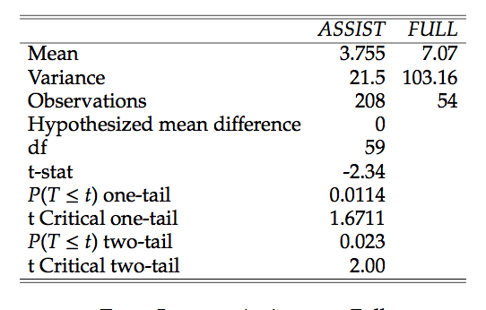

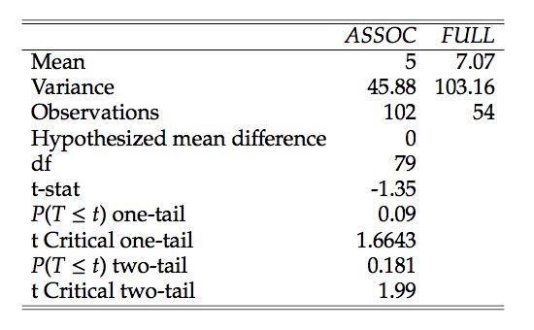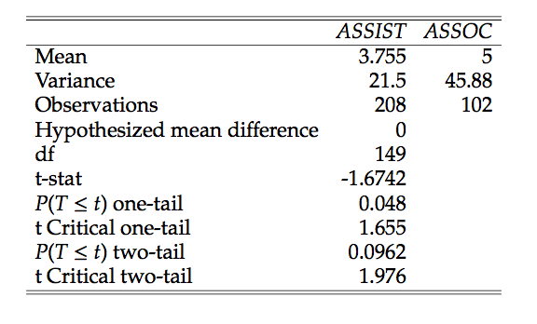
Based on these results we conclude that the only significant difference at the 5% level is between ASSIST and FULL. That is, full professors in the sample publish more on average then assistant professors in the sample.

Caveats We did not attempt to control for length in the current rank. This is a source of significant possible skew in the data, as assistant professors in their first-second year are likely to have a lot fewer publications than full professors in their 17th year. In addition, while time-in-rank can realistically be taken to be bounded above by 6 years for ASSIST and ASSOC, the reasonable upper bound for FULL is more like 25 years. A better indicator to use (rather than raw number of publications) would be publications per year in rank, if one wanted to better gauge research productivity across ranks.
Another issue with our data is that reporting was voluntary, and as such, some level of self-selection is reasonable to assume to have happened. Faculty how believe that research is an important part of our job (as important as teaching and service) are (i) more likely to have responded to the survey, and (ii) are more likely to have consistent publication records. As such, we direct particular attention to the rather low participation rate among full professors. Note that participation rates were 5.7% for lecturers, 26.8% for full professors, 41% for associate professors, and 55.9% for assistant professors, which may be taken as an indicator for level of interest/expectation in research corresponding to the various ranks.
Conclusion Our data allowed for some rudimentary statistical analysis of research activity on campus. The survey completion rate was 19%, which tends to be in line with large institutional survey completion rates. The average number of publications (3.75 for assistant professors, 5 for associate professors, and 7.07 for full professors) tell a story of involvement in research across all ranks. Participation rates in the faculty research survey (especially for full professors) may indicate that the fraction of faculty involved in research may be decreasing with rank. Finally, full professors in the sample publish significantly more on average than assistant professors in the sample, while there is no significant difference between the average number of publications of assistant and associate, or associate and full professors.

Appendix D – Qualitative Analysis of Responses to Q4

Numerical breakdown of responses to the yes/no part of Question 4.

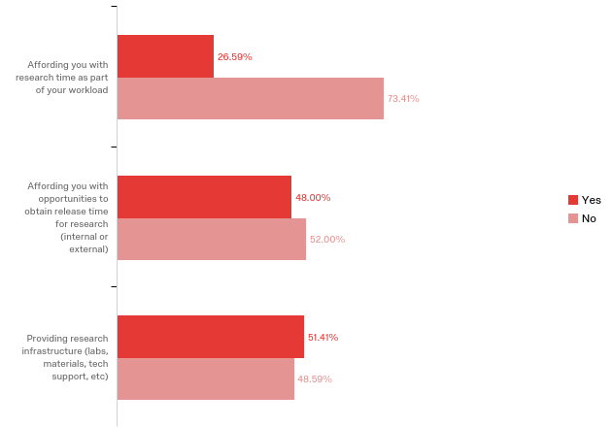

# | Question | Yes |  | No |  | Total
1 | Affording you with research time as part of your workload | 26.59% | 67 | 73.41% | 185 | 252
2 | Affording you with opportunities to obtain release time for research (internal or external) | 48.00% | 120 | 52.00% | 130 | 250
3 | Providing research infrastructure (labs, materials, tech support, etc) | 51.41% | 128 | 48.59% | 121 | 249

Q4/1: Is Fresno State’s support adequate in affording you research time as part of your workload?

Summary
The overwhelming response to this question is “no,” for the reasons listed below. Course overload is the most pervasive theme. This is accompanied by other teaching-related themes: lack of tenure density, increased class size without teaching assistance, new course prep, and scattered scheduling. Supervising student research, advising, administrative duties, service on committees, and general busy work also recur as aspects of workload that encroach on research time. Some have commented on the lack of time to even apply for release time or funding for research.

Another consistent theme is that when research happens it does so on the faculty member’s personal time and/or is made possible by external grants (which require time to apply for).

Some few comment that they are satisfied with the research support they are currently getting; these are mostly new hires who have not yet assumed the full course load. A couple of faculty members say that the question does not apply to them, either because they are adjuncts or because they do not have a research agenda.

This report includes all comments that faculty provided in response to Question 4:1. Where a single comment covered two or more themes, I have either broken it up in order to group it with the respective theme or, very occasionally, entered the entire comment twice, under different headings.

Course overload
I am aware of all of the opportunities. But four classes is a lot. There is simply not time for all of it.
Teaching load should be 2/2.
Although my appointment includes 25% research release, I am often overloaded in terms of teaching WTUs
I have been overwhelmed with teaching responsibilities and haven't had adequate time to research.

Loads are too heavy--especially a meagre 1.3 WTU received for large classes that require outside student evaluation.

Teaching four courses is not sustainable. A 3-3 load would be much more manageable as far as balancing research and teaching, and also making time for faculty to incorporate students into their research projects as it takes a lot of effort and pre-planning to do so.

The workload of 4/4 needs to be reduced. It, along with the amount of service required, makes it difficult for me to focus on my research.

The school is providing some much-needed support to get teaching load down to a 3/3. However, a 2/2 or a 3/2 is what is needed for us to move to Carnegie II.
This year I have intentionally focused on my teaching, so my response is a little skewed.
We get 3 units of research/other activities as part of our 15 unit workload. This amount of time (in addition to 3 or 4 classes) is inadequate in performing high quality research.
Are you serious? With all of the classes to teach, student advising, tutoring, course prep work, online surveys, compliance/risk management training, meetings, shall I continue? When do I have time to do research?

A teaching load of 12 WTUs doesn't allow enough time for research.

12 WTUs/semester with four preparations most of the time!!

4-3 every other year is not a research job, at all. 3-3 with opportunities for release is.

Not sure what you mean "as part of my workload." I don't feel that creative, scholarly, or research work is valued as much as classroom teaching at Fresno State.

With a 4/4 teaching load it is difficult to find large chunks of time to work on research.

Not really. As we all know, 12 units of teaching with 3 preparations each semester is a heavy teaching load.

The course load of 4/4 makes it very hard to research. Many of my courses are in the GE with a 2000 word writing requirement. This detracts greatly from the time available for research.

It's been difficult for me to balance my teaching demands with my need to do research. This semester I have some time because I created an imbalance in my schedule with a higher teaching load in the fall to afford me some time in the spring to do research.
Yes, but more release time would lead to more research productivity. Would like to see a reduced teaching load.

[We should teach] no more than 3 classes per semester.

My first two years I received new faculty buy-out for research. During that time I was productive and feel that it was useful. Since that time, I have not received the opportunity to obtain release time. I currently teach 4 courses with 3 different preps. I also have administrative duties that require a significant amount of time each week. I understand that we are a teaching institute, and I greatly value that work. Opportunities to obtain release time for research would be appreciated.

I have a 4:4 teaching load. The occasional course release helps, but I have to get the bulk of my research and writing done during the summer.

The teaching load is twice more than average values in prestigious universities.

It is difficult to teach a full load and do research.

The teaching load is twice more than average values in prestigious universities.

Very large teaching load
Though my chair and dean are incredibly supportive, a lower teaching load would be very helpful to maintain an active research agenda.
it is to the extent that time spent doing research with students counts towards teaching load. It is not possible to teach 12 WTUs per semester and keep up significant research and advising.

While the college and university does provide course releases, our current teaching load greatly inhibits my ability to do research and write during the semester.

A 4-4 teaching load does not leave much time for conducting new research or writing on existing data.

We only get one unit of time for research each semester after our first two years---I honestly don't know how I'm going to keep up my research productivity when 12 units of my time is devoted to teaching.

I would appreciate fewer classes, even if it meant a higher unit count per class, if it meant more time for research.

teaching is my primary workload.

As a new hire. I'm not sure how I'll juggle 4 courses plus research

With the base teaching load of 12 units, allocating time for research is extremely hard. At the moment research does not appear to be a part of workload.

A 4-4 teaching load does not allow for much research.

4-4 teaching load is very heavy, which leaves little time for research during the semester.

I still have to teach full 12 credits per semester.

The teaching load is too high to ensure a greater quality of research output.

Too many new course preps
First off I would like to note that, as a new faculty member, my experiences likely are not representative of the typical experience at Fresno State with research time. However, my time here thus far has been spent prepping two entirely new classes each semester leaving no time for research.

This aspect of my requirements for tenure could improve. Although I am required to complete a fair amount of publications in order to receive tenure, I am regularly given new courses to prep each semester, which - in my opinion - takes away from time I can dedicate to my research. It would be preferable if I were assigned courses that I have previously taught (which are plentiful) instead of being asked to develop new courses each semester.

I teach world and Asian history: I am rarely able to double up sections - teach two American history sections for example - so I'm often preparing four different courses.
Lack of tenure density
With so few TT faculty (compared to lecturers) in our department, the admin/committee/advising load is really high -- a FT job by itself.

A 12 WTU teaching schedule each semester is not conducive to high volumes of research. More faculty are needed.

As the only TT-T professor in my area I am fully responsible for all aspects of running the studio etc. Until 2010 there were two tenured professors in this area. Since the retirement of my colleague, (aside from teaching responsibilities now shared with a PT instructor) I have managed a workload previously shared by two faculty members. Thus, while school is in session there is practically no time for my research and creative activities.

Seriously understaffed in terms of tenure track faculty.

There is no time for this. My option has 2 faculty who've managed to not teach in the option at all, and 1 lecturer who teaches in an area completely outside of his knowledge base. The chair is aware of it, but since it doesn't impact his option, it don't matter to him.

the workload increases every year; we need full time faculty to share the workload, and have had several retirements that have not been replaced. We have the highest FTEs in our college and not enough full time faculty.
Advising/administrative overload
With so few TT faculty (compared to lecturers) in our department, the admin/committee/advising load is really high -- a FT job by itself.

Teaching and advising are time important priorities for my workload

I have had less time to work on research as department chair. Without generosity of new Interim Dean regarding release time, I would be unable to move forward with any projects.

My first two years I received new faculty buy-out for research. During that time I was productive and feel that it was useful. Since that time, I have not received the opportunity to obtain release time. I currently teach 4 courses with 3 different preps. I also have administrative duties that require a significant amount of time each week. I understand that we are a teaching institute, and I greatly value that work. Opportunities to obtain release time for research would be appreciated.

Too many duties that administration should be handling, in particular having faculty do department assessment for administrative needs.

With administrative and teaching duties, I am working 10-12 hour days on a regular basis and have very little time for research

Mentoring/supervising students consumes available research time.
The University (and System) needs to understand the amount of time necessary to conduct research, including mentoring students in techniques, data collection, analysis, and communication. Without my currently having externally-funded assigned time for research, there is no way I would have been able to be productive enough with research students to be on a strong track to tenure (i.e. having obtained external funding, published in peer-reviewed journals AND had the time to attend to classes sufficiently to maintain strong teaching evaluations). In my mind, our 12 WTU for teaching should more liberally include solo or small-group mentorship to reflect the amount of actually time spent on those efforts.

[M]aking time for faculty to incorporate students into their research projects as it takes a lot of effort and pre-planning to do so.

-not unless it is already identified in funded research; there is no opportunity to have dedicated time to explore other possible opportunities to diversify -mentoring of students through independent study is never given the credit (and time) that is required

Supervising experimental research students take a lot of time. So far we have been using Independent study to get some relief but never sufficient.
Supervising student research is dismally under compensated in terms of time.
Service overload
For the most part (the exception addressed in my response to the next question), the demands of teaching and service in themselves amount to full-time jobs, making research something to be accomplished by the equivalent of massive overtime hours.

The workload of 4/4 . . . , along with the amount of service required, makes it difficult for me to focus on my research.

Although providing research time, other service time such as community, service, committees are included.

Not really. . . . We also have to serve on different committees at department, college, and university levels.

3 WTUs is barely enough for committee works, and leaves no time for scholarly activities.

The service load is intensely, extremely high at the department level in particular, and service at other levels only compounds our exhaustion. For a relatively small department (faculty-wise) with a huge amount of majors and minors, we are overloaded trying to ensure that the standard business of our program is all handled.

There are too many service obligations, and too many damn meetings for me to be able to do research anymore.

Increase in class size, but no T.A.

ABSOLUTELY NOT!! Since arriving at Fresno State 10 years ago, my class size for all courses has doubled while the number of courses taught has not decreases (4 per semester). Also, in my department there is no opportunity to assign a GTA to assist with teaching. So, no, Fresno State is not supportive of faculty in the tenure and/or promotion track in regards to affording faculty time for research.

Teaching 4 upper division classes a semester with 40-50 students each requires quite a bit of grading to take place, if one wants to go beyond the multiple-choice questions. Multiple choice exams can make use of Bb to cut down on time spent on exams during the semester but Bb does not grade short answers or essays automatically. One way to cut down on my time spent grading the latter assignments would be to have a grader. I would be willing to train him/her, provide the answer keys and help in the event that s/he does not know what grade a particular answer deserves, but that would allow me more time in the lab.

Smaller classes (enrollment kept below 100) and a 9 WTU teaching load, with 3WTUs for research would help.
Applying for research time requires time.
Since I've been hired, there's been a constant pressure to teach, and in order to get research time, I have to spend time outside my alloted WTU load to work on proposals for research release time. This has not been ideal, and along with campus and system-wide initiatives to increase student success, faculty research (for me) has not been supported.

Even with periodic opportunities of release time - which themselves take time and effort to apply for - the workload is just bearable for teaching and service.

I regularly have to spend time on applying for internal release time, (3 WTU) which sometimes ends up being not sufficient for a full course release in terms of the number of courses taught
Too much busy work
Are you serious? With all of the classes to teach, student advising, tutoring, course prep work, online surveys, compliance/risk management training, meetings, shall I continue? When do I have time to do research?

Too much busy work. It really gets in the way of research.

Class scheduling

Scattered class scheduling is really impacting the time I have for research. Alternate semester loads can help.
General comments re. inadequate support as part of workload:
Other than 2 sabbaticals in 30 years, have never received time for research for creative activities.

I received one semester sabbatical to take advantage of my Fulbright Fellowship in 40 years of teaching.

The time allowed for research is not anywhere near enough.

Since it is part of our job, those with a publishing track record should be afforded automatic research time to continue doing so.

I have none alotted, but an expected to maintain an extensive research record for tenure.
My job is complicated and requires my presence at various times, with high frequency.

Research is not scheduled in as part of workload, Creative bookkeeping is required to acquire sufficient time to conduct and complete research.

My role was never understood. I was not given time or credit for my work.
I didn't even know that this was an option.
[I would like to see] 3 units of a full-time course load of 15 units.
Only for the first 2 years as part of CSU new faculty buy-out
Being a lecturer, research is not primary to my role, however, I have done and continue to do research. Having research time built into my workload would definitely make the work environment much better.

By default no time is given. If you have money, then support is there.
No. Although research is expected, it is not viewed as part of my workload except when I get release time. When I get release time, I'm often reminded that this is "unfunded", as if I somehow had to be grateful for a special favor afforded to me. There is no mechanism (course) but into the workload that accounts for the time I put into research in a realistic manner.

No: I carve out research time through externally funded assigned time and through carrying an insane workload. All my research time as an associate professor has been externally funded assigned time (bought out at full rate); I have received no support from Fresno beyond allowing me to buy out my time. My work load is typically 6 WTUs of teaching, 25 hours of service (incl. professional service), and 30 hours of research = 80 hour week. Counting all our teaching as part of our WTU load (incl. undergraduate and graduate independent study and research units) would be a step in the right direction. Smaller classes (enrollment kept below 100) and a 9 WTU teaching load, with 3WTUs for research would help. It's two-faced to require research (scholarly activity) and service for promotion and tenure, but give no time to do so. The 3 WTUs given currently (reducing our teaching load from 15 to 12) is given for student advising, not service, not research. We need a workload overhaul!

To my knowledge, lecturers are not provided release time for research and publications on a permanent basis. I would love to have 3-6 WTUs dedicated to research as part of my contract. I am a very productive researcher but unfortunately do not feel that it is valued by Fresno State.
I feel like all I have time for is teaching, prepping, and grading (plus the service and regular meetings).
I would like more time
Apart from the union-negotiated releases in the first two years, we are not allotted dedicated research time. Any "research" time is gained only through assigned time -- which is filled by the assignment that justifies the course release. We have research expectations, but we are not provided with time to do that research.
Even with new faculty release time I find it difficult to have any time outside of teaching to perform research. Hopefully this will ease up as I grow more comfortable in my class load.
There are not enough sabbaticals. There are too many service obligations, and too many damn meetings for me to be able to do research anymore.
I do research but only on personal time and/or with external grants.
Absolutely NOT! To be able to do my work I have to carve it out of my family life.

I'm a part-timer. I teach fewer units so I can use my own free time to focus on creative work.

I utilize my own time to research and update material to use in my class.

I've mostly had to fund this from my own external grants, university needs to offer more to sustain. Critical, for including students in research and publishing papers.

The work gets done, but much of it gets done on my spare time (nights, weekends, winter and summer breaks).
There is currently no research time as part of my workload. All research is done in addition to, particularly during the summer.
Not even close. I do most of my research during my unpaid time in the summer. My teaching and service responsibilities/choices take significantly more than 40 hours per week.
I do my research on my own time. Teaching five class each with 27 students leaves little time for research.
I have a 4:4 teaching load. The occasional course release helps, but I have to get the bulk of my research and writing done during the summer.
Research is done outside the allocated workload of 3 classes, one clinic section, advising, and committee meetings.

I am a performing musician. Performances are a part of my scholarly and creative activities, and publication. I do not get release time for the 4-8 hours of rehearsal and practice time I spend outside of school each day to keep my technique and repertoire up to an internationally recognized standard.
I collect data and write primarily on breaks.

I spent extra time for research.

As we all know, our positions use all the time for teaching, so research is something extra, except for sabbaticals.
Nope - hired in the days when we were expected to teach full load and do research on overload, weekends, summer . . and frankly, we got it done. Support might have been nice but I don't see greater productivity from junior faculty now . .and ours get 1/2 teaching load for 2 years .

My teaching load is 15 units and during the semester I have to carve out a little time to keep going.

No: I carve out research time through externally funded assigned time and through carrying an insane workload.

One must get grants to allow for research time.

There should be no cap on how much release time can be bought with grant funding or other sources.
There is absolutely not enough time allocated toward research. I have four publications, but only because of external grants and the fact that I work in my personal time, nearly all the time, in order to remain active in my research area. That, unfortunately, with life's other demands, is simply unsustainable.

Research is completely on my own time beyond the 100% teaching load
At present I have adequate support as part of workload because:
I have some release time as part of my agreement with the Dean.

Summers off.

I am a new tenure track faculty member at Fresno State. As such, I am being released 3 WTUs for research, presentations and publications for the first two years. Please know that I am very appreciative of this support.

New faculty release time is sufficient for current work.

I teach only one course per semester, so I have plenty of time to do research. To survive, however, I would be happy to teach two more sections.

I am a new hire so this is survey is premature, in my case. I feel that my job description affords adequate time.

As a librarian, my work is my research. I am fairly new in my position, but every time I've been inspired to try a new approach to teaching, develop a new service, or evaluate a program, my administration has been positive and supportive, not just in affirming and providing feedback for ideas, but also, in connecting me to other resources including research funds, experts, or systems that could be of use.

I am in my second year, so having the one course release has been helpful.

I am in my first two years with the standard 6 WTU release time and I am happy with it. It will be great if there are release time after my first two years to support my research with both faculty and students.

Yes with caveats: I am currently still on start-up, so I have half-time teaching as part of my contract. Once that is over, unless I have external funding, I am out of luck. External funding is so difficult to come by, and without time to do research, I'll not be a competitive grant applicant, meaning I won't get external funding, meaning I won't have time to do research, perpetuating this cycle.

Question is not applicable because:

I have no known research goals.

No need.

As a part-time Lecturer, research is not required. However, I am involved in other activities which enhance the profile of my department / college, on a voluntary basis.
Adjunct
Other/unclear:

Did research and submitted for publication as part of my Doctoral of Nursing Practice (DNP)through state.

I don;t understand the question.

Q4/2: [Is Fresno State] Affording you with opportunities to obtain release time? (internal or external)

Theme 1: Lack of opportunities

Code: No opportunities or few opportunities

Again, as a new faculty member, I've been told these opportunities are allowed and will arise but have yet to see evidence (at least of internal opportunities) at this point.

Have not had this opportunity so far.

Opportunities are there, but there should be available for more faculty. I hae sporadically used such opportunities because I really enjoy teaching the classes that I do and am loathe to subtract one or two of them.

In the past year, we have not been offered opportunities to obtain release time.

Opportunities are very limited.

Minimal at best and the few opportunities tend to go to chair and dean friends…My release time as option coordinator goes up and down and on the whims of the chair.

Too few opportunities to obtain release time for research. In my college, there is a competitive research release time opportunity, but there are not enough awards and preference goes to assistant profs and the tenure track.

Additional release time opportunities would be very helpful to maintain an active research agenda.

Faculty could benefit from more opportunities for release time.

Only through Danoy or other grants.

There are few opportunities, but normally I take the money instead because it is more useful to pay student then take the few hours for myself.

Well, the usual college and provost opportunities to apply for release time. More would have been very helpful.

There are some opportunities but we need more especially after my first two years.

There are a few sporadic opportunities to obtain release time, but not nearly enough to offset the time commitment for working on large grants.

Once a year, competing with other research active colleagues for very limited number of Scholar and Creative Activity Awards affording release time, when the decision process is very subjective, cannot be called "adequate support."

There are reasonable opportunities, but too few total WTU for the number of applicants.

Need far more opportunities for release time particularly. Current internal funding opportunities are very inadequate.

The system does provide the opportunity to apply for minimal research release time, so the answer here is more yes/no. In the humanities, obtaining buyouts via grants is essentially impossible, so any course release come via assigned the one research release we can apply for annually (which includes rewarding those who have not received a release before fist -- which makes it harder for productive researchers to obtain it in future years).

Only if I receive external grant funds am I able to buy out my time to do research.

The release time for research is a special category and only really relevant if we go after external funding. i.e. in my understanding, my work time is supposed to be 24 WTU teaching, and 6 WTU of university service.

Would be an excellent use of university resources to expand those opportunities if at all possible.

Other than 2 sabbaticals in 30 years, have never received time for research for creative activities.

Code: Lecturer unsupported

I'm a lecturer, aka second class faculty member; overlooked and taken for granted.

As a part-time lecturer, research is not required. However, I am involved in other activities which enhance the profile of my department/college, on a voluntary basis.

I do my own writing and research on my own time. I've never asked for time off because I assume that, as a part-timer, I won't be granted it without also losing pay, which I don't want to lose.

I am a lecturer no releases of any sort.

My primary role as a lecturer limits my ability to spend time and effort on research opportunities.

Adjunct

Code: Pre-tenured/junior/assistant faculty provided assigned time

CSM has shown strong support (at least of pre-tenured faculty in providing assigned time for research for grant-writing.

The university grant release time is--understandably--primarily for assistant profs. It would be especially helpful to have University release for more senior faculty for research.

Most assigned time for research is given (appropriately) to younger faculty, but those associate and full professors still require assigned time, especially between grants.

Theme 2: Not enough time

Code: Release time is not enough

I have gotten release time for research, but you can never count on it, and its only 3 unites release. I was offered to write a textbook by OXFORD but since I couldn't be guaranteed sustained release time I turned it down… pretty sad…

More time will be appreciated, if possible.

The CSM offers 3 units of release time for research through the college programs. Faculty need to apply for it and my experience has been that I still taught 3 classes (3 units each instead of 4 units) when I got this award. This was extremely disappointing as it doesn't really give us enough time to perform research. It would be helpful to see a single course release rather than a 3 unit release as part of the college program. I have stopped applying for these programs for the same reason.

There are opportunities for release time, but they are insufficient.

NSF DMR is not favoring to award applicants' teaching release time. Internally, there are one program from CSM and one program from the University for faculties to apply. However, not enough funds to cover all eligible faculties. Sometimes we need to bargain with the college dean directly but still not enough.

There is regular money, a small pool. But the application procedure or materials changes ever so slightly every year and we are routinely reminded that the money is not guaranteed in the future. And 1 course release a year is barely enough to make a difference anyhow, even if one gets.

Most universities are at a maximum of a 3-3 load if there are research expectations of faculty. A one course release does not even bring me to semester equivalent of a 3 course load.

Somewhat but not enough. Sabbatical leave is helpful but it is one semester every 7 years.

No. There are not enough course releases available for faculty who want to pursue a vigorous research agenda.

Release time is too little and too short to allow the completion of a meaningful program.

There is not enough time to do research every semester or to complete research as part of a normal work week (i.e. without sustain work time on nights and weekends).

It would help my more productive colleagues to remain so if they were given 6 WTUs/year rather than just 3 WTUs.

More assigned time for research is necessary.

Release time is infrequent.

KSOEHD's Dandory grant become unavailable for research funding.

Received some release time, but definitely not enough.

We can only apply for 3WTU per academic year. I would like to be able to apply for 3WTU per semester.

There are once a year calls for 3 WTUs release for one semester. This is completely inadequate to support any long term research program. Fresno State needs to figure out a way to give release time for faculty involved in research. Other CSUs have done this so it is possible.

One semester maximum per year of release time still = a 3-4 teaching load. Even with the service evenly spread among us, the amount required for our department to function means that one course release, plus three full courses, and the thesis or project supervision, is really not enough to produce a full-length, publishable article in the funded semester.

I did get a sabbatical to do my research the spring of 2015. I am grateful to the University and College of Science and Mathematics for that. I need more time to finish.

There are opportunities for course releases, but it seems like the expectation is that we should be able to conduct research and publish within one semester. That often leaves me with research completed but not time to do the writing and revision it takes to publish.

There are internal opportunities, but we should be allowed for release time for two semesters, when the project is a big one. Moreover, the College/University should provide matching funds in the form of release time when a faculty member has a research grant that does not allow for course buy out time.

Some release time but not nearly enough.

Assigned time per year would be better than per semester.

Code: Release time doesn’t ease load of work

Basically, the load issue “trumps” any time left over for research. Release time helps, but even then, the loads are heavy.

Sort of. I have received course releases as new faulty and for research once, but there is so much advising/admin, it's hard to hold that time open for research.

There are so many WTU's that "can" be used for release in the APM 337 Appendix B, which aren't granted, meaning that in order to maintain good classes, collaborate in departments, colleges, and the entire campus, a lot of the teaching work we do is unsupported, which turns into even more prohibited research.

Only if funds are already brought in--it is always a negotiation--time to write quality proposals (to get funded) is never considered part of the workload.

My Chair did not allow for release time for the third and fourth grant. I have been consistently over units and giving leadership responsibilities which make it difficult in getting an opportunity to complete research and write for publication.

Has been available, not always realistic because of teaching load and committee obligations.

Yes, I am writing my own grants to get eternal funding for my research. Thank you for allowing me to submit grants. As an assistant prof, I got internal assigned time (3 research WTUs in total over 5 years). Nothing internal since my promotion. The support from Fresno to write proposals and execute grants is inadequate for (tenured) faculty. I don’t have time to research and then chase after little internal pots of money...

Administrative duties really get in the way. I get release for admin but then I can't take more release for research.

There are opportunities which are helpful. But if there are requirements attached to a probationary plan, it is my opinion that time should be allocated in our normal workload to meet those requirements. It should be a given, not something that requires additional work to be able to do it in the first place.

I firmly believe that we need more ongoing support, rather than a one-off 3 WTU release.

Very limited support

Code: Understaffed

The opportunities do exist to apply for release time, but our Department is currently very understaffed, and nobody can teach my courses if I have release time. We even struggle to find outside people to teach Viticulture courses since the field is very specialized.

While it was made clear this was an option at NFO, it has unofficially said within the department that no one is available to teach the classes being release from.

In small programs, when an instructor has release time, then courses that need to be offered so that students can graduate in 4 years are not being offered. It is difficult to choose between meeting one's own goals in research and meeting the graduation goals of the student body.

Sometimes this happens but usually a lot of pressure due to lack of tenure density to dover classes.

Theme 3: Opportunities and helpful

Code: There are opportunities and helpful

Thanks to former Dean Vida Samian of CAH, I was awarded release time of one course over two semesters to complete a book.

Yes, the College has been generous with awarding release time to those who apply for research awards.

All of my books were supported in part by RSCA awards and a sabbatical in Fall 2012.

COSS does offer good support in this area.

I am currently being released 3 WTUs for working on my research project on behalf of the Dean since I am new faculty. However, this will not be the case starting ini the Fall 2017. Please know that I am very grateful to have the first two years available for my research endeavors.

It is possible to apply for a competitive intramural grant for release time once a year, giving us 3 WTU of research time.

CHHS granted me 3 WTU release time this spring for which I appreciate.

I teach only one course per semester, so, yes, there is enough time.

There are opportunities for release time and for grant funds for expenses such as student assistants.

I received released time for research several times.

There are college opportunities for release time that have made a big difference.

I have taught no more than two classes in the spring (due to NSF - or College-derived release time). This has been extremely helpful.

Code: Know but have not applied for

I know this is a possibility, but I have not applied for it, as that is one more thing to do.

There are opportunities. I have not taken advantage of them as much as I should have.

Haven't needed to take advantage of this because of the nature of my position, but I know there are opportunities available if I had a project or work that warranted it.

Theme 4: Barriers

Code: Competitive

There are College awards but it seems competitive.

The college of science and math awards release time for research on a competitive basis.

Internal grant is competitive but I got a few in the past 15 years.

Fresno State has done a good job with providing internal opportunities for release time in the past---but more people are starting to take advantage of these and they're getting much more competitive, since the same or less amount of funding is being provided each semester. With federal funding the way it is, the options for obtaining release time are all starting to look pretty grim.

With more research0intensive faculty here, competition for these coveted releases is extremely high. Applying for release time affords no guarantee that you'll get it.

Code: Didn’t know about release time

I am not clear that the University can afford this. I think it is up to me to obtain a grant that allows me to buy out my time.

I had not heard of any release time yet.

I didn't even know this was an option.

Not clear how to obtain research time.

Did not know I could qualify for release or research time as associate instructor. However, also teaching nursing clinical during obtaining doctoral and working, so to know if I qualified would have been very beneficial.

Code: Not financially sustainable

I have been awarded one semester sabbatical (to those of us who are single it is financially unattainable to take a year long leave) for my own research/creative activities. I also have received two course releases for community oriented volunteer projects.

I am disappointed that junior faculty are contractually ineglible for difference in pay leave if they receive an external fellowship. This creates a great financial burden, especially now that Affordable Care Act is being dismantled.

Only if indirects can compensate for your salary.

Q4/3: [Is Fresno State] Providing [sufficient] research infrastructure? (labs, materials, tech support, etc)

Themes:

- Lab/research space x22
- More technology workers x2
- More tech support in general x6
- Lessen workload for them x3
- Need to be more aware of materials support
- More materials provided by the university/office staff x5
- Funding for technicians/student interns/post-docs x4
- Make it easier to hire them
- Travel funds x3
- Qualified personnel staff to run equipment/instruments x3
- Updated or better maintained equipment x2
- Research support x2
- More journals/databases available x2
- Stronger communication between college administrators and faculty x2
- Research startup funds
- Funds to update lab space
- Funds for lab equipment aside from what you receive from startup funds
- Funds to pay for a consultant who can facilitate training for data collectors
- Rule changes on the way funds are used (internal or external)
- Research assistance for newer faculty
- Prevent senior faculty from abusing resources
- Improved facility
- Create a faculty research resource center
- More opportunities to exchange ideas and construct collaborations
- Free qualitative research software
- Equipment to support tenured/tenure-track faculty research
- Stronger leadership between the dean and department chair
- Support system for high impact studies
- More programs to obtain lab equipment
- Statistics center
- Equipment support
- Help with maintenance/service contract payments
- Effective support from Foundation
- Running hot water year round
- Animal facilities (to control/maintain room temperature)
- More internal funds to apply for more external funds
- Need grant managers
- Tuition waivers for grad students that wants to do research

Comments
For bench ("wet") biology research, spaces are outdated and too small, mainly for the number of students that would like to be involved in mentored research.
I have a great lab and my grants will help offset the cost for materials. Having more funding for technicians, student interns and post-docs will be very helpful. Grants are seldom large enough to employ the actual research support needed.
Travel funds are nonexistent
our tech folks are WAY overworked.
This is a yes and no response. I would like to see some assistance. Most of what I have found regarding research assistance is because I have found out on my own.. and as a newer faulty member I do not know what I don't know. It has not been easy.
As a social scientist, tech support would be most helpful; so too would changing the rules about how we can use our funds (external or internal) to compensate research participants. Right now they are restrictive and run counter to the best practices in my field (anthropology), thus preventing my colleagues and I from pursuing exciting research opportunities or completing existing projects.
Not really applicable to my academic focus (art history).
It's super challenging to purchase any software or hardware -- so much so that I've just about given up. Our unit tech staff are apparently overwhelmed with work and cannot process any requests (all of these require their approval) until I've made numerous appeals over long periods of time...
I don't have lab space, and there's been disagreement in CSM about JARC use, so again, it's been very difficult to find time and space for disciplinary research.
This could be improved at the University level. I feel it is strong at school level.
The Madden Library staff have been a big support for me in terms of located peer-reviewed journals that I can begin to explore for future submissions.
The equipment provided to me is adequate for performing research. I thank the University for this infrastructure.
There is plenty of infrastructure, as long as I use tenured faculty materials.
Hiring students gets me resistance from my admin support staff because it's too difficult and getting space allocated gets me resistance from colleagues who want the space although they have no need for it
I am a Palaeopathology, so this isn't something I'm truly expecting from an American university.
-never enough, particularly for large, technical equipment and instruments. -need more dedicated personnel staff hired to assist with instrumentation, otherwise, undergrads and grads are not sufficient expectation to always run equipment/instruments
Not essential in my field.
Space is a constan issue.
As a part-time Lecturer, research is not required. However, I am involved in other activities which enhance the profile of my department / college, on a voluntary basis.
I haven't checked into what types of infrastructure would be available to me. Again, I don't know what I can expect as a part-timer.
If there was a middle of the road response, I would mark that. I have start up that will allow me to purchase materials that will benefit data collection. However, I have to carefully prioritize how to spend the money-- I will ultimately have to spend money out of pocket or obtain grants in order to move my work forward. It would also be nice to have funds to pay for a consultant who can facilitate training for data collectors.
To date, there is no research infrastructure to speak of in terms of lab space or materials, both of which are essential to conduct research in my area of expertise.
Not really necessary in my case
Laboratory space has been satisfactory for me, but I have colleagues that have more trouble with space.
Space and equipment are limited and I needed to fight with senior faculties who have been abusing the resources to get what I need. It waste me time and energy.
As a humanist, I don't need much.
as above
I guess so. I'm writer. So library resources are good and the laptop helps a lot.
Some.
No need
The facility is basic but it is better than nothing.
On two occasions I received approximately $500 to offset the expense of participation/registration fees for creative symposiums abroad. There is no infrastructure provided for faculty use at our department. On occasion I use the studio/lab on campus during weekends and school holidays.
NA
largely irrelevant for my research
Fortunately most of my research is not instrumentally intensive. For such work I need to collaborate outside of Fresno State.
I have been fortunate in this regard, but my colleagues are woefully underserved for lab space.
No support whatsoever.
I was initially given startup funding that was helpful at the beginning of my teaching here. The Dean has always been supportive of my research, especially when it involves working with students.
N/A
not applicabel
Several assistant professors in College of Science and Math do not have access to any research spaces on campus.
Only hired as part time lecturer but would like opportunity
I didn't even know that this was an option.
Mathematics doesn't need equipment in many cases, only time.
There is a serious lack of space for me to conduct my research (like rooms). I do have the basic equipment, but the space is something that needs to be improved.
some support.
Not really an applicable question.
I have applied for research grant funds to support my research. I also use a rooms at USU for our research projects. It would be advantageous to have a faculty research resource center to discuss experimental design, statistical analysis and have support for data analyses.
My startup allowed me to buy basic instrumentation.
I recently discovered that the graduate statistic center available to graduate students can assist me in analyzing my data which is fantastic. Grant fundings through my college has helped in purchasing needed materials for my study and the use of the USU for research purposes has been helpful.
It would be very helpful if I could have a designated room for lab space, but none have become available.
Qualitative research software should be provided at no cost. There are several journals that are not available through the library also.
There is not enough support for materials, or from office staff. Office staff are not permitted to super the faculty.
Department and college are not capable or willing enough to direct funding to labs, materials, and technical support for research purposes. Research labs have been inactive for several past years!
Material needs are limited and provided for.
Not applicable
I have finally joined the FLC Work for Writing and Publications. I aim to publish at least 2-3 articles by the end of the year.
I appreciate the variety and quality of resources provided by the university.
Basically non existent. When asked about wants/needs in this area the chair does not take note and pushes his own options needs/wants to the front regardless.
My college strongly lacks the facilities (physical space) and equipment to support tenured/tenure-track faculty research. In fact, each year my department loses more and more space to athletics and other departments in our own college. This College needs STRONG leadership from both the dean and department chair to protect our interests and secure the necessary infrastructure to allow faculty to remain current AND relevant in their research. Also, there is greater need for communication from college administrators (dean & chair) with faculty on matters that will affect their opportunity for productivity at research AND teaching. More faculty governance please!!!
Department does not have research infrastructure and support system (e.g. grant manager, assistants, etc) to do high impact studies that R1 universities do, and thus we are not qualified to seek large scale grants from institutions like NIH.
We have one lab that is shared among all faculty in our department. We would benefit greatly from additional lab space.
Not applicable
Good support of research startup funds and research support, particularly in the area of specialized technical support in the form of a very qualified and professional technician in my department.
Interlibrary loan seems to work remarkably well
infrastructure not needed for my research
N/A
There are several useful, though expensive, databases that would greatly aid my research, but which the university library cannot afford to purchase.
In the CSM, what is missing is a tech or two with mass spectrometer expertise. We have several MS from RIMI, we had one in collaboration with Ag and Engineering that are simply unused...
Tech support is available but difficult to connect with. Not aware of materials support.
It would be my dream to have space in which to conduct single-case research, and to have available assistance with statistical analysis, construction of data charts, and so forth.
I cannot answer yes because I have not requested time to conduct research.
More programs are needed to obtain lab equipment. We need a workforce as well, department funded graduate assistants go along way, especially if you have two. Tech support is fine.
In my research I could use some research facilities that would enable me to set down a more permanent lab. When I get a project, it becomes an issue of where to house the equipment and exmpeiment
I am a new hire so this is survey is premature, in my case. I feel that the Civil Engineering hydraulic lab are adequate, but could use more funding to update them.
Utilized graduate writing center. They are an excellent resource. It would be great to have a statistics center to help with research.
More space is absolutely necessary.
Good space and equipment support.
My research doesn't require labs
Generally fine, but one thing when one gets a big grant, foundation needs to play more than mere gate keeping roles.
Yes, absolutely, and if they aren't available in-house they try to connect us to resources elsewhere.
i was not provided a research space even though my start up included purchasing research equipment
I work in theoretical physics so the infrastructure needs for this work is almost non-existent. Thus what Fresno State offers in terms of infrastructure for my research program is adequate, but in talking with research active experimental colleagues of mine they constantly complain about infrastructure and research support.
But I haven't needed anything
This is not a problem.
I do not need much support.
My start-up was definitely very helpful in getting my lab up and running. More help with maintenance/service contract payments would be appreciated, but I realize that's low on the list of priorities.
Not enough travel funding
The library is the best thing here; the tech support for research is very poor, it is taking months for them to buy me a computer with my research funds.
But not necessarily needed for the type of work I do.
but not really required
nothing is provided--no work space, and my salary has been so low that i cannot afford to rent studio space. currently my salary has fallen below my peers who have put in less time than i have.
This, for me, is about time to go out and do the qualitative research that is common in my field. With that said, I have probably not done enough to capitalize on the opportunities there are to request the time needed.
No need. The only thing I need is time.
Lab space good, tech support terrible.
Infrastructure is utterly inadequate. We don't have effective support from Foundation (pre- and post award staff are so often just time sinks, inventing paperwork rather than facilitating research; there are some wonderful people working there, but the climate at Foundation is not right). What technical support? IT is doing an amazing job with the personnel they are allowed (they are totally overworked and understaffed). Other technical support is utterly missing: I build and fix my own research setups, with no help from tech other than IT (thank you IT!). Running hot water would be fabulous too, but even that is not possible year round. I have seen third-world-country- and field labs with better infrastructure (i.e. running hot water; lab and animal facilities that allow scientists to control and maintain desirable and constant-enough room temperature). At Fresno, we have to resort to expensive climate-controlled chambers ($20,000 per chamber!) or other technology for all our work to insulate our experiments and organisms from the utterly inadequate, and widely varying = out-of-control 'room temperatures'. Expensive equipment that in the not-so-distant past then would get destroyed in power outages (thank you for fixing the power outages!). Most of us have given up working with vertebrates, and altered our research program to not be continually held back or thwarted by chronic and acute Fresno infrastructure issues.
I feel like the university offers lots of opportunities for us to get what we need
There is a very limited budget for laboratory equipment that typically needs to come from start-up finds, which lecturers do not receive. There are some small internal funding opportunities but it typically does not cover the cost of equipment or student labor.
However, I am not taking advantage of all of the possibilities because it takes time to interact and search out the potential supports.
Need time more than materials
It would be nice if the university could provide more internal funds that can support us to apply for more external funds.
In Mathematics, time for research is the most valuable commodity and, generally, the only one required.
Equipment is frequently outdated or broken as few pieces have maintenance contracts.
Need grant managers. University takes 40% indirect but then the PI has to navigate the system. Need a one stop shop.
Adjunct
Lack of funds for equipment maintenance and upgrade of obsolete equipment is minimal
Library facilities are very good.
A lot of my data collection is time consuming and requires a lot of entering data, coding, etc. Research assistants would make this process a lot faster.
Very limited support.
I'm still new and haven't used all my start-up funds, but certainly plan to.
Do not need much of this, though
Humanities research. Startup funds were sufficient.
Grad students should have tuition waivers should they be on assistantship. It is nearly impossible to attract outside students to do research here.
Until Susan was our Dean, support for our XRF lab was automatic. Sue oversaw the demise of an essential lab. But before then, the strong support helped me collect essential data, and integrate students into my research.
Because of my profession, I don't need labs or materials but I need a chance to exchange ideas and construct collaborations. It's getting a little bit limited.
More support for lab space and tech support would be better.
Good access to funding for research travel (using startup funds).
Yes & No. The JARC will be very useful though purchasing and clearances are taking longer than I would like. The farm is an interesting resource, though it is very difficult to engage in research as the facility seems most concerned with production.
I don't really require a lot in the way of infrastructure, so I don't see this as a negative, but it might be for other fields.
don't know yet
The department has some infrastructure to support research but the turn around time for fabrication is long.
The infrastructure to complete my research is fine.
I would like more access to journals and databases.

