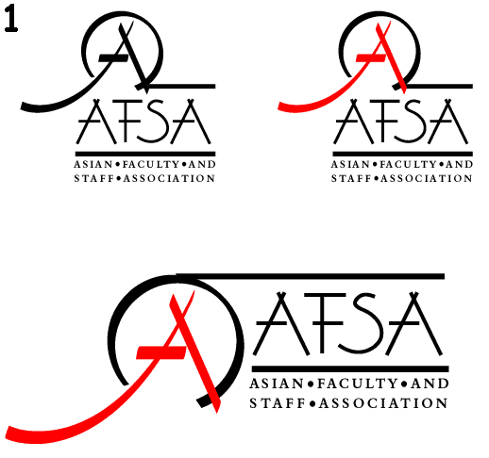
Asian Faculty and Staff Association (AFSA)
Events, AY 2014-2015
Martha Vungkhanching, PhD (AFSA President, (AY 2014-15)
June 8, 2015

DATE & TIME | EVENTS
October 10, 2014  1:00-300pm, HML 2108 | AFSA Academic Success Seminar & Tea Social  Navigating Academic Career: A Seminar  Speaker: Soua Xiong (Ph.D. Student, SDSU/CGU Joint Doctoral Program in Higher Education, San Diego State University)  2-3 p.m. Tea Social
October 28, 2014  HML | ASPIRE Diversity Forum – AFSA Faculty & Student Panel Discussion. Speaker: Dr. Teranishi
November 7, 2014  1:00-300pm, HML 2108 | AFSA Academic Success Seminar & Tea Social  Mapping Your Major: A Seminar  Speaker: Gee Xiong, Degree Advising Office  2-3 p.m. Tea Social
January 7, 2015 | Fresno State Student Affairs conference  Fostering Student Success: A Day of Professional Development  Speaker: Gena Gong
January 23, 2015  6:00-8:00 pm | AFSA New Year Potluck Dinner  At Don & Dianne Beauregard’s home
February 10, 2015  1:00-4:00pm, HML | Faculty & Staff Leadership Development/Engagement  Exploring Possibilities for Making a Difference: An interactive workshop.  Speaker: Kay Iwata
March 4, 2015  12:00-2:00pm  PB 191 | Amerasia Week Celebration  Aging the Asian American Way: Reflections on art, music, and race  Speaker: Dr. Pat Hayashi
March 19, 2015  12:00-1:30pm, ED 215 | Seminar on Home Buying and Mortgage  Speaker: Yanhua Wu, Wells Fargo
March 28, 2015  San Diego, CA | AACU Conference: Diversity, Learning, and Student Success  Presenters: Gena Gong, Hiromi Kubo, Yoshiko Takahashi
April 8-10, 2015  San Francisco, CA | Asian Pacific Americans in Higher Education (APAHE) Conference; 8 AFSA members received partial funding
April 23, 2015  12:00-1:00pm, ED 215 | AFSA Mochi Social
May 2, 2015  10am, MCL 121 | Journey to Success  Student Panel: Who am I as an Asian American?  Moderator: Joy Goto & Franklin Ng (AFSA members)
May 9, 2015  12:00-2:00pm, NG 118 | AAPI Graduation Commencement  AFSA Book Awards (2 x $250)
June 7, 2015  10:00-12:00pm | Community Service – Poverello House

Acknowledgement: Hosting several AFSA events/programs were possible through funding from the Provost. We are grateful for the support and funding.

AFSA Scholarly Activities

Grants

The CSU Chancellor's Office awarded Fresno State (Gong, Kubo & Takahasi) a one-year grant ($211,581) to implement the Action Research Project on supporting Southeast Asian student success (designed based on the AFSA Student Success Survey findings) and foster the strategic use of data to improve student success (2014, November 14).

Publication

Gong, G. L., Kubo, H. & Takahashi, Y. (2014, October). The academic challenges of Southeast Asians at Fresno State. Office of Institutional Effectiveness Research (pp. 1). Office of Institutional Effectiveness: California State University, Fresno, CA.

Presentations

Gong, G. L. (2015, January). Fostering Student Success: A Day of Professional Development. Fresno State Student Affairs Conference.

Gong, G. L., Kubo, H., & Takahashi, Y. (2015, April 10). Fostering Southeast Asian American Student Success. Research presented at the Asian Pacific Americans in Higher Education National Conference. San Francisco, CA.

Gong, G. L., Kubo, H., & Takahashi, Y. (2015, March 28). Addressing Ongoing Academic Challenges among Southeast Asian Students at an AANAPISI Institution. Research presented at the Association of American Colleges & Universities, Diversity, Learning, and Student Success Conference. San Diego, CA.

Gong, G. L. (2014, October 28). The Challenge Facing Asian American Students at Fresno State. President's Commission on Human Relations and Equity, Diversity Forum. California State University, Fresno, CA. Gong represented the research team.

Gong, G. L., Kubo, H., & Takahashi, Y. (2014, September 5). The Challenge Facing Asian American Students at Fresno State. Presentation and panel discussion at the California Commission on Asian and Pacific Islander American Affairs, Public Hearing on Why Education Data Disaggregation Matters: Challenges and Opportunities to Closing the Achievement Gap for Southeast Asian Students, Fresno City Hall, Fresno, CA.

