Annual Assessment Report for 2020-2021 AY
Reports completed on assessment activities carried out during the 2020-21 AY will be due September 30th 2021 and must be e-mailed to the Director of Assessment, Dr. Douglas Fraleigh (douglasf@csufresno.edu).
Provide detailed responses for each of the following questions within this word document. Please do NOT insert an index or add formatting. Furthermore, only report on two or three student learning outcomes even if your external accreditor requires you to evaluate four or more outcomes each year. Also be sure to explain or omit specialized or discipline-specific terms.
Department/Program: Department of Viticulture and Enology; BSc. Viticulture
Assessment Coordinator: Luca Brillante

- Please list the learning outcomes you assessed this year.
This report includes assessment activities from 2020/2021. The corresponding SLOs are:
Outcome 1: Graduates will be able to schedule irrigation in grapes.
- What assignment or survey did you use to assess the outcomes and what method (criteria or rubric) did you use to evaluate the assignment? Please describe the assignment and the criteria or rubric used to evaluate the assignment in detail and, if possible, include copies of the assignment and criteria/rubric at the end of this report.
Method of assessment: In the final exam of General Viticulture 1, VIT 101, one question will specifically assess ability in scheduling irrigation through common practices. Students will have to calculate the required water amount, based on the evapotranspiration. Accuracy of calculated amounts will be scored as correct or incorrect. 75% of students are expected to meet the learning outcome.
- What did you learn from your analysis of the data? Please include sample size (how many students were evaluated) and indicate how many students (number or percentage instead of a median or mean) were designated as proficient.
The assessment is performed on a major requirement for the BS in Viticulture. In Fall 2020 we had 15 students enrolled in this class and 14 of them were evaluated. The students received an average rate of 78% of accurate responses on the overall irrigation quiz. As described in point 2, the SOAP restrains the evaluation to one specific question where students need to calculate actual water amounts for irrigation. In this case 79% of students responded correctly, thus fulfilling expectations.
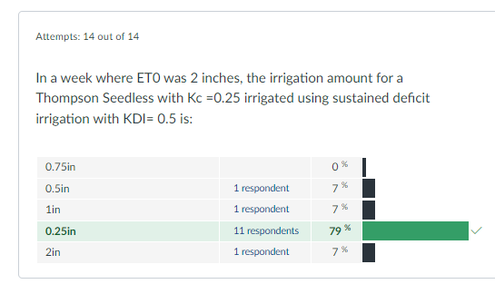
- What changes, if any, do you recommend based on the assessment data?
Additional guided exercises in the classroom may increase the success rate for this outcome

- If you recommended any changes in your response to Question 4 in last year’s assessment report, what progress have you made in implementing these changes? If you did not recommend making any changes in last year’s report please write N/A as your answer to this question.
N/A

- What assessment activities will you be conducting during the next academic year?
Outcome 2: Graduates will be able to recognize core cultivars, clones, and rootstocks and compare and contrast their suitability for field, storage, and market/consumer environments
Method of assessment: The final exam of Grapevine Rootstocks and Varieties, VIT 165 will address ability in recognizing core cultivars, clones, and rootstocks and compare and contrast their suitability for field, storage, and market/consumer environments. Students will have to use core concepts to identify cultivars and rootstocks given in the final exam. 80% of students are expected to meet this learning outcome.
- Identify and discuss any major issues identified during your last Program Review and in what ways these issues have or have not been addressed.
- Difficulty to access classes from other departments: students struggle to access classes that are required in the program but offered by other departments. As a response to this, faculty has created new courses to mitigate problems related with delays in time to graduation. New courses are already underway to be approved by the University.
- Vineyard access for hands-on activities present but not in sufficient quantity or quality. This issue stems from budget restrictions and commercial scope of UAL where a minimal allocation is dedicated to classroom activities.
Appendix A.
Example of assessment:

This is a whole quiz of 50 questions on irrigation of grapevines. Example of questions directly related to the learning outcome are encircled in a red box.
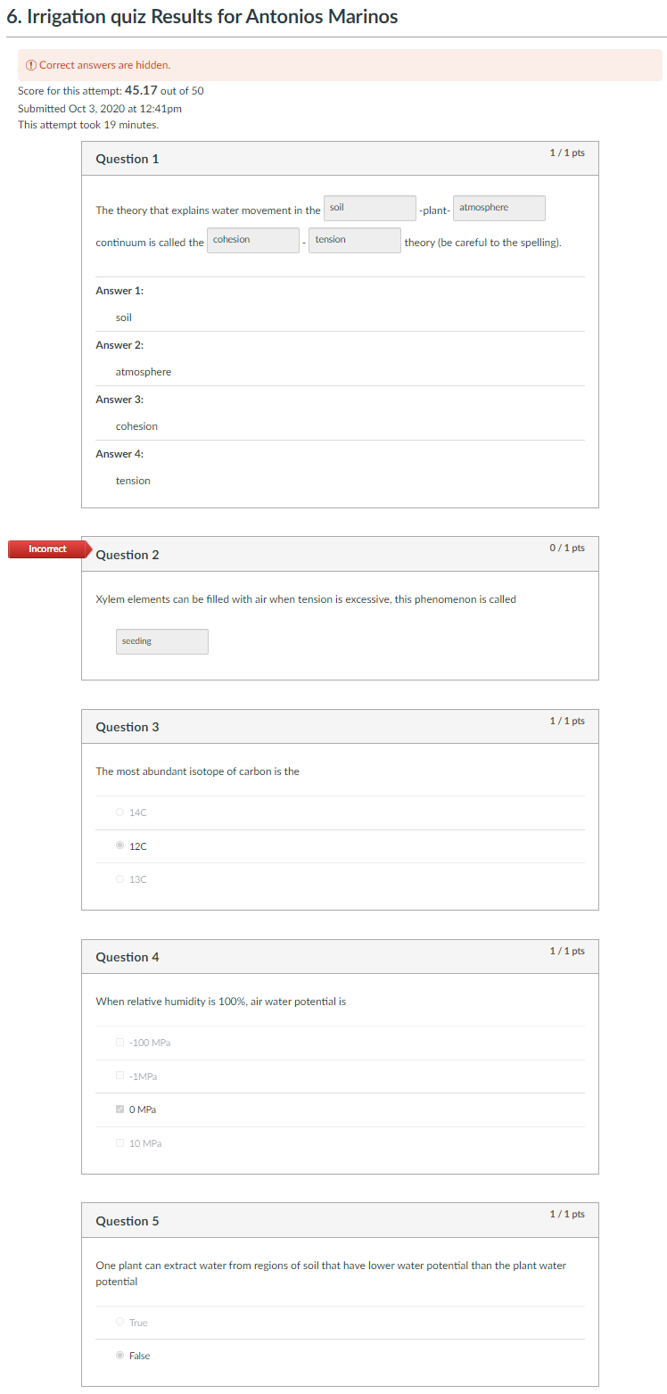
Student X
