Annual Assessment Report for 2018-2019 AY

Department/Program: Department of Construction Management
Degree: BS in Construction Management
Assessment Coordinator: Wei Wu, PhD; weiwu@mail.fresnostate.edu; 559-278-6011

Please list the learning outcomes you assessed this year.

The following SLOs were assessed in 2018-19 AY:
- SLO 1 Create Written Communication Appropriate to the Construction Discipline
- SLO 2 Create Oral Communication Appropriate to the Construction Discipline
- SLO 3 Create Construction Project Safety Plan
- SLO 4 Create Construction Project Cost Estimates
- SLO 9 Apply Construction Management Skills as a Member of a Multi-Disciplinary Team
- SLO 10 Apply Electronic-Based Technology to Manage the Construction Process
- SLO 11 Apply Basic Surveying Techniques for Construction Layout and Control
- SLO 12 Understand Different Methods of Project Delivery and the Roles and Responsibilities of All Constituencies Involved in the Design and Construction Process
- SLO 20 Understand the Basic Principles of Mechanical, Electrical and Piping Systems

What assignment or survey did you use to assess the outcomes and what method (criteria or rubric) did you use to evaluate the assignment? Please describe the assignment and the criteria or rubric used to evaluate the assignment in detail and, if possible, include copies of the assignment and criteria/rubric at the end of this report.

The table below summarizes the direct and indirect assessment measures used to assess the SLOs.
SLOs # | Assessment Measures
 | Direct Assessment Measure (DA) | Indirect Assessment Measure (IA)
1 | CM107L – Lab Memo 1  CM180B – Individual Research Paper | Senior Exit Survey
2 | CM18 – Final Presentation  CM180B – Individual Research Video | Senior Exit Survey
3 | CM180B – Capstone Project Safety Plan  CM134 – RFQ Site Specific Safety Plan | Senior Exit Survey
4 | CM110 – Final Exam | Senior Exit Survey
9 | CM18 – $300 House Challenge Project  CM180B – Capstone Team Project | Senior Exit Survey
10 | CM20 – Lab 07 | Senior Exit Survey
11 | GME15L – Final Project | Senior Exit Survey
12 | CM20 – Exam 2 | Senior Exit Survey
20 | CM140 – Exam 1.1, 3.1 & 4.1 | Senior Exit Survey

The following paragraphs provide detailed description of Direct Assessment measures and grading criteria used for assessment.

SLO 1 – DA1: CM107L Advanced Building Structures Lab Memo 1
Performance Criteria
At least 80% of student population earn 70% (C) or better

Assessment Implementation
Semester: Spring 2018
Course Instructor: Yupeng (Vivien) Luo

Student Work Assessed
Students review the lab technical details and send the instructor a memo that summarizes the lab procedures, test data collected and findings.

Rubric Used for Assessment

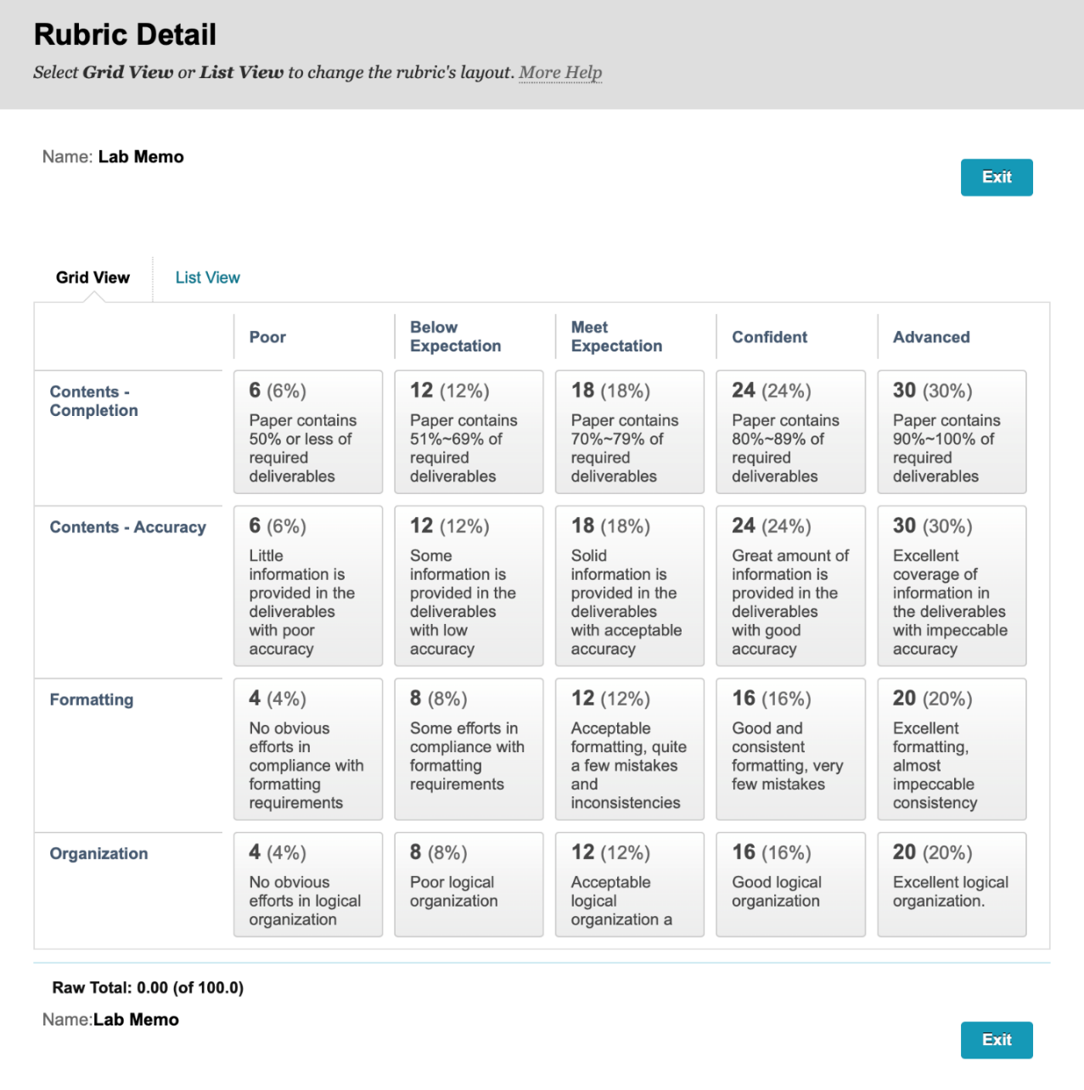
SLO 1 – DA2: CM180B Construction Management Capstone 2 Individual Research Paper
Performance Criteria
At least 80% of students earn 70% (C) or better

Assessment Implementation
Semester: Fall 2018
Course Instructor: Brad Hyatt, Lloyd Crask, Yupeng Luo, Wei Wu

Student Work Assessed
An individual project/research paper with minimum 2000 words. Topics are closely related to prior coursework in construction management, and each student is supervised by a faculty subject matter expert. Noticeably, Fall 2018 was the 1st semester that a supervised model of CM180B was adopted and the individual project/research paper requirements were elevated significantly as a response to our IAB’s request on enhancing students’ written communication skills.

Rubric Used for Assessment
The AACU Written Communication Value Rubric is adopted.

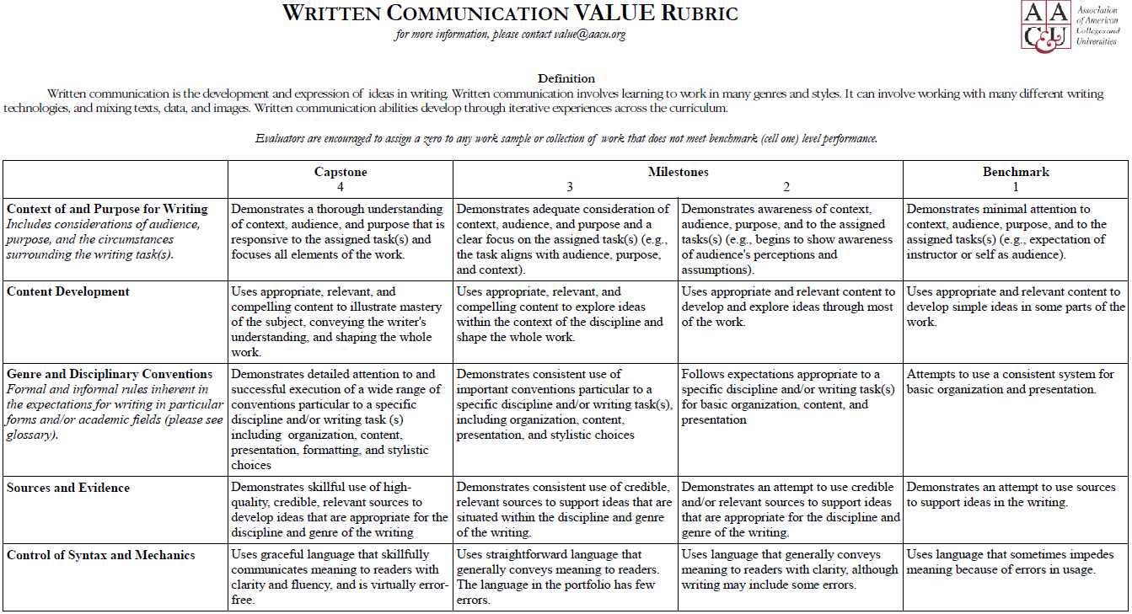

SLO 2 – DA1: CM18 Construction Graphics Final Presentation
Performance Criteria
At least 80% of student population earn 70% (C) or better

Assessment Implementation
Semester: Fall 2018
Course Instructor: Wei Wu

Student Work Assessed
Students are tasked to conduct an 8-10 minutes formal presentation publicly on the final project they had worked for 1 month. Although the presentation took place as a team, each student was assessed individually.
Rubric Used for Assessment

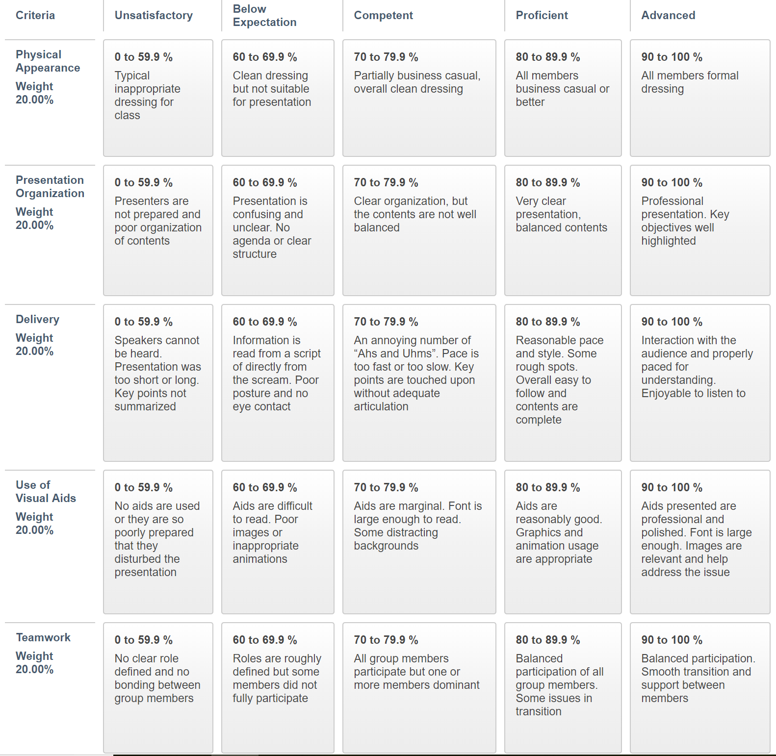

SLO 2 – DA2: CM180B Construction Management Capstone 2 Individual Research Video Presentation
Performance Criteria
At least 80% of students earn 70% (C) or better

Assessment Implementation
Semester: Fall 2018
Course Instructor: Brad Hyatt, Lloyd Crask, Yupeng Luo, Wei Wu

Student Work Assessment
Students were required to create an individual video to present their individual research paper outcomes and findings.

Rubric Used for Assessment
The AACU Oral Communication Value Rubric is adapted to assess individual presentation.

Criteria | Capstone  4 | Milestones  3 2 |  | Benchmark  1
Organization  (25%) | Organizational pattern (specific introduction and conclusion, sequenced material within the body, and transitions) is clearly and consistently observable and is skillful and makes the content of the presentation cohesive. | Organizational pattern (specific introduction and conclusion, sequenced material within the body, and transitions) is clearly and consistently observable within the presentation. | Organizational pattern (specific introduction and conclusion, sequenced material within the body, and transitions) is intermittently observable within the presentation. | Organizational pattern (specific introduction and conclusion, sequenced material within the body, and transitions) is not observable within the presentation.
Delivery  (25%) | Delivery techniques (posture, gesture, eye contact, and vocal expressiveness) make the presentation compelling, and speaker appears polished and confident. | Delivery techniques (posture, gesture, eye contact, and vocal expressiveness) make the presentation interesting, and speaker appears comfortable. | Delivery techniques (posture, gesture, eye contact, and vocal expressiveness) make the presentation understandable, and speaker appears tentative. | Delivery techniques (posture, gesture, eye contact, and vocal expressiveness) detract from the understandability of the presentation, and speaker appears uncomfortable.
Supporting Material  (25%) | A variety of types of supporting materials (explanations, examples, illustrations, statistics, analogies, quotations from relevant authorities) make appropriate reference to information or analysis that significantly supports the presentation or establishes the presenter's credibility/authority on the topic. | Supporting materials (explanations, examples, illustrations, statistics, analogies, quotations from relevant authorities) make appropriate reference to information or analysis that generally supports the presentation or establishes the presenter's credibility/authority on the topic. | Supporting materials (explanations, examples, illustrations, statistics, analogies, quotations from relevant authorities) make appropriate reference to information or analysis that partially supports the presentation or establishes the presenter's credibility/authority on the topic. | Insufficient supporting materials (explanations, examples, illustrations, statistics, analogies, quotations from relevant authorities) make reference to information or analysis that minimally supports the presentation or establishes the presenter's credibility/authority on the topic.
Central Message  (25%) | Central message is compelling (precisely stated, appropriately repeated, memorable, and strongly supported.) | Central message is clear and consistent with the supporting material. | Central message is basically understandable but is not often repeated and is not memorable. | Central message can be deduced, but is not explicitly stated in the presentation.

SLO 3 – DA1: CM180B Capstone Project Safety Plan
Performance Criteria
At least 80% of student population earn 70% (C) or better

Assessment Implementation
Semester: Fall 2018
Course Instructor: Yupeng Luo

Student Work Assessed
Students were asked to create a site-specific safety plan (SSSP) for the capstone project they chose. The SSSP has to address both general and site specific safety issues and management methods, including site logistics, material handling, operation of equipment, security, access and traffic control, to name a few.

Assessment Grading Rubrics
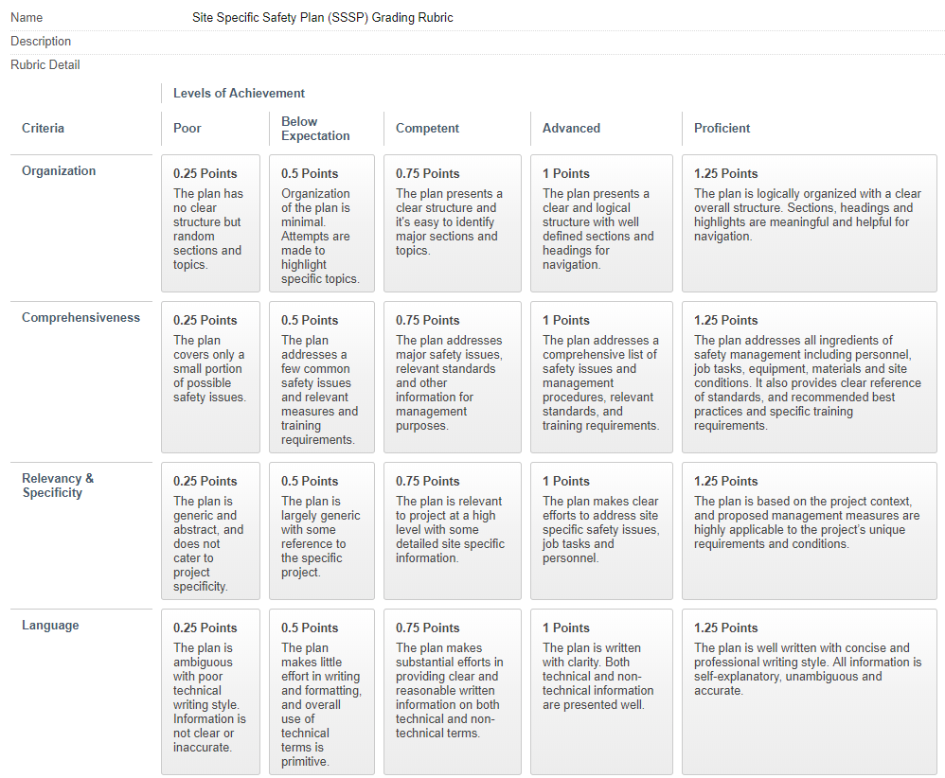

SLO 3 – DA2: CM134 RFQ Site Specific Safety Plan
Performance Criteria
At least 80% of student population earn 70% (C) or better

Assessment Implementation
Semester: Fall 2018
Course Instructor: Wei Wu

Student Work Assessed
Students were asked to create a site-specific safety plan (SSSP) for the Request for Qualification (RFQ) package with the 2015 Design Building Institute of America National Student Competition RFQ document.

Assessment Grading Rubrics

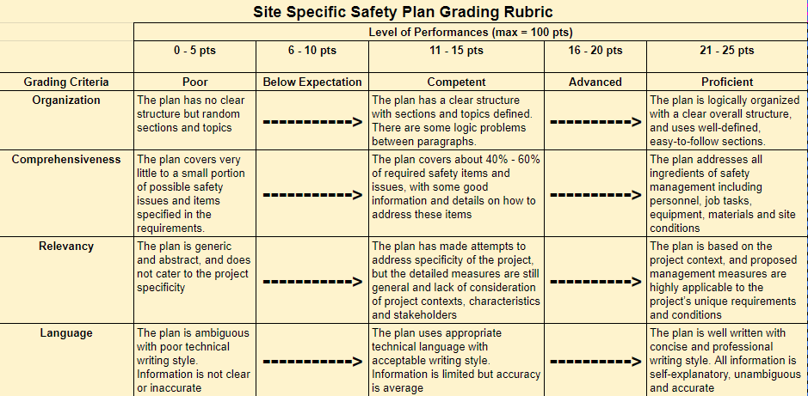

SLO 4 – DA1: CM110 Final Exam
Performance Criteria
At least 80% of student population earn 70% (C) or better

Assessment Implementation
Semester: Fall 2018
Course Instructor: Lloyd Crask

Student Work Assessed
The final exam used a series of 6 questions to comprehensively assess students’ knowledge and abilities to perform a well-rounded cost estimate with consideration of materials, labor and equipment costs.

Final Exam Questions & Keys

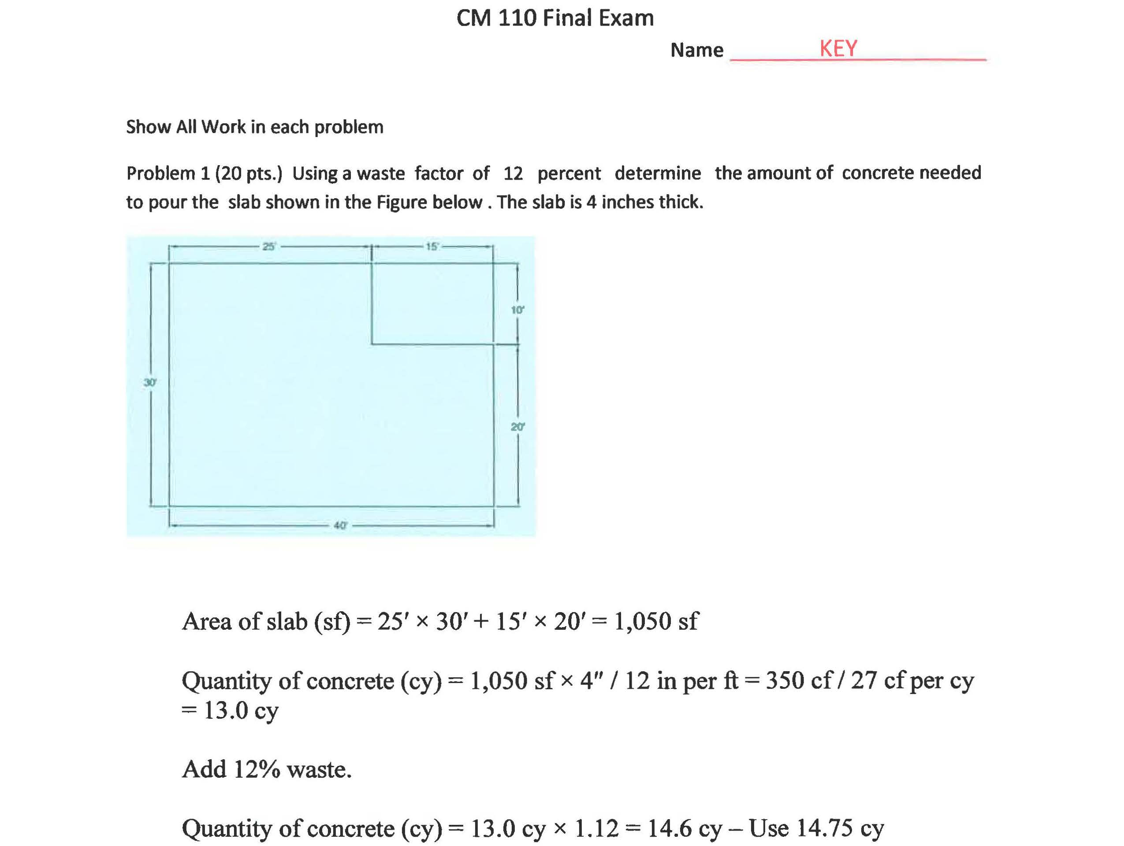
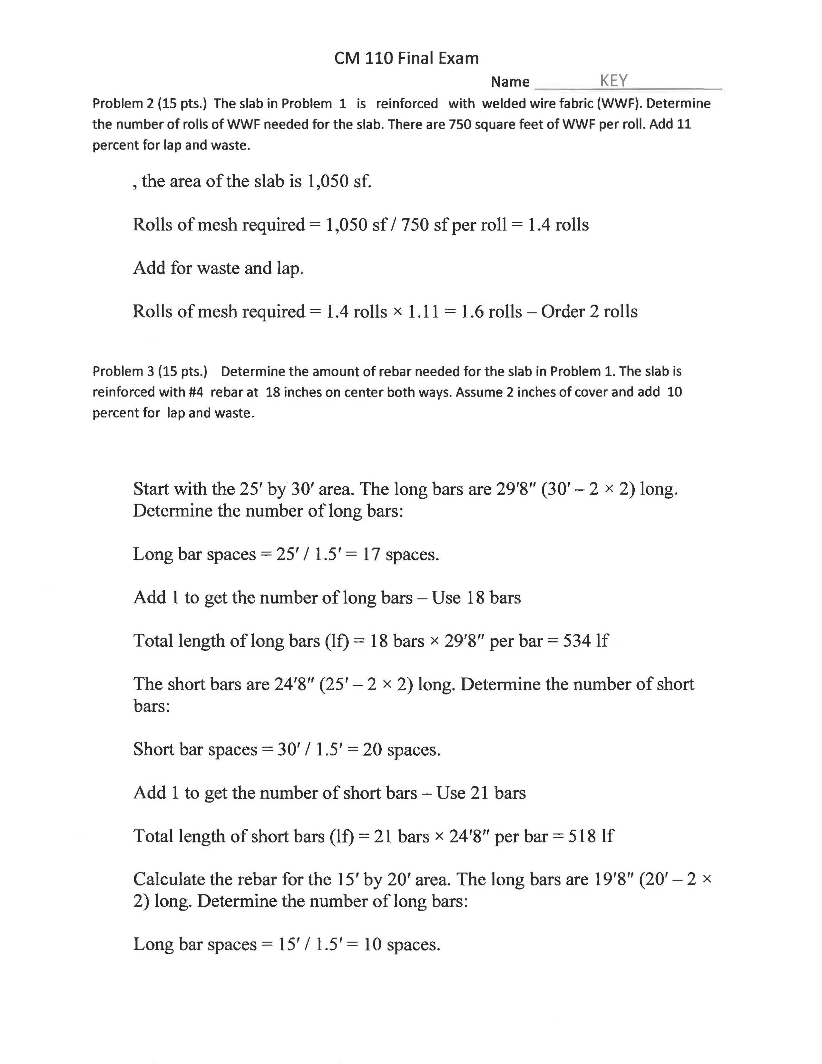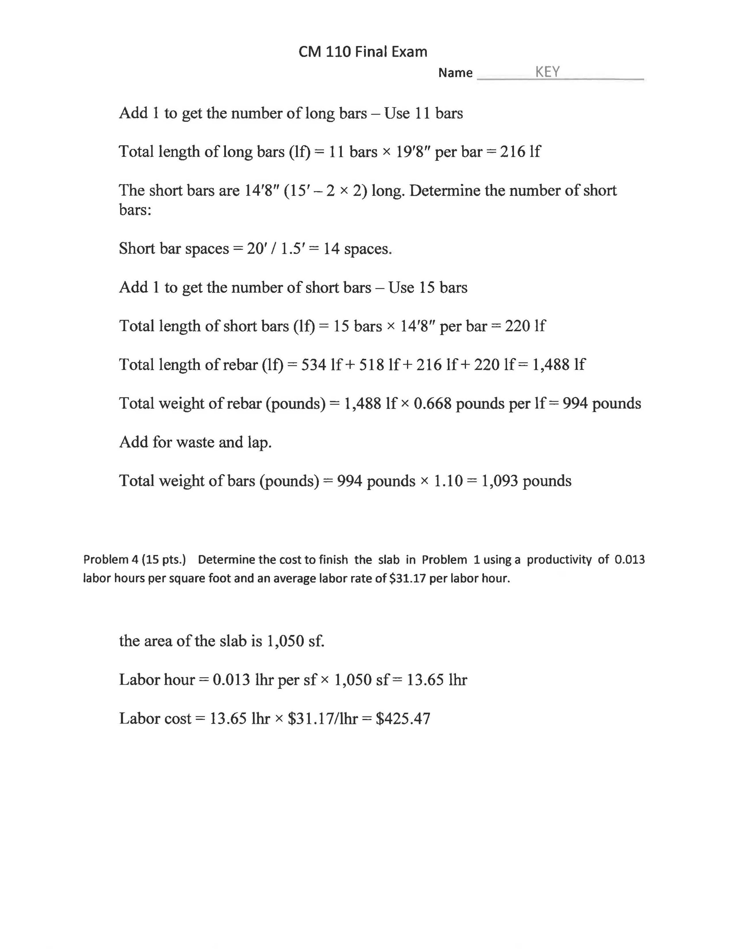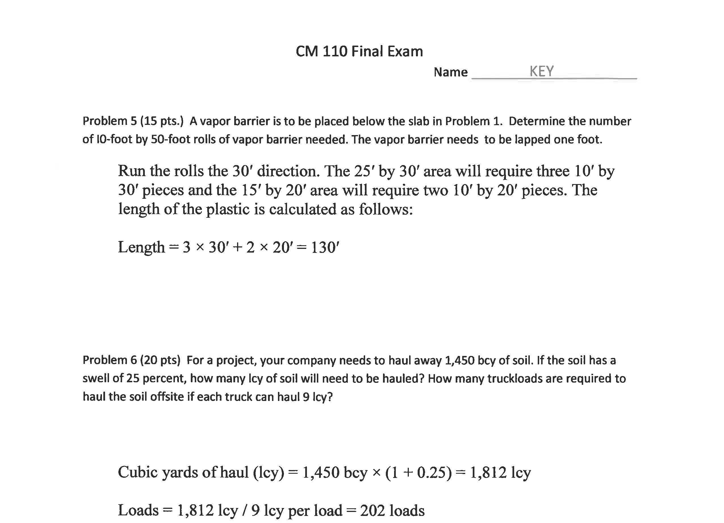

SLO 9 – DA1: CM18 Construction Graphics $300 House Challenge Project
Performance Criteria
At least 80% of student population earn 70% (C) or better

Assessment Implementation
Semester: Fall 2018
Course Instructor: Wei Wu

Student Work Assessed
Students are tasked to form teams to design an extremely low cost ($300) house to address homeless issues and provide solutions to affordable homeless shelter. The deliverables include a design with criteria and narrations, construction details, material specifications, cost estimates, formal poster, and project reflection. In order to assess individual performance within a team, a time-log was kept, and a peer-evaluation was also conducted. The individual performance was based upon project deliverables and peer evaluation.

Rubric Used for Assessment

Criteria | Excellent (20 pts) | Meet Expectation (15 pts) | Below Expectation (10 pts) | Fail (0 pts)
Design Concept | Clearly defines the design problem and identifies design strategy to propose solutions with evaluation of a broad spectrum of factors. Excellent documentation of design development process with artifacts evidence. | Demonstrates the ability to define design problem and identify design strategy through evaluating relevant factors. Consistent documentation of design process. | Begins to demonstrate the ability to define design problem and identify design strategy. Some evaluation, and limited documentation of design process. | Limited or no definition of design problem. No design strategy identified, and design evaluation is superficial. Poor documentation of design process.
Design Completion | Thorough design with great details that address the design intention; model contains all required components and view representations with high level of accuracy. | Complete design with good amount of details; model contains all required components with good level of accuracy. | Attempts to complete the design with some details; model contains some required components, with average of low level of accuracy. | Design is incomplete and does not address design intention; model is incomplete, and accuracy of model components is low.
Material Specification | Comprehensive discussion on material selection process utilizing criteria that consider both performance and cost factors; clearly states final decision on all building materials with justification. | Good discussion on selection process on building materials showing consideration on either performance or cost factors; good summary on final material specifications with justification. | Attempts to discussion material selection process with some understanding of selecting criteria. Lack of summary on final material specifications. | Materials are not defined with little to none efforts on selecting or evaluating materials according to performance or cost factors.
Cost Estimate | Comprehensive calculations of all building materials cost with realistic numbers obtained from vendors and relevant cost database. Clearly summarizes the estimated project cost and whether or not the project budget will be met. | Detailed calculation of all building materials cost with realistic cost information from reliable resources. Indicates whether or not the project budget will be met. | Attempts to calculate material costs with generic cost information without reference to reliable sources. Total project cost is missing. | No efforts made to calculate building material cost. Does not indicate if the project budget will be met.
Reflection Critical Thinking | Demonstrates understanding of project contexts, articulates on personal perceptions towards the project, and learning experience and conducts objective self-evaluation of learning outcomes. | Demonstrates understanding of project contexts; discusses learning experience and project outcomes. | Demonstrates understanding of project intention but needs some clarification; discussion on learning experience and project outcomes are superficial. | Do not understand project intention; no recognition on personal perceptions and no discussion on learning experience or project outcomes.

SLO 9 – DA2: CM180B Construction Management Capstone 2 Team Project
Performance Criteria
At least 80% of students earn 70% (C) or better

Assessment Implementation
Semester: Fall 2018
Course Instructor: Brad Hyatt, Lloyd Crask, Yupeng Luo, Wei Wu

Student Work Assessment
Students were required to pick a capstone project and form a project team to perform required tasks and submit specific project deliverables. The team will be assessed with considering individual’ roles and responsibilities. Typical individual student performance data include their attendance in team meetings, assigned individual assignments within the scope of the team project, participation in progress report and final deliverables, participation in presentations and finally individual reflection on team project experience.

Rubric Used for Assessment
Considering the wide spectrum of deliverables required for the capstone project, each deliverable had its own rubric (e.g. Team Report was graded using the AACU Written Communication Rubric; Team Presentation was graded using the AACU Oral Communication Rubric; Digital Design was graded using instructor developed grading rubric; Cost Estimate and Milestone Schedules were assessed upon 5-point Likert scales, etc.) These gradings were then normalized and computed into a series of 5-point Likert scales as the overall grading rubric and was used for assessment.

Deliverables | Likert Scale
 | 5 | 4 | 3 | 2 | 1
Digital Design | Design deliverable was graded at 80% or above |  |  |  | Design deliverable was graded at 20% or lower
Cost Estimate | Cost estimate deliverable was graded at 80% or above |  |  |  | Cost estimate was graded at 20% or lower
Milestone Schedule | Milestone deliverable was graded at 80% or above |  |  |  | Milestone deliverable was graded at 20% or lower
Written Report | Written report deliverable was graded at 80% or above |  |  |  | Written report was graded at 20% or lower
Presentation | Oral Presentation deliverable was graded at 80% or above |  |  |  | Oral Presentation was graded at 20% or lower
Participation | Meeting minutes deliverable was graded at 80% or above |  |  |  | Meeting minutes was graded at 20% or lower

SLO 10 – DA1 CM20 Lab 07
Performance Criteria
At least 80% of student population Pass the assessment.

Assessment Implementation
Semester: Fall 2018
Course Instructor: Christi Banks

Student Work Assessed
Students were tasked to perform a QTO for masonry using BlueBeam.

Grading Rubric for Lab 07
Due to the fact that the purpose of this assessment was related to the use of technology for QTO, student work was assessed with a Pass/Fail grading rubric instead of a numeric score. Students have to pass both criteria in order to pass this assessment.

Criteria | Pass | Fail
QTO Preparation | Student clearly demonstrated an understanding of masonry QTO process and preparatory steps in defining the right scope of work, and referencing correct drawings and specs | Student did not provide evidence of preparatory work in attempt to define the scope of work and mark up the correct drawings and specs
QTO Using Bluebeam | Student clearly presented the mark ups created for QTO in Bluebeam and produced the desired QTO of Masonry | Student failed to present the mark ups in Bluebeam and did not produce the QTO of masonry

SLO 11 – DA1: GME 15L Engineering Surveying Lab Final Project
Performance Criteria
At least 80% of student population Pass the lab activity requirements

Assessment Implementation
Semester: Fall 2018
Course Instructor: Scott Peterson

Student Work Assessed
Students were required to use a range of surveying equipment to perform a radial survey of an area acquiring data to produce a final 2-D planimetric map created in AutoCAD.

Rubric Used for Assessment
Due to the nature of the assessment, a Pass/Fail grading rubric was used instead of numeric scores. The grading rubric is listed below:

Criteria | Pass | Fail
Surveying Data Process | A clear process showing surveying data collection | Lack of or none evidence on surveying data collection
Planimetric Map Production | A digital map generated in AutoCAD with critical drawing elements included | No digital map generated, or map does not include prescribed elements

SLO 12 – DA1: CM20 Exam 2
Performance Criteria
At least 80% of student population earn 70% (C) or better

Assessment Implementation
Semester: Fall 2018
Course Instructor: Brad Hyatt

Student Work Assessed
Students were assessed for basic responsibilities of each project participant and their contractual relationships in various project delivery methods.

Exam 2 Questions & Keys

SLO 20 – DA1: CM140 Building Mechanical, Electrical, and Plumbing
Performance Criteria
At least 80% of student population earn 70% (C) or better

Assessment Implementation
Semester: Fall 2018
Course Instructor: Kelly Yost

Student Work Assessed
Exam 1.1, with a focus on HVAC systems.

Assessment Tools & Answer Keys
Exam 1.1 with keys are attached below

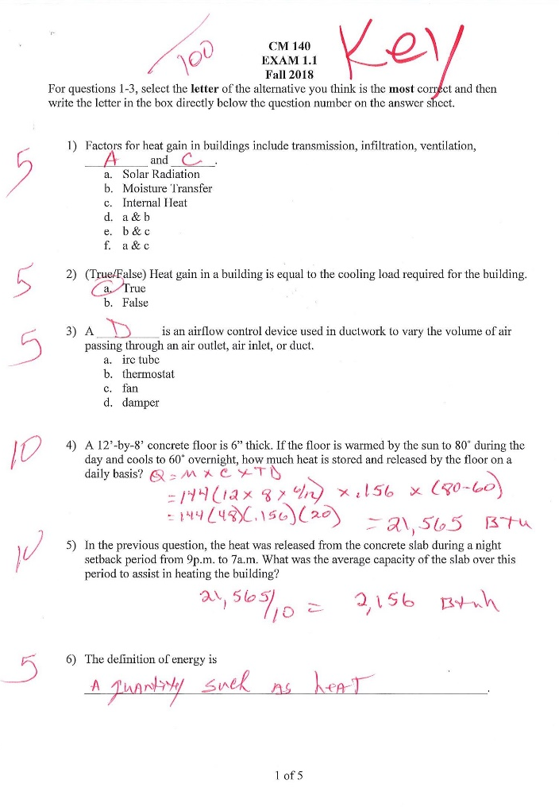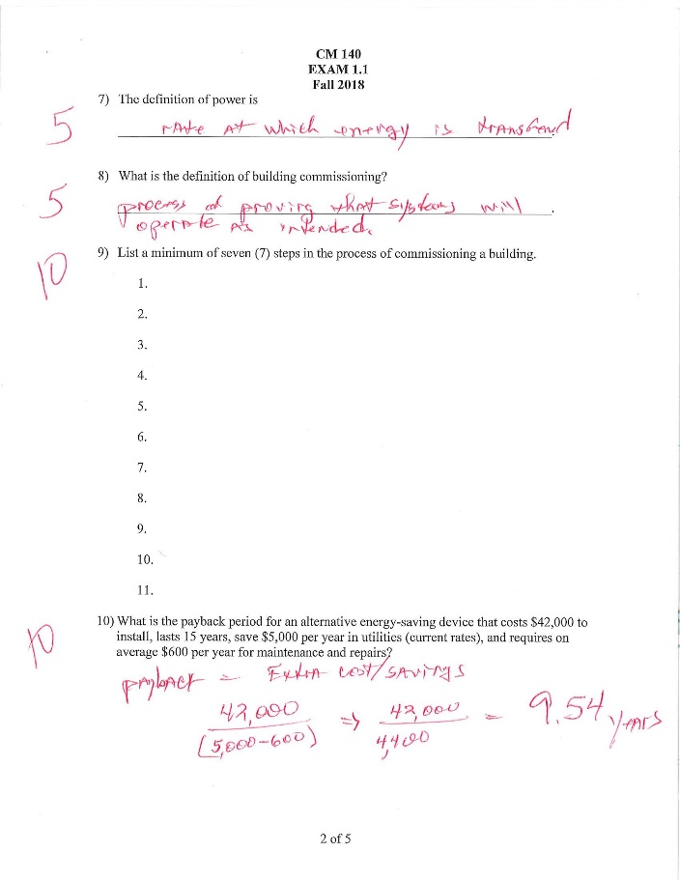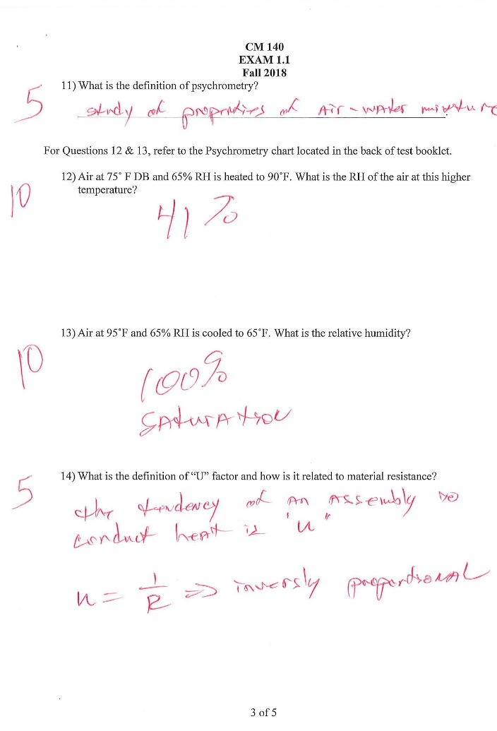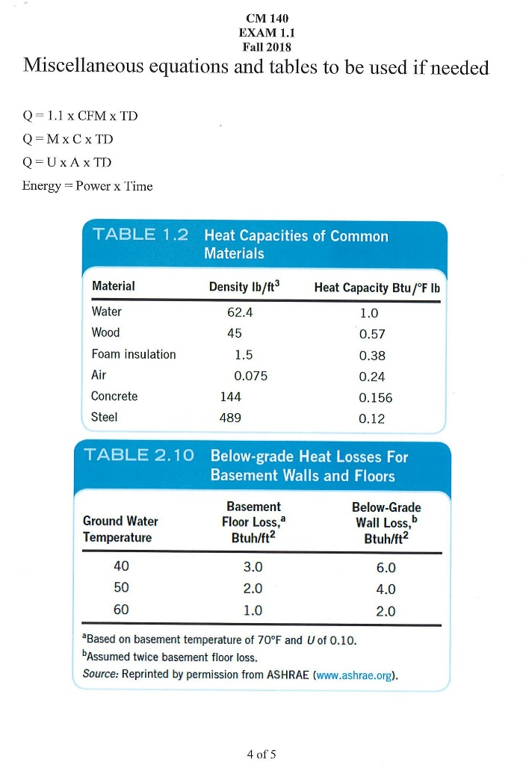
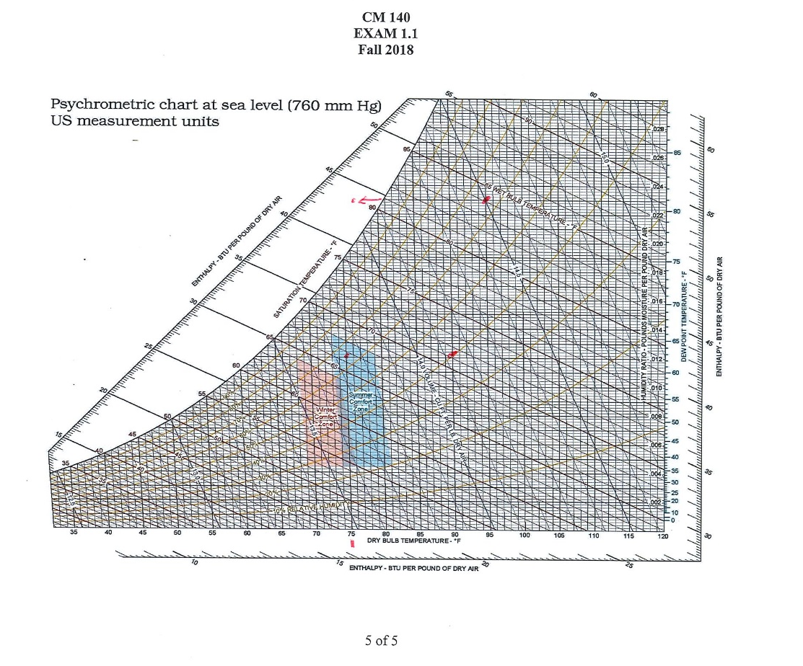

SLO 20 – DA2: CM140 Building Mechanical, Electrical, and Plumbing
Performance Criteria
At least 80% of student population earn 70% (C) or better

Assessment Implementation
Semester: Fall 2018
Course Instructor: Kelly Yost

Student Work Assessed
Exam 3.1, with a focus on plumbing systems.

Assessment Tools & Answer Keys
Exam 3.1 with keys are attached below

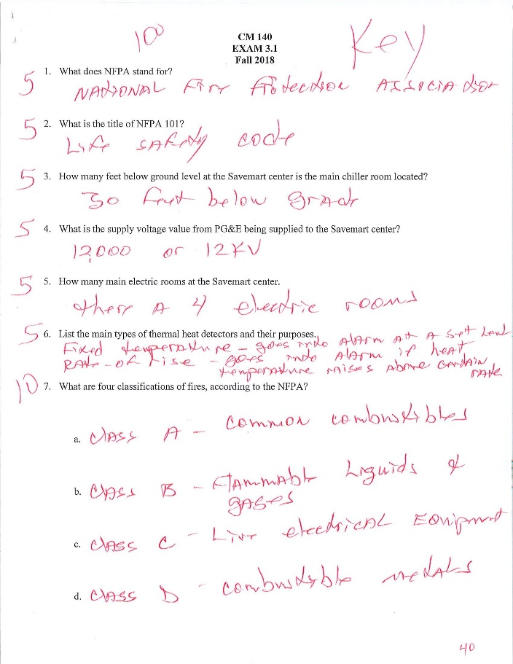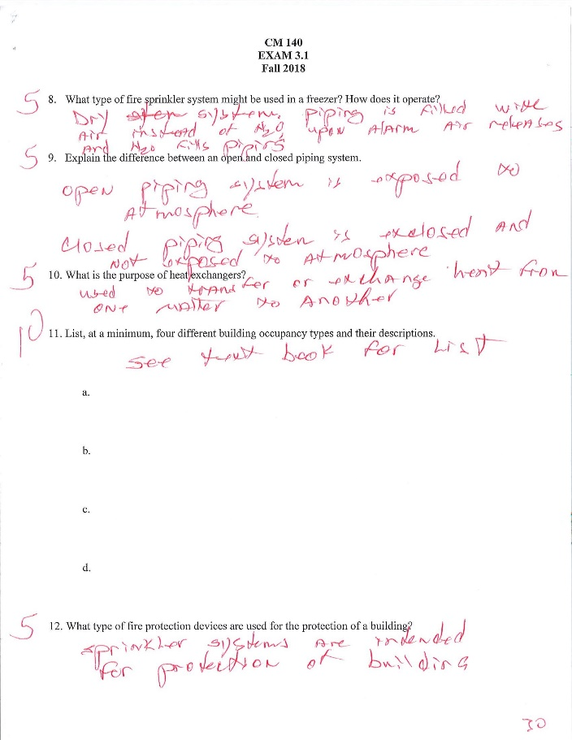
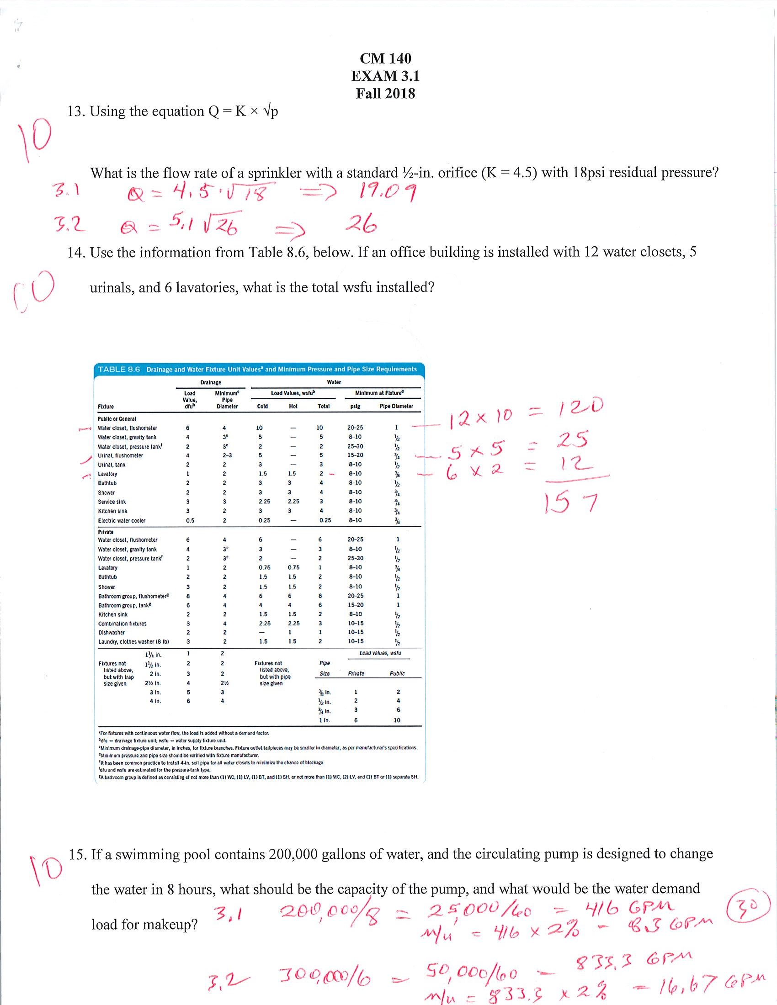

SLO 20 – DA3: CM140 Building Mechanical, Electrical, and Plumbing
Performance Criteria
At least 80% of student population earn 70% (C) or better
Assessment Implementation
Semester: Fall 2018
Course Instructor: Kelly Yost

Student Work Assessed
Exam 4.1, with a focus on electrical systems.

Assessment Tools & Answer Keys
Exam 4.1 with keys are attached below.

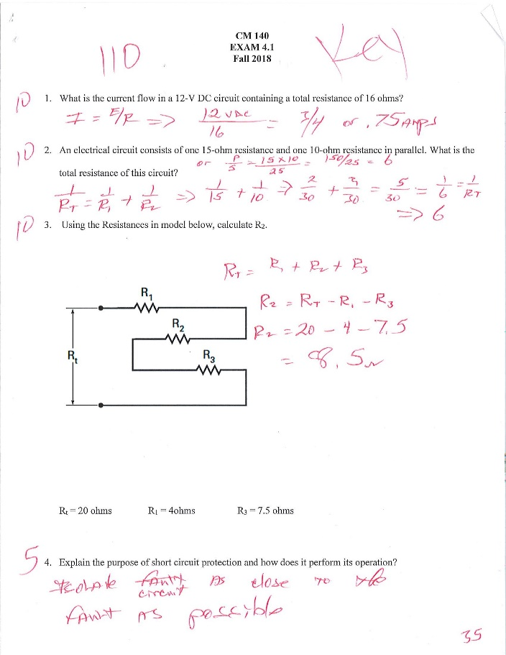
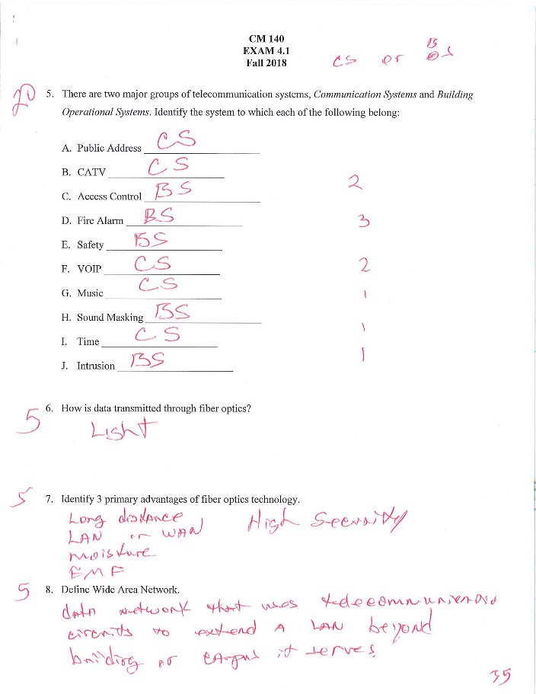
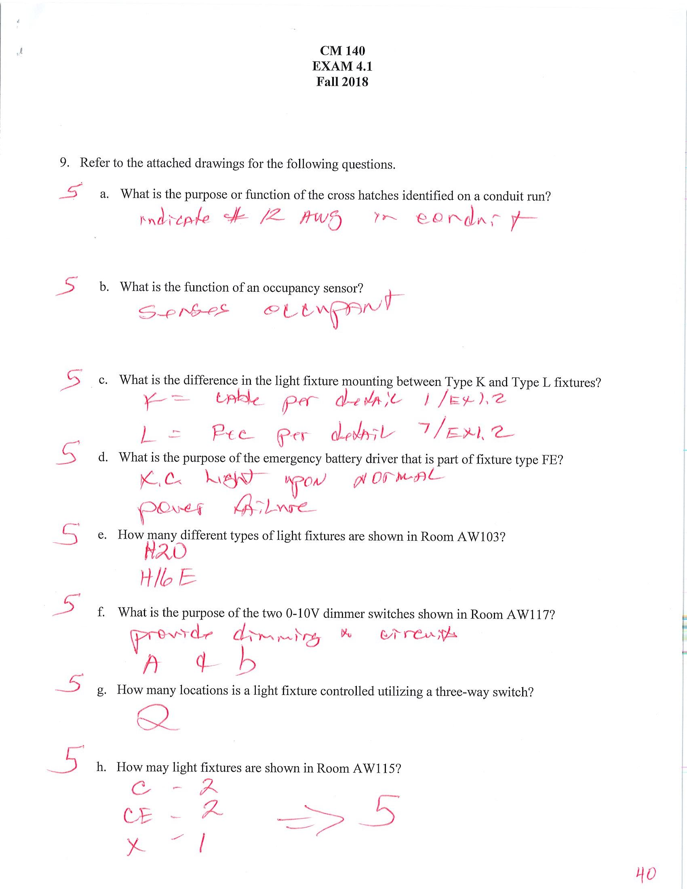

Indirect Assessment of the SLOs rely on the Senior Exit Survey. Graduating seniors were asked to rate their levels of agreement on achieving these SLOs with a 5-point Likert scale.

Performance Criteria
Average score at least 3.5 out of the 5-point Likert-type scale, where:
- 1 – Strongly Disagree
- 2 – Disagree
- 3 – Neither Agree nor Disagree
- 4 – Agree
- 5 – Strongly Agree

Assessment Measure
SLO#1 Survey Question: “I am able to create written communications appropriate to the construction discipline”
SLO#2 Survey Question: “I am able to create oral communications appropriate to the construction discipline”
SLO#3 Survey Question: “I am able to create construction project safety plan.”
SLO#4 Survey Question: “I am able to create construction project cost estimates.”
SLO#9 Survey Question: “I am able to apply construction management skills as a member of a multi-disciplinary team.”
SLO#10 Survey Question: “I am able to apply electronic-based technology to manage the construction process.”
SLO#11 Survey Question: “I am able to apply basic surveying techniques for construction layout and control.”
SLO#12 Survey Question: “I am able to understand different methods of project delivery and the roles and responsibilities of all constituencies involved in the design and construction process.”
SLO#20 Survey Question: “I am able to Understand the Basic Principles of Mechanical, Electrical and Piping Systems”

What did you learn from your analysis of the data? Please include sample size (how many students were evaluated) and indicate how many students (number or percentage instead of a median or mean) were designated as proficient.

The following table summarizes the direct assessment results, including the % of students that meet the performance criteria, and the total number of students assessed.

SLOs | No. of Students Assessed | % of student earn 70% (C) or better | Performance Criteria Met?  80% of student earn 70% (C) or better
1 | 15 | DA1: 100% | Yes
 | 9 | DA2: 66.7% | No
2 | 17 | DA1: 100% | Yes
 | 9 | DA2: 77.8% | No
3 | 4 | DA1: 100% | Yes
 | 7 | DA2: 100% | Yes
4 | 27 | DA1: 100% | Yes
9 | 17 | DA1: 100% | Yes
 | 9 | DA2: 100% | Yes
10 | 23 | DA1: 82.6% | Yes
11 | 10 | DA1: 70% | No
12 | 23 | DA1: 78.3% | No
20 | 21 | DA1: 52% | No
 | 21 | DA2: 86% | Yes
 | 21 | DA3: 90% | Yes

The following table summarizes the indirect assessment results, based on the senior exit survey responses.

SLOs | Semester | No. of Responses | Average Score Out of 5 | Performance Criteria Met?  >= 3.5 of 5
1 | F2018 | 3 | 4.5 | Yes
 | S2019 | 13 | 4.4 | Yes
2 | F2018 | 3 | 4.5 | Yes
 | S2019 | 13 | 4.5 | Yes
3 | F2018 | 3 | 4.5 | Yes
 | S2019 | 13 | 4.1 | Yes
4 | F2018 | 3 | 4.5 | Yes
 | S2019 | 13 | 4.0 | Yes
9 | F2018 | 3 | 4.5 | Yes
 | S2019 | 13 | 4.2 | Yes
10 | F2018 | 3 | 4.5 | Yes
 | S2019 | 13 | 4.4 | Yes
11 | F2018 | 3 | 3.5 | Yes
 | S2019 | 13 | 3.8 | Yes
12 | F2018 | 3 | 4.0 | Yes
 | S2019 | 13 | 4.1 | Yes
20 | F2018 | 3 | 4.0 | Yes
 | S2019 | 13 | 3.9 | Yes

What changes, if any, do you recommend based on the assessment data?

SLO 1: Assessment Reflection & Action Plan
Written communication has been identified as a critical skill set by our IAB, and the CM Department was urged to enhance SLO 01. As the assessment data indicated, although the SLO 01 had been consistently achieved prior to Fall 2018, it was only because the assessment requirement was relatively low. In Fall 2018, the Department decided to revamp the capstone experience and adopted a supervised instruction model to assign students with different faculty members as the subject matter experts, and significantly elevated the standards of the individual writing paper. The changes were pretty drastic: as some students were struggling in this new individual paper assessment, a group of student leaders also stood out and actually produced scholarly publications out of this capstone project. We are expecting in a few more rounds, as our students are getting used to this higher standard, our assessment results on SLO 01 will eventually improve.

SLO 2: Assessment Reflection & Action Plan
Oral communication has been identified as one of the most critical skills by our IAB and recruiters, and the CM Department was urged to enhance SLO 02. To achieve this goal, we started to incorporate oral presentation requirements into lower division courses and instill public speaking capacities among students early on. In the meantime, realizing our capstone projects were largely relying on team/group based assessment, which were not eligible for ACCE SLOs assessment purposes, we revamped our capstone courses in Fall 2018 and started to demand individual presentation deliverables. These curriculum changes were quite chaotic at the beginning but from the long-term perspective, it will benefit our students and cultivate their communication skills.

SLO 3: Assessment Reflection & Action Plan
Due to the fact that our current curriculum doesn’t have a class dedicated to construction safety, we’ve been lagging behind in SLO 3 assessment. For the last several years, OHSA 30-Hour certification has been the only measure we’ve used to provide students with general education on construction safety. The main incentive behind this came from our employers and industry partners who explicitly recommended OSHA certification as they would like to make sure that students had some basic knowledge of construction safety.

Our current commitment and action plan is to assess SLO 3 using the site-specific safety plan (SSSP) at least twice in the curriculum:
- CM134 and other sector electives: although CM134 is an elective, it is mandatory that all CM students have to take 1 sector elective. We decide to use the sample assessment measure in all sector electives to make sure that all students will be assessed;
- CM180B: the capstone project should be the ideal place where SLO 3 should be assessed. Our current challenge is mostly the capstone projects are completed by a team, while the assessment requires individual performance data. A possible work around will be pairing the main capstone project with a smaller individual project.

SLO 4: Assessment Reflection & Action Plan
Both direct and indirect assessment data suggested consistent achievement of SLO 4. The instructor who assessed SLO 4 shared that students needed to build confidence in building systems, work breakdown structures and construction production process. He also suggested that some of the students lacked fundamental math skills when coming into CM110 Estimating and Building. The scaffolding skills of cost estimating, including print reading and contract documents were also discussed. Some actions were planned to include creating a “student success” lower-division elective course focusing on engineering/construction math problems, and encourage early exposure to industry practice via internship.

SLO 9: Assessment Reflection & Action Plan
Given the fact that both our direct and indirect assessment data suggest consistent achievement of SLO 9, assessing individual student’s performance in a team-setting remains challenging. Part of the reason is that Fresno State doesn’t have an architectural program, neither do we have truly multidisciplinary team settings in the capstone projects. Our current assessment has been focusing on how students can independently complete allocated roles and responsibilities on a capstone project team, yet we could not really simulate the real-world scenarios in which they will be actually interacting with clients, architects/engineers, subcontractors and other stakeholders. In CM18, we’ve actually got a better situation because many engineering students also enroll in CM18 to fulfill engineering graphics requirements. From that perspective, CM18 seems to be a better option to assess SLO 9 even it’s a lower division course. The assessment results of CM18 thus tend to be more reliable.

In the future, the Department plans to explore other options for SLO 9 assessment. At the most recent ACCE annual conference, Dr. Mike Jackson from Clemson University recommended a very innovative solution: using internship programs to assessment SLO 9 by soliciting written evaluation from student interns’ supervisor. We find this approach quite feasible to us since internship is a mandatory requirement for our students.

SLO 10: Assessment Reflection & Action Plan
Both direct and indirect assessment data suggested improvement on SLO 10 in recent years. The Department has made substantial efforts in integration technology in the curriculum, including:
- Enhancing partnership with industry technology leaders;
- creating technical electives in BIM;
- adding new “student success” course focusing on CM software application such as PlanGrid, BlueBeam, ProCore;
- establishing a digital building and integration lab for student project and undergraduate research;
- integrating virtual reality and mixed reality technology in outdoor lab projects.

The Department has also explored future options to consistently address the digital transformation in the construction industry across the curriculum, and better cultivate students’ technological competency.

SLO 11: Assessment Reflection & Action Plan
Since last accreditation cycle, we have been in conversation with Geomatics faculty in terms of adding a lab dedicated to Construction Management students to address construction layout and control topics. Currently the GME 15L Planimetric Map lab activity is the best that the Geomatics Department could offer. The CM Department is reluctantly exploring possible opportunities to integrate construction layout and control in upper-division CM outdoor lab projects. However, there was a lack of dedicated faculty and equipment. The Geomatics Department recently went through their ABET reaccreditation, and they agreed to sit down with the CM Department to discuss possible course redesign since they perceived construction layout and control could benefit their own students as well.

SLO 12: Assessment Reflection & Action Plan
Our direct assessment data suggested the performance gaps for SLO 12. Although the indirect assessment data seemed to indicate a better performance. Students seemed to lack a thorough understanding of alternative delivery methods other than traditional design-bid-build. They may understand the contractual relationship among stakeholders but seemed to be unfamiliar with roles and responsibilities in project settings. The Department has been also integrating the Design Build Institute of America (DBIA) Core Curriculum to introduce alternative PDMs such as Design Build into the curriculum. However, at this moment, it remains as an upper-division elective course. Another place that the Department found possible to address PDM was the mandatory internship program, which was firstly implemented in Fall 2018, and is currently under review for further discussion.

SLO 20: Assessment Reflection & Action Plan
The assessment data suggested recent improvement in achieving SLO 20 in both direct and indirect assessment, with the exception of HVAC part of learning, which failed to achieve the SLO for 3 semesters in a row. Discussions with the instructor and students who took the class suggested the following issues:
- CM140 as a 3-credit hour course was not appropriate to cover all M, E, and P contents. Instructor was rushing a little to make sure there was enough time to go through all lectures;
- Students did not get use to the type of knowledge of MEP systems, and the HVAC part was usually assessed at the very beginning of the semester, when they had barely get used to the terminology and understand the concepts;
- Both the instructor and students agreed that it might be better to dedicate CM140 to only one subject area, and create other courses to host the other 2 subject areas;
- The resulting action plan was the Department went ahead and proposed a series of 3 M, E, and P courses (with new course number CM160, CM162, and CM164) as part of the major curriculum revision taking place between 2018 and 2019. The new CM160 Plumbing Systems was firstly offered in Fall 2018. CM140 would be offered until students who were on the old catalog graduate from the degree program.

If you recommended any changes in your response to Question 4 in last year’s assessment report, what progress have you made in implementing these changes? If you did not recommend making any changes in last year’s report please write N/A as your answer to this question.

Progress of action plans have been integrated in narration in Section 4 above.

What assessment activities will you be conducting during the next academic year?

The CM department is going through its 6-year American Council for Construction Education (ACCE) reaccreditation review. In preparing the self-evaluation study, the department identified a few weakness and concerns of current curriculum and student learning outcome assessment plan. The following assessment activities are planned for the next academic year:
- Conduct a comprehensive review of ACCE SLOs mapping with Course Learning Outcomes (CLOs) assigned to courses and instructors;
- Develop new assessment measures for SLO 3 Create a construction project safety plan; SLO 9 Apply construction management skills as a member of a multi-disciplinary team; and SLO 11 Apply basic surveying techniques for construction layout and control;
- Change current Assessment Implementation Plan from Course Kaizen to SLOs Kaizen;
- Assess the following SLOs
  - SLO 6 Analyze professional decisions based on ethical principles
  - SLO 7 Analyze construction documents for planning and management of construction processes
  - SLO 8 Analyze methods, materials, and equipment used to construct projects
  - SLO 13 Understand construction risk management
  - SLO 14 Understand construction accounting and cost control
  - SLO 15 Understand construction quality assurance and control
  - SLO 16 Understand construction project control processes
  - SLO 17 Understand the legal implications of contract, common, and regulatory law to manage a construction project
  - SLO 18 Understand the basic principles of sustainable construction
  - SLO 19 Understand the basic principles of structural behavior

What progress have you made on items from your last program review action plan?

Our last program review was also aligned with the ACCE accreditation review, and the visiting team identified 4 weakness:
- Lack of consistent assessment data and evaluation
- Curriculum – Missing topical content
- Relations with public – Website missing info
- Course Syllabi – Not consistent
As well as 2 concerns:
- Academic Progress – course sequencing
- Faculty Evaluation – evaluation of PT faculty
The CM Department has taken the following actions to resolve the identified weakness and alleviate the concerns:

Weaknesses | No. | Description | Status
 | 1 | Lack of consistent assessment data and evaluation | Alleviated – Consistent use of SOAP
 | 2 | Curriculum – Missing topical content | Alleviated – Now included
 | 3 | Relations with public – Website missing info | Alleviated – Completed
 | 4 | Course Syllabi – Not consistent | Alleviated – Template now used
Concerns | 1 | Academic Progress – course sequencing | Alleviated – Transition complete
 | 2 | Faculty Evaluation – evaluation of PT faculty | Alleviated – Following policy

