Annual Assessment Report for 2018-2019 AY
Department/Program: Economics Degree: BA
Assessment Coordinator: Dr. Qin Fan

What learning outcomes did you assess this year?

Economic Competencies (SOAP GOAL 1):
- For upper division courses, students will interpret the assumptions behind different economic perspectives or paradigms. (SOAP SLO 1.4)
- Students will apply/use the formal language and concepts of the discipline (theory & praxis) to issues of contemporary and historical relevance. (SOAP SLO 1.5)

Analytic Competence (SOAP GOAL 2)
- Students will apply formal logical, statistical, and econometric analyses, in order to evaluate a wide array of hypotheses, qualitative- and quantitative evidence and interpret the results (SOAP SLO 2.1)

Communication Skills (SOAP GOAL 4)
- Students will demonstrate proficiency in writing knowledgeably, coherently, and persuasively on an array of conceptual and/or real, contemporary and/or historical topics related to the discipline. (SOAP SLO 4.1)

Application of Economics (SOAP 5)
- Students will practice independent economic research, including—but not limited to— use of professional and scholarly resources, secondary source materials, and statistical/econometric analyses. (SOAP SLO 5.1)

What assignment or survey did you use to assess the outcomes and what method (criteria or rubric) did you use to evaluate the assignment?

- Course Embedded Assessment (SLOs 1.5, 2.1, 4.1, and 5.1)
ECON 123 Introduction to Econometrics is typically offered in Spring by Dr. David Vera. According to the Economics catalog (2018-2019), this course covers “statistical data analysis in economics. Use of multiple regression analysis, time series analysis, index numbers. Basic theory; computer applications using major economic data sources; interpretation of results.”

The individual class project, which is one of the course assignments, was rated by Dr. Vera for each student, and for each of the applicable SLOs using Google Form. Rating outcomes for each of the SLOs are visualized in Google Form. The assessment scoring rubric as shown in Appendix A was used to rate each student’s project for each of the applicable SLOs.

- Senior survey (SLOs 1.4 and 5.1)
The senior survey has been implemented since Spring 2014, allowing the department to obtain graduating seniors’ feedback. The information allows the department to gauge graduating students’ opinion on their experience in Economics courses as well as their overall satisfaction with the program. As pertaining to the Student Outcome Assessment Plan (SOAP), two specific survey questions are in line with SOAP goals and SLOs. Following expected changes from AY 2016-2017, two particular questions were revised in Spring 2018 to explicitly relate them to specific SOAP SLOs (see these questions in Appendix B).

In the Spring 2019, the survey was administered in a class session of senior project (ECON 192). Drs. Vera and Kim facilitated the survey in class. All the 27 class attendees (senior-standing) participated in the survey.

- Surveys for Service-Learning Projects (SLOs 1.5, 4.1, and 5.1)
Dr. Qin Fan worked with the Jan & Bud Richter Center for Community Engagement and Service-Learning and redesigned the upper-division course ECON 119 Urban and Regional Economics by incorporating a service-learning (SL) component as an option. In the redesigned course, students could choose either individual research (IR) project under the supervision of the instructor or SL project that requires a minimum of 15 community service hours, which accounts for 30% of the total grade.

During the last week of class, students completed an anonymous survey in class about their experience participating in the SL project. (Please see Appendix C for the survey). The survey questions are designed to assess three SOAP SLOs (question #1 for SLO 1.5; question #2 for SLO 5.1; and question #4 for SLO 4.1) along with other SLOs.

To better assess the value of SL project, students were divided in two groups. The treatment group consists of students who selected the SL project, while the control group comprises students who chose the IR project. A balanced data sample was collected with 13 responses from students who selected the SL project and 15 responses from students who chose the IR project.

In response to previous year’s assessment evaluation report that recommends revising the service learning scale to include more details about student learning rather than their levels of agreement, Dr. Fan revised the survey to reflect levels of student learning (see details in Appendix C).

- Focus Group Study (SLOs 1.5; 2.1; 4.1; 5.1)
Conducting focus groups provides a good opportunity to ask open-ended questions and for us to understand students’ overall experience of the major, and how well the knowledge students have gained and skills students have developed through the curriculum prepared them for their future study and career plans.

In Spring 2018 and Spring 2019, the Department Chair Dr. Vera conducted the focus group study in the Senior Project class and students enrolled in the senior project (senior standing) participated in this study. PowerPoint presentation was given by Dr. Vera that introduces topics and questions to be discussed by students in group (see Appendix D for details of topics and questions). Students were grouped randomly to discuss open-ended questions by topic and each group submit their answers via Google Doc.

What did you learn from your analysis of the data?

- Course Embedded Assessment (ECON 123)
Table 1 below summarizes the number of students, rated by the instructor (scales from poor, fair, competent, good, excellent) for each of the applicable SLOs. The assessment sample includes 18 individual class projects completed by the students enrolled in this course. The percentage of scales (from poor to excellent) for each of the applicable SLOs (SLOs 1.5, 4.1, 5.1, and 2.1) was visualized in the chart below Table 1.

Table 1. Course Embedded Assessment (Rated by the Instructor for Each Student and Each of the Applicable SLOs)
SLOs | Excellent | Good | Competent | Fair | Poor
SLO 1.5  Apply formal concepts | 4 | 9 | 4 | 1 | 0
SLO 4.1  Demonstrate writing proficiency | 6 | 7 | 4 | 1 | 0
SLO 5.1  Application of Economics | 8 | 6 | 3 | 1 | 0
SLO 2.1  Become proficient in basic econometric analysis | 0 | 14 | 3 | 1 | 0
Note: numbers entered into the table represent number of respondents rated for each scale

Economic Competence (SLO 1.5)

Figure 1. Percent of Students for Each of the Rated Scales (SLO 1.5)
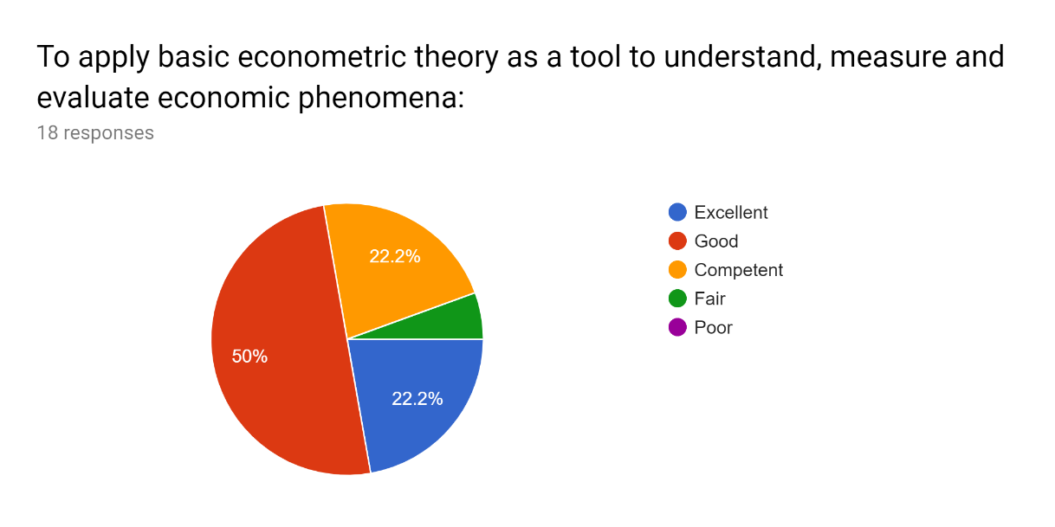

Communication Skills (SLO 4.1)

Figure 2. Percent of Students for Each of the Rated Scales (SLO 4.1)
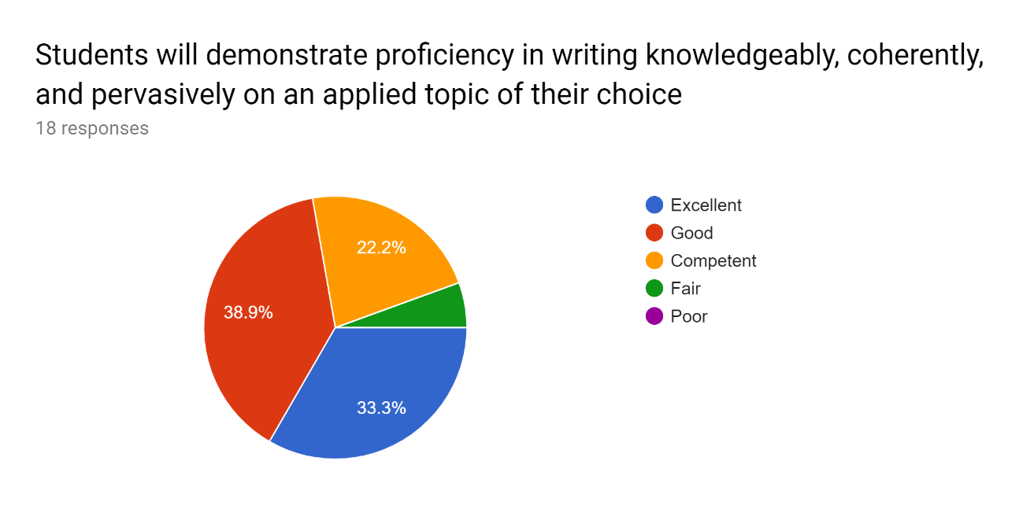

Application of Economics (SLO 5.1)

Figure 3. Percent of Students for Each of the Rated Scales (SLO 5.1)
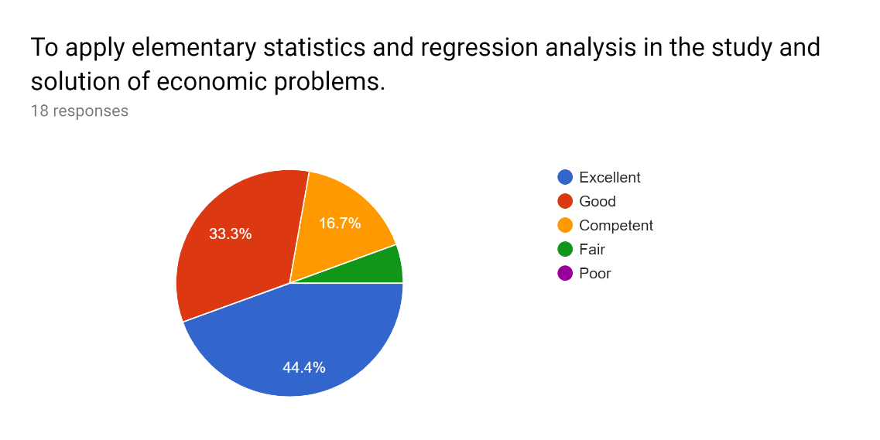
Analytic competence (SLO 2.1)

Figure 4. Percent of Students for Each of the Rated Scales (SLO 2.1)
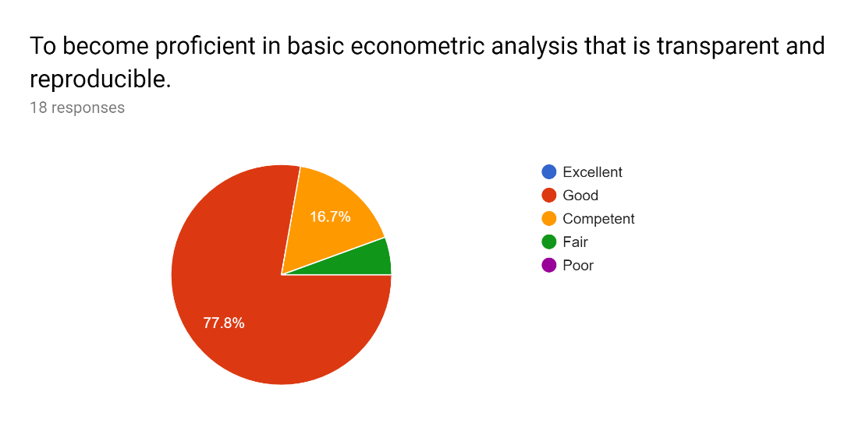
From the charts above, it is shown that no student (0%) was rated “excellent” for SLO 2.1 (SLO 2.1. “To become proficient in basic econometric analysis that is transparent and reproducible”), although 78% students were rated as “good” for this outcome. The analytic skills could be improved through different ways adopted and proposed to close the existing loop (e.g. a broader discussion on transparency and reproducibility as part of the on-going class instruction as well as more emphasis on this topic during lab sessions. In addition, data camp session hosted by the Econ Club to expose students to concepts and software commonly used in data analysis).

- Senior Survey
The charts (Figures 5.1 and 5.2) below show number of students (respondents) who rated the applicable scale (strongly disagree, neither agree nor disagree, agree, and strongly agree) for question related to SLO 5.1, respectively for Spring 2019 and Spring 2018. There are 27 respondents in Spring 2019 and 28 respondents in Spring 2018. The percentages of students who rated for each of the scales were visualized in Figures 6.1. and 6.2. In Spring 2018, approximately 75% of the students agree or strongly agree that “I have practiced independent economic research and relied on professional and scholarly resources, secondary source materials, and statistical/econometric analyses. As far as I can tell, these skills prepared me for a career in economics”. In contrast, only about 56% of students agree or strongly agree on this statement in Spring 2019, while approximately 37% of students neither agree nor disagree. Breaking down long question in the future could accommodate our future assessment and research on a particular SLO (e.g. breaking this long question into two to separate SLO 2.1 “analytic competence” from SLO 5.1. “application of economics”). Skill preparation for a career in economics will also be assessed through an open-ended question as designed in focus group study.

Figure 5.1. Number of Students Who Rated Each of the Scales in Spring 2019 (SLO 5.1)
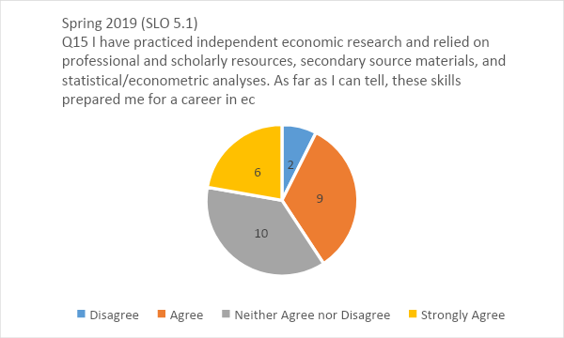

Figure 5.2. Number of Students Who Rated Each of the Scales in Spring 2018 (SLO 5.1)
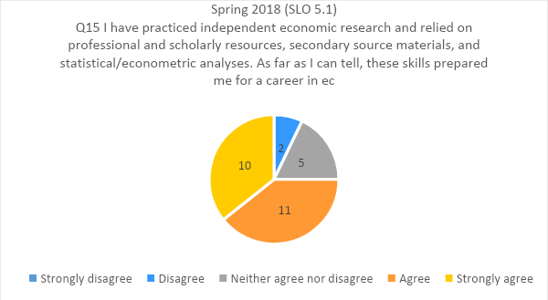

Figure 6.1. Percentage of Students Who Rated Each of the Scales in Spring 2019 (SLO 5.1)
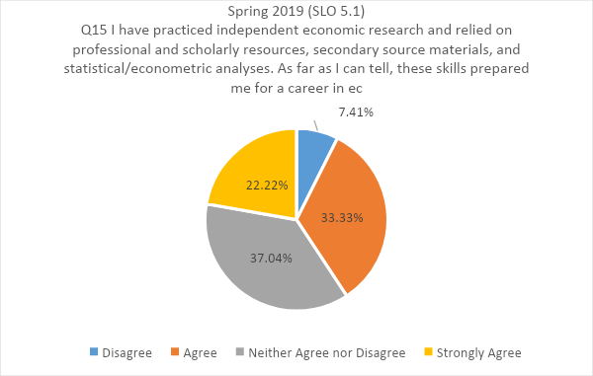

Figure 6.2. Percentage of Students Who Rated Each of the Scales in Spring 2019 (SLO 5.1)
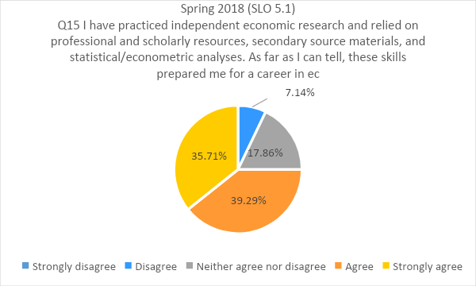
Similar to the charts above, the following charts (Figures 7.1. and 7.2) show number of students who rated for each of the scales (from strongly disagree to strongly agree), respectively for Spring 2019 and Spring 2018, for SLO 1.4. There were 27 respondents in Spring 2019 and 28 respondents in Spring 2018. The percentages of students who rated for each of the scales are displayed in Figures 8.1 and 8.2, which consistently suggest that for each of the semesters, approximately 93% of students agree or strongly agree that “I am able to understand and interpret the assumptions behind different economic perspectives or paradigms”.
Figure 7.1. Number of Students Who Rated Each of the Scales in Spring 2019 (SLO 1.4)
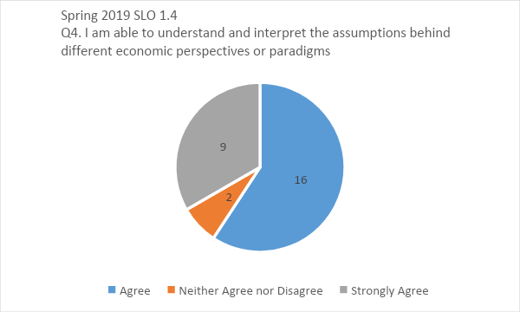

Figure 7.2. Number of Students Who Rated Each of the Scales in Spring 2018 (SLO 1.4)
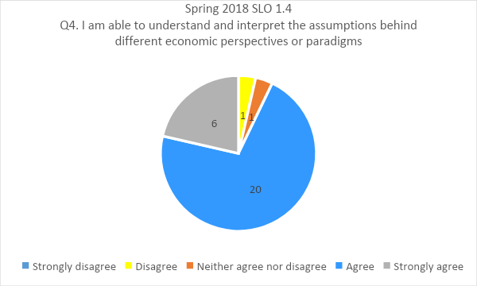

Figure 8.1. Percentage of Students Who Rated Each of the Scales in Spring 2019 (SLO 1.4)
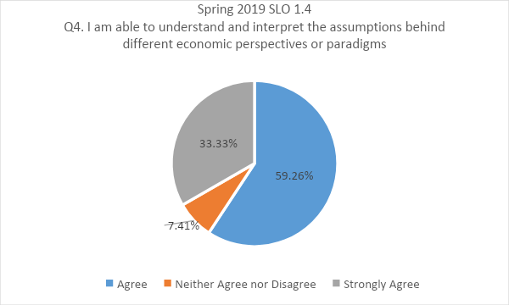

Figure 8.2. Percentage of Students Who Rated Each of the Scales in Spring 2018 (SLO 1.4)
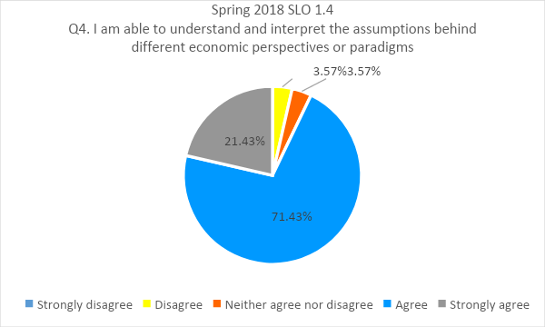

- Surveys for Service-Learning Projects
The following table shows the number of students rated for the applicable learning level for each of the following groups. (1) treatment group comprising SL project participants; and (2) control group consisting of SL project non-participants.
In response to the previous year’s assessment evaluation report that recommends revising the service learning scale to include more detail about student learning rather than their level of agreement, scales 1 (strongly disagree) to 4 (strongly agree) are used to indicate students’ level of knowledge (none, low, moderate, and high).
Table 2. Number of Respondents Rated for Each Learning Scale (SL Project Participants and Non-Participants)
Treatment  /Control | SLOs | None  (Have no knowledge of the content) | Low (Know nothing about the content; there is little to learn) | Moderate (Have basic knowledge; there is more to learn) | High (Consider myself very knowledgeable)
SL project participants | SLO 1.5 | 0 | 0 | 5 | 8
 | SLO 4.1 | 0 | 0 | 5 | 8
 | SLO 5.1 | 0 | 1 | 7 | 5
SL project non-participants (students who selected research projects) | SLO 1.5 | 1 | 3 | 3 | 9
 | SLO 4.1 | 1 | 3 | 6 | 5
 | SLO 5.1 | 1 | 0 | 6 | 8
Note: numbers entered into the table represent number of respondents rated for each scale.
The percent of respondents rated for each learning scale can be visualized in the figures below (Figures 9.1 and 9.2). Compared to SL non-participants, Larger percentage of respondents who participate in SL rated for “high” level (“considering myself very knowledgeable) for questions 1 and 4 that relate to SLO 1.5 and SLO 4.1.

Figure 9.1. Percent of respondents rated for each learning scale (SL participants)
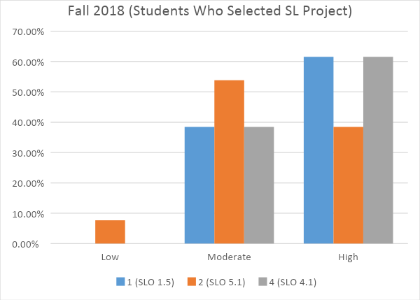

Figure 9.2. Percent of respondents rated for each learning scale (SL non-participants)
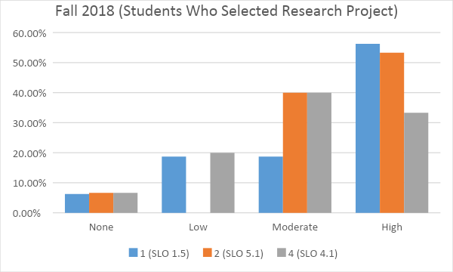

- Focus Group
In Spring 2019, all 27 student attendees (senior standing) participated in focus group study. Students were randomly assigned to a group (approximately 5 students in each of the 5 groups). Based on the group response submitted via Google Doc, we identify the following three issues and cited some group responses/feedback below:

- Issue: career advising/path
“We feel that advising could be better in helping students try and figure out what they can do for the future. Whether it is job or school related, advisors need to be as straightforward as possible when dealing with student futures.

“Our group has not used this resource. However, we felt like there is a lack of push for advising services. Some of us are not aware of where to go to get help.”
Overall we have had good experiences with the advising center and Dr. Vera. They helped us get on track and graduate on time. Not much was done in terms of career readiness, besides minor suggestions. May be worth creating a mandatory meeting in the Junior year to make sure students are on track. The economic major requirements can be confusing and misunderstood.
Overall for our group, we agreed that whenever we took action to go approach professors for advising they were ready to meet us and help, specifically Dr. Vera and Dr. Kim.

- Issue: Data analysis skills/ excel training:
We have mixed feelings about our ability to apply data analysis skills. Some of us feel confident, some of us feel somewhat confident, and others do not feel confident at all.
We feel semi-confident. Econometrics is the only class that every truly focuses on that and most of us took that a couple years ago. We would like to see more classes with that focus to better ingrain that skill.

- Issue: More math
“There is not enough math requirements. There should be B.S. in Econ available for those students who want to major in Econ, but be more mathematics inclined. Need to offer more courses so students will be able to graduate faster.
More math should be involved in the Econ major because of the amount of math required for graduate school for those that want to go further. Even those that do not want to go to graduate school will still benefit from more math in the department.
There are not enough courses that are math intensive. I believe I only had 2 courses that were (Econ 123 and 100A)”
“There are definitely not enough course options with high math; a lot of upper division courses have kids in them that are not math/econ students which leads us to believe that math has been dialed down.”
We believe that there is not enough course options particularly those with high math requirements. Another Econometrics course would be ideal. We feel like there is a lack of service learning experiences. The only courses that really pushed for service learning were the courses that Dr. Fan offered.

What changes, if any, do you recommend based on the assessment data?
Consist with the finding from the previous senior survey conducted in AY 2017-2018, results from AY 2018-2019 senior survey suggest that majority of the students either agree or strongly agree (56%) that they have practiced independent economic research and relied on professional and scholarly resources, secondary source materials, and statistical/econometric analyses; and these skills prepared them for a career in economics. However, an increasing number of students (37%) neither agreed nor disagreed on this statement as suggested by AY 2018-2019 senior survey results. While other findings from assessment activities (ECON 123 and ECON 119) consistently suggests majority of students (more than 70%) achieve at least the moderate level for SLO 5.1—economics application (have basic knowledge; there is more to learn), focus group allows us to ask open-ended questions regarding particular topic like economics application and career preparation. From the focus group discussions and feedback, one group anonymously wrote that “no real talk about career paths was done in terms of advising; only essentials about courses but didn’t go above and beyond to transfer us into our future job goals”. Another group wrote that “I think the resources (teachers) are there if students wish to get advised but I don’t think the advising helps too much with our career paths”. I suggest we continue working with the student organization (e.g. econ club) to host career oriented advising workshop and events (e.g. get alumni to meet current students; inviting local business to speak with students about internship and career opportunities). In the future, internship supervisor survey may be used as an indirect measure for student learning outcomes.

The writing checklist (rubric) adopted previously for the courses ECON 117, ECON 146, and ECON 115T is adapted for the ECON 123 assessment in AY 2018-2019 using Google form. It is recommended that this checklist (rubric) that specifies SLOs could be used as a department-wide assessment checklist for the use of future assessment activities. Google form could be used to easily visualize the findings and student outcomes.

To address the need for excel training, the instructors have incorporated more assignments in excel across the curriculum (e.g. ECON 100A; ECON 123). To address the need for more math-intensive courses, ECON 125 (Introduction to Mathematical Methods for Economics) may be offered in the rotation; providing students with opportunities to be exposed to more options could also be helpful (e.g. advising students about the data analytics option in CSB). Faculty advising will also emphasize available courses in the Math department (e.g. calculus sequence, linear algebra) to provide additional quantitative training.

We hope to develop some standardized assessment tool (e.g. electronic survey or test) in the future to incorporate all sections of lower-division courses (e.g. ECON 40 and ECON 50) in the assessment. This will help us to assess the SLOs using larger representative data sample covering larger groups of students and to determine whether we are meeting our SLOs and SOAP goals as well as to identify possible ways to close loops.

If you recommended any changes in your response to Question 4 in last year’s assessment report, what progress have you made in implementing these changes? If you did not recommend making any changes in last year’s report please write N/A as your answer to this question.

It was recommended in the last year’s assessment report that senior survey could be complemented with “focus group study” that is designed to assess specified SOAP SLOs to guide the continuous improvement of the assessment process. The focus group study can allow us to ask open-ended questions to understand how and if these SOAP goals and SLOs are met; in particular, we want to find out whether we are meeting the goals of preparing our students for their future study and career plans. In fact, we have made good progress in implementing these changes. We have conducted focus group study in Senior Project (ECON 192) in Spring 2018 and again Spring 2019.

In response to the previous year’s assessment evaluation report that “consider revising the service learning scale to include more detail about student learning rather than their level of agreement”, the SL post survey was redesigned to reflect student learning levels in Fall 2018. In particular, the following learning levels were created in line with the level of agreement.

Table 3. Learning Level Related to Rating Scales
1 (strongly disagree) | 2 (somewhat disagree) | 3 (Somewhat agree) | 4 (Strongly agree)
None | Low | Moderate | High
Have no knowledge of the content | Know nothing about the content; there is little to learn. | Have basic knowledge; there is more to learn | Consider myself very knowledgeable

What assessment activities will you be conducting during the next academic year?

Table 4. Possible assessment activities for AY 2019-2020
Assessment activities | Assessment methods  /instruments | Time Frame | Assessment goals
 |  |  | Economic competence | Analytic competence | Communication skills | Application of economics | Social awareness and responsibility
 |  |  | (Goal #1) | (Goal #2) | (Goal #4) | (Goal #5) | (Goal #6)
ECON 50  and ECON 40 (multiple sections) | Pre/post survey or/and course embedded | Fall 2019 or/and Spring 2020 | X
Focus group | Focus group | Spring 2020 | x | x | x | x
Senior survey | Survey | Spring 2020 | x |  |  | x
ECON 123 | Course-embedded | Spring 2020 |  | x
ECON 114 | Course-embedded | Spring 2020 |  |  |  |  | x

What progress have you made on items from your last program review action plan?

  - Core Course Review—the Committee on Undergraduate Program (CUP) of the Craig School of Business reviewed some of the Pre-Business core courses including our ECON 40 (Principles of Microeconomics) and ECON 50 (Principles of Macroeconomics) in terms of consistency of course syllabi, course goals, SLOs across sections/instructors. In Spring 2019, CUP continued reviewing capstone courses including ECON 192 (Senior Project). Positive feedback from CUP especially their support for and appreciation on continuous efforts on conducting focus group were shared with the Economics Department faculty.
  - Promoting the use of supplemental instruction (SI) sections for ECON 40 and ECON 50 and mobile technology in the classroom (DISCOVERe sections)
  - To support the Craig School Committee on Undergraduate Program (CUP)’s efforts on reviewing Pre-Business core courses, the Department Chair Dr. Vera communicated through email with all full-time faculty and part-time instructors, who teach ECON 40 and/or ECON 50, regarding inclusion of the standard SOAP SLOs and GE SLOs along with the new GE Program ePortfolio requirement in the course syllabi. The Chair also meets individually with part-time instructors to discuss these requirements.
  - Senior survey and focus group are continuously used as assessment tools to assess students’ perception about the major and SOAP goals and SLOs.
  - Service learning component is introduced as an option in ECON 119 to provide students with opportunities to interact with community organizations and contribute to local economic development/addressing pressing economic development issues utilizing economic knowledge learned in class.

Appendix A
APPENDIX A: Student Learning Outcomes Assessment
ECON 123 Introduction to Econometrics
Fall 2018
Student Number________________
Economic Competence

 | Excellent | Good | Competent | Fair | Poor
Students will apply basic econometric theory as a tool to understand, measure and evaluate economic phenomena (SLO 1.5)

Communication Skills

 | Excellent | Above Average | Average | Below Average | Poor
Students will demonstrate proficiency in writing knowledgably, coherently, and pervasively on crime related topics using economic analysis. (SLO 4.1)

Analytic Competence

 | Excellent | Good | Competent | Fair | Poor
Students will apply formal logical, statistical, and econometric analyses, in order to evaluate a wide array of hypotheses, qualitative- and quantitative evidence and interpret the results. (SLO 2.1)

Application of Economics

 | Excellent | Good | Competent | Fair | Poor
Students will become proficient in basic econometric analysis that is transparent and reproducible while practicing independent economic research. (SLO 5.1)

APPENDIX B: Senior Survey Selected Questions (Spring 18)

Please indicate your level of agreement with the following statements.

 | Strongly Disagree | Disagree | Neither Agree nor  Disagree | Agree | Strongly Agree
Q#4: I am able to understand and interpret the assumptions behind different economic perspectives or paradigms.
(SLOs 1.4)
Q#15: I have practiced independent economic research and relied on professional and scholarly resources, secondary source materials, and statistical/econometric analyses. As far as I can tell, these skills prepared me for a career in economics.
(SLO 5.1)

Appendix C
Service-Learning Post Survey (Fall 2018)
Which assignment have you selected?

Individual research project
Service-learning project

Please rate your response to each question by marking the appropriate box. The scales 1 (strongly disagree) to 5 (strongly agree) are used to indicate students’ level of knowledge through participating in a particular class project:
1 (strongly disagree) | 2 (somewhat disagree) | 3 (Somewhat agree) | 4 (Strongly agree)
None | Low | Moderate | High
Have no knowledge of the content | Know nothing about the content; there is little to learn. | Have basic knowledge; there is more to learn | Consider myself very knowledgeable

Questions about the Experience
 | Level of Knowledge
 | None | Low | Moderate | High
As a result of participating in this experience: | 1 (strongly disagree) | 2 (somewhat disagree) | 3 (somewhat agree) | 4 (strongly agree)
1 I increased my understanding of how to apply concepts and theories learned in class to identify the community agency’s contribution to regional economic development. (SLO 1.5)
2 I increased my understanding in utilizing economic models and tools to analyze the practical project at the learning site. (SLO 5.1)
3. I gained experience in using professional and scholarly resources, qualitative or quantitative analysis to help the community agency with their missions.
4. I gained experience in how to communicate effectively with the community agency or target population for service (SLO 4.1)
5. I gained knowledge in how to describe policy decisions/processes used to address the issues identified in the project.
6. I find myself being able to diffuse economic knowledge in the community through any of the following: collecting and analyzing data, or interacting with target population for service, or participating in practical project.
7 I increased my understanding of how my college education can benefit both me and my community.
8 I am now more likely to involve myself in community service in the future.
9 I now see myself as having the capacity to become a community leader.
10. I now see myself as having the capacity to create positive community change.

Appendix D
Economics Students Focus Group Assessment Activity (Spring 2019)
The Economics major:
Why did you select Economics as your major?
Would you recommend the Economics major at CSU-Fresno to others? Why?
Course (1):
What economics course(s) or other features of the economics program did you find the most interesting/useful? Why?
Courses (2):
What economics course(s) or other features of the economics program did you find the least interesting/useful? Why?
Courses (3):
Do you feel there are enough course option (particularly those with high math requirements)?
Do you feel that there is a lack of service learning experiences?
Your skills (1):
Please tell us about how confident you are in your ability to apply your data analysis skills?
Your skills (2):
Please tell us about how confident you are in the ability to reason analytically regarding economic issues, theories and institutions?
Advising:
Are you satisfied with the advising for Economics majors?
Does the advising help you with your career paths (graduate school, banking and finance, information management, data mining and analysis, operations and quality)
Resources:
Do you feel that the economics program provides you with adequate resources, such as study areas or technology?
What improvements would you like to see in these resources?
Is there anything we didn’t ask but you wished we had?

