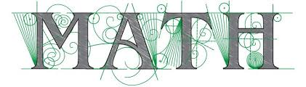

Sonia Kovalevsky Mathematics Day
At Fresno State
Saturday, March 20, 2021

9:00 - 9:15 Welcome - Dr. Carmen Caprau

9:15 - 10:20 Fantastic Fractals
Plenary talk by Dr. Andrea Arauza Rivera (CSU, East Bay)

10:30 – 11:30 Mysteries of the Mobius strip
Interactive activity (led by Fresno State students)

11:30 - 12:00 Lunch Social

12:00 - 12:30 Who Wants to Be a Mathematician?
Talk by Dr. Jenna Tague (Clovis Community College)

12:40 - 1:10 Women in Math Panel
What Exactly Does a Math Major Do (in college and in their careers)?

1:10 - 1:15 Closing Remarks

