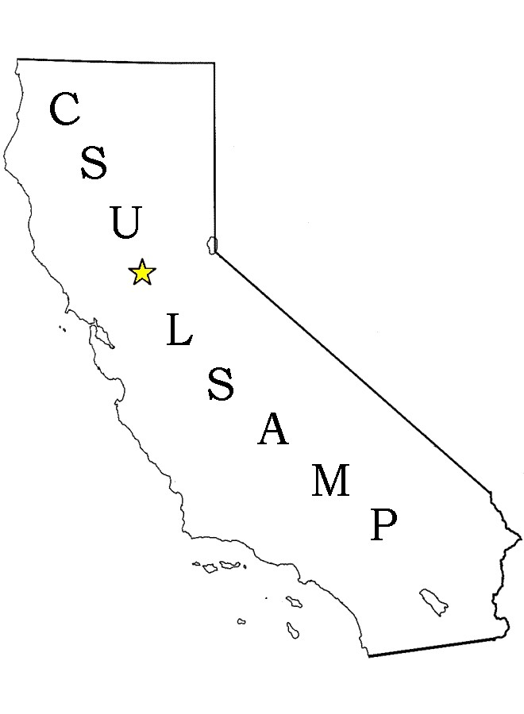

CSU-LSAMP Fresno State Summer 2015 &

Academic Year (AY) Research Program 2015-2016

This is a supplemental application. You must have been accepted to the CSU-LSAMP Fresno State Program in order to be eligible to apply for the
Research Program.

Priority deadline: February 27, 2015

Please type

Name |  |  |  |  |  |  | Home Number
 |  |  |  |  |  |  | Cell phone
Student ID #
Email
Address

City |  |  |  |  |  |  |  | Zip
Major |  |  |  |  |  |  |  | Cum GPA
Career Goal |  |  |  |  | Expected Date of Graduation
Ethnicity |  | African American |  | Hispanic/  Latino |  | Native American |  |  |  | Pacific Islander |  |  |  | Other, please specify:
Class Status (check one) |  | Freshman |  | Sophomore |  | Junior |  |  |  | Senior |  |  |  | Post-bac/  Graduates are not eligible

The program is designed for students interested in obtaining research degrees.

Students interested in obtaining professional degrees (law, medicine, dentistry, pharmacy, or an MBA degree or teaching credential) are not eligible.

It is recommended that you review campus STEM faculty research interests and also discuss research interest with your faculty advisor(s) prior to submitting this application in order to address the following question.

Name ___________________________

Submit a one-page essay describing your research interests, previous research experience (if any), and how participation in this research program will contribute to your academic and professional development.
You may indicate your research project preference (i.e. which faculty mentor and department you plan to conduct research with).

Name ___________________________

Please Read the Following:

- You must have a completed general CSU-LSAMP application on file in order to apply to the LSAMP Summer Research Program and/or the LSAMP Academic Year Research Program.

- If selected to participate, you will be required to complete 160 hours total during the summer component and may be eligible to continue for an additional160 hours during the academic year. This requirement must be met in order to receive your stipends. If total research hours are not met stipend amounts may be prorated.

- If selected to participate you will be required to conduct an oral power point presentation at the end of the summer for the LSAMP Summer Research.

- If selected to participate you will be required to conduct a poster board presentation at the end of the spring semester (May 2016) for the CSU-LSAMP Academic Year Research Program at the College of Science and Mathematics Celebration of Student Research and/or Lyles College of Engineering Projects Day.

- If selected to participate you will be required to attend (encouraged to apply and present) at the Central California Research Symposium at Fresno State in April 2016. Additionally, you will need to discuss other conference opportunities with your faculty mentor. Note: LSAMP may be able to fund your conference participation if funding is available. Priority is given to students presenting research.

- If selected to participate you must attend research program meetings, team building activities (summer EDGE Ropes Course), GRE preparation (if offered), attend at least on California Forum for Diversity in Graduate Education during the academic year.

- All stipends are processed through the Financial Aid office.

Are you currently receiving federal support for conducting research or participating in another federally funded program which provides stipend support for research? If so, name the program and or research project. Note: Federal funding for similar research projects is not allowed.

Yes _____ No ______

I have read the above requirements and understand that I must commit and fully participate in the LSAMP Research Program and all related events and activities in order to successfully complete the program and receive full payment of stipends.

Print Name _____________________________________

Signature ________________________________________ Date ________________

Please return this application form to the LSAMP office in Science1 100.

The application may be hand delivered, or faxed to (559) 278-7804. For more information call Lilia De La Cerda at (559) 278-4748 or e-mail liliad@csufresno.edu

This material is based upon work supported by the National Science Foundation under grant No. HRD-1302873 and California State University.

Any opinions, findings, and conclusions or recommendations expressed in this material are those of the author(s) and do not necessarily reflect the views of the National Science Foundation.

