Announcing the 2015 Application to the
LSAMP GLOBAL AWARENESS PROGRAM, CHIANG MAI, Thailand
Tentative dates: June 18-July 31, 2015

CSU-LSAMP will be supporting up to eight (8) students to participate in collaborative research with Thai faculty and students at Chiang Mai University, Thailand. The CSU-LSAMP program is supported by funds from the United States National Science Foundation (NSF:HRD-0802628), the CSU Office of the Chancellor, and 23 participating CSU campuses. Possible research projects are available in all of the STEM disciplines including chemistry, math and engineering.
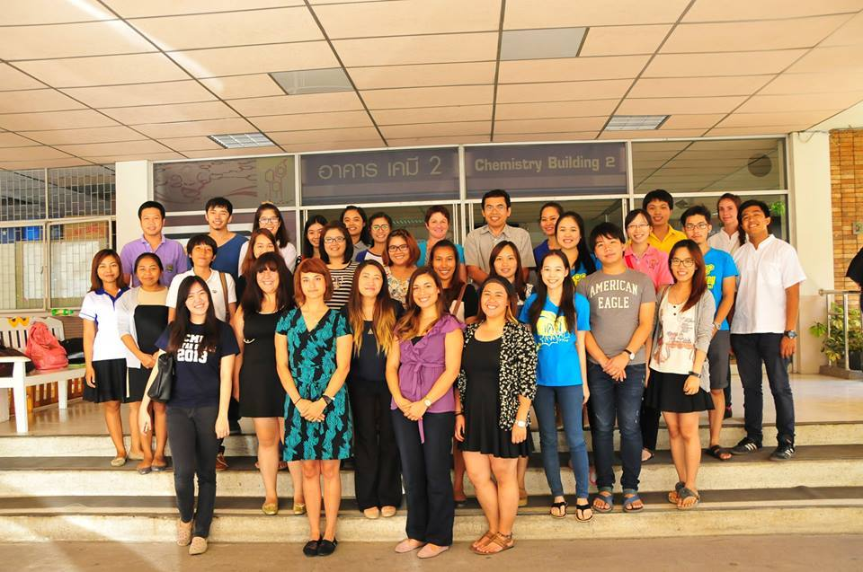
Only current, active LSAMP students with at least one semester remaining before graduation are eligible to apply. Minimum GPA in the major should be above 2.8 with at least 12 units of major core courses completed. Participants must have a current passport and will need to get a tourist visa before travel. Covered costs include return airfare travel LAX to Thailand, housing in Thailand and a per diem to cover incidentals, local travel, and food. In addition to conducting research students will also travel to cultural areas and learn about the Thai culture.

Participants will be selected on the basis of their academic qualifications and preparation, faculty and program director recommendations, ability to adapt to a different culture and climate, ability to work in a team, enthusiasm for international education and research, and the availability of project in their selected field. All applicants will be interviewed by Skype, and the initial selection of participants will begin February 23, 2015. Applications received after February 23 will be reviewed only until all places are filled. Final decisions are expected to be made by March 2, 2015.
For questions concerning the Global Awareness Program, contact the LSAMP program at CSUF LSAMP@fullerton.edu or your campus coordinator. Previous trips and student blogs are also featured on the CSUF-LSAMP facebook page at https://www.facebook.com/CSUFLSAMP/timeline

DEADLINE: For full consideration all materials should be received by 8:00am, February 23, 2015 at LSAMP@fullerton.edu. Applications are available on the web site (http://lsamp.fullerton.edu/) or by emailing LSAMP@fullerton.edu.

