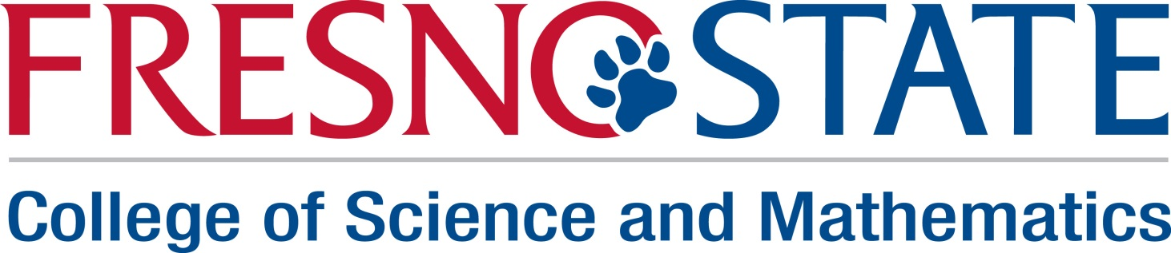
CSU STEM VISTA POSITION DESCRIPTIONS
The College of Science and Mathematics is proud to announce its selection to host two AmeriCorps*VISTA (Volunteers in Service to America) members during the 2014-2015 academic year. These are two of 15 VISTA positions awarded to STEM (Science, Technology, Engineering and Mathematics) programs throughout the CSU system and the only VISTA awards among CSU campuses in the Central Valley. The new CSU STEM VISTA program has as its theme “Building Institutional Capacity for a Stronger Baccalaureate.”

Our VISTAs will help the College of Science and Mathematics launch its new Advising and Resources Center (ARC), opening in June 2014, focusing on expanding service learning, undergraduate research and internship opportunities in the College.
Overall expectation: A one-year commitment beginning July 15, 2014 to support the College of Science and Mathematics and its Advising and Resource Center (ARC).

Position #1: Science Service Learning (SSL) VISTA

This VISTA will be an integral part of the ARC, focusing on developing enhanced programming for our students in Science Service Learning (SSL).

The SSL VISTA will work specifically with faculty in the Biology, Chemistry and Earth and Environmental Sciences (EES) departments to enhance existing SSL courses. The VISTA will assist faculty in developing new service learning opportunities and will assess student benefits in existing courses.

Specifically, the SSL VISTA will work under the supervision of the ARC Director to:

- develop workshops to help students understand SSL and how to become involved;

- develop outreach programming to develop deeper ties with community organizations and industry supporters, and to broaden our external partnerships;

- develop a plan to track student engagement in SSL experiences and evaluate the effectiveness of SSL courses and programs;

- assist faculty with proposed CSU STEM SL research projects

Position #2: Research, Internships and Career Knowledge/Explorations (RICKE) VISTA

This VISTA will be an integral part of the ARC, focusing on developing enhanced programming for our students in Research, Internships and Career Knowledge/Explorations (RICKE). The RICKE VISTA will help the College coordinate, promote and enhance student opportunities to participate in research, obtain internships and learn more about science and mathematics related career opportunities.

Specifically, the RICKE VISTA will work under the supervision of the ARC Director to:

- help coordinate, promote and enhance student opportunities to participate in research;
- identify internship and career opportunities related to science and mathematics;
- work with faculty to inventory and advertise campus research opportunities and off-campus Research Experiences for Undergraduates (REUs) at other universities and countries;
- assist campus-based summer research programs, such as our current NSF-funded REU in mathematics;
- develop a timely and comprehensive database of internships available to STEM majors; create a mechanism for advertising them; connect students with opportunities; and help students make smooth transitions to internship experiences.
- develop an improved mechanism to advertise and track opportunities for CSM students, possibly using a software package with online advertising and tracking of internship and career opportunities. Tracking will focus student career trajectories to improve our ongoing outreach after graduation. It will also provide a database as we establish and nurture industry partnerships.

- function as liaison to University Career Services and work with departments and the CSM Dean’s office to make new career connections with relevant industry partners.

Required qualifications for BOTH VISTA positions:

B.S. or B.A. in a STEM or STEM-related discipline. VISTA will have strong organizational skills and the ability to collaborate at the local department, college and university level, including establishing partnerships with community K-12 programs and industry partners. Vista must have strong and effective written and oral communication skills. Applicants from groups traditionally underrepresented in STEM (minority, first-generation student, female) will be particularly valuable to our project. Hispanic and Hmong applicants are especially encouraged to apply.

