Quick Guide to CWS/CMS

Release 6.8 Changes

Effective 6/8/2013



Central CA Training Academy

Terry Luna, CWS/CMS Training Project Coordinator
559-278-5757
terril@csufresno.edu

Quick Guide to 6.8 Changes

ICPC

Outgoing Page 3 -7

Incoming Page 8 -11

- Other ICPC Considerations Page 12

- Navigation Tool Page 13

Dual Agency Status for a Child Page 14 -15

Safety Assessment for NMD’s Page 16 -17

Other NMD Related Changes Page 18

Safe and Timely Interstate Placement of Foster Child Act – 2006

PL 109-239 – Safe and Timely Interstate Placement of Foster Child Act of 2006 and SB 703 chaptered in October 2007 requires states to:
- Develop a process to ensure that foster care and adoptive home studies for children placed across state lines are completed within 60 calendar days and that the results are available to be reported to the federal government.
- Establish a 14 day time frame for agencies to reject the foster or adoption home study done in another state for the purpose of placing a CA child across state lines.
- Ensure that caregivers have the right to be heard in any court proceeding.
- Require the court to consider both in-state and out of state options in a variety of circumstances involving permanency planning decisions.
The pertinent provisions of SB 703 were effective January 1, 2008.

This release automates the data collection requirements of this Act.

ICPC: Initiating an ICPC Request – Outgoing to another State

ICPC 100A Page: Use this page to begin documentation of the request for services from another state on behalf of a child who presently comes under the jurisdiction of a California juvenile court.

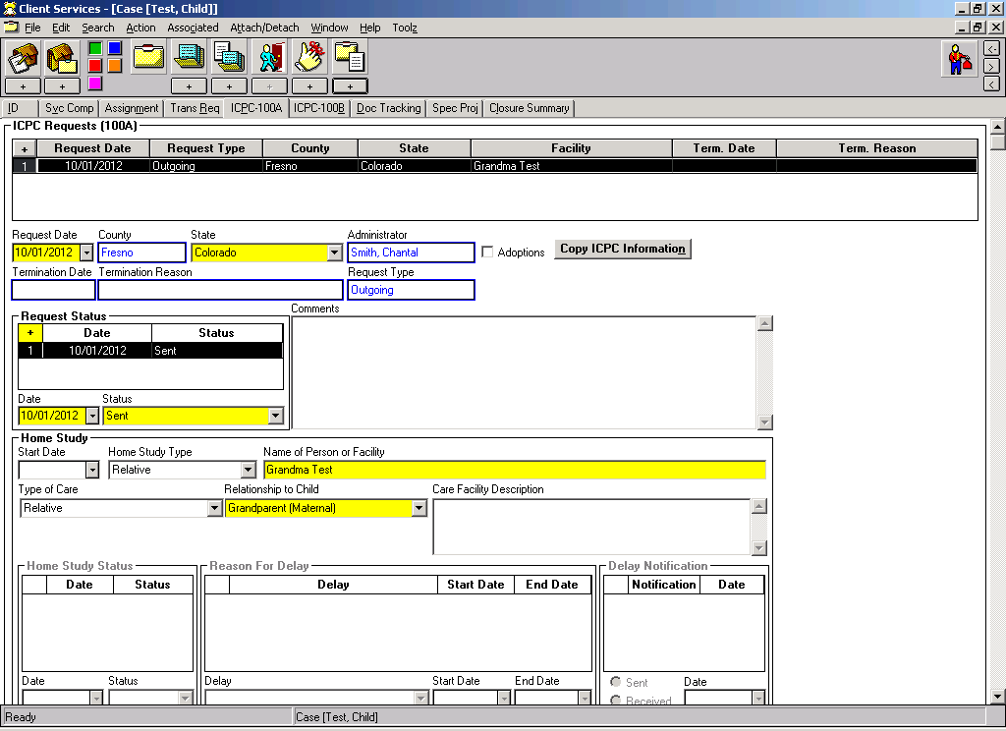
Use the + to begin the request, choose the State to send the packet to.
Use the Request Status grid to document the status of the outgoing ICPC packet: date it was sent to the other state, date it was accepted as complete or rejected by the other State.
In the Home Study section: select the type of home study, record person or facility name, and type of care and relationship.
If the ICPC request is for multiple related children – use this button to copy the information to each child’s case. You must have each case open in the background.
If potential adoption, check here.


Use the plus + to Create New Documents:

You will find the ICPC 100A here, as well as the Financial / Medical Plan which should be sent with the initial request along with other documents, such as: child’s social history, court orders, etc…..

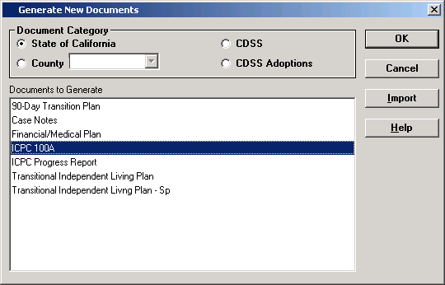

Once the documents are created, they are saved under “existing case document’ icon.

You can generate only one 100A form. If there are updates to the page regarding home study status, remove the 100A form, and then recreate to re-populate.

Documenting Status of a Home Study Request:
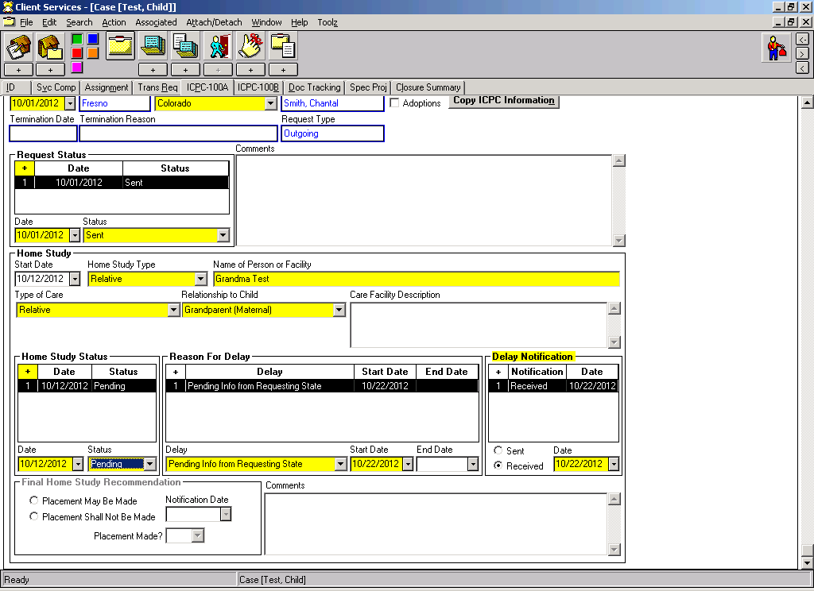
Home Study Start Date: The date the ICPC Request packet was accepted as complete by the other state.

Use these grids to keep track of home study progress.
Home Study Status: | Reason for Delay
Pending | Caregivers’ Home Needs Correction(s)
Completed | Child Abuse Central Index (CACI)
Provisional | Department of Justice (DOJ)
Withdrawn | Education/Training Requirements
 | FBI Request
 | Live Scan/Fingerprint Process
 | Medical Forms
 | Need to Process Criminal Exemption Rqst
 | Noncompliance from Prospective Caregiver
 | Out-of-State Adam Walsh Request
 | Pending Info from Requesting State
 | Other (comments become mandatory)

Final Home Study Recommendation:
This area will allow entry only if Home Study has been updated to “completed”. Recommendation may be made for or against placement.
Placement Made? Yes or No can be selected.

ICPC 100B: Using the 100B for Correspondence:

The ICPC 100B form is used to notify the receiving/sending state:
- When the child is placed pursuant to receipt of written approval.
- When there is a change in the placement status of the child.
- When placement is terminated.
- When there is any other significant change in plans for the child.
Before you can generate the form, complete the ICPC-100B Page.
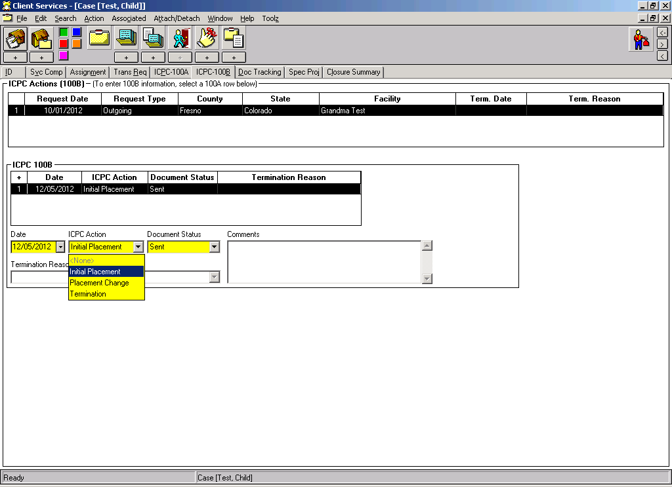
Use the ‘Create New Document’ icon to generate the form ICPC-100B.
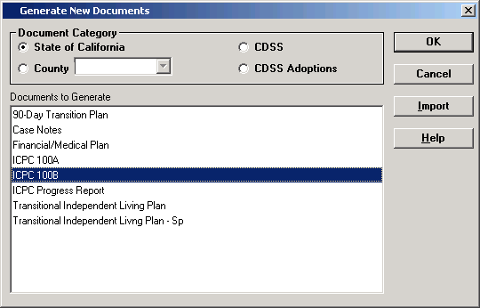
You can generate only one form per 100B line.
Creating an ICPC Case (Incoming): After Receipt of ICPC-100A from Another State

A case must be opened for the child so that contacts and ICPC transactions can be recorded. A separate case must be opened for each child if this is a sibling group the home study is requested for.

Search the CWS/CMS database for the child, parents, etc., to see if any of the clients exist already in our database.

CREATE NEW CASE:



Use the ‘Create New Case’ command to begin the child’s case. This is one of just a few times that a case should be created without a referral!

If you found a Match in your SEARCH: Select the child that you want to create the case for.
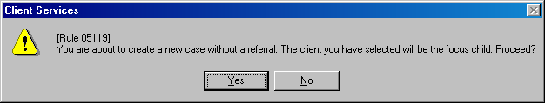

If you did not find a match in your search, the select dialogue box will be blank. Use the NEW button to proceed and you will see this message.

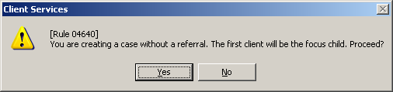

Click yes to whichever message you get, and make this first client the Case Focus Child.
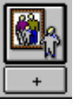

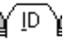 , , ,

If you attached the child from the database, review these pages for accuracy.
If you created the child from scratch, complete these pages with as much information as you have.
Create or Attach additional clients as necessary. (If a sibling group – create a case for each child: then you can relate all children on the Related Clients page.)

 Click ‘Open Existing Case’ to get the case pages in focus.
- Complete the case name – this is the name of the focus child, last name, first name.
- The Start date is the date the ICPC-100A was received.
- The Intervention Reason – “Incoming ICPC Request”.
- The State field will become YELLOW, select the State that is requesting the ICPC.
- Complete the ‘Status’ of the case – court or voluntary – if the service component is anything other than Emergency Response.
- Select the appropriate program for the child on the Service Component page.
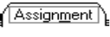
- Only ‘Secondary’ assignments can be recorded on the case. Record the ICPC worker assignment in the county. An ‘out of state’ contact can be recorded here also by selecting the radio button: Assignment Destination – Out of State.
SAVE TO DATABASE

ICPC-100A Page:
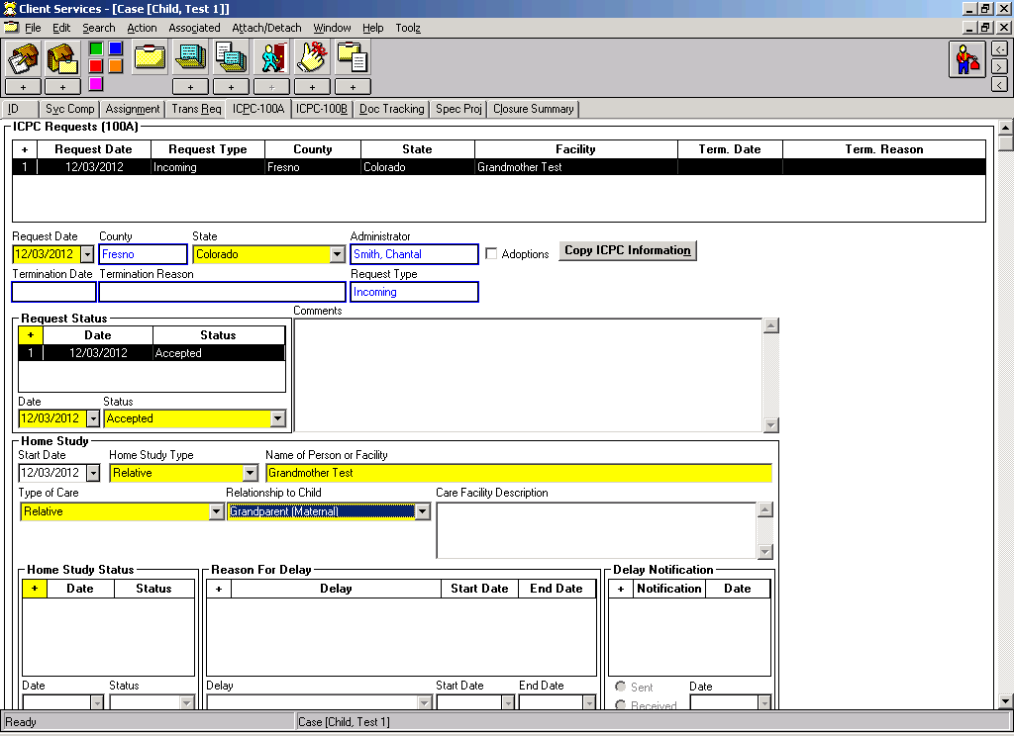
Received, Pending, Accepted or Rejected can be recorded here.
When the ICPC packet is received and accepted by the county, complete the Request Status area. Then the Home Study area will be enabled, so that the information on the Person/Facility can be entered, and the steps toward approval or denial, including any reasons for delays.

Home Study Start Date: The date the ICPC Request packet was accepted as complete by the county.

Use these grids to keep track of home study progress.
Home Study Status: | Reason for Delay
Pending | Caregivers’ Home Needs Correction(s)
Completed | Child Abuse Central Index (CACI)
Provisional | Department of Justice (DOJ)
Withdrawn | Education/Training Requirements
 | FBI Request
 | Live Scan/Fingerprint Process
 | Medical Forms
 | Need to Process Criminal Exemption Rqst
 | Noncompliance from Prospective Caregiver
 | Out-of-State Adam Walsh Request
 | Pending Info from Requesting State
 | Other (comments become mandatory)

Final Home Study Recommendation:
This area will allow entry only if Home Study has been updated to “completed”. Recommendation may be made for or against placement.
Placement Made? Yes or No can be selected.
Following review by the receiving state, the 100A is the official notification that the proposed placement may or may not be made.
ICPC-100A can be generated at any stage of the home study process. Remove the old document to refresh and regenerate the new one.

ICPC 100B: Using the 100B for Correspondence:

The ICPC 100B form is used to notify the sending/receiving state:
- When the child is placed pursuant to receipt of written approval.
- When there is a change in the placement status of the child.
- When placement is terminated.
- When there is any other significant change in plans for the child.

Termination: When Termination is selected: worker must select a termination reason.
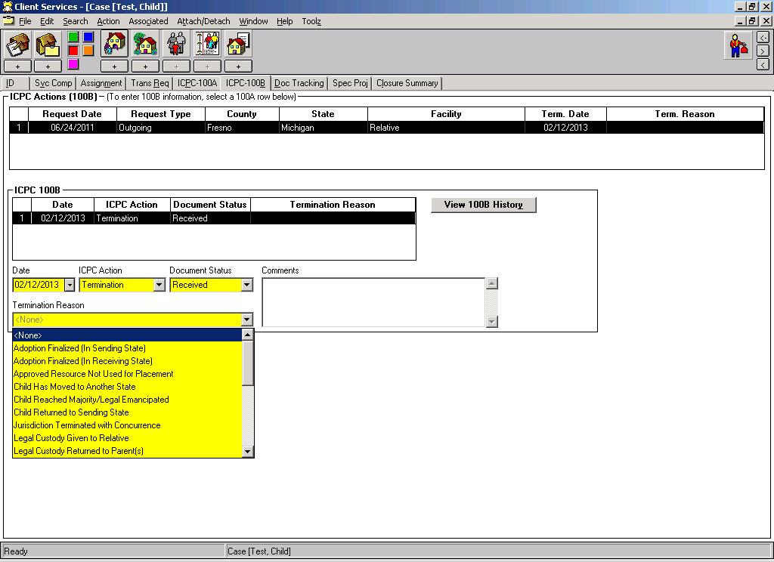
Termination Reasons:
- Adoption Finalized (in Sending State)
- Adoption Finalized (in Receiving State)
- Approved Resource Not Used for Placement
- Proposed Placement Request Withdrawn
- Child Has Moved to another State
- Child Reached Age of Majority/Legal Emancipated
- Child Returned to Sending State
- Jurisdiction Terminated With Concurrence
- Legal Custody Given to Relative
- Legal Custody Returned to Parent(s)
- Treatment Completed
- Unilateral Termination
- Other (comments are mandatory)

Other ICPC Considerations:

Incoming | Outgoing
Child a dependent of another state | Child a dependent of California
Need to Create a New Case. | Already an Open Case.
Can only have a ‘secondary’ assignment. | The county has ‘primary’ assignment.
Record all ‘contacts’ in relation to the home study. | Record all normal case activity: Contacts, Case Plans, Court Reports, etc.
If the results of the home study indicate a Positive placement – Create the Placement in CWS/CMS.  Legal Authority = Out of State ICPC.  No Ongoing Requests page as payment is other State’s responsibility. | If the results of the home study indicate a Positive placement – Create the “out of state” placement in CWS/CMS.
If the results of the home study indicate a Negative placement – End the Case  (If more than one county has assignment to the case – it cannot be ended until both counties have completed the process). | Education Notebook: Out of State Schools – many are in CWS/CMS – just need to search. If not in the database, contact Help Desk to create.
 | Health Notebook – available for entry.

Ending a Case:
You cannot close a case unless you have ‘terminated’ the ICPC request on the ICPC-100-B Page: See page 10 for details.

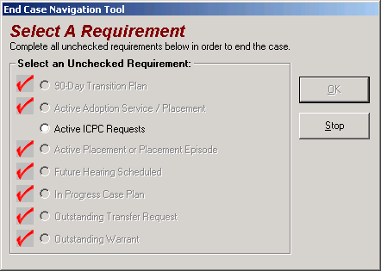

You can also see ICPC-100A & B transactions in the Case/Referral Overview Tool.

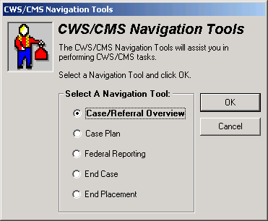

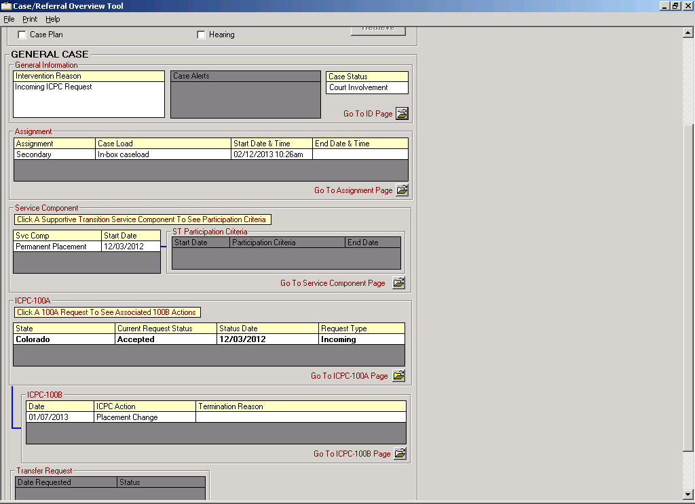

Dual Agency Status for a Child

ACL 08-17 – 03/28/08 – provided information regarding the new dual agency rates, effective 07/01/07, for children served by both California Regional Centers and California Child Welfare and Probation Agencies.
W&IC Section 11464(h) requires CDSS and DDS to report to the Legislature various data regarding dual agency children twice a year. Data can be documented in CWS/CMS with this new release to assist in the report.

Definition:
A dual agency child is a child in a foster care home, a child in adoptive placement, or adopted from the foster care system, who receives AFDC-FC or AAP benefits and who is concurrently a consumer of California Regional Center services due to a developmental disability, as defined by the Lanterman Act, and/or children receiving services under the California Early Start Intervention Services Act.

Health Notebook:

` 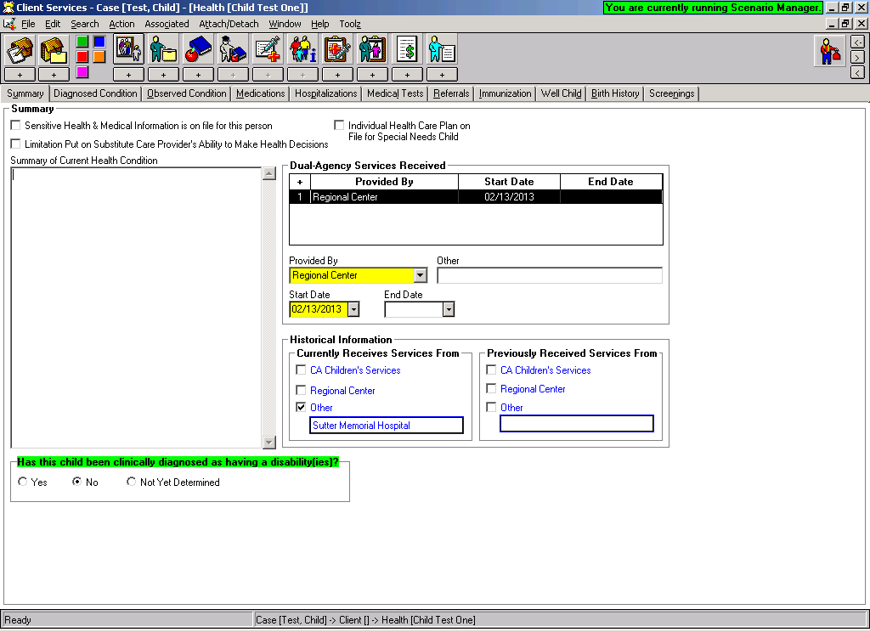
New grid added to the child’s Health Notebook – Summary page. You can indicate here if a child is receiving services from CA Children Services, a Regional Center, or ‘other’.
If ‘other’ is selected – you can specify.
This historical grid will only appear if prior to the release, the user had selected ‘currently receives or previously rec’d services from a regional center.
This information will populate to the HEP.

Documenting the Dual Agency Rate:

Placement Notebook: Ongoing Requests page:

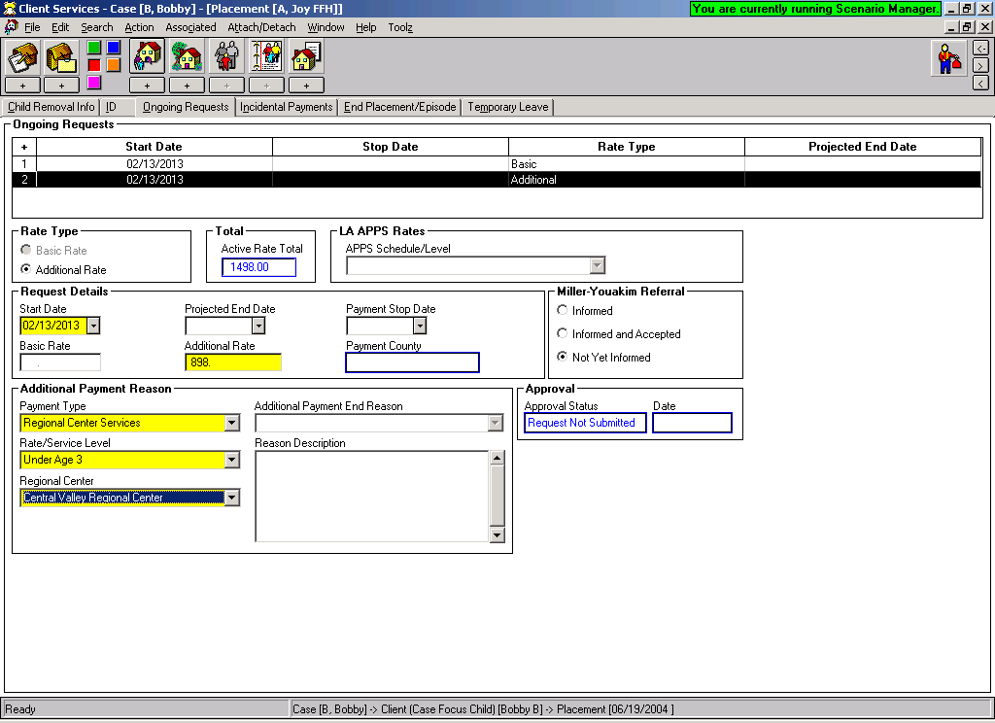
Note: The Additional Payment End Reason will only be enabled for Education Transportation.

Under the Additional Payment Reason section, you can now select ‘Regional Center Services’. That will enable the other two drop-down menus: Rate/Service Level and Regional Center.

Rate/Service Level: Regional Center:

1 Regional Centers in CA listed here.
2 – Staff or Owner
3 – Staff or Owner
4A through 4I
Age 3 or over
Age 3 or over with supplement
Under age 3

Safety Assessment for Non-Minor Dependents

ACL 11-77 dated November 18, 2011

Additional provisions of AB 12 and amendments to W&IC section 16504(c) authorize the child welfare agency to evaluate for an emergency response to an allegation that a NMD is endangered by abuse, neglect, or exploitation by a licensed or approved caregiver in order to determine if the placement is safe and appropriate. The suspected abuse by a licensed or approved caregiver shall be cross reported to the appropriate licensing or approval agency.

Health & Safety Code section 1636.1 requires the same type of notification to the licensing agency for NMDs in licensed foster homes or facilities when there is suspected abuse or other incidents that would jeopardize the health and safety of any other residents in the home or facility. If it is suspected that a NMD who is living in a SILP is being abused by a roommate, this should be reported to local law enforcement, but will not be recorded in this ‘safety assessment’ area.

ID Page of Case Notebook:

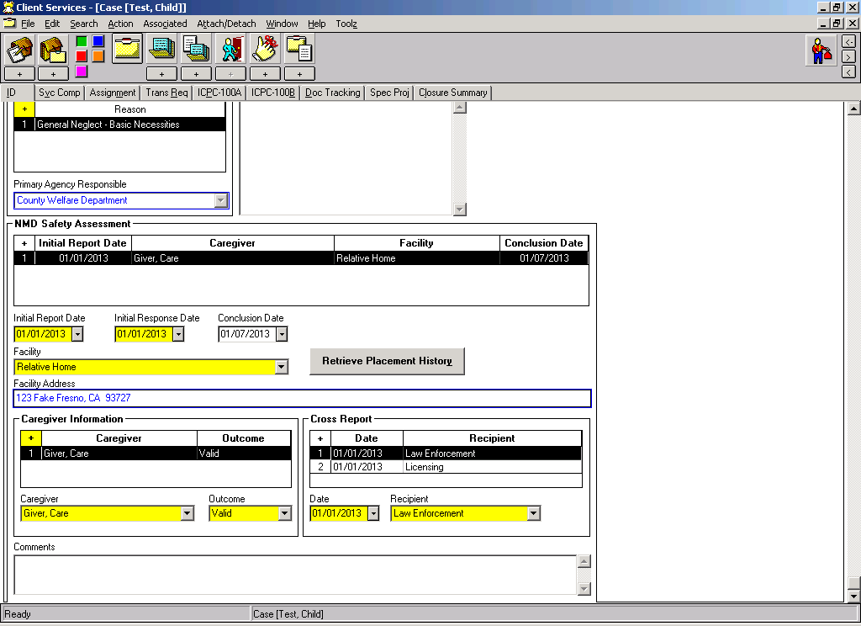
Record the dates of ‘initial report’ and ‘initial response’ in regards to a safety assessment of NMD. Retrieving all placement history will bring all facilities and SCP’s into the drop down menu for selection. Once an ‘outcome’ has been entered – you can record the ‘conclusion date’. Any cross reporting completed can be recorded here.
This grid will be visible for entry if the case focus child is 18 or over.

If a ‘valid’ Safety Assessment has been recorded in the NMD’s case – the Safety Assessment information will populate to the ID page of the Placement Home. This will be an indicator of a safety issue that has been investigated and concluded in relation to this facility / caregiver. The NMD’s case number will show here for reference.

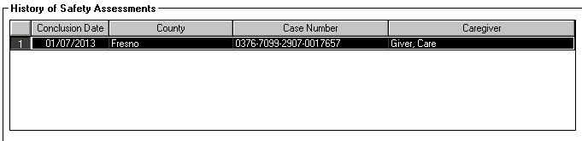

The message: **NMD Safety Assessment History Exists** will display on the ID page of the NMD’s case, and the ID page of the Placement Home.

Contact Notebook:

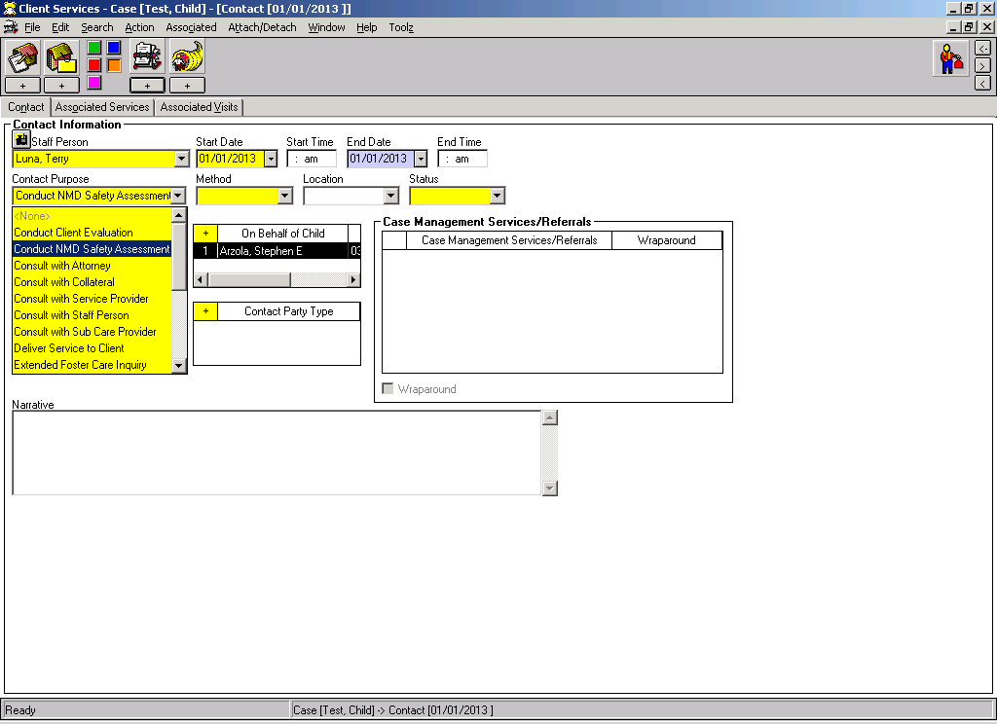
A new value of “Conduct NMD Safety Assessment” has been added in the contact purpose drop down menu to easily identify safety assessment narration.

Other NMD Related Changes:

Contact Notebook:

Contact Purpose: A new value added: Extended Foster Care Inquiry
The intent is to use this value when a contact is made with a NMD that is contemplating returning for extended foster care but have not yet reopened their case.
Note: Contacts can be recorded in closed cases.

Reminders:

- State ID Missing reminder extended to encompass all focus children under age 26 in an active case or referral.

- Psychotropic Medication reminder age limit extended to clients under age 26 who are in an active case / referral.

Client Notebook:

- Confidentiality Check Box – defaults to Yes for any client that is being created or selected as a case focus child. This will keep that client’s address from populating key documents, such as the Health & Education passport.

- For all children that are ‘case focus children’ regardless of their age – the ICWA fields on the ID page of the Client notebook will be available.

Placement Home Notebook:

- Age range in a Placement home defaults to age 18 – but can be increased manually up to age 25.

