Cathy Latona Pluta CSUF 1971
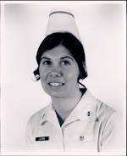
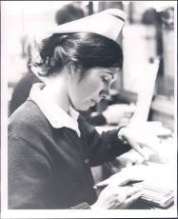
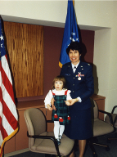
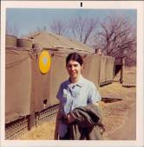
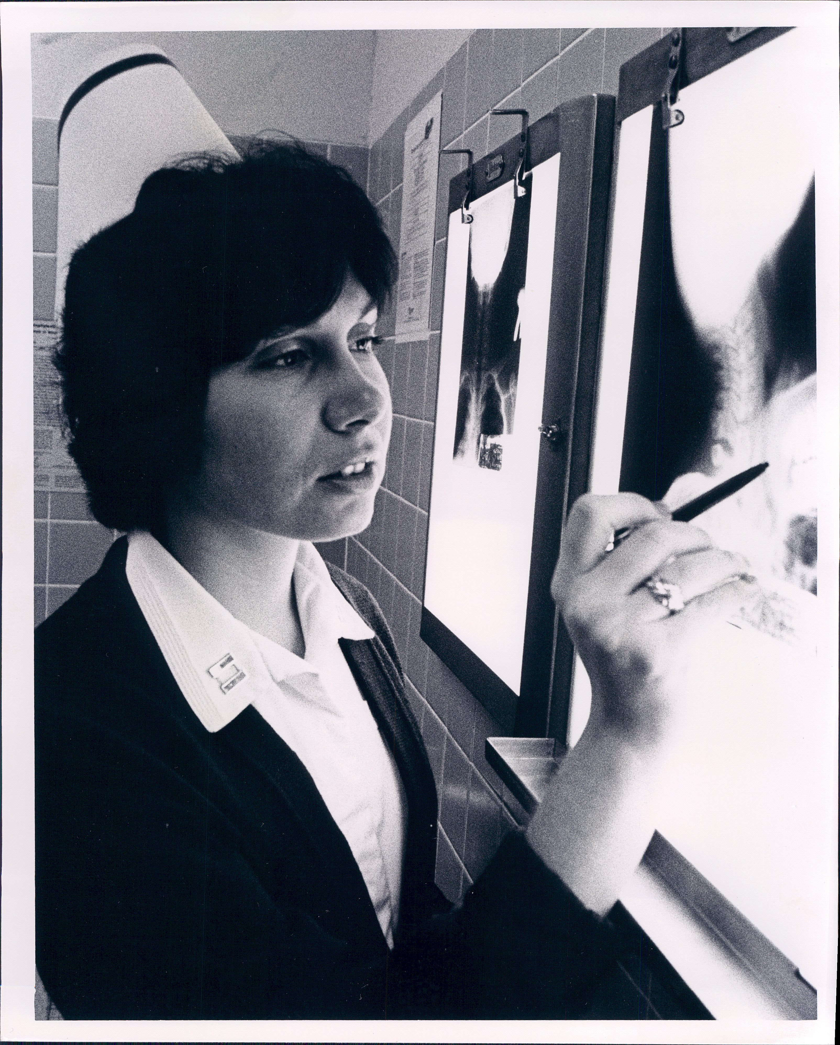
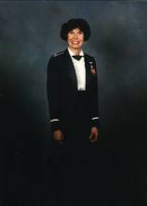
I was the first daughter born to Mary and Horace Latona. My mother was/ is an RN who graduated from a diploma school of nursing in South Dakota.
She had several jobs before joining the Army and moving to California. After WWII she moved to Fresno, met my father and married.
I graduated from San Joaquin Memorial HS in 1967. At an early age I new I wanted to be a nurse. When it came to apply to schools my mother said. "You will go to Fresno State and you will get your bachelors in Nursing." In 1967 she was the future of nursing and knew the importance of a BSN.
After graduation (Summer school grad 1971) I worked OB at Valley Medical Center for a very short time. I took state boards in Long Beach in
September (I took them on my 22nd birthday). I had my AF physical about the same time. In February I was on my way to Loring AFB Maine. The beginning of my 20 year career in the AF. Years of memories, travels, experiences, education and friends. In 1977 I attended the AF OB/GYN nurse practitioner school. And worked as an NP until retirement in 1992 as a Lt Colonel. While on AD I completed a masters in Health Science from Chapman college. In 1990 I adopted a baby while stationed at Edwards AFB. Then married a former B 52 pilot I met in 1972.
We now live in Walnut Creek. I have been working as an NP for Kaiser Permanente in Antioch since Sept 1992, and I work harder now than I ever did while in the Air Force. Thank God I only work 3 days a week.
You asked about memorable experiences in school. I think we all remember our first patients. And I remember that mine was a former army nurse that did not want a bed bath or a back rub. And of course those were the first things we were taught to do. And a few weeks later I saw here name in the obituaries. I was also doing my OB rotation during the campus unrests/riots after the Kent State disaster. It was time for finals. So we took our final at our instructor, Mrs. Chang's, house. And she served us Dim Sum. When I was stationed in Japan 1973-1975 I went to Taiwan to visit her. She was on sabbatical there and showed me the hospital, warning..." just look, don't say anything" Very different hospital conditions. I remember seeing two babies in one isolate.
How do I feel about nursing?.... I am proud to be a nurse. And I am usually proud of my profession. However, sometimes when I hear hospital and
nursing stories I am ashamed and embarrassed. Nursing is not what it used to be and what it should be. My mother would agree. At 91 years of age she
is now a feisty patient that does not hesitate to speak up when it comes to
nursing care.
So what do we need? More instructors! More instructors would provide more students and more nurses and better care for patients. The profession needs to make advanced degrees more available, and the positions more attractive with higher salaries. When I was a sophomore my med/ instructor told me to get my masters... and I didn't. I did become an advanced practice nurse but did not get my MSN. Therefore I am not qualified to “practice what I preach" And I really never want to go to school again, I admire anyone who does.

