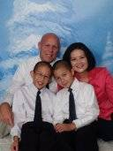
LeRoy A. Marklund MAJ, AN CSUF 1993
1) Briefly tell about our family background
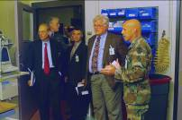
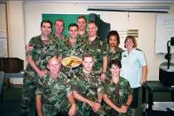
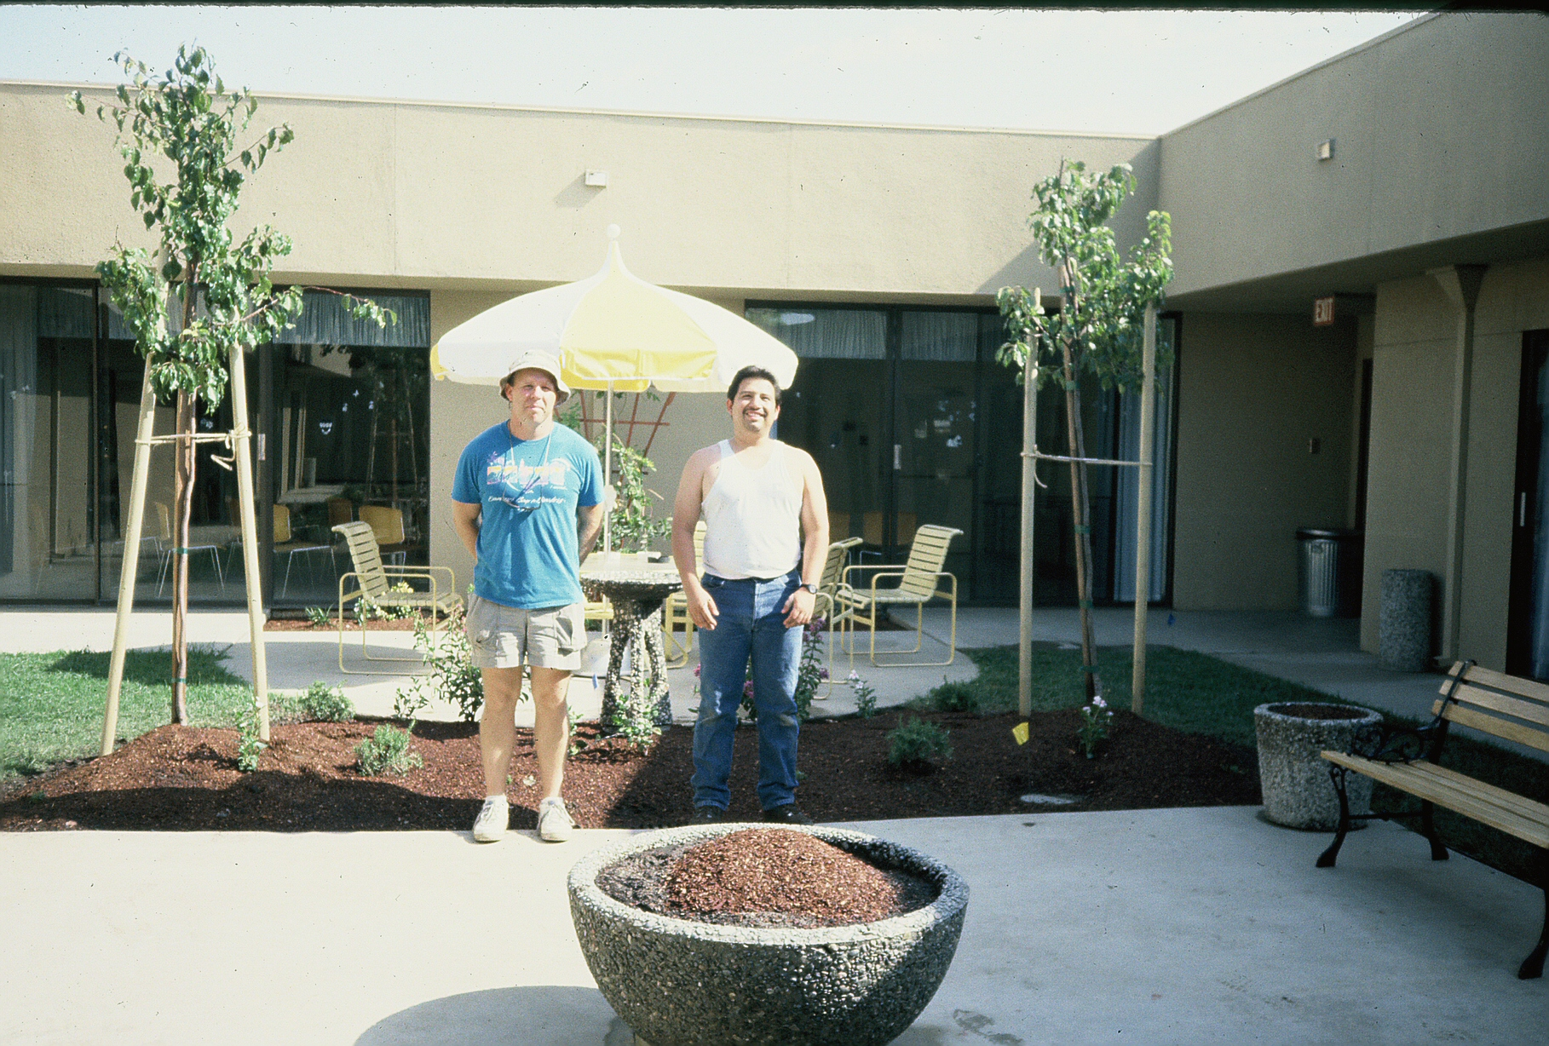
I was born and raised in Madera, California. I was the middle of five children born to Charles and Hazel Marklund. I was the third to go to college in my family and the second nurse. I received my BSN at CSUF in 1993. I obtained my masters at the University of Maryland at Baltimore in 2000. I married Happy Joe in 1995, we have two sons; Neil age 11 and Lee age 10. Neil is a 7th grader and plays piano and viola. Lee is a 6th grader and plays piano and violin. Nursing is my second career. I worked for over 15 years in agriculture and previously earned my BS (1977) & MS (1980) in agriculture from CSUF. I was enlisted in the U.S. Army Reserves during my undergraduate nursing studies, while serving as a Patient Administrator Specialist with the 359th Combat Support Hospital in Fresno, California. On 25 September 1993, I was commissioned into the U.S. Army Nurse Corps with no regrets. I entered active duty on 5 March 2004 and served as a staff nurse at the 121nd General Hospital, Yongsan Garrison, South Korea, 1994 to 1995; staff nurse at the 5th Mobile Army Surgical Hospital and Womack Army Medical Center, Fort Bragg, NC, 1995 to 1997; staff nurse at Walter Reed Army Medical Center, Washington, DC, 1997 to 2000; Officer in Charge of the Aeromedical Isolation Team, U.S. Army Medical Research Institute of Infectious Diseases, Fort Detrick, MD 2000 to 2002; Company Commander, A Company, 86th Combat Support Hospital, Fort Campbell, KY, 2002 to 2004; Brigade Nurse, 10th Support BDE, 10th Mountain Division, Fort Drum, New York, 2004 to 2005; Clinical Nurse Specialist, U.S. Army Trauma Training Center, Miami, Florida, 2005 to 2008; and currently serving as Staff Officer, U.S. Army Medical Research Institute of Chemical Defense, Aberdeen Proving Ground, MD.
2) List any student nurse experience you may remember and any faculty?
My most memorable experience as a nursing student at CSUF was combing my agriculture experience with nursing and working closely with one of my fellow classmates and life-long friend. Dr. Judith Allender approached me and Michael Martinez about building a garden for Fresno Community Hospital’s Alzheimer Care Facility, which is located in North Fresno. With Mike’s construction experience, we had no choice but to jump at this opportunity for our “Senior Project.” The end result was a beautiful court yard garden complete with water fountains, shade trees, park benches, raised vegetable garden beds, and an abundance of colorful and aromatic vegetation that clients and staff members could enjoy. In addition, staff physical therapists and the recreation coordinator provided useful ideas to make our project multipurpose and improve quality of life. Talk about synergy! I am also grateful toward Dr. Michael Russler. He is sincere about consistently contacting me and asking about my professional career and the well being of my family. Dr. Russler is a true role model and leader.
3) Tell about any interesting patient of nursing care stories as a new nurse?
I have to be honest, during my entire undergraduate nursing experience, I dreaded pediatric nursing. To this day, I am not a pediatric nurse nor do I aspire to be one, but the experience I gained under the guidance of Professor Terea Giannetta at Valley Children’s Hospital will always be appreciated. Ten years after graduating from CSUF, I was placed in an austere military setting and my nursing practice changed. I was assigned to the only U.S. Army hospital during the initial stage of Operation Iraqi Freedom. When President Bush announced to the world that Coalition forces were ordered to liberate Iraq, we received wounded soldiers. Three days later, we were also treating critically injured civilians, many of them were children. At that time, I had no choice but to be the best pediatric nurse I could be because no one else was available to take my place. Professor Giannetta was right when she said, “The nursing profession involves a continuum of care from cradle to grave. So learn all you can about pediatrics now because you may need to take care of children in the future.”
4) How do you feel about nursing then and now, and in the future?
My feeling about nursing is steadfast and has never wavered. Nurses have an obligation to care for the sick and dying. I strongly believe any medical profession, be it nurse or physician is a Divine calling. You have the choice to accept or reject this mission. Nursing is a life long journey and the training never ends as student, mentor, or educator. The future of the nursing profession is currently at a cross road and nurses are obligated to sustain a humanized health care system in the midst of political turmoil and legal agendas because the plight of human suffrage is more than votes and financial gains.
5) Any bits of wisdom you have learned over the years? (If you have changed professions, has your nursing education helped?)
Formal education is great and it will help you professionally, however, informal education is better. The best course I took to prepare me as a nurse was being a patient. As a patient, I realized what pain is and how important the role of the nurse is in the healing process. Thank God for nurses who place patients first and strive to improve their practice.


