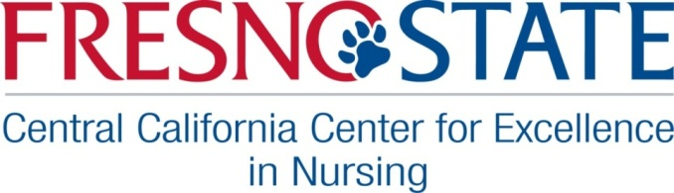

Nursing Legacy Project

Greetings Fresno State Nursing Graduates,

We would love to have a short nursing career biography of you, some family background, and your contact information. The information will be for the specific use of the School of Nursing, Central California Center for Excellence in Nursing, and Nursing Legacy Project for invitations to events and oral history requests.
(See confidentiality form below)

Optional: Contact Sheet Information

Name of School and date of graduation: year

Single/married/divorced/ (check one) Spouse Partner
(Females) maiden name or student name:
Date of Birth: / /
Current address:
City State Zip Code

Home phone: __ ____________Work phone: ___ _______
Cell phone: __ ____________ Home E-mail: ____ _____
Other phone? ____________ Work E-mail ___ ____
Home FAX: __ ______ Work FAX:__ _____

Name of children and spouses’ name and address or phone or e-mail to be able to contact you if you should move: (Or younger sibling or friend or parent)

Are you planning to move somewhere when you retire? (Even if you don’t have a permanent address yet?)

Please email this form along with any photos to ploewen@csufresno.edu or mail to: CCCEN atten: Pam Loewen, Alumni Liaison and Historian, 1625 E Shaw Ave Suite 146, Fresno, CA 93710. (When submitting photos by mail place your name on the back and originals will be returned, Thank You.)
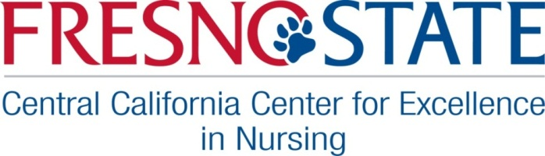

Nursing Legacy Project

Fresno State Nursing Department Alumni Written History:

We want to know how our nurses have impacted the community. This can be a paragraph or a page.

- Briefly tell about your family background. Below is a sample, please add in any other information you would like.

My name is Pam Loewen; I was born in Reedley, Ca. I was the oldest of 2 children born to Lenort and Jessie Loewen. I was the first to go to college in my family and the first nurse. I got my BSN at FSC in 1966. I obtained two masters at the Univ. of Hawaii in 1982, an MPH and MSN. I worked for the FGH for 2 years and as a staff nurse on maternity from 1966-68. I then worked at Fresno County Health Dept. as a Staff Public Health Nurse and Sr. PHN for 7 ½ years and then went into the United States Air Force Nurse Corps from 1975-1980. I worked etc…)
Please fill in the blanks: My name is , I was born in . I was the of children born to & . I was the to go to college in my family, and the nurse in my family. I graduated from Fresno State in with my degree. I also obtained degree/certificate from Univ. of . My spouse/partner is , we have children, (name) (age) and (name) (age) . One is a (profession/ job) and one is a (profession/job). I worked at as a nurse from - (years). Etc…

Please add in any additional information you would like in the box below
(optional: attach your own word document.)

- List any student nurse experience you may remember and any faculty?

- How do you feel about nursing then, now, and in the future?

- Any bits of wisdom you have learned over the years?
(If you have changed professions, how has your nursing education helped?)

Please email this form along with any photos to ploewen@csufresno.edu or mail to: CCCEN atten: Pam Loewen, Alumni Liaison and Historian, 1625 E Shaw Ave Suite 146, Fresno, CA 93710. (When submitting photos by mail place your name on the back and originals will be returned, Thank You.)
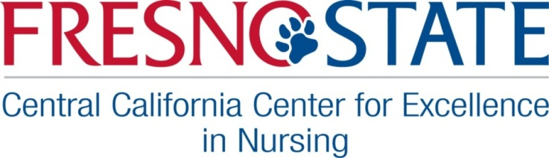

Nursing Legacy Project

Confidentiality Form:

Confidential contact information will only be available to the Fresno State’s School of Nursing, Central California Center for Excellence in Nursing and Nursing Legacy Project for contact invitations and oral history requests, and with your permission, to your designated reunion committee.

I give my permission for the above.

Signature Date

