GE Area A3: Critical Thinking
SLO Evaluation Report May 2019

Background/Description of GE Program ePortfolio:
Prior to the 2017-2018 AY, departments/programs were responsible for assessing GE student learning outcomes and submitting a report every year for the GE Committee to review. This system had several weaknesses. Departments and programs were responsible for deciding which of the two to four outcomes designated for a specific GE Area to assess; thus some outcomes were evaluated multiple times within a year and others were not evaluated at all in certain years. It was also not possible for departments to access and evaluate a representative sample of student work, nor was it possible to compare the results from GE courses in the same GE Area taught by different departments/programs, because each department/program used its own criteria/rubrics. Finally, the GE Committee was not able to review and analyze the GE assessment reports in a comprehensive fashion, since the committee was also tasked with reviewing all GE curriculum proposals, as well as with discussing and updating GE policies and procedures.
Therefore, Fresno State developed a proposal for a new system of evaluating GE student learning outcomes during the 2014-2015 AY. The proposal was approved by Fresno State’s Academic Senate in May 2017 and by Dr. Joseph Castro in August of 2017. Essentially, all freshmen and transfer students admitted to Fresno State beginning in Fall 2018, submit one designated assignment aligned to one GE student outcome from lower-division (for freshmen) and upper-division (for freshmen and transfer students) GE courses to a GE Program ePortfolio. Students will also write 300-word reflections (freshmen write three and transfer students write one) about their learning and submit these to the GE Program ePortfolio. The GE Program ePortfolio was set up by the Director of Assessment and students were automatically enrolled. Handouts, videos, and other resources that were posted previously to Blackboard were uploaded to Canvas when the campus transitioned from Blackboard to Canvas.
During the first year of implementation (2017-2018 AY), efforts focused on electing members to the new GE Assessment Subcommittee and on approving common rubrics to be used to evaluate GE student learning outcomes. Fresno State’s GE student learning outcomes were approved by the Academic Senate in 2010. These are the forty outcomes that will be evaluated on a five-year schedule. Beginning in the 2018-2019 AY, a team consisting of the Director of Assessment, the ten faculty members serving on the GE Assessment Committee, and the student representative selected a random sample of student submissions for all ten outcomes in GE Areas A1, A2, and A3, then evaluated these submissions to determine proficiency in the GE student learning outcomes for GE Area A.
GE Assessment Subcommittee: Evaluation and Norming Process:
The GE Assessment Subcommittee had previously reviewed and approved common rubrics for evaluating each of the ten GE student learning outcomes designated for GE Area A. The committee also discussed the specific assignments submitted for each outcome and evaluated how well each assignment aligned to a specific GE student learning outcome. Finally, after two committee members were assigned to evaluate specific student learning outcomes, the Director of Assessment held a two-hour meeting with all five faculty teams. During these meetings, the appropriate rubric was used to evaluate sample student work as part of the norming process. Each reviewer scored the student work independently. Clarification was provided as necessary during the period in which the faculty teams were reviewing and scoring the assignments. After scoring the work, faculty teams met to identify common strengths and weaknesses; a third reviewer scored all assignments on which the two reviewers did not agree about proficiency.
Outcomes and measures (assignments) used to evaluate A3 outcomes:
Critical Thinking (Area A3)
Upon completion of an Area A3 (Critical Thinking) course, students will be able to:

- Recognize, analyze, evaluate and construct arguments in ordinary language.

- Distinguish between inductive and deductive reasoning.

- Identify common fallacies of reasoning.

- Analyze and evaluate the various types of evidence for various types of claims.

Assignments:
There are more than a dozen courses offered by eleven different departments/programs in GE Area A3 which focuses on critical thinking. As a result, there were a diverse array of assignments submitted to the GE Program Portfolio. In cases where there was more than one assignment that aligned to a specific outcomes, at least two different assignments were used and there was at least one assignment that was closely aligned to each of the four outcomes. For outcome one, two different kinds of papers were used to evaluate the outcome. One of the papers was a brief research paper in which students constructed an argument with a thesis and key point and supported these points with evidence from sources. The second paper was one where students identified and analyzed an argument in an article assigned by the professor. For the second outcome, an assignment where students had to analyze an article and distinguish between examples of inductive and deductive reasoning. There was only one assignment focused on inductive/deductive reasoning submitted to the GE Program Portfolio and not all students enrolled in the course with this assignment uploaded their assignments to the GE Program Portfolio and so the sample was very small. Going forward students will submit additional assignments related to inductive and deductive reasoning and a larger sample will be evaluated. For outcome three, two different assignments that asked students to identify fallacies of reasoning within scholarly or non-scholarly articles were used to determine proficiency in the outcome. Finally, for outcome four an assignment a climate analysis worksheet that required students to identify key points and discuss whether or not the evidence provided was valid and reliable was used.
Review Process:

Thirty assignments are considered the minimum sample size for GE outcomes and beginning in the 2019-2020 AY more than thirty assignments will be evaluated. It was possible to use thirty or more assignments for A3 outcomes 1, 3, and 4 during the assessment. However, because this was the first year that students submitted assignments to the GE Program Portfolio and there was only one assignment that directly aligned to A3 outcome 2 it was only possible to evaluate sixteen assignments. Despite working directly with the faculty member, only about two thirds of students in a relatively small course submitted the assignment to the GE Portfolio. All of the assignments used to evaluate the A3 student learning outcomes aligned very closely to one of the specific outcomes.

Results for A3 outcomes 1, 2, 3, and 4
Outcome 1 focuses on student’s ability to recognize, analyze, and evaluate or to construct arguments and the rubric had three criteria. Out of the 29 students evaluated, 22 (76%) were considered proficient in the first criteria with 12 of the 22 designated as advanced. Twenty-one (72%) were considered proficient in criteria 2 with 12 of those students were deemed advanced. Twenty of twenty-nine (69%) were designated proficient in criteria three, with twelve of the twenty scoring advanced and eight of the twenty scoring proficient. Overall, across the three criteria, 75.9% of students were deemed proficient. Outcome 2 assesses the ability to distinguish between inductive and deductive reasoning, 14 (88%) out of the 16 students evaluated were deemed proficient and 5 of the 14 were deemed advanced instead of merely proficient. Out of thirty students evaluated for their ability to identify common fallacies of reasoning (outcome 3), 25 (83%) were deemed proficient and 5 were designated as not proficient. Analyzing and evaluating claims for various types of evidence (outcome 4) is an important skill and thirty (86%) out of the thirty-five students evaluated were deemed proficient in both criteria one and criteria two.
Table 1. Student Proficiency and Inter-rater Reliability Averages for GE Area A3
 | A3.1 | A3.2 | A3.3 | A3.4 | Overall
Student Proficiency | 75.9 | 87.5 | 83.3 | 85.7 | 82.5
Inter-rater  Reliability | 98.8 | 100 | 100 | 100 | 99.7
N | 35 | 16 | 30 | 39 | 120

Inter-rater reliability
Two faculty members evaluated A3 outcome 1 and 2 and two different faculty members evaluated A3 outcomes 3 and 4. A third reviewer was not necessary for any student assignments in GE Area A3. Given there were 120 student evaluations for learning outcomes in GE Area 3 and taking into account that there were actually seven separate criteria evaluated in all it is very impressive that inter-rater reliability for all outcomes and criteria was nearly 100%. All faculty who evaluated A3 outcomes teach at least one GE course and two of the faculty evaluators teach courses in GE Area A3 which was being assessed. The faculty reviewing assignments in GE Area A3 went through the same “norming” process as all other faculty serving on the GE Assessment Sub-Committee and evaluating work but the inter-reliability rate was higher for GE Area A3 than for GE Areas A1 or A2.
Figure 1. Graph of Student Proficiency and Inter-rater Reliability Averages Area A3
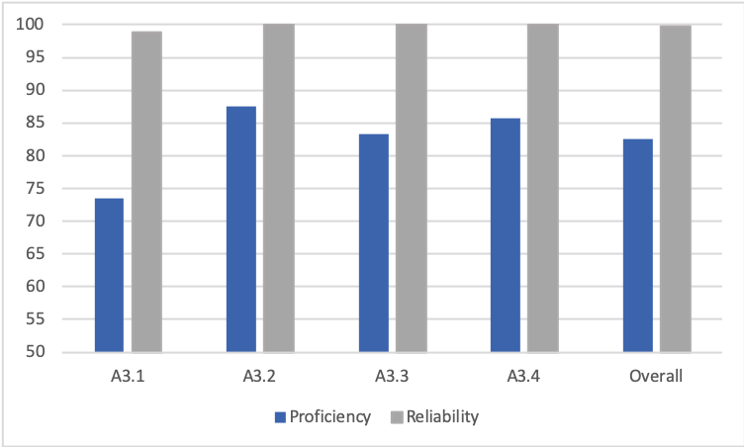

Conclusions
While the benchmark of 90% was not met for any of the four outcomes in GE Area A3, students performed relatively well and more than 80% of students were proficient in all criteria for outcomes 2, 3, and 4. However, students performed significantly less well on outcome 1 which required them to either recognize, analyze, and evaluate or construct an argument. Only 69% of students were designated proficient in outcome one, criteria three which is the ability to evaluate an argument (or to connect evidence). Comments by reviewers indicate that students are unable to critically evaluate or construct an argument without weaknesses. An additional analysis of assignments aligned to GE Area A3 outcome 1 in order to see if an evaluation of a larger sample of work confirms the lower rate of proficiency in this outcome. This information should also be provided to all faculty and departments/programs who teach courses in GE Area A3.

