Department of Psychology
M.A. Graduate Assessment Report 2016-2017

Martin Shapiro
Graduate Assessment Coordinator

Constance Jones
Department Chair

1. What learning outcome(s) did you assess this year?
Learning Outcome Goal 2.2 | Students can evaluate the appropriate use of various data analytic techniques for addressing different types of questions and hypotheses.
Learning Outcome Goal 2.3 | Students can use the library, data bases, and the internet to locate relevant research, theory, and information necessary to plan, conduct, and interpret results of research studies.
Learning Outcome Goal 2.5: | Students can enter and analyze data using a computer statistical package and interpret basic descriptive and inferential statistics.
Learning Outcome Goal 2.6: | Students can apply the scientific method and statistical techniques in research (e.g., thesis).
Learning Outcome Goal 3.1:  Learning Outcome Goal 3.2:  Learning Outcome Goal 4.1: | Students can evaluate the logic and data of research.  Students can defend arguments, compare perspectives and  theories, differentiate assumptions and facts, and  develop hypotheses based on research literature.  Students can produce well-organized papers and essays  without grammatical errors.
2. What instruments did you use to assess them?

Embedded Questions
To assess Learning outcome goals 2.2 and 3.1, we used embedded questions in the final exam given in Measurement, Research Design, and Statistics (Psychology 244A), a course required for all first-year graduate students.
“Selecting Statistics” questions were worth 6 points and ask students to read a number of research scenarios and select the appropriate statistic to evaluate the results. This question addresses Learning Outcome Goal 2.2.
“Interpreting SPSS Output” questions were worth 9 points and asked students to inspect an SPSS output and answer a number of questions regarding the substantive meaning of the output. This question addresses Learning Outcome 3.1.
“Tabling Output” questions were worth 6 points and asked students to create APA-style tables or figures to represent the results of a data set. This question also addresses Learning Outcome 3.1. Although no standards for these assessments are outlined in the current SOAP, it is expected that more than 75% of students will get each of these questions correct.

Thesis Evaluation Rubric
To assess learning outcomes 2.3, 2.6, 3.2, and 4.1, we used a thesis evaluation rubric that is filled out by all members of a thesis committee upon successful defense of that thesis. The rubric asks raters to rank the various components of the thesis -- Introduction, Literature Review, Method, Results, Discussion, and Mechanics -- on a 4-point scale (1 = Inadequate; 2 = Adequate; 3 = Good; 4 = Excellent). Evaluation of the thesis Introduction and Literature Review address Learning Outcome 2.3. Evaluation of the thesis Method addresses Learning Outcome 3.2. Evaluation of the thesis Results and Discussion address Learning Outcome 2.6. Evaluation of the thesis Mechanics addresses Learning Outcome 4.1. Although no standards for these assessments are outlined in the current SOAP, it is expected that all theses will be rated with 3s or 4s on each of the thesis rubric questions.

Entering and Analyzing Data
To evaluate Learning Outcome Goal 2.5, first year General/Experimental graduate students only were given a statistical competency examination. They were given ten completed questionnaires that had demographic and personality data. The students were then asked to score the data, enter data into a spreadsheet, and analyze the data using SPSS. From these results, students were asked to answer ten true or false questions.

3. What did you discover from these data?
Embedded Questions
The final exam for Psychology 244A included twelve (0.5 points each) embedded items testing students' ability to identify the correct statistical test to use to answer various research questions (n = 24). The mean number correct was 5.60 (93.4%) with a standard deviation of 0.47 (7.76%).
The final exam also included nine items (1 point each) testing students' ability to read and interpret SPSS output. The mean number correct was 7.45 (82.9%) with a standard deviation of 0.78 (8.7%). These means are generally in line with the previous year’s values (78% & 89%, respectively).
For the first time this year, students were asked to create tables or figures from two data sets (3 points each). The mean score was 5.57 (92.8%) with a standard deviation of 0.82 (13.6%). Students from all three subspecialties: General Experimental, Applied Behavioral Analysis and Educational Specialist (Ed.S) School Psychology, participated in these embedded questions. A repeated measures ANOVA found no significant overall difference between these groups (F < 1) and no a group by question interaction (F < 1).
Thesis Rubric Evaluation
41 M.A. theses were evaluated using the rubric. Each student’s thesis is associated with a committee of at least three members, each of whom is responsible for evaluating the thesis using the rubric. The department received 106 evaluations demonstrating an approximately 86% submission compliance rate for committee members. The following table outlines the proportion of each response for each of the evaluation questions relevant to the current assessment report.

Table 1. Results from thesis assessment for the 2016-2017 academic year.
Thesis Rubric | Excellent | Good | Adequate | Inadequate
Intro & Lit Review | 49 (45.8%) | 50 (47.1%) | 7 (6.6%)
Method | 39 (36.8%) | 61 (57.5%) | 6 (5.6%)
Results & Discussion | 35 (32.6%) | 60 (56.6%) | 10 (9.4%) | 1 (0.9%)
Mechanics | 61 (57.5%) | 34 (32.1%) | 9 (8.5%) | 2 (1.9%)

For comparison, below is the same table from data collected during the 2015-2016 academic year. Not only are there many more responses (106 versus 46) but most 2016-2017 values show a significant improvement from the previous year.
Table 2. Results from thesis assessment for the 2015-2016 academic year.
Thesis Rubric | Excellent | Good | Adequate | Inadequate
Intro & Lit Review | 40 (43.5%) | 35 (38%) | 17 (18.5%)
Method | 16 (34.8%) | 26 (56.5%) | 4 (8.7%)
Results & Discussion | 30 (32.6%) | 47 (51.1%) | 14 (15.2%) | 1 (1.1%)
Mechanics | 21 (45.7%) | 17 (37%) | 6 (13%) | 2 (4.3%)

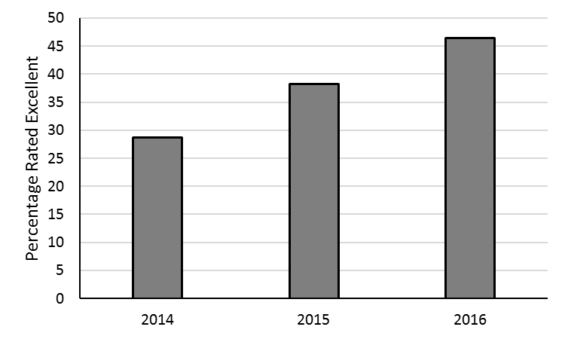
Figure 1. This graph shows the percentage of those rated as excellent averaged over all sections of the thesis. This gives some indication of an overall improvement of thesis quality coming from our students over the past three years.
The data are encouraging, both in terms of responses from committee members and in the distribution of responses. However, the Department would like to see improvement in the overall quality of the MA theses, with a particular emphasis on Literature Review, Results, and Discussion. The Psychology Graduate Committee will address this issue, with a focus on how those components of the thesis might be improved.

Statistical Competency Examination
We gathered results for the past two years on the statistical competency examination (data entry and analysis). In Spring, 2016 fifteen students earned 100% and 1 student earned 90% on the 10-question exam. In Spring 2017, seven students earned 100% and two students earned 90%.
4. What changes did you make as a result of the findings?
Although department standards were met in the assessment of each learning outcome, it is clear that steps could be taken to exceed the standards by a wider margin. Following suggestions from the 5-year program review, the MA degree recently went through a curriculum overhaul that has just been implemented in the Fall 2017 semester. The following changes have been made:
- Two 1-unit courses were added for our General/Experimental students: Psych 201 (First-semester seminar in graduate experience) and Psych 202 (Second-semester seminar). These courses are designed to help our General/Experimental students adjust to the demands of graduate school and to get directed assistants with their thesis literature view and research proposal.
- A mandatory statistics course was added for our General/Experimental students: Psych 244B (Statistics and Analysis Tools Competency – 1 unit), to be taken the Spring semester of the first year.
- We added the Statistical Proficiency Exam for use as a qualification for advancement to candidacy. This exam is offered at the end of the Spring Semester in the first year. Students are allowed a maximum of three attempts to pass the exam.
- The SOAP and assessment goals for the program are also being modified. It is expected that this overhaul will result in several changes consistent with the goal of exceeding current standards by wider margins. These curriculum changes (and consequent SOAP and assessment changes) have been evaluated and approved by the curriculum committee of the College of Science and Mathematics, and are now being implemented.

5. What assessment activities will you be conducting in the 2017-18 academic year?
It is expected that all assessment activities reported for the 2016-17 year will also be conducted in the 2017-18 year. Additionally, the Psychology Department will administer an exit survey to all outgoing MA students.
Efforts will be made to evaluate Learning Outcome 4.2: Students can develop a presentation appropriate for submission to a scientific conference. Each year, the Psychology Department sends several undergraduate and graduate students to regional and national conferences to present posters (e.g., Western Psychological Association Conference). This year, we will create a rubric and evaluate several posters and present the results in the next assessment report.

6. What Progress Have You Made on Items from Your Last Program Review Action Plan?

The following goals are listed in our 2014-2018 Action Plan:

Track graduate student alumni career progress via a telephone survey of recent graduates.

Data were collected from Psychology graduate student alumni Fall 2014 via telephone survey. A total of 127 alumni were identified who graduated between Fall 2007 and Spring 2014. Unfortunately, only 24 alumni were successfully contacted (19% response rate); 14 were School Psychology graduates, 8 were General/Experimental graduates, and 2 were Applied Behavior Analysis graduates. All respondents (100%) were glad they chose to further their education at Fresno State, and 87.5% were currently employed full-time. Because the response rate and the overall sample was so low, data were examined by the Chair, but results were not presented to the faculty nor were results presented in a scientific venue.

Revise our M.A. SOAP

We revised our SOAP, clarifying and simplifying goals and learning outcomes, and, in parallel, modified our course structuring for the General/Experimental students, adding a “research data analyst” track, including coursework and practicum experiences. Those documents were approved by the department Spring 2016, and approved by the College-level committee in Spring 2017.

Coordinate with the Division of Graduate Studies to allow student thesis format to more closely approximate scientific manuscript format.

This topic has been discussed in the Psychology Graduate Committee, and additional encouragement of this format will be seen from our new Graduate Coordinator and Assessment Coordinator, Dr. Martin Shapiro.

Increase number of tenure-track faculty

2017-2018: We were approved for a search for a new tenure-track faculty member specializing in neuroscience with a special interest in electroencephalography.

2017: Dr. Steven Payne returned from a 1-year leave of absence.

